Fire protection and Prevention Equipment
Name
Institutional Affiliation
Date

Smoke detectors.
Smoke detectors are equipment that senses smoke, typically indicating a fire. The smoke can be detected by either physical process known as ionization or optically, also called photometric method. Smoke detectors can use either or both processes in detecting smoke.
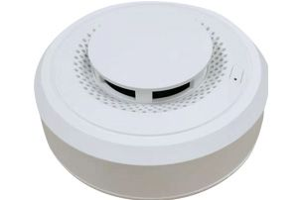
Standalone smoke detector
Heat detectors.
Heat detectors are fire safety sensors that respond to the unusually high temperatures usually present during the fire. They work by often sensing the high temperatures and the abrupt increase in temperatures. They do not detect heat as faster as the smoke detectors. The standalone Heat detector is recommended in areas where the smoke detector can be triggered in the environment that contains Moisture, heavy dust, and the smoke due to the everyday activities.
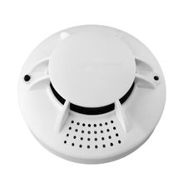
Fire extinguishers.
Fire extinguishers are active devices of fire protection used in controlling fire, usually in an emergency. Usually, this device is not intended to be used on fire that is already out of control. Fire extinguishers contain the vessel in the cylindrical form, with discharged agent to put off the flame. They are of two main types that is those with pressure stored in within and those operated by the cartridge.
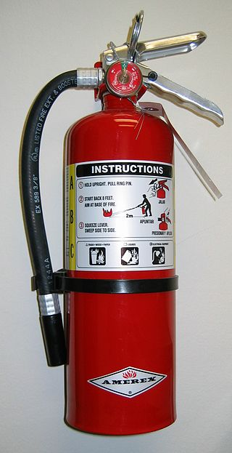
Sprinkler heads
Sprinkler head is are constituents of the fire sprinkler system which helps in discharging water when fire effect fire effect is detected example is when temperatures exceed normal temperature. It is usually attached to a pipe which is linked to a water source that is outside the building. When it is activated by the heat, a valve opens, allowing water that is under pressure to flow out in the pipe system.
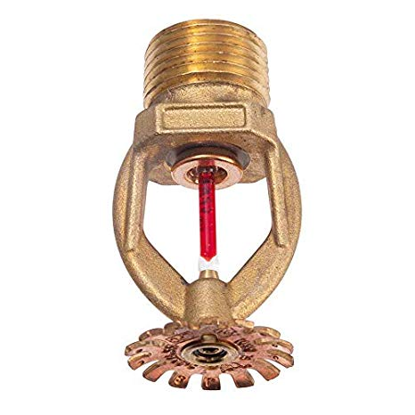
Frame
Deflector
Temperature Sensitive Glass Bulb
Sealing Assembly
Fire hydrants
Fire hydrants are a safety measure that is essential in buildings. It comprises of various components, when assembled, provides a spring of water helping authorities during incidents of fire. The equipment works in such a way that, when covers are removed, it can be attached to the valves, then open the valves to allow the flow of water through the hydrant into the hoses.
