Fire Ecology

Prescribed burn plan

State: Georgia

County: Carifoll

Site: Newnan RD

Burn :

Target burn window:

Table of Contents
Fire Ecology 1
Burn : 1
Target burn window: 1
General information 2
Project description 3
Fuel conditioning 5
Fire breaks 5
Pre-burn planning 6
Smoke management 8
Air quality issues 8
Down drainages 8
Weather 10
List of the equipments used 11
Logistics 12
Operations 14
Water management 14
Communications 14
Smoke management concerns 15

General information
Ownership: Greg Cohn
County: carifoli
Fuels
Litter, pines, and the hardwoods.
Types of burn
Ecological management
Goals
To offer protection and management of forests, rivers, deserts, wetlands, and distinct wildlife species.
Objectives
Conservation partnership
Assessment conservation opportunities
Offering scientific conservation education
Analyzing the landscapes and conducting different field studies
Sharing the knowledge and the skills the experts have.
Permits
Burn permit from the North county division of forest resources; Carifoli county ranger
Contact; (360) 778-5800
Notifications
Local newspaper legal notices
Emergence resistance
Emergence call; 911 or any Director of forest resources office

Project description
Shape: rectangular-shaped wildlands, forests, and marine covers are running from North to south. They are two types of management in these sections, one being forest and the other one being land management. On the upper side, they are different types of trees like pine and other hardwood trees. The lower side consists of wetlands vegetations.
Topography; it is elevated to 10599 ft, meaning it is moderately sloppy and hilly. The lowest elevation is 1569 ft; therefore, it is the area with the lowest elevation in the state.

Newnam elevation map

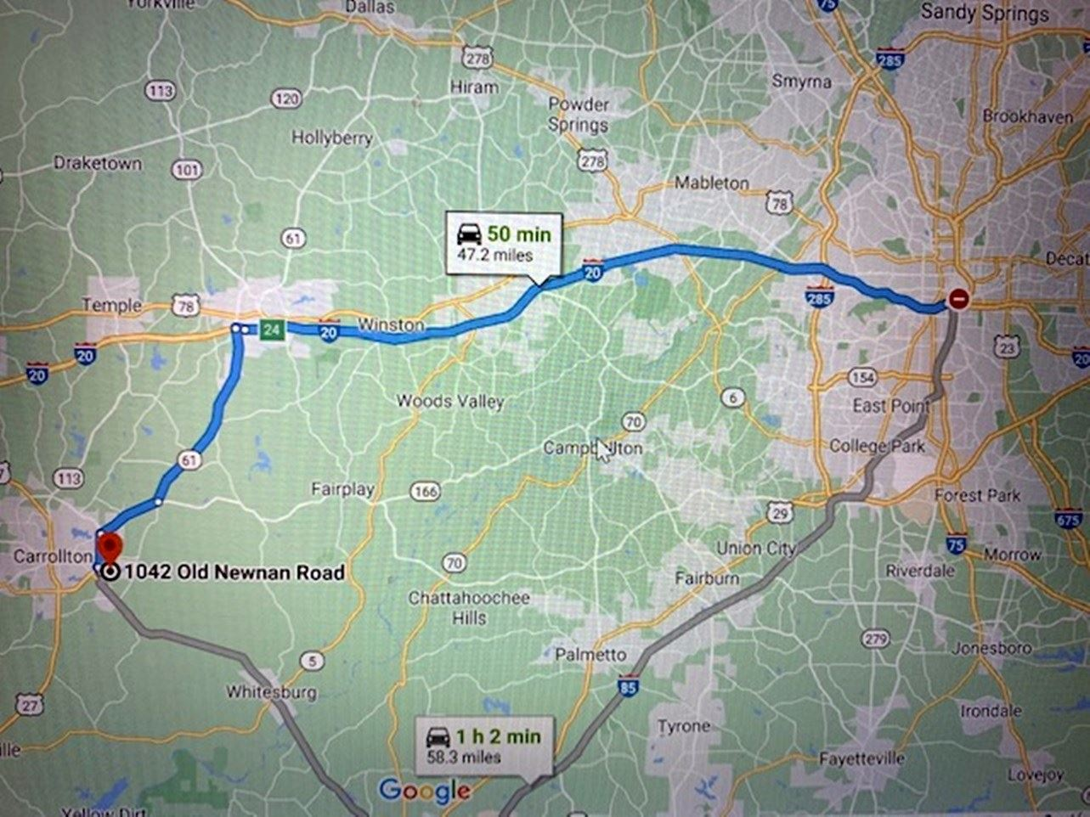
Vegetation
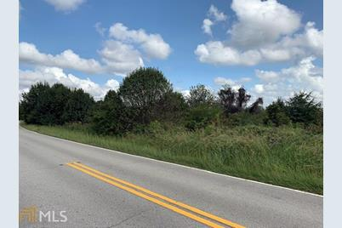 Overstory; various pines and different species of hardwood
Understory; hardwood species
Ground covers; wiregrass and forbs.
Vegetation is highly affected by the fires due to some of the dry matters inside the foliage, which leads to more acceleration of the fires. When there is a fire in the vegetation, other wildlife habitats are destroyed.

Fuel conditioning
Type of the fuel conditioning used was petrol and paraffin. The horizontal arrangement is applied where they spread from east to west, causing the significant occurrence of the fire where the fire was more critical and consumed the vegetation within a short duration. The fire was more continuous in steeply areas, shrubs, and agricultural areas than forest due to more fuel load. The fire continued for a short duration in the shrubs, vegetation than in the forests due to the complex matters in the woods than in the vegetations.

Fire breaks
It is the barrier between the vegetation and the other consumable materials that hinder the spread or continuation of the fire. They can either be natural like the river or human-made like roads and highways.
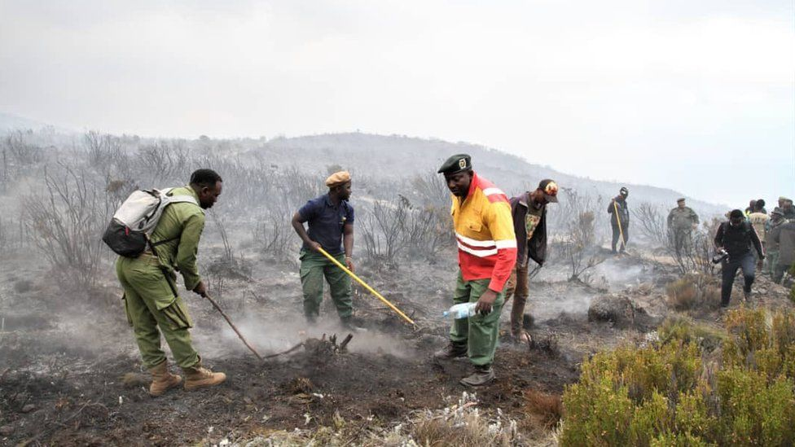 Fire break occurring.
Roads
When fires occur, most roads act as fire breaks preventing more fire spread; this is because they contain no substance that can accelerate the fire outbreak. Roads in the forest areas help the wildlife animals during the outbreaks of the fire as they assemble in the road until the fire has been cooled down.
Structures
Most structures like the buildings and the other amenities are severely damaged by the fire, which leads to more loss; this is because the structures contain some materials, e.g., the cupboards and oil used in painting that accelerates the fire. Every structure should have an emergence kit to take care of those affected by the fire outbreaks.

Pre-burn planning
1] Day (s) before burning
Clear all the vegetations and wait for at least one day for any animal in the foliage to shift to avoid killing the wildlife species
Identify the tracts that may need fire treatment to avoid destroying others.
Check the history associated with the tract to avoid burning more fertile pieces of the land.
Identify the number and the time favorable to do the burning in a particular fuel model.
Day[s] of burning
Identify the equipment needed in the burning and those required in putting off the fire like the water supply, Fire extinguishers kits.
Check the length and the width to be covered during the burning.
Analyze the weather condition whether it is suitable for burning.

Map of the burning unit
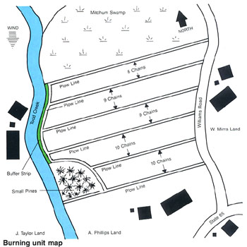 Contracts/permission needed.
In these cases, the adjacent landowners are supposed to be informed before the action, local authority, and the national government.

Smoke management
Considerations; Check and indicate the smoke sensitive areas, the wind direction in the burn unit, the method used to disperse the wind will be essential to avoid the spread of the fire to unnecessary areas where the smoke can lead to a lot of impacts if the fire is not controlled like breathing complications. The areas prone to smoke are houses, airports, communities, and the roads where they are a lot of people making the movements or residing.
SSA check for the structures within the burn unit to control the spread of the fire, where the smoke will be prevented from facing specific directions.

Air quality issues
Burning should happen in particular weather conditions when the weather is calm to avoid pollution of the air. A lot of smoke in the atmosphere pollutes the air, which can cause a lot of complicated health issues. The wind direction is another factor to consider to ensure that the smoke does not face the direction where they are residents building to ensure there is quality air for the residents.

Down drainages
Minor factors should not hinder the burning process as the issues can be rectified or implemented after the burning at minimal costs.
Smoke management objectives
Undertake the burning cautiously to ensure that there is minimal air pollution.
Preventing the smoke from affecting the SSAs within the burning unit.
Put down the fire within the twenty–four hours after the blazing starts to avoid more spread of the smoke, which brings many hazards.
Smoke management actions
Direct the smoke away from the living residents, social amenities, and the infrastructures to avoid contaminating the air, thus enhancing the residents' air quality.
Burn the areas within certain weather conditions and time of the day to avoid more spread of the smoke like burning in the evening will reduce more stretch of the smoke as the strength of the wind is low.
Smoke management consideration
Smoke contingency plan
Sensitive areas | Direction from the burning area | Distance to the area being burnt
Neighbor residents | South | 35 miles
roads | east | 10 miles
Water sources | Southeast | 45 miles
Smoke plume

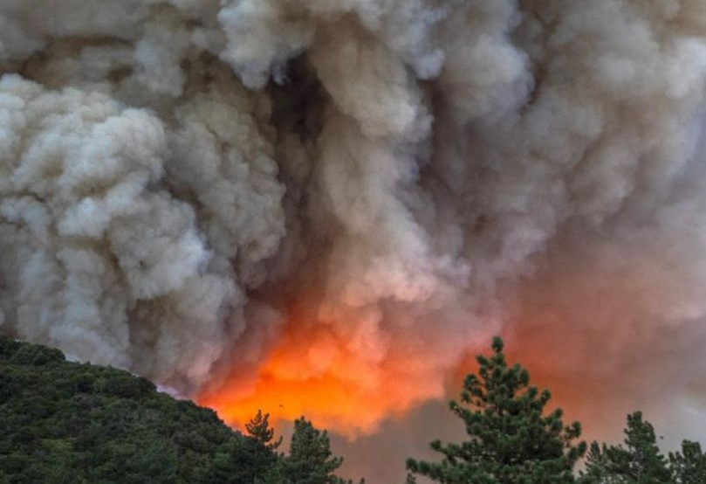

Weather

Relative humidity 30-60%
Wind 1-6mph
Temperature 24-60F
Fine moisture 10-30%
Soil moist
The above weather conditions match the burner's objectives because the conditions are moderate, not to cause any unnecessary burning, reduce the pollution of the air, and maintain the weather regulation of maintaining suitable atmospheric temperatures. Tools used in determining the weather conditions are the thermometer for the temperatures, windsock and wind vane for the direction and the speed of the wind,

List of the equipments used
Hand tools
Shovels 7
Rakes 5
Flappers 2
Power tools
Saws [chine] 3
Blower 1
Weather
Weather kit 1
Scale and FM sticks 1
Emergency
Emergency kit 1
Smoke warning signs 3
Ignition
Torches 4
Fuses 4
Water handling equipments
Pumps 4
Nozzles 4
Hoses 4
Tanks 2
Pumps 2

Logistics
Personnel
Qualified fire personnel: crew size, 4-5
Prescribed burn boss James peter
Weather observer Andrew Michael
Crew function Assist in the fire ecology practices
The crew boss leads the crew in performing the task effectively and efficiently to avoid any health hazards that may arise. The boss is also supposed to decide on the progress of the work. Lastly, the boss should coordinate with the other crew to ensure they work to deliver the duties assigned.
Types of equipment used; Water handling equipment like the hoses, pumps, and tanks. Weather equipment like the emergency kit, scales. Emergency equipment like the kits. Hand tools and power tools.
Crew outfit
The crew wore the outfit when should be of good standard to increase efficiency at work and avoid any accidents while working.
Fire shelter
Map of units
Matches
Canteen
Leather gloves
Leather boots
Complete full clothing attires
Hard hat with shield for visual

Operations
Ignition
The fire will be set at the right corner of the field, where if the fire does not follow the prescription that is faced in a specific direction, it should be extinguished immediately to avoid more damages. The crew should test the burning with a small piece of the land, like 30*40 piece of land, to see the reaction of the fire where they will decide on the next move to undertake. Some crew members will ignite while the others secure the fires from spreading to sides that are not meant to be burnt.

Water management
The water should be stored in tanks where the engines will be used to pump the water from the tanks to the allocated areas.
The water also will be spread to other areas using the hose pipes and the different nozzles.

Communications
The crew leaders will have cellular phones to ease the communication with the team leaders and the management.
The crew will communicate to another if there are abnormal movements of the fire to enable earlier rectifications.

Smoke management concerns
Every burning site should be extinguished before leaving the area. Also, smoke signs will be instituted in different locations until the whole operation is over this is to avoid accidents caused by the blockage of the smoke.
Estimated duration
Preparation before the burn day 7 hours
Preparation on the burn day 2 hours
Actual burn 5 hours
Mop-up 1 hour
Post burn evaluation 2 hours
Total 17 hours

