OPPORTUNITY COST IN FISHERIES

Students’ Name:
Professors’ Name:
Course:
Subject:
Date:

Opportunity Cost
Across world economies, fishing, mining, agricultural activities among other land use activities are part of economic activities. Having tried various economic activities for the welfare of the society and the entire nation, I chose to practice fishing instead of agricultural farming of crops. Practically, I applied the trade off or opportunity concept in choosing between the two income generating activities. Basically, the cost of production, availability and reliability of the climatic conditions facilitated in my decision making. For maximum and economic utilization of my limited resources, such as land, water as well the harsh climatic conditions, I saw it irrational to capitalize on crop growing which could fail in the due course due to shortage of rains among funds shortage.
Marginal Analysis
I practically targeted at marginal analysis as my decisional tool in evaluating the best economic activity to venture with between the two. In addition, I focused at the market returns and the cost expected from implementation to harvesting time, resource availability and affordability to ensure competence in my performance as well as maximization in profit making. Fortunately, among the additional benefits I had in my project choice over the agricultural farming is absence of competition in the fish industry across the local market in my locality. similarly, due to shortage of rains, I could not make to grow crops in large scale or crops in need for rainfall for over 90 days. consequently, I could preserve the available rain water in a reservation tank, trap a lot of it in my fish pod and initiate the process of fish rearing. Little labor cost in fish production influenced my decision too.
However, few producers were found in the fish farming industry and especially in the local market. Disequilibrium in the fish demand triggered more ideas which helped making my choice since I analytically observed that. Demand for fish in the market had overcome supply for a reasonable period and thus we needed to fill the market gap in the market. Statistically, in long run I speculated that I will be able to dominate the market depending with the analysis I had made from the market and the strategies I developed. Most adventitiously, fishing sector compared to agricultural sector had little competitors. In fact, it was more of an oligopolistic market in focusing it from our local area.
Marginal Benefit and Marginal Loss
For instance, considering the graphical figure A below, for elaboration between marginal benefit and marginal cost as I applied in investment opportunities such as in my choice making between agricultural crop farming and fish farming. Remember, marginal benefit refers to the extra advantage one us on forgoing a given unit of another opportunity. For instance, choosing a between the two given investments above, I chose to forgo agricultural produce due to its plentyness in the market at the expense of fish production and distribution .in doing so, the concept of marginal benefit applies. In the graph, it lies on the right-hand side of above marginal benefit.
However, marginal loss is the value of the opportunity for the choice you make. For instance, choosing an apple over a mango, the value of the mango is the marginal loss for that case. Provided the marginal benefit exceeds the marginal loss, the choice made should be more fruitful to the other.
Catch Shares
To mitigate the problem in fisheries, the government organizes the fishers to obtain secured rights to an allotted section of the fishery despite of when they secure their section in the course of the year. Simply, catch shares are useful for managing the fishery system. They can be used to slow down competition through timing their catches to cop with the market demand hence focus on diverging profit opportunities across the season. Most adventitiously, this mechanism can minimize possible hazards as well as improving the quality of fish produced.
Analytically, scientists and economists have maintained that catch shares can minimize economic resource wastage, safety measures as well as ecological disturbance that can occur when fishers race to satisfy catch levies seasonally. Doubtfully, policy makers have failed to put the economists and scientists’ theories into consideration since the theory is said to have been narrowed down to some specific fisheries only.
Majorly, on focusing in large scale fisheries there are policies that can be applied and fail to mitigate the economic wastage as said above theoretically. Through application of command and control policies, such as defining specifically the size of fish to catch, the days to fish, excluding some fishing vessels, set quotas for violation of specific policies among others. In return, this policy shall simply control overfishing but not economic costs. Mostly, the catch shares turn down the rate of destruction in fisheries thus improvement in fishing conditions. this simply a control mechanism applied by the government in large scale commercial fisheries. The mechanism has proved to be effective enough only with few exceptions.
Researchers David Kaczan, Smith, Birkenbach among other asserted that, in big fisheries with various species, fishermen speed up in catching the minor species thus giving time for more pursuit and growth. With all factors held constant, the benefits overcame the negatives.
Ultimately, I would recommend the policy makers to put the concept of trade off into consideration when making decisions concerning catch shares.

Figure A, depicting marginal benefit and marginal cost.

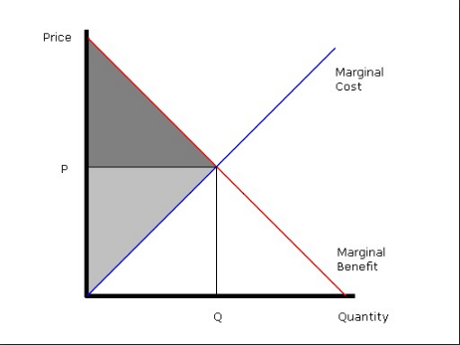

Below is a graphical presentation of the effectiveness of catch shares policy applied in various fisheries as indicated.
