F.A.S.T. Rescue Inc.
750 Oakdale Rd., Suite 56
Toronto, Ontario, Canada
M3N 2Z4
Website: www.fast-rescue.com
Phone: (905) 760-2045
Toll Free: (866) 706-SAVE (7283)
Fax: (905) 418-0395
Toll Free Fax: (888) 313-836
E-Mail: info@fast-rescue.com

Online Training
ALL online courses listed in our website are included at no charge in the Systems 24-7 Business and Enterprise Editions



FAST RESCURE INC

ABOUT:
- F.A.S.T Rescue has been driving wellbeing and security preparing activities, zeroed in on medical aid to catastrophe the executives, for significant associations and people on security across Canada.
- F.A.S.T. Salvage originated from offering people and organizations a reasonable, customized, quality medical aid program.
- Check it out and Online Training and enroll on the course of your choice on our Web site at https://fast-rescue.com/online-training-programs/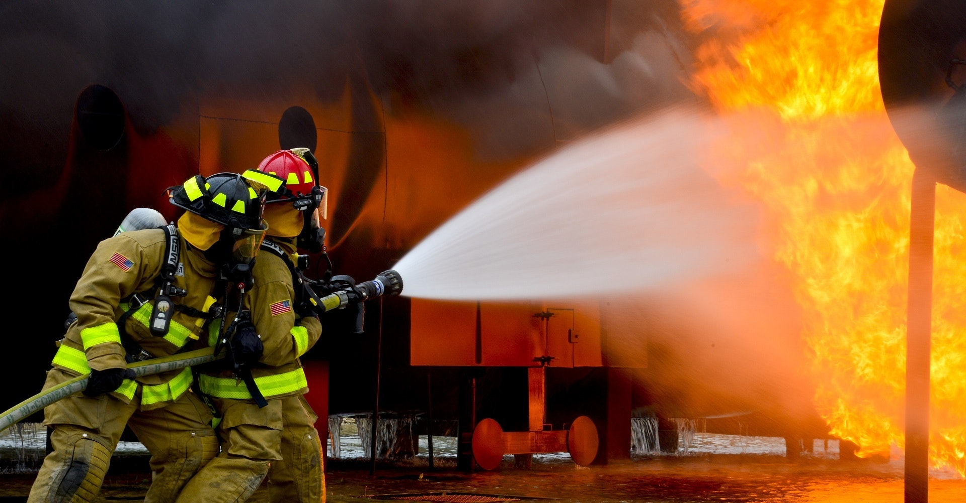

To give you peace of mind by reducing risks in your workplace

