Student: __________________________ Date: ______________
Professor: ______________________________________________________________
PATIENT INFORMATION:
NAME: Mr. John
AGE: 42 SEX: male
SUBJECTIVE:
HPI .John 42 years old man comes to the clinic after feeling pain in his right toe. He was unable to move by himself, he is barefooted. The intense pain began in the night, while during the day he was busy carrying activities in his farm. According to john, he does not recall if he did anything that injured his toe. His farm boots were on while he was at the farm. The previously night he was complaining of pain that made him not to fall asleep. The pain that he was feeling is described as a sharp pain which was stabbing. Even after taking some painrelivers the pain was still intense. He still feels the same pain at the moment. He does not experience any form of symptoms pain he was complaining of .he does not feel pain in the fingers, wrists, elbows, knees, or ankle .he has been experiencing lingering discomfort Previously.
PRIMARY CARE SOAP NOTE
ALLERGIES:
The patient says he is allergic to antibiotic such as penicillin; he is also allergic to cold and milk.
CURRENTMEDICATIONS
There is no current medication that the patient was on
PMHX: None
FAMH: Patient denies none of his family member has suffered from monoarticular arthritis
SOCHX: Patient accepts he has been using alcoholic beverage. He denies use of the drugs illegal.
REVIEW OF SYSTEMS:
CONSTITUTIONAL: Monoarticular pain. ( ) gouty arthritis
Constitutional symptoms such as intense pain, limited range of motion, inflammation, redness and lingering discomfort
HEENT:
HEAD: _Traumatic, normocephalic, with no visible recessions, scarring or palpable masses.
EYES: There were no symptoms of infection on the lid and the conjunctiva. After conducting the exam for the pupil, it revealed that the pupil was reactive with no defect associated with papillary. Optic discs had normal color, and were cupped bilaterally. Retinas were flat with normal vasculature in an out position. No peripheral holes were observed
EARS: Eustachian tube had no abnormalities. Cochlea, vestibules and semicircular tubes were intact.
No uric acid crystal on the surface of the ear
NOSE: The nasal bones had no abnormalities, nasal septum was intact and nasal cartilage were in normal condition
THROAT: Throat exam revealed the hypopharynx were, there was no sore in the throat, no reddish color on the skin around the throat
RESPIRATORY: The evaluation of respiratory test revealed that respirations were occurring without use of muscles accessory .there were no intercostals rectifications. No chest resonance after conducting chest percussion. There was normal tactile fremitus
CARDIOVASCULAR: Peripheral vascular system exam revealed varicosities absent, full to palpation, no edema, and extremities warm to touch, and no abnormalities were noted .no thrill was noticed on the heart palpation which is found on the fifth intercostals in mildvicular line
GASTROINTESTINAL: The GI test revealed no abnormalities on the stomach and the esophagus. The small intestine had no abnormalities
GENITOURINARY: After conducting vaginal vault exam, the result showed no abnormalities.
MUSCULOSKELETAL: The station exam showed midposition had no abnormalities.
NEUROLOGIC: Examination of cranial nerves showed no deficits, Deep tendon reflexes were normal. Vibratory, pin proprioception sensations and touch are normal. The insight for the patient is well as well as his judgment.
PRIMARY CARE SOAP NOTE
OBJECTIVE:
CONSTITUTIONAL: The joints which were affected were warmer as compared with the other part in which the patient was not complaining of the pain. The toe was swollen; this could be noticed even before the patient started explaining. The joints which were affected were tender. There was redness on the joints which were affected by the diseases. The patient was unable to move his joints normally; the joints were able to move after he excited certain pressure on them.
The blood test was carried out to determine the level of uric acid in the blood. Since the level of uric acid varies among different individuals, it cannot be used to determine if someone has gout or not. A joint fluid test was conducted where the fluid was withdrawn from the affected joint of the patient by the use of the needle to examine the presence of the urate crystal on the microscope. Additionally, the ultrasound was carried out to detect the availability of urate crystals in the joints.
To certain more, if the pain is has a result of gout; x-ray imaging was conducted on the affected joint to determine the real cause of the inflammation that was resulting in the pain. Different x-ray images which were captured from a different angle of the affected joints were combined to observe the presence of urate crystal in the joints.
SKIN: _on the toe there was formation tophi this resulted due more accumulation of the urate crystal in the body.
HEENT:
NECK: Neck exam reveals no abnormalities. Thyroid examination reveals no abnormalities.
RESPIRATORY: The evaluation of respiratory test revealed that respirations were occurring without use of muscles accessory .there were no intercostals rectifications. No chest resonance after conducting chest percussion. There was normal tactile fremitus
CARDIOVASCULAR: Peripheral vascular system exam revealed varicosities absent, full to palpation, no edema, and extremities warm to touch, and no abnormalities were noted .no thrill was noticed on the heart palpation which is found on the fifth intercostals in mildvicular line
GASTROINTESTINAL: The GI test revealed no abnormalities on the stomach and the esophagus. The small intestine had no abnormalities
PRIMARY CARE SOAP NOTE
GENITOURINARY: After conducting vaginal vault exam, the result showed no abnormalities
MUSCULOSKELETAL: The station exam showed midposition had no abnormalities
NEUROLOGIC: Examination of cranial nerves showed no deficits, Deep tendon reflexes were normal. Vibratory, pin proprioception sensations and touch are normal. The insight for the patient is well as well as his judgment.
PRIMARY CARE SOAP NOTE
ASSESSMENT:
DIAGNOSIS:
The patient had swollen toe, which was warmer as compared to the other parts of the body. It was reddish as well as tender. After carrying out the test, the urate crystals were observed in the joints that the patient was complaining of pain. Around the elbow, and the back of the fingers tophi was seen. On the fingers on which the tophi were observed, gritty white material with pus-like fluid was flowing. On the x-ray images, the bone and the cartilage around the affected area were damaged by the growth of the tophi

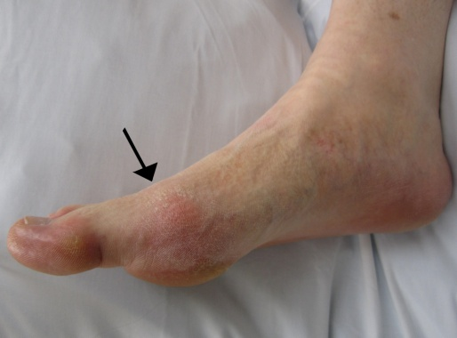
THE toe infected with gout
DIFFERENTIAL DIAGNOSIS:
The differential diagnosis is administered after the symptoms of the infection was determined such redness of the skin. The diagnosis was done after the patient condition could not improve. To help with diagnosis, the synovial fluid gram staining was performed as well as the culture. The tophi were located in the patient joint.
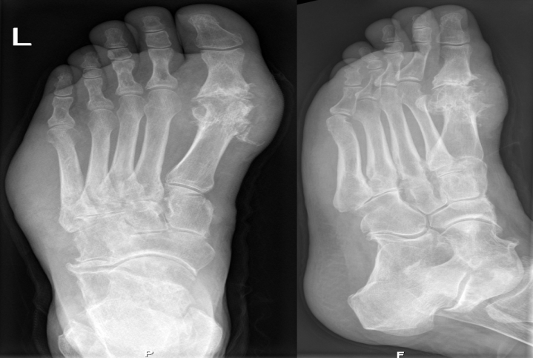
X ray image of foot suffering from gout
PLAN:
The gout was treated by using two methods. One method was to decrease the pain which is associated with inflammation when someone is attacked by gout. The other method was administered to lower the amount of uric acid in the body of the patient thus minimizing the complications which are associated with the disease.
Non-Pharmacologic treatment:
The patient was also encouraged to do regular exercise while at home this will ensure that his body remains healthy and having a good weight thus reducing the risk of suffering from gout. To avoid food that contains a high amount of purines such as red meat, sardines, scallop, and mussels. Additionally, the patient was encouraged to be taking more water and avoids alcoholic beverages as well as drinks that as sweetened with fructose.
Pharmacologic treatment:
MEDICATIONS:
The patient has been treated with nonsteroid anti-inflammatory drugs (NSAIDs) which will help to reduce inflammation and the pain which is associated with gout. The NSAIDs which the patient was given were naproxen, ibuprofen and diclofenac. The patient was advised that in case he starts feeling such pain, he can use the drugs which the doctor prescribed him. Since the NSAIDs are usually prescribed for a long period, a proton pump inhibitor was also administered to prevent the patient from digestive system problems.
Colchicine was also used for the treatment of gout. It is usually effective when it comes to inflammation reduction which is caused due to accumulation of the urate crystal. The patient was instructed on how to take the medicine, incases the symptoms starts. Corticosteroid drugs were also administered which can control pain and inflammation. Corticosteroids were injected into the patient's joint; however, the patient was informed about the side effects which are associated with this medication.
The patient was also advised on how to prevent the complications which are associated with the disease through taking medication that will ensure the production of uric acid is blocked. A drug such as a login limits the ability of the body to make uric acid. Furthermore, the patient was advised how he can improve the removal of uric acid from the body by taking medication such as probalan.
FOLLOW-UPS/REFERRALS:
The follow up was schedule after 2 weeks of treatment. In case of similar pain in different body part the patient should notify the doctor immediately.
RATIONALE:
When the drug is started in acute gout, the quicker the response is. Poor patient compliance result to the failure of the treatment. Prophylactic treatment should not be administered during or after the episode of gout. The dose of allopurinol to remain unchanged during an acute episode of gout

