HOMICIDE
Institution
Date of submission

America has six times as many firearm homicides as Canada and nearly 16 times as many as Germany.

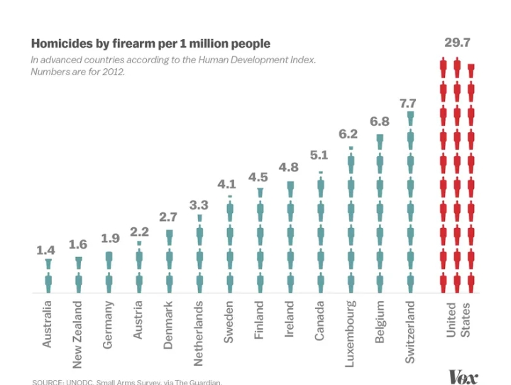

From the graph above, America has indicated a high number of homicide cases compared to other countries. Australia has the lowest cases that have been rated to be 1.4, followed by New Zealand, Germany, Denmark, and the Netherlands. Other countries that have shown an increase in homicide cases are Luxemburg at 6.2, Belgium has 6.8, and Switzerland is the second country that has recorded many homicides with 7.7. United States of America is the highest in the cases that it records 29.7 cases of homicide per 1 million. Homicide in the USA has increased due to social inequality that has been granted by legal rule where some minority groups are not protected against the harsh regime of the law abusers. Racism and discrimination have elevated the number of deaths in the USA because some government agencies do not take adequate precautions during the execution of their duties.
Immigration issues have also increased homicide issues. This is evident in the states that at the Atlantic side of the country host many immigrants from different places that tend to be violent and constantly involving themselves in illegal drug trafficking. States that are in the central part of America have reduced cases of homicide cases. There are also high cases of individuals who own guns, which has led to more deaths due to rogue gun owners. Other reasons that have resulted in increased homicide cases are drug abuse in the United States of America and increased strained relationships between family members who own firearms, resulting in violence and deaths.

Reference
https://www.vox.com/policy-and-politics/2017/10/2/16399418/fedex-indianapolis-mass-shooting-gun-violence-statistics-charts

