By: Deborah Oehlman Forbes
School of Health and Human Sciences, Southern Cross University
Megan Lee
School of Health and Human Sciences, Southern Cross University;
Richard Lakeman
School of Health and Human Sciences, Southern Cross University
Acknowledgement: Deborah Oehlman Forbes provided a complete first draft along with the conception of idea, analysis, and interpretation, developed inclusion/exclusion criteria, screened all articles, conducted the appraisals, and drafted themes. Megan Lee proofed the initial draft, liaised with university librarians in construction of literature search, conducted the second literature search and data extraction, formatted tables and figures, drafted content throughout manuscript, formatted referencing, and proofed the entire final draft. Richard Lakeman analyzed content, drafted content across the manuscript, including the abstract and discussion, proofed, and provided edits on the article. Deborah Oehlman Forbes wishes to thank Tom O’Brien from The University of Queensland, School of Medicine, for his clinical guidance and support for this article. The authors declare no potential for conflict of interest.
Children who experience interpersonal trauma often have difficulties with aspects of mentalization, particularly reflective functioning, affect, and emotion regulation (Berthelot, Lemieux, Garon-Bissonnette, Lacharité, & Muzik, 2019; Halfon, 2017). Mentalization is an umbrella term that has evolved out of the psychoanalytic and psychodynamic psychotherapy tradition and is broadly “defined as the ability to understand feelings, cognitions, intentions and meaning in oneself and others” (Robinson, Skårderud, & Sommerfeldt, 2019, p. 1). Mentalization has subsequently been validated in studies of human development, neuroscience, and psychology as a form of metacognition or “thinking about thinking” of oneself and others (Bateman & Fonagy, 2013; Malda-Castillo, Browne, & Perez-Algorta, 2019; Ridenour, Knauss, & Hamm, 2019). The concept is now explicitly embedded in contemporary treatment models such as mentalization-based therapy for children (Muller & Midgley, 2015).
Early in infancy, humans begin to attribute intentionality to people, and in early childhood, “theory of mind” develops, whereby children begin to understand the beliefs and desires of themselves and others (Ensink & Mayes, 2010). The development of mentalization has been found to mediate against the impact of childhood trauma positively and contribute to resilience in the face of childhood adversity (Ensink, Bégin, Normandin, Godbout, & Fonagy, 2017; Taubner & Curth, 2013). Trauma in formative periods of childhood development can disrupt the development of mentalization capacities and predispose individuals to later problems with emotional regulation and distress tolerance manifested in conditions such as borderline personality disorder (Weinstein et al., 2016).
Although the literature on interpersonal childhood trauma is quite broad, accounting for no single definition, children’s exposure to interpersonal victimization and violence may result in co-occurring symptoms such as separation anxiety, disruptive behavior, or mood disorder (D’Andrea, Ford, Stolbach, Spinazzola, & van der Kolk, 2012). According to the National Centre of Excellence for Complex Trauma, interpersonal trauma can be defined into three categories: (a) “trauma from something done to a child” (Blue Knot Foundation, 2020, p. 2), which could be physical, sexual, or emotional abuse internal or external to the place of residence; (b) “trauma from something that doesn’t happen” (Blue Knot Foundation, 2020, p. 3) in the form of neglect of a child’s basic physical and emotional needs; and (c) “trauma because a child’s parent or caregiver is affected by their own trauma” (Blue Knot Foundation, 2020, p. 4), including postseparation conflict, parental mental illness, substance or alcohol misuse, or the effects of an imprisoned parent.
Strathearn (2011) has suggested that neglect lies at the core of all forms of child abuse (sexual, psychological, bodily harm) and that neglect may be at the center of attachment trauma in children burdened by psychological isolation and loss of psychological attunement. Bowlby (1988) suggested that when attachment trauma has taken place, and attachment is threatened, there are anxiety and anger in the child, and where an attachment is broken, there is grief and depression. Interpersonal childhood trauma has been found to lead to posttraumatic stress disorder as well as complex developmental impairment such as self-regulation capacity (Musicaro, Ford, Suvak, Sposato, & Andersen, 2020). When trauma is linked to mentalizing failure, reflecting a secure attachment helps ameliorate and regulate a child’s overwhelming emotions (Allen, 2012). Psychotherapy is, therefore, an attachment relationship that aims to provide the child with a safe place to reorganize intrusive memories, make sense of attachment loss and redevelop a secure base (Allen, 2012).
Fonagy and Adshead (2012) suggested that most forms of psychotherapy, including cognitive therapy, mindfulness training, interpersonal therapy, patient-centered therapy, and behavioral therapy work by enhancing mentalization. However, only some schools of psychotherapy such as mentalization-based therapy (Bateman, O’Connell, Lorenzini, Gardner, & Fonagy, 2016) and some forms of psychodynamic therapy explicitly examine or measure the development of mentalization capacities and correlate these with symptom improvement.
Psychotherapy with children is approached differently than with adults. Psychotherapy has a long standing tradition of including play therapy adapted to treat complex psychopathology in children (Blazek, 2013; Greenberg, 2018). Winnicott (1974) suggested that through play, adults could engage with children in an authentic, less defended way (Tal & Tal, 2017). The “play space” is where children can freely express their thoughts, feelings, and needs, including the development of reflective functioning, thus increasing the capacity to mentalize (B. Or, 2010). Only recently have there been systematic attempts to measure improvements in mentalization in children (Fonagy et al., 2016). The research appears to focus on specific diagnoses such as attention-deficit/hyperactivity disorder (Conway, Lyon, Silber, & Donath, 2019), autism spectrum disorder (Keenan, Newman, Gray, & Rinehart, 2017), and eating disorders (Kelton-Locke, 2016). A critical role of research is theory-testing, which identifies and investigates some of the reasons how, why, and for whom specific interventions are effective (Kazdin, 1997). There is strong theoretical support for the development of mentalization being disrupted by trauma and support for mentalization enhancement in therapy. However, there is weaker empirical support for these propositions, which this review attempts to address. The nature of psychotherapy with children is that it is often lengthy and intensive and rarely allows the degree of control or scale associated with randomized controlled trials (RCTs) of brief interventions for circumscribed problems.
There are current gaps in the literature on the impact of childhood interpersonal trauma on mentalization, such as conceptual implications for working with child psychopathology and their families. These gaps suggest that practitioners who work in the foster care and child protection systems may find mentalization a developmentally oriented and sound clinical approach combining long-established and contemporary theory. This scoping review will seek to draw together and summarize the evidence on psychotherapy process and outcomes relating to mentalization in children. This scoping review summarizes and presents themes across the studies and will describe how mentalization is measured and accounted for in child psychotherapy.
Method

A systematic scoping review was conducted using the Preferred Reporting Items for Systematic Review and Meta-analysis (PRISMA) statement (Moher, Liberati, Tetzlaff, & Altman, 2009) to document search logic. Scoping reviews can help to identify research gaps, set research agendas, improve evidence-based practices, and provide recommendations for policymakers and practitioners (Levac, Colquhoun, & O’Brien, 2010). This scoping review was informed by steps outlined by Arksey and O’Malley (2005) and was considered the best approach to answer the research question, “What is the role of mentalization in child psychotherapy, interpersonal trauma and recovery in school-age children?”
Search Strategy
The strategy was developed with the aid of a librarian and consisted of the following key search terms: mentalization, mentalization, mentalization-based therapy, child*. Adding the terms “trauma” and “recovery” to the literature search did not yield more results. Therefore, screening of titles and abstracts informed the authors if the study was related to mentalization in child psychotherapy, interpersonal trauma, and outcome and recovery.
The search was limited to title, abstract, and keywords in the English language. Secondary and gray sources of literature were excluded. Five databases were searched, including the Psychology and Behavioral Sciences Collection, MEDLINE, PsycARTICLES, PsycINFO and Cochrane’s Central Register of Controlled Trials electronic databases. These databases were chosen because they reflect a range of articles from the psychiatric, psychotherapy, and psychology fields relevant to the intervention type. Searches for studies published between 2002 and 2019 ensured relevant studies were not missed, given that adult and adolescent studies have taken precedence with a much slower uptake for child studies in the identified age range. It was noted that several empirical studies are currently in the protocol and pretrial phase. The reference lists of chosen articles were also examined for missing articles.
Study Selection
Articles were screened by title and abstract by two independent reviewers (Deborah Oehlman Forbes and Megan Lee). Results that met all the following inclusion criteria were included: studies that were (a) primary research, (b) described intervention techniques from child psychoanalytic/psychodynamic and/or mentalization-oriented assessment, (c) clinically relevant to relational trauma, maltreatment, or neglect, (d) included children between the ages of 6 and 12 years, and (e) scholarly peer-reviewed sources. The full text of articles that met the inclusion criteria were read and included in the scoping review.
The literature search method yielded 425 articles, including three studies through citation chaining. Once duplicates (n = 47) were removed, the title and abstract of 381 articles were screened for inclusion in this review. A total of 353 articles were excluded for the following reasons: age of participants (either infants or those older than mentioned in the inclusion criteria), the outcome not related to trauma, or the intervention not specific to mentalization. For example, although one RCT measured affect recognition, mentalizing, and social skill in children with autistic spectrum disorder, the intervention related to computer-assisted face processing instruction and was not specific to trauma (Rice, Wall, Fogel, & Shic, 2015). Other articles were excluded because they presented protocol and feasibility phases of an RCT currently being conducted in the U.K. foster care system, with the outcomes yet to be published (Midgley et al., 2017; Midgley et al., 2019). See Figure 1.
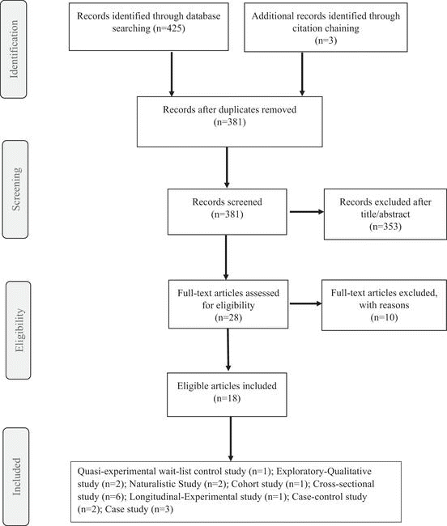Figure 1. PRISMA flow diagram of article screening and selection.
Charting the Data, Analysis, and Reporting the Results
Decision-making processes were made by consensus between all three authors. This procedure involved determining the study’ inclusion and exclusion criteria through negotiation at the beginning of the scoping review process as recommended by Levac et al. (2010). This was followed by discussions on clarifying the concepts and identifying and agreeing on three key themes: (a) trauma and mentalization, (b) measurement of mentalization, and (c) charting recovery. The data from the selected articles were extracted and presented in table form for comparison (see Table 1). All authors contributed to drafting theoretical content, conducting data analysis/synthesis, and using comparative analysis to compare different mentalization interventions and their applicability.
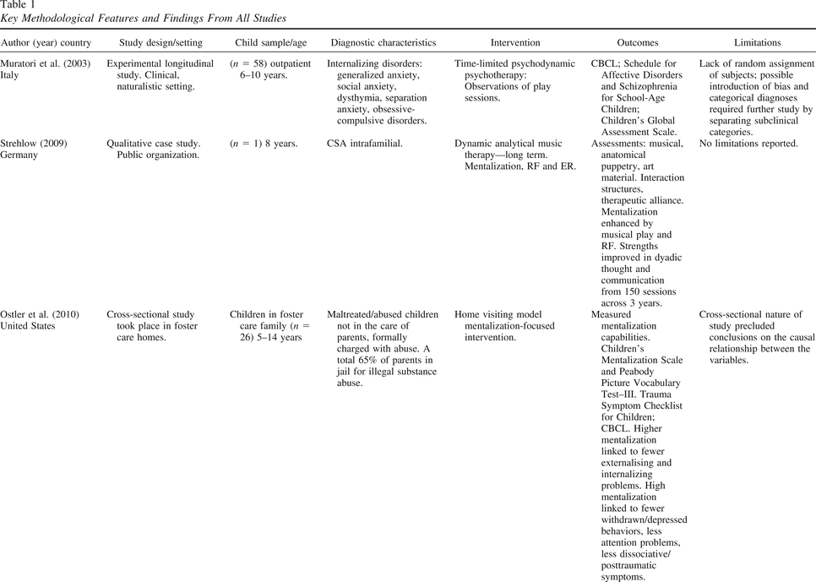Key Methodological Features and Findings From All Studies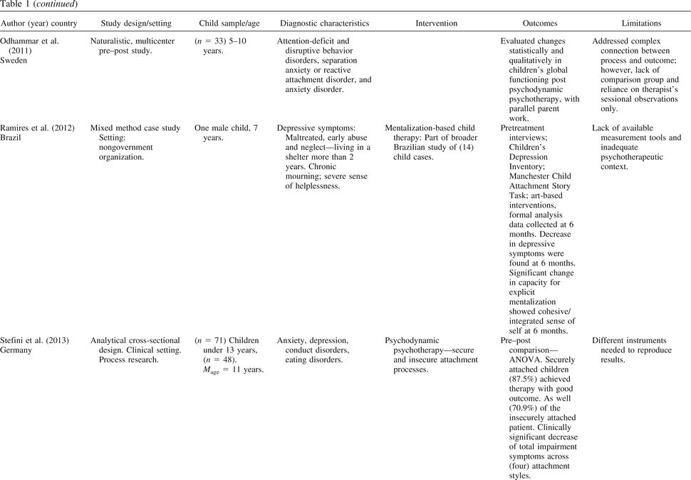Key Methodological Features and Findings From All Studies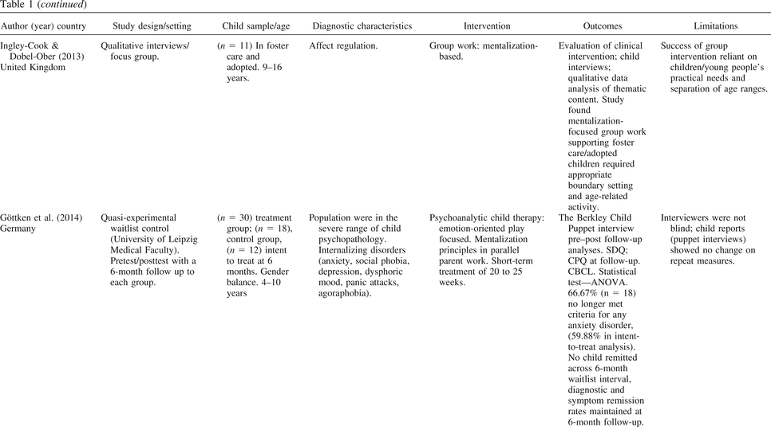Key Methodological Features and Findings From All Studies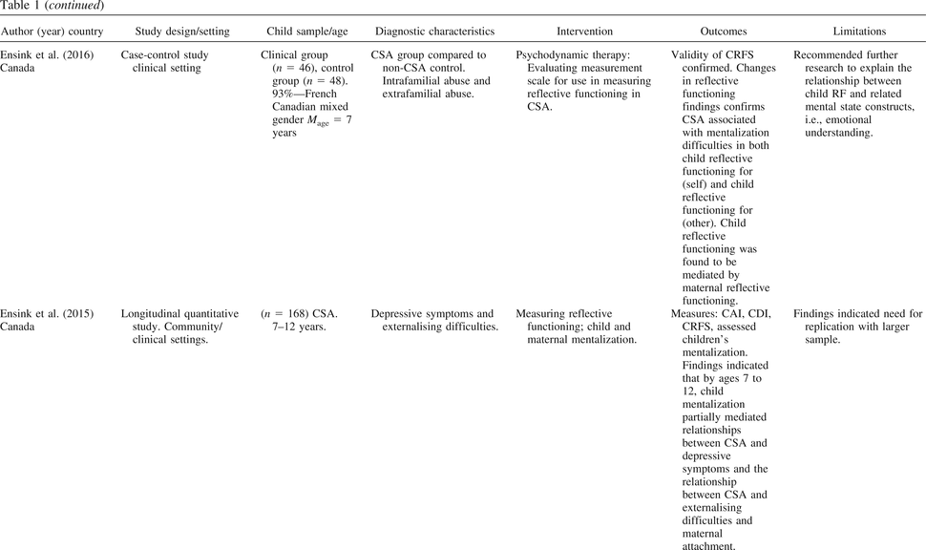Key Methodological Features and Findings From All Studies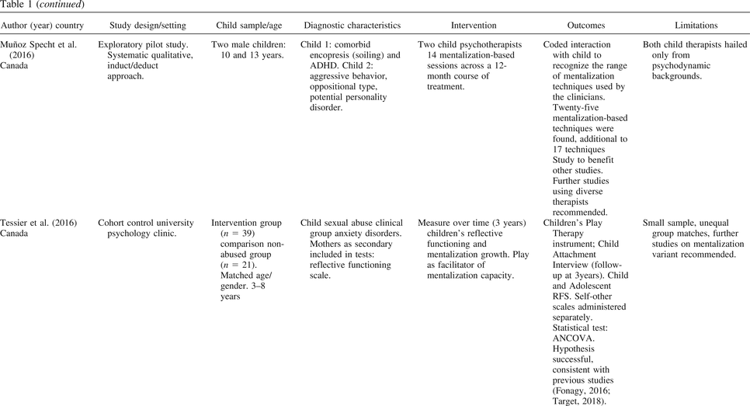Key Methodological Features and Findings From All Studies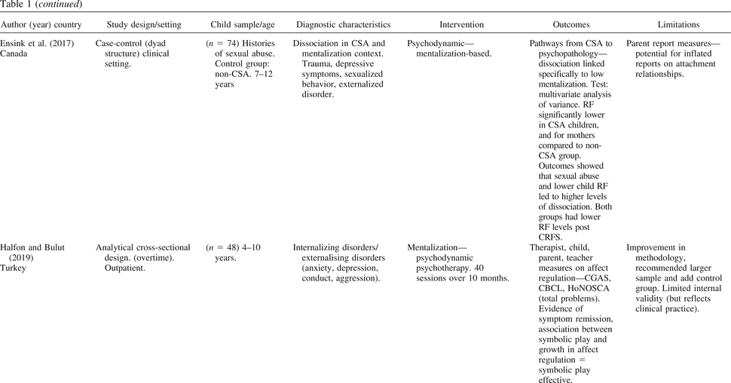Key Methodological Features and Findings From All Studies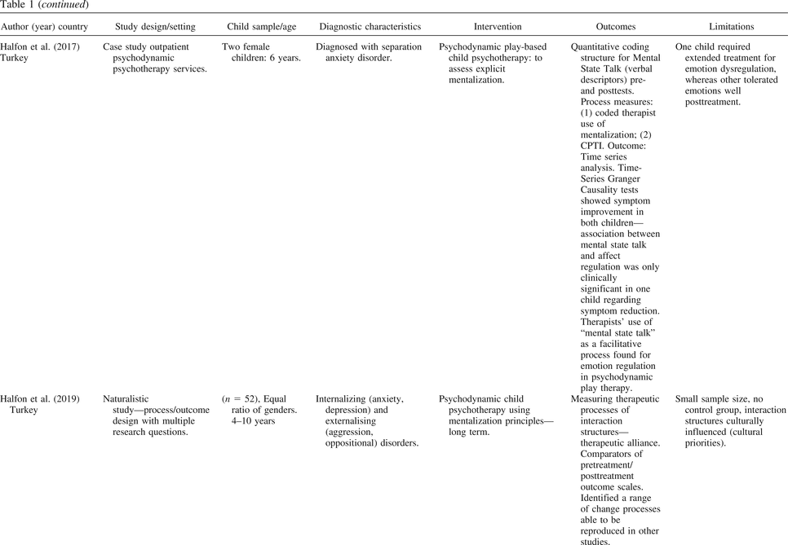Key Methodological Features and Findings From All Studies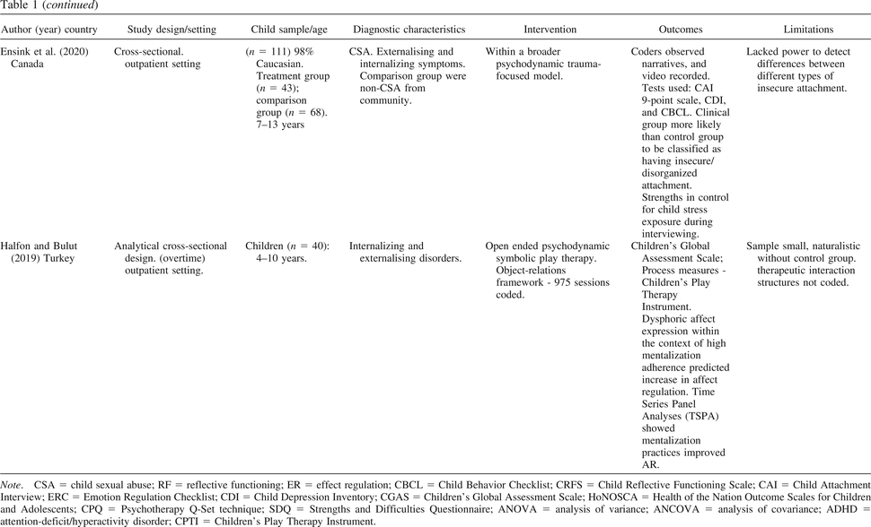Key Methodological Features and Findings From All Studies
Results

Collectively, the studies involved 719 child participants; 396 were female, and 323 were male. Most of these studies included children with no significant developmental delays, psychotic symptoms, significant risk of suicide, or current abuse. The results are summarized under the following themes: (a) interpersonal trauma and mentalization, (b) measuring mentalization, and (c) charting recovery.
Quality of Studies
A scoping review does not generally require a critical appraisal of the quality of every study acquired, and there is presently a lack of consensus on how to undertake such an appraisal when the research may include different methodologies (Tricco et al., 2018). This review has taken a pragmatic approach to the appraisal of quality, which is in accord with the recommendations of Pluye, Gagnon, Griffiths, and Johnson-Lafleur (2009), to utilize professional judgment in appraising content validity and relevance. The authors have commented (Table 2) on issues such as sample size, rigor, and control and potential for bias as reported in the articles or inferred from reading them.
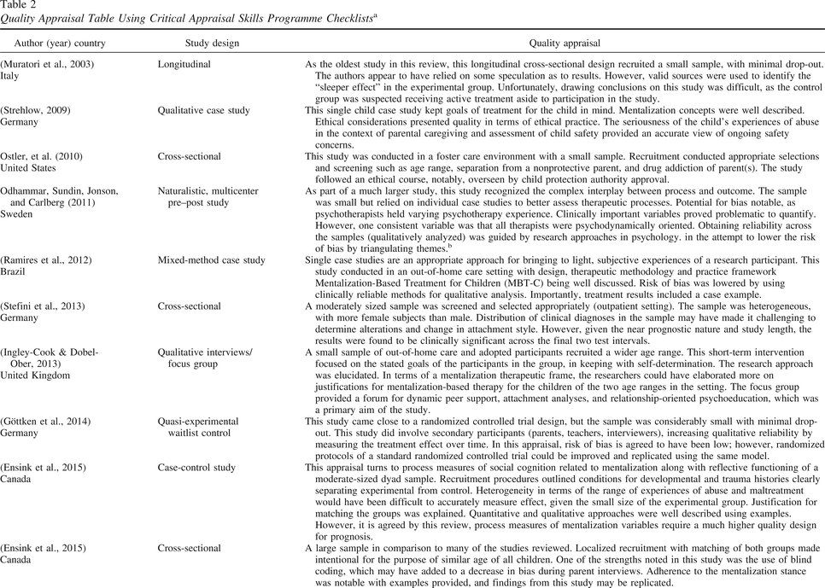Quality Appraisal Table Using Critical Appraisal Skills Programme Checklistsa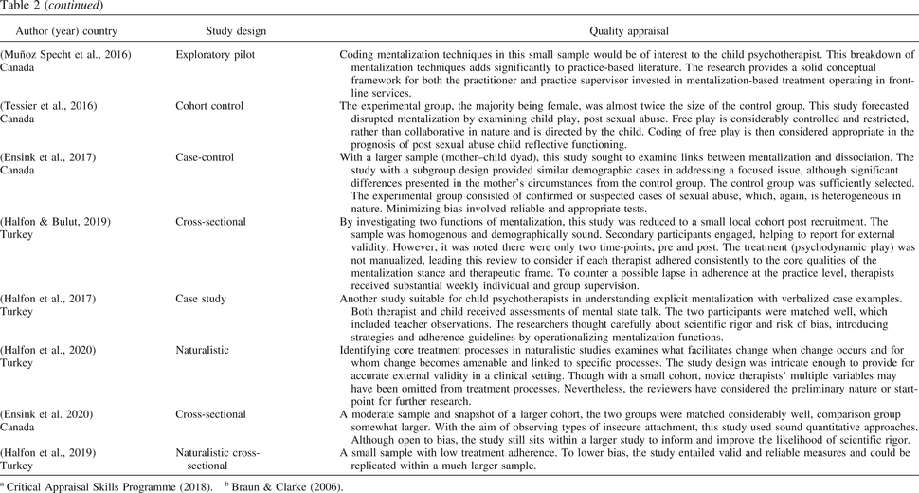Quality Appraisal Table Using Critical Appraisal Skills Programme Checklistsa
Interpersonal Trauma and Mentalization
Interpersonal trauma described in the studies reviewed included childhood sexual abuse, neglect, maltreatment, and witnessing violence. Across the studies, children were diagnosed with a range of co-occurring conditions such as major depression with soiling, anxiety with eating disorders, and emotional disorders. Children in the most severe range of psychopathology had a history of neglect, violence, deprivation, loss, and abandonment (Ramires, Schwan, & Midgley, 2012). In five studies childhood sexual abuse was described as having a damaging effect on a child’s capacity for growth in mentalization, and development of psychopathology leading to increased dissociation. Dissociation was found to be a critical mental process that mediated the impact of sexual abuse (Ensink, Borelli, Normandin, Target, & Fonagy, 2020; Ensink et al., 2017; Ensink, Normandin, et al., 2015; Strehlow, 2009; Tessier, Normandin, Ensink, & Fonagy, 2016). In one study where the index trauma was sexual abuse (Ensink et al., 2017), the capacity to mentalize was impaired, and this diminished capacity was conceptualized as a “defensive shutdown” to deal with affect and distress. Maternal mentalization and insecure attachment were associated with increased psychopathology in sexually abused children, such as lowered reflective functioning, depressive symptoms, child externalizing difficulties, and sexualized behaviors (Ensink, Bégin, Normandin, & Fonagy, 2016). During the early stages of play-based psychotherapy, children with sexual abuse histories who experienced trauma symptoms were found to struggle to symbolize (i.e., through toys and art) and to create play narratives when engaged in pretend play (Tessier et al., 2016).
Measurement of Mentalization
The capacity to mentalize was operationalized as affect and emotion regulation, reflective functioning, and attachment security. Across the studies, multiple measurement tools were used, including evidence-based assessments and questionnaires such as the Emotion Regulation Checklist (Shields & Cicchetti, 1997), Children’s Global Assessment Scale (Shaffer et al., 1983), Manchester Child Attachment Story Task (Goldwyn, Stanley, Smith, & Green, 2000), and the Children’s Play Therapy Instrument (Kernberg, Chazan, & Normandin, 1998). Studies conducted in the foster care system used a combination of trauma, mentalization scales, and attachment-based interviews (Ingley-Cook & Dobel-Ober, 2013; Ostler, Bahar, & Jessee, 2010). Five studies used the Child Reflective Functioning Scale to measure affect regulation, reflective functioning, attachment, and implicit mentalization (Ensink et al., 2017; Halfon & Bulut, 2019; Stefini et al., 2013; Tessier et al., 2016) When using the Manchester Child Attachment Story Task, Ramires et al. (2012, p. 4) assessed for significant improvement in mentalization capacity for “self-representation, perception of own mental functioning, and perception of others’ feelings and thoughts”. Halfon and Bulut (2019) used a wide range of measurement tools to measure the complexity of play patterns, affect regulation, coping and defensive strategies, appraising the feelings and intentions of others as well as psychosocial functioning including parent and teacher measures. Measuring utterances in mentalization in a subsequent study on separation anxiety disorder by Halfon, Bekar, and Gürleyen (2017), mental state talk in narratives were coded and combined with the Children’s Play Therapy Instrument to determine a change in affect regulation.
Charting Recovery
The final theme, charting recovery, included length of the therapeutic relationship, process and outcome. The research varied in how authors measured or accounted for recovery. Studies using quasi-experimental, case-control, and cross-sectional design showed clinical significance in children treated by psychoanalytic/psychodynamic play therapy. These studies suggested that play was both a mediator and a predictor of change in the severe range of internalized and externalized disorders, along with gains in mentalization processes (Ensink et al., 2020; Göttken, White, Klein, & von Klitzing, 2014; Halfon, Yılmaz, & Çavdar, 2019). When charting the recovery of children diagnosed with separation anxiety, reactive attachment disorder, attention-deficit and disruptive behavior disorders, as well as general anxiety disorder, it was the naturalistic and longitudinal studies that reported significant symptom reduction, notwithstanding the short-term study by Göttken et al. (2014). Further to these reductions, there was an improvement in psychological and global functioning as well as repaired parent attachments, improved peer relating, frustration tolerance, mental state talk and higher self-mentalizing, including a reduced risk of relapse and comorbid conditions (Halfon, Goodman, & Bulut, 2020; Muratori, Picchi, Bruni, Patarnello, & Romagnoli, 2003; Odhammar, Sundin, Jonson, & Carlberg, 2011).
Discussion

According to Fonagy and Adshead (2012), mentalization is an important process and a therapeutic factor in most forms of psychotherapy. This scoping review focused on mentalization as an explicit process and focus of therapy in childhood trauma. It has drawn together psychotherapy research that attempts to measure aspects of mentalization and relate therapeutic change or resolution of psychopathology to changes in mentalization capacity. The studies that reflected diverse research methodologies were mostly descriptive, and there was considerable variation in therapeutic approaches. The range of clinical problems were also heterogeneous despite the focus on exposure to interpersonal trauma. There were no RCTs or tightly controlled manualized treatment approaches as are often used in brief psychotherapy research, which is somewhat reflective of research into psychodynamic styles of therapy in general. Some authors recommend that naturalistic studies observing the phenomena over time without the constraints of randomized control are best for psychotherapy research (Gelo, Pritz, & Rieken, 2015). However, this lack of control, standardization, and rigor makes it difficult to extrapolate findings and makes generalizing about effectiveness difficult.
Mentalization-based treatment for personality disorder has the most robust evidence for its effectiveness (Malda-Castillo et al., 2019). However, recent reviews can only conclude that results are promising and recommend the urgent need for methodologically sound and sufficiently powered studies to investigate both effectiveness and efficacy (Volkert, Hauschild, & Taubner, 2019). An even stronger caveat needs to be made in interpreting the body of work on mentalization-based treatment in children. All the studies reviewed supported the hypothesis that improvements in mentalization were associated with various measures of symptom reduction and improved functioning. However, there may be publication bias in the current body of work, and bias inherent in the chosen methodologies, in that these studies are primarily undertaken by highly skilled and trained clinicians who believe in the process of therapy and often invest long periods (sometimes years) in therapy with children and caregivers. It would be quite unlikely for champions of mentalization to invest in sharing case studies which do not demonstrate evidence of improvement. This review echoes the authors of other reviews which call for the development of a more robust evidence base for mentalization-based treatment in children.
Acknowledging the demands placed on the researcher to produce robust evidence, this review considers the implications for the child psychotherapist. It is important to recognize the pragmatic aims and challenges of the therapist in a complex interchange between delivering psychotherapy intervention and research-related factors that may impede expected treatment outcomes. By highlighting diverse research designs across a variety of ecological settings, these factors come to light. One factor for the child practitioner is that children coming out of abuse and neglect contexts require a degree of “readiness” when entering psychotherapeutic intervention (Howarth et al., 2019). This human capacity for readiness includes the protective parent or carer experiencing their readiness simultaneously to support the child, as well as the severity of symptoms and children with mixed diagnoses requiring longer treatments than initially forecast. These additional factors can significantly alter therapist and researcher objectives in terms of drop-out rates, balancing intervention and control groups, through to obtaining follow up treatment and testing.
Most studies were naturalistic and observed real-world therapy with real-world children and families in real psychotherapy services. The state of knowledge that this review highlights is that mentalization based treatments appear to work in naturalistic settings and enhances mentalization capacity in children, improves functioning and reduces symptoms. How mentalization should be measured in clinical practice remains a somewhat contested question (Shaw, Lo, Lanceley, Hales, & Rodin, 2020).
Capturing implicit mentalization during interpersonal encounters is very likely to remain challenging due to natural and instinctual turn-taking in conversation (Davidsen & Fosgerau, 2015). Psychotherapy within a mentalization therapeutic frame has the hallmarks of attending to ruptures in secure attachment, providing “a safe haven and a secure base” (Allen, 2012). According to Muñoz Specht, Ensink, Normandin, & Midgley (2016), the mentalization therapeutic frame encompasses the empathic stance and exploration of the child’s mental states. The following example demonstrates attentiveness in play therapy from the therapists’ mentalizing stance, illustrating responses to a child, aged 9, experiencing emotional dysregulation. TherapistI felt you did so well when we worked together to build your dream home, I could see you thought carefully about how many rooms you’d like, and at the moment your new house has you feeling like you want to smash it to pieces . . . Exploring mental states is a technique used when a lack of coherence in the mentalization process is noticed, namely, when a child is functioning in opposing ways. The therapist adopts a “not knowing” stance, displaying explicit perception and using curiosity. TherapistAlthough you said you really enjoyed building your new house, I am really curious to learn what you were seeing when you clenched your fists ready to smash your house down. . . By adopting the mentalizing stance and for the child to achieve self-understanding, the therapist tentatively becomes present in the mind of the child by sharing the child’s subjective experience as well as naming verbal and nonverbal affect states such as thoughts, feelings, wishes, and beliefs. The therapist makes exploratory links between behaviors and emotions and collaboratively works with the child to organize their mental states. TherapistYou said you didn’t want to be angry today, this is a safe place for you to feel or think anything you wish. So if you could choose any figure (symbol) from the shelf and sit with me, to talk about how the figure is you today, I will carefully listen to your story . . . As with many psychotherapies, the therapist’s manner of relating (to the child), their use of empathic understanding and exploration of the child’s sense of self also rest within the most extensively studied therapeutic alliance (Allen, 2012).
There is an evidence base for mentalization-focused treatment in symptom remission for both internalizing and externalizing disorders and for shaping mentalization deficits over time. With the continuance of primary research and systematic reviewing of new studies as they become available, the work involved in building an evidence base is about establishing better precedents in treating complex childhood mental health difficulties. Therefore, having conducted a robust literature search and an assessment of the findings, the implementation of a child mentalization-based model as a preventative intervention may contribute to increased positive outcomes for vulnerable children.
Limitations
Developing this review presented challenges regarding study design choice, as there is limited research on this topic in vulnerable school-age children. As discussed by Munn, Stern, Aromataris, Lockwood, and Jordan (2018), the difficulty of reviewing different study designs, ambiguous terminologies, and diverse research methodology may present some confusion when providing a source of evidence. On the other hand, the choice to conduct a pluralistic review appeals to the strengths of both quantitative and qualitative methodology (Munn et al., 2018) and attends to the idea of a comprehensive overview. Another challenge was appraising two research dimensions—process and outcome—as both are essential aspects of psychotherapy research (Gelo et al., 2015).
Conclusion
The term “mentalization” is used as an umbrella term for developmental processes sustaining mental, emotional, social, and cognitive capacities, and the included studies describe how disrupted mentalization capacities could be a consequence of child psychopathology. Reviews of child psychotherapy, interpersonal trauma, and recovery outcomes using scoping review methodology have not been published to the authors’ knowledge. Therefore, an extensive systematic review would be warranted and positioned to complement this review as future studies become available. The clinical implications for program leaders and practitioners who work in child protection, foster care, family support services and in independent practice who have sought preferencing for more cognitive-behavioral–based interventions may find that a mentalization approach could improve the quality of attachments and developmental functioning and advance their mentalizing self in relation to their clients.
References
Allen, J. G. (2012). Restoring mentalizing in attachment relationships: Treating trauma with plain old therapy. Washington, DC: American Psychiatric Publisher.
Arksey, H., & O’Malley, L. (2005). Scoping studies: Towards a methodological framework. International Journal of Social Research Methodology, 8, 19–32. 10.1080/1364557032000119616
Bateman, A., & Fonagy, P. (2013). Impact of clinical severity on outcomes of mentalisation-based treatment for borderline personality disorder. The British Journal of Psychiatry, 203, 221–227. 10.1192/bjp.bp.112.121129
Bateman, A., O’Connell, J., Lorenzini, N., Gardner, T., & Fonagy, P. (2016). A randomised controlled trial of mentalization-based treatment versus structured clinical management for patients with comorbid borderline personality disorder and antisocial personality disorder. BMC Psychiatry, 16, 304. 10.1186/s12888-016-1000-9
Berthelot, N., Lemieux, R., Garon-Bissonnette, J., Lacharité, C., & Muzik, M. (2019). The protective role of mentalizing: Reflective functioning as a mediator between child maltreatment, psychopathology and parental attitude in expecting parents. Child Abuse and Neglect, 95, 104065. 10.1016/j.chiabu.2019.104065
Blazek, M. (2013). Emotions as practice: Anna Freud’s child psychoanalysis and thinking doing children’s emotional geographies. Emotion, Space and Society, 9, 24–32. 10.1016/j.emospa.2013.02.003
Blue Knot Foundation. (2020). What is childhood trauma?National Centre of Excellence for Complex Trauma. Retrieved from https://www.blueknot.org.au/Resources/Information/Understanding-abuse-and-trauma/What-is-childhood-trauma
Bowlby, J. (1988). A secure base: Parent-child attachment and healthy human development. New York, NY: Routledge.
Braun, V., & Clarke, V. (2006). Using thematic analysis in psychology. Qualitative Research in Psychology, 3, 77–101. 10.1191/1478088706qp063oa
Conway, F., Lyon, S., Silber, M., & Donath, S. (2019). Cultivating compassion ADHD project: A mentalization informed psychodynamic psychotherapy approach. Journal of Infant, Child, and Adolescent Psychotherapy, 18, 212–222. 10.1080/15289168.2019.1654271
Critical Appraisal Skills Programme. (2018). CASP checklists. Retrieved from https://casp-uk.net/casp-tools-checklists/
D’Andrea, W., Ford, J., Stolbach, B., Spinazzola, J., & van der Kolk, B. A. (2012). Understanding interpersonal trauma in children: Why we need a developmentally appropriate trauma diagnosis. American Journal of Orthopsychiatry, 82, 187–200. 10.1111/j.1939-0025.2012.01154.x
Davidsen, A. S., & Fosgerau, C. F. (2015). Grasping the process of implicit mentalization. Theory and Psychology, 25, 434–454. 10.1177/0959354315580605
Ensink, K., Bégin, M., Normandin, L., & Fonagy, P. (2016). Maternal and child reflective functioning in the context of child sexual abuse: Pathways to depression and externalising difficulties. European Journal of Psychotraumatology, 7, 30611. 10.3402/ejpt.v7.30611
Ensink, K., Bégin, M., Normandin, L., Godbout, N., & Fonagy, P. (2017). Mentalization and dissociation in the context of trauma: Implications for child psychopathology. [ISSD]. Journal of Trauma and Dissociation, 18, 11–30. 10.1080/15299732.2016.1172536
Ensink, K., Borelli, J. L., Normandin, L., Target, M., & Fonagy, P. (2020). Childhood sexual abuse and attachment insecurity: Associations with child psychological difficulties. American Journal of Orthopsychiatry, 90, 115–124. 10.1037/ort0000407
Ensink, K., & Mayes, L. C. (2010). The development of mentalisation in children from a theory of mind perspective. Psychoanalytic Inquiry, 30, 301–337. 10.1080/07351690903206504
Ensink, K., Normandin, L., Target, M., Fonagy, P., Sabourin, S., & Berthelot, N. (2015). Mentalization in children and mothers in the context of trauma: An initial study of the validity of the Child Reflective Functioning Scale. British Journal of Developmental Psychology, 33, 203–217. 10.1111/bjdp.12074
Fonagy, P., & Adshead, G. (2012). How mentalisation changes the mind. Advances in Psychiatric Treatment, 18, 353–362. 10.1192/apt.bp.108.005876
Fonagy, P., Luyten, P., Moulton-Perkins, A., Lee, Y. W., Warren, F., Howard, S., . . .Lowyck, B. (2016). Development and validation of a self-report measure of mentalizing: The reflective functioning questionnaire. PLoS ONE, 11, e0158678. 10.1371/journal.pone.0158678
Gelo, O., Pritz, A., & Rieken, B. (2015). Psychotherapy research: Foundations, process and outcome. Vienna, Austria: Springer. 10.1007/978-3-7091-1382-0
Goldwyn, R., Stanley, C., Smith, V., & Green, J. (2000). The Manchester child attachment story task: Relationship with parental AAI, SAT and child behaviour. Attachment and Human Development, 2, 71–84. 10.1080/146167300361327
Göttken, T., White, L. O., Klein, A. M., & von Klitzing, K. (2014). Short-term psychoanalytic child therapy for anxious children: A pilot study. Pyschotherapy, 51, 148–158. 10.1037/a0036026
Greenberg, J. (2018). Kleins’ technique. The International Journal of Psychoanalysis, 99, 979–989. 10.1080/00207578.2018.1490986
Halfon, S. (2017). Play profile constructions: An empirical assessment of children’s play in psychodynamic play therapy. Journal of Infant, Child, and Adolescent Psychotherapy, 16, 219–233. 10.1080/15289168.2017.1312875
Halfon, S., Bekar, O., & Gürleyen, B. (2017). An empirical analysis of mental state talk and affect regulation in two single-cases of psychodynamic child therapy. Psychotherapy, 54, 207–219. 10.1037/pst0000113
Halfon, S., & Bulut, P. (2019). Mentalization and the growth of symbolic play and affect regulation in psychodynamic therapy for children with behavioral problems. Psychotherapy Research, 29, 666–678. 10.1080/10503307.2017.1393577
Halfon, S., Goodman, G., & Bulut, P. (2020). Interaction structures as predictors of outcome in a naturalistic study of psychodynamic child psychotherapy. Psychotherapy Research, 30, 251–266. 10.1080/10503307.2018.1519267
Halfon, S., Yılmaz, M., & Çavdar, A. (2019). Mentalization, session-to-session negative emotion expression, symbolic play, and affect regulation in psychodynamic child psychotherapy. Psychotherapy, 56, 555–567. 10.1037/pst0000201
Howarth, E., Moore, T. H., Stanley, N., MacMillan, H. L., Feder, G., & Shaw, A. (2019). Towards an ecological understanding of readiness to engage with interventions for children exposed to domestic violence and abuse: Systematic review and qualitative synthesis of perspectives of children, parents and practitioners. Health and Social Care in the Community, 27, 271–292. 10.1111/hsc.12587
Ingley-Cook, G., & Dobel-Ober, D. (2013). Innovations in practice: Group work with children who are in care or who are adopted: Lessons learnt. Child and Adolescent Mental Health, 18, 251–254. 10.1111/j.1475-3588.2012.00683.x
Kazdin, A. E. (1997). A model for developing effective treatments: Progression and interplay of theory, research, and practice. Journal of Clinical Child Psychology, 26, 114–129. 10.1207/s15374424jccp2602_1
Keenan, B. M., Newman, L. K., Gray, K. M., & Rinehart, N. J. (2017). A qualitative study of attachment relationships in ASD during middle childhood. Attachment and Human Development, 19, 1–21. 10.1080/14616734.2016.1246580
Kelton-Locke, S. (2016). Eating disorders, impaired mentalization, and attachment: Implications for child and adolescent family treatment. Journal of Infant, Child, and Adolescent Psychotherapy, 15, 337–356. 10.1080/15289168.2016.1257239
Kernberg, P. F., Chazan, S. E., & Normandin, L. (1998). The children’s play therapy instrument (CPTI): Description, development, and reliability studies. The Journal of Psychotherapy Practice and Research, 7, 196–207.
Levac, D., Colquhoun, H., & O’Brien, K. K. (2010). Scoping studies: Advancing the methodology. Implementation Science, 5, 69. 10.1186/1748-5908-5-69
Malda-Castillo, J., Browne, C., & Perez-Algorta, G. (2019). Mentalization-based treatment and its evidence-base status: A systematic literature review. Psychology and Psychotherapy, 92, 465–498. 10.1111/papt.12195
Midgley, N., Besser, S. J., Dye, H., Fearon, P., Gale, T., Jefferies-Sewell, K., . . .Wood, S. (2017). The Herts and minds study: Evaluating the effectiveness of mentalization-based treatment (MBT) as an intervention for children in foster care with emotional and/or behavioural problems: A phase II, feasibility, randomised controlled trial. Pilot and Feasibility Studies, 3, 12. 10.1186/s40814-017-0127-x
Midgley, N., Besser, S. J., Fearon, P., Wyatt, S., Byford, S., & Wellsted, D. (2019). The Herts and Minds study: Feasibility of a randomised controlled trial of mentalization-based treatment versus usual care to support the wellbeing of children in foster care. BMC Psychiatry, 19, 215. 10.1186/s12888-019-2196-2
Moher, D., Liberati, A., Tetzlaff, J., & Altman, D. G. (2009). Preferred reporting items for systematic reviews and meta-analyses: The PRISMA statement. Annals of Internal Medicine, 151, 264–269. 10.7326/0003-4819-151-4-200908180-00135
Muller, N., & Midgley, N. (2015). Approaches to assessment in time-limited mentalization-based therapy for children (MBT-C). Frontiers in Psychology, 6, 1063. 10.3389/fpsyg.2015.01063
Munn, Z., Stern, C., Aromataris, E., Lockwood, C., & Jordan, Z. (2018). What kind of systematic review should I conduct? A proposed typology and guidance for systematic reviewers in the medical and health sciences. BMC Medical Research Methodology, 18, 5. 10.1186/s12874-017-0468-4
Muñoz Specht, P., Ensink, K., Normandin, L., & Midgley, N. (2016). Mentalizing techniques used by psychodynamic therapists working with children and early adolescents. Bulletin of the Menninger Clinic, 80, 281–315. 10.1521/bumc.2016.80.4.281
Muratori, F., Picchi, L., Bruni, G., Patarnello, M., & Romagnoli, G. (2003). A two-year follow-up of psychodynamic psychotherapy for internalizing disorders in children. Journal of the American Academy of Child and Adolescent Psychiatry, 42, 331–339. 10.1097/00004583-200303000-00014
Musicaro, R. M., Ford, J., Suvak, M. K., Sposato, A., & Andersen, S. (2020). Sluggish cognitive tempo and exposure to interpersonal trauma in children. Anxiety, Stress, and Coping, 33, 100–114. 10.1080/10615806.2019.1695124
Odhammar, F., Sundin, E. C., Jonson, M., & Carlberg, G. (2011). Children in psychodynamic psychotherapy: Changes in global functioning. Journal of Child Psychotherapy, 37, 261–279. 10.1080/0075417X.2011.614744
Or, M. B. (2010). Clay sculpting of mother and child figures encourages mentalization. The Arts in Psychotherapy, 37, 319–327. 10.1016/j.aip.2010.05.007
Ostler, T., Bahar, O. S., & Jessee, A. (2010). Mentalization in children exposed to parental methamphetamine abuse: Relations to children’s mental health and behavioral outcomes. Attachment and Human Development, 12, 193–207. 10.1080/14616731003759666
Pluye, P., Gagnon, M.-P., Griffiths, F., & Johnson-Lafleur, J. (2009). A scoring system for appraising mixed methods research, and concomitantly appraising qualitative, quantitative and mixed methods primary studies in mixed studies reviews. International Journal of Nursing Sudies, 46, 529–546. 10.1016/j.ijnurstu.2009.01.009
Ramires, V., Schwan, S., & Midgley, N. (2012). Mentalization-based therapy with maltreated children living in shelters in southern Brazil: A single case study. Psychoanalytic Psychotherapy, 26, 308–326. 10.1080/02668734.2012.730546
Rice, L. M., Wall, C. A., Fogel, A., & Shic, F. (2015). Computer-assisted face processing instruction improves emotion recognition, mentalizing, and social skills in students with ASD. Journal of Autism and Developmental Disorders, 45, 2176–2186. 10.1007/s10803-015-2380-2
Ridenour, J., Knauss, D., & Hamm, J. A. (2019). Comparing metacognition and mentalization and their implications for psychotherapy for individuals with psychosis. Journal of Contemporary Psychotherapy, 49, 79–85. 10.1007/s10879-018-9392-0
Robinson, P., Skårderud, F., & Sommerfeldt, B. (2019). Minding the body. In P.Robinson, F.Skårderud, & B.Sommerfeldt (Eds.), Hunger: Mentalization-based treatments for eating disorders (pp. 1–14). Cham, Springer International Publishing. 10.1007/978-3-319-95121-8_1
Shaffer, D., Gould, M. S., Brasic, J., Ambrosini, P., Fisher, P., Bird, H., & Aluwahlia, S. (1983). A Children’s Global Assessment Scale (CGAS). Archives of General Psychiatry, 40, 1228–1231. 10.1001/archpsyc.1983.01790100074010
Shaw, C., Lo, C., Lanceley, A., Hales, S., & Rodin, G. (2020). The assessment of mentalization: Measures for the patient, the therapist and the interaction. Journal of Contemporary Psychotherapy, 50, 57–65. 10.1007/s10879-019-09420-z
Shields, A., & Cicchetti, D. (1997). Emotion regulation among school-age children: The development and validation of a New Criterion Q-Sort scale. Developmental Psychology, 33, 906–916. 10.1037/0012-1649.33.6.906
Stefini, A., Horn, H., Winkelmann, K., Geiser-Elze, A., Hartmann, M., & Kronmüller, K. T. (2013). Attachment styles and outcome of psychoanalytic psychotherapy for children and adolescents. Psychopathology, 46, 192–200. 10.1159/000341591
Strathearn, L. (2011). Maternal neglect: Oxytocin, dopamine and the neurobiology of attachment. Journal of Neuroendocrinology, 23, 1054–1065. 10.1111/j.1365-2826.2011.02228.x
Strehlow, G. (2009). The use of music therapy in treating sexually abused children. Nordic Journal of Music Therapy, 18, 167–183. 10.1080/08098130903062397
Tal, R., & Tal, K. (2017). Child-parent relationship therapy—A dialogue with Winnicott’s Theory. International Journal of Play Therapy, 26, 151–159. 10.1037/pla0000051
Target, M. (2018). 20/20 hindsight: A 25-year programme at the Anna Freud Centre of efficacy and effectiveness research on child psychoanalytic psychotherapy. Psychotherapy Research, 28, 30–46. 10.1080/10503307.2017.1349351
Taubner, S., & Curth, C. (2013). Mentalization mediates the relation between early traumatic experiences and aggressive behavior in adolescence. Psihologija, 46, 177–192. 10.2298/PSI1302177T
Tessier, V. P., Normandin, L., Ensink, K., & Fonagy, P. (2016). Fact or fiction? A longitudinal study of play and the development of reflective functioning. Bulletin of the Menninger Clinic, 80, 60–79. 10.1521/bumc.2016.80.1.60
Tricco, A. C., Lillie, E., Zarin, W., O’Brien, K. K., Colquhoun, H., Levac, D., . . .Straus, S. E. (2018). PRISMA extension for scoping reviews (PRISMA-ScR): Checklist and explanation. Annals of Internal Medicine, 169, 467–473. 10.7326/M18-0850
Volkert, J., Hauschild, S., & Taubner, S. (2019). Mentalization-based treatment for personality disorders: Efficacy, effectiveness, and new developments. Current Psychiatry Reports, 21, 1–12. 10.1007/s11920-019-1012-5
Weinstein, S. R., Meehan, K. B., Cain, N. M., Ripoll, L. H., Boussi, A. R., Papouchis, N., . . .New, A. S. (2016). Mental state identification, borderline pathology, and the neglected role of childhood trauma. Personality Disorders: Theory, Research, and Treatment, 7, 61–71. 10.1037/per0000139
Winnicott, D. W. (1974). Playing and reality (Vol. 2). Middlesex, UK: Penguin Books.
Submitted: February 19, 2020 Revised: July 16, 2020 Accepted: July 16, 2020

