By: Jamie D. Aten
Humanitarian Disaster Institute, Wheaton College;
Wendy R. Smith
School of Psychology, Counseling, and Family Therapy, Wheaton College
Edward B. Davis
School of Psychology, Counseling, and Family Therapy, Wheaton College
Daryl R. Van Tongeren
Department of Psychology, Hope College
Joshua N. Hook
Department of Psychology, University of North Texas
Don E. Davis
Department of Counseling and Psychological Services, Georgia State University
Laura Shannonhouse
Department of Counseling and Psychological Services, Georgia State University
Cirleen DeBlaere
Department of Counseling and Psychological Services, Georgia State University
Jenn Ranter
Humanitarian Disaster Institute, Wheaton College
Kari O’Grady
Loyola College of Maryland
Peter C. Hill
Rosemead School of Psychology, Biola University
Acknowledgement: This article was made possible through the support of a grant from the John Templeton Foundation (Grant 44040). The opinions expressed in this article are those of the authors and do not necessarily reflect the views of the John Templeton Foundation.
In the past century, natural disasters (e.g., floods, storms, earthquakes, extreme temperatures, and droughts) and human-caused disasters (e.g., technological disasters, such as transportation and industrial accidents, and terrorism/mass-violence disasters) have increased exponentially in frequency and impact. For example, globally, in 1970 there were 81 natural disasters, 16 technological disasters, and 651 terrorism/mass-violence disasters, whereas in 2015 there were 396 natural disasters, 202 technological disasters, and 14,806 terrorism/mass-violence disasters, representing approximately a fourfold, 10-fold, and 20-fold increase in these respective disaster types. Since 1970 there have been over 13,000 natural, 8,000 technological, and 150,000 terrorism/mass-violence disasters worldwide. Hundreds of those natural disasters caused over 1,000 deaths and/or $1 billion in damage, and hundreds of those technological and terrorism/mass-violence disasters caused over 100 deaths (Centre of Research on the Epidemiology of Disaster [CRED], 2016; EM-DAT, n.d.; National Consortium for the Study of Terrorism and Responses to Terrorism, 2016).
Humans have long turned to supernatural, sacred, or spiritual explanations for negative events that occur beyond their control (Aten & Boan, 2016). Disasters can challenge people’s deepest convictions and beliefs because they (a) violate expectations about the way the world operates, (b) disrupt longstanding beliefs about the divine, and (c) disturb one’s social support network and ability to cope with the negative consequences of surviving catastrophic loss (Liang, Hayashi, Bennett, Johnson, & Aten, 2015). Disasters are typically community-wide stressors that may threaten people’s sense of meaning. In response, people often turn to religion/spirituality (R/S) to restore meaning after a disaster (e.g., Stephens, Fryberg, Markus, & Hamedani, 2013). Consequently, disasters provide a unique context for examining how disruptive life events affect people’s R/S, including the ways individuals view and relate to the sacred (e.g., Aten, O’Grady, Milstein, Boan, & Schruba, 2014).
Research has also shown that survivors may draw on R/S to cope with anxiety and other trauma-related symptoms. (cf. Shaw, Joseph, & Linley, 2005; Soenke, Landau, & Greenberg, 2013). For example, the disaster experience might compel some disaster survivors to draw even closer to the sacred and to other R/S social/community resources (e.g., coreligionists: other adherents of one’s faith tradition; Krause & Ellison, 2009) to support coping, self-regulation, and meaning-making (e.g., see Granqvist & Kirkpatrick, 2013, for review). Conversely, for other disaster survivors, their disaster-related experiences may have the opposite effect, eliciting a negative transformation in their conceptual understanding of what God is like (i.e., God concepts) and in how they experientially relate to God (i.e., God images), thereby contributing to spiritual decline or even disengagement. For instance, potentially traumatic events sometimes evoke negative R/S attributions (e.g., God caused this event; God was unable or unwilling to stop this event) that place substantial strain on the divine-attachment relationship, perhaps to extent of temporarily or permanently disrupting that bond (e.g., Spilka, Shaver, & Kirkpatrick, 1985). Thus, the way disaster survivors engage the sacred may have direct implications for resilience (see Cook, Aten, Moore, Hook, & Davis, 2013).

Purpose

Because of the increase of disasters and severity in which they are impacting society there is a significant need to better understand the psychology of R/S in disaster contexts. We begin by synthetizing the empirical research that has been conducted in this subfield. Building on key findings from our review, we then provide a research prospectus to help advance future psychology of R/S and disaster research. Overall, our hope is this article will spark greater interests among researchers and clinicians alike to further explore this understudied area of investigation.

Method

Our review was limited to psychology of R/S and disaster research, which we define as an empirical approach to studying the impact of disasters on R/S phenomena, as well as the relationship between R/S phenomena, cognition, behavior, and well-being (i.e., emotional, spiritual, and physical) in disaster contexts. The following definitions of disaster were also used to help guide and place limits on the sorts of events reviewed. First, a disaster refers to a “potentially traumatic event that is collectively experienced, has an acute onset, and is time-delimited” (McFarlane & Norris, 2006, p. 4). Second, “a disaster is a sudden, calamitous event that seriously disrupts the functioning of a community or society and causes human, material, and economic or environmental losses that exceed the community’s or society’s ability to cope using its own resources” (International Federation of Red Cross and Red Crescent Societies, n.d.).
We also adopted a traditional conceptualization of disasters which categorizes disasters based on whether the disaster was caused by nature (e.g., hurricane, flood, tornado, earthquake) or human-caused (e.g., technological accidents such as a major dam collapse; mass acts of violence caused by terrorist attacks; Coppola, 2015). Thus, our review only includes studies of actual or simulated (e.g., laboratory simulation or stimuli) acute events capable of overwhelming local or regional capacity for response and recovery. This means that smaller scaled events like a crisis or emergency (e.g., house fires, isolated flooding) were not incorporated. Humanitarian crises (e.g., Syrian refugee crisis), civil conflicts (e.g., Rwanda genocide), and epidemics (e.g., 2014–2016 Ebola outbreak) also fell beyond the scope of this review.
Searches were conducted in PsycINFO, PsycARTICLES, Medline databases, and through personal communication with study authors covering a period from 1975 (from the earliest identified study meeting our criteria) to 2015. In addition to our definitional and conceptual guideposts, we had several other key inclusion criteria. Articles were required to (a) be empirical in nature (e.g., quantitative, qualitative, mixed-method design), theoretical articles and case studies were omitted, (b) be published in a peer-reviewed journal, (c) have an explicit focus on R/S, (d) have intrapersonal or interpersonal (e.g., family unit) emphasis (i.e., not institutional and organizational), and (e) specifically address natural and human-made disasters.

Results

A total of 51 articles met the inclusion criteria. We organized the empirical findings under five main categories, which emerged from sorting studies by their primary R/S focus: (a) general religiousness, (b) God representations, (c) religious appraisals, (d) R/S meaning making, and (e) religious coping.

General Religiousness and Disasters
We found a sizable number of articles that examined general religiousness; the role faith plays in people’s everyday lives (see Table 1). Studies on general religiousness explored topics like religious background, religious affiliation, transcendence, and religious motivation (intrinsic or extrinsic) within a disaster context. The studies falling into this category examined changes in their general religiousness, perceived posttraumatic growth, changes in religious behavior, impact of religious motivations, and association with a wide range of disaster mental health outcomes.
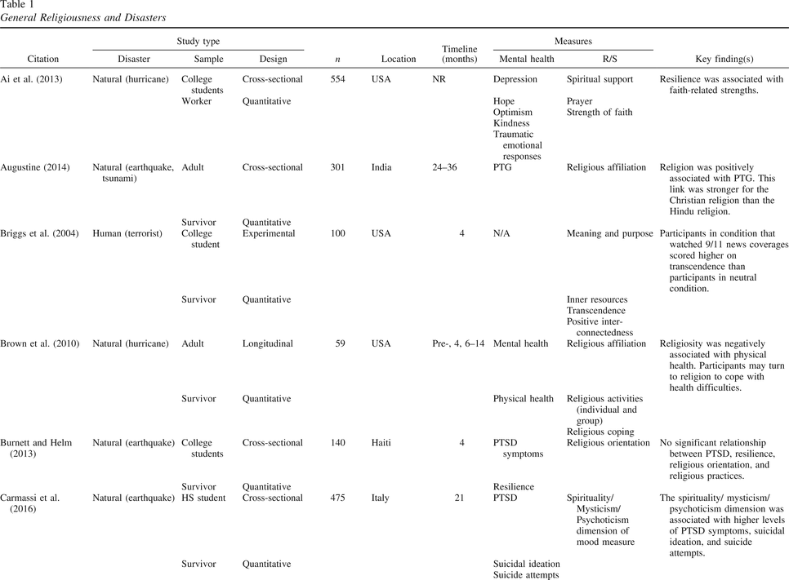General Religiousness and Disasters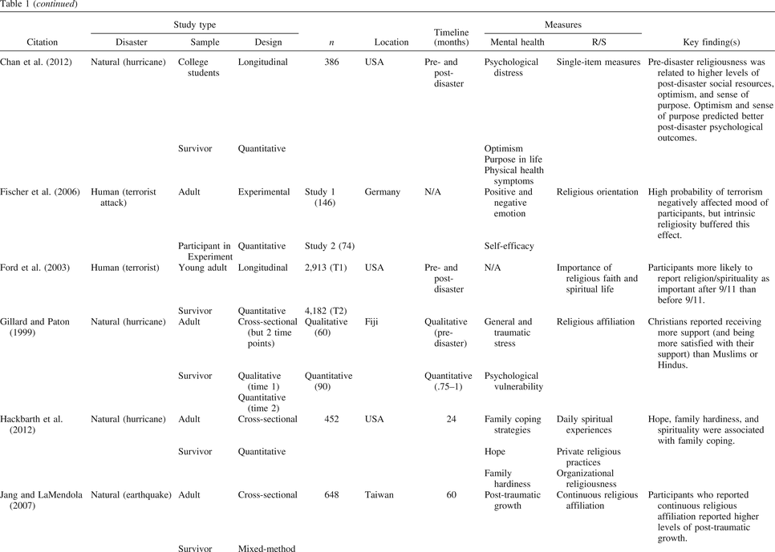General Religiousness and Disasters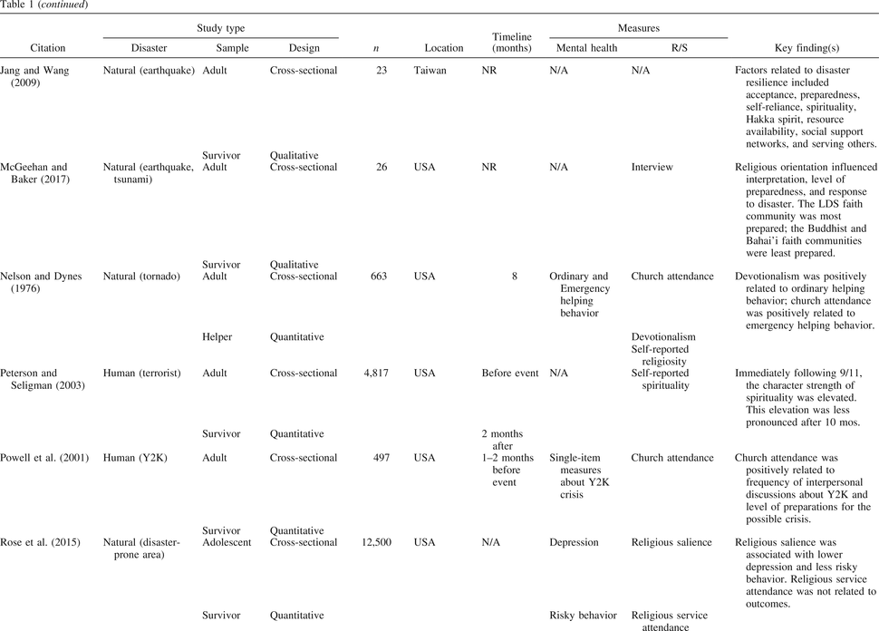General Religiousness and Disasters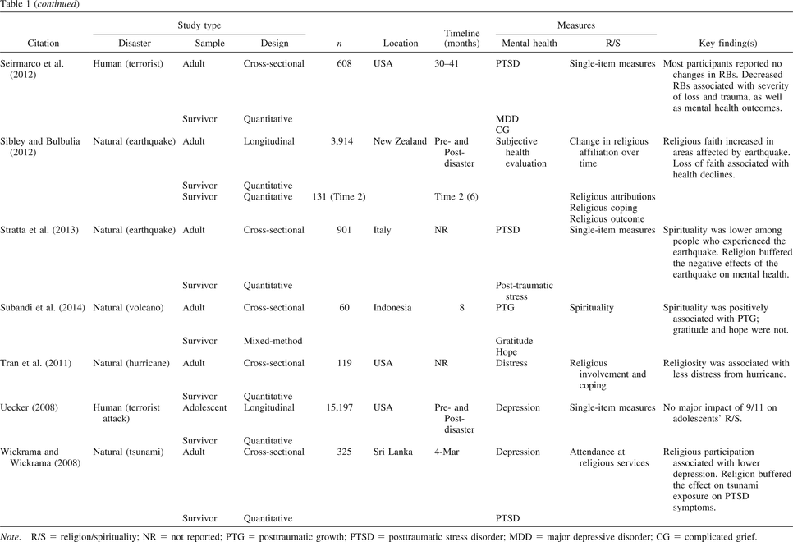General Religiousness and Disasters
Culture
Several studies examined cultural factors (e.g., race/ethnicity or religious identification) that affect the degree to which religion buffers individuals from developing mental health symptoms after a disaster. For example, Ai and colleagues (2013) found that in the aftermath of hurricanes Katrina and Rita, the relationship between faith-based strengths and resilience occurred among racial/ethnic minority volunteers; however, among White volunteers, there was a stronger relationship between altruism and resilience. Also, in a sample of 150 Fijians, Gillard & Paton (1999) found that being affiliated with the Christian religion meant that there were more international resources to assist in recovery. People within the Muslim and Hindu religions reported less external support, so were encouraged to personally assist one another in the recovery, regardless of personal loss. This disparity in resources led to variations in the amount of actual help received and variations in the level of satisfaction with the recovery process based on religious affiliation. Augustine (2014) reached similar conclusions from studying earthquake and tsunami survivors. Religion was linked to posttraumatic growth among survivors; the effect was stronger for participants who reported adhering to the Christian religion than the Hindu religion. The authors speculated that this might have been due to more available helping and meaning-making resources available among the Christian community than the Hindu community following the disaster. Researchers conceptualizing spirituality/mysticism/psychoticism as a unique cultural dimension of general RS was associated with higher levels of posttraumatic stress disorder (PTSD) symptoms, suicidal ideation, and suicide attempts among Italy earthquake survivors (Carmassi et al., 2016).
Motivations
Results regarding general religiousness were also mixed when religious motivations were taken into account. Intrinsic religiousness can be characterized as a genuine, internally driven faith, whereas extrinsic religiousness is driven by external rewards (e.g., Allport & Ross, 1967). In an experimental study, Fischer and colleagues (2006) found that intrinsically religious people experienced more negative moods when faced with a potential terrorist threat than nonreligious people. However, Burnett and Helm (2013) found no relationship between intrinsic (or extrinsic) religiousness and PTSD after the 9/11 attacks.
Changes in R/S
Briggs, Apple, and Aydlett (2004) used an experimental design manipulating salience of the World Trade Center attack (half watched news coverage about the attack, half watched a neutral video). The group that watched the 9–11 news coverage scored higher on the transcendence component of spirituality. Ford, Udry, Gleiter, and Chantala (2003) found similar positive trend among adolescent males who were more likely to report R/S as important after 9/11 than adolescent males interviewed prior to the terrorist attacks. Peterson and Seligman (2003) also reported seeing spirituality levels elevated among adults immediately after 9/11, but tapering off 10 months after the event. However, Uecker (2008) and Fischer and colleagues (2006) found that positive changes attributed to general religiousness tended to decline over a couple of months postdisaster.
Sibley and Bulbulia (2012) conducted a longitudinal study in New Zealand among earthquake survivors and found that turning from religion during a crisis negatively impacted outcomes. More specifically, they found that survivors who reported being religiously identified before but not after the disaster demonstrated greater declines in subjective health, relative to survivors who were religiously unidentified both before and after the disaster. Similarly, in a study conducted two to three years after 9/11, Seirmarco and colleagues (2012) found that bereaved people who reported a decrease in importance of religion were more likely to have experienced complicated grief, posttraumatic stress disorder, or major depression than those who reported no change. These findings suggest that potential changes in R/S may be just as important as R/S in general in predicting disaster outcomes.
Outcomes
General religiousness tended to be related (directly or indirectly) to positive emotional, spiritual, and/or physical outcomes (Chan, Rhodes, & Perez, 2012; Jang & Wang, 2009; Stratta et al., 2013; Tran, Chan, & Nguyen, 2011; Wickrama & Wickrama, 2008). For example, Jang and LaMendola (2007) discovered that consistent religious affiliation over time contributed to resilience and posttraumatic growth following an earthquake in Taiwan. Subandi and colleagues (2014) also found that spirituality was related to posttraumatic spiritual growth after a volcano in Indonesia.
A positive correlation was found between general religious behavior (e.g., church attendance, frequency of prayer, religious salience) and positive religious and psychological outcomes after a flood in the Midwest, and this was particularly true when positive religious coping was used (Smith, Pargament, Brant, & Oliver, 2000). Based on a telephone survey with a random sample of Alabama residents that examined the Y2K threat that never materialized, Powell, Bodon, and Hickson (2001) found a positive relationship between religious involvement (e.g., church attendance) and preparation for an anticipated technical disaster. They reported that, compared to nonchurchgoers, churchgoers tended to engage in more discussion about the impending Y2K threat and greater preparation activities for this danger. R/S was associated with greater family coping and resilience after Hurricane Katrina (Hackbarth, Pavkov, Wetchler, & Flannery, 2012). Specifically, higher religious salience was related to improved behavioral health outcomes (lower depression, less risky behavior such as binge drinking and marijuana use) among adolescents living disaster vulnerable areas along the Gulf Coast area. Likewise, Rose, Shields, Tueller, and Larson (2015) discovered religious salience was associated with lower depression and less risky behavior among Gulf Coast adolescents over time in the aftermath of Hurricane Katrina. Yet in another study, after Hurricane Katrina and Rita researchers found women endorsed more mental health difficulties than men and that there was a negative association between religiosity (e.g., beliefs, practices) and physical health (Brown et al., 2010).
General religiousness was also related to disaster preparedness and recovery activity. Nelson and Dynes (1976) also showed that church attendance was related to emergency helping behavior, while devotionalism was related to ordinary helping behavior. Moreover, McGeehan and Baker (2017) found that religious orientation influenced interpretation, level of preparedness, and response to disaster. The LDS faith community was most prepared; the Buddhist and Bahai’i faith communities were least prepared.

God Representations and Disasters
God representation is an overarching umbrella term that encompasses how people think about God (i.e., God concept) and how people relate or experience God (i.e., God image; Davis, Moriarty, & Mauch, 2013 ). This category included individuals’ views of God, as well as predictors (i.e., degree of resources loss) in the disaster and impact on one’s views and beliefs about God, as well as outcomes such as well-being and posttraumatic growth (see Table 2).
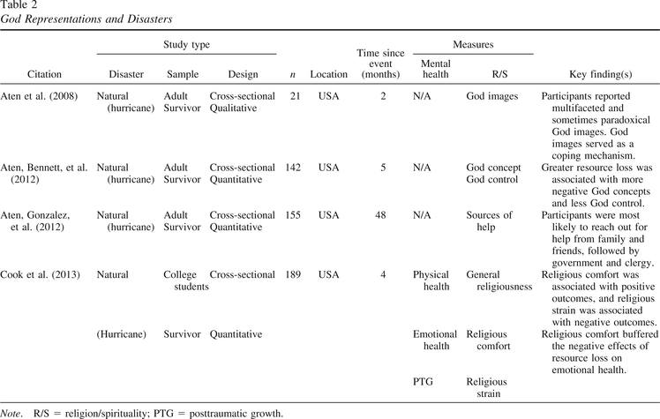God Representations and Disasters
Views
Aten and colleagues (2008) found that a community sample of Hurricane Katrina survivors reported experiencing conflicting God representations immediately following the disaster. At 2 months postdisaster, survivors reported experiencing God in often paradoxical ways, such as fluctuating between experiencing God as a loving father figure (e.g., benevolent God images) and a punitive/judgmental figure (e.g., authoritarian God images).
Predictors
In another community sample of adult Katrina survivors, Aten and colleagues (2012) found that greater disaster-related resource-loss predicted less positive God concepts (i.e., conceptual views of God as benevolent, guiding, and caring) and more negative God concepts (i.e., conceptual views of God as worthless, condemning, or wrathful). Race/ethnicity also explained negative God concepts, with African American participants reporting higher levels of negative God concepts compared with their White counterparts. The authors noted that African Americans tended to report a personal view of God, whereas Whites tended to report a more abstract view of God. It may be that the African American participants experienced their losses (which were higher than other participants sampled) as more personal in nature, which may have resulted in higher reports of negative God concepts. Individuals with greater resource loss also reported lower God control (i.e., R/S attributions that God is in control over life events). Loss of food and water was the strongest predictor of negative views of God (i.e., less positive and more negative god concepts). Taken together, such cross-sectional results suggest that resource-loss in general—and basic resource-loss in particular—is predictive of negative God representations.
Outcomes
Positive God representations tended to be related to increased levels of well-being and growth and to protect against emotional and physical outcomes. For examples, Cook and colleagues (2013) sampled college students directly impacted by Hurricane Katrina within 4 months of the storm. They found that more positive views of God were associated with positive outcomes and helped protect participants from negative emotional and physical outcomes commonly associated with resource loss. Positive views of God were associated with higher levels of general well-being and posttraumatic growth. Conversely, religious strain, which included negative emotions toward God, was inversely correlated with emotional health. Higher levels of religious strain also mediated the negative relationship between resources loss and health. In sum, more positive views of God were associated with more positive outcomes, whereas more negative views of God were associated with more negative outcomes.

Religious Appraisals and Disasters
Religious appraisals are R/S latent evaluations of stressors and potential resources available for dealing with a stressor (see Table 3). One’s religious background, type of disaster experienced, and personal characteristics seemed to impact appraisals. Further, several studies yielded well-being outcomes that were related to one’s religious appraisals.
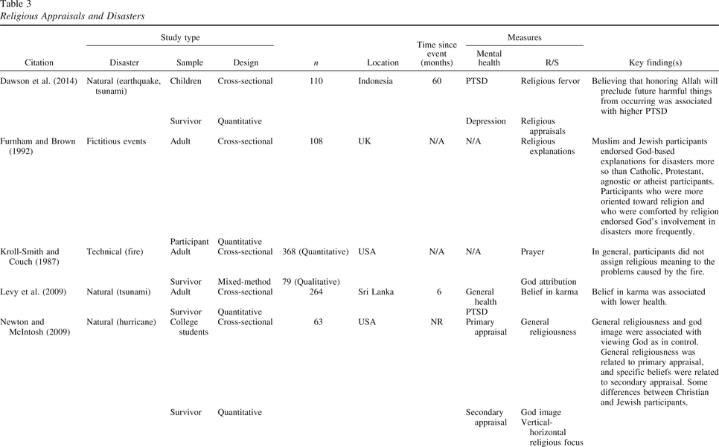Religious Appraisals and Disasters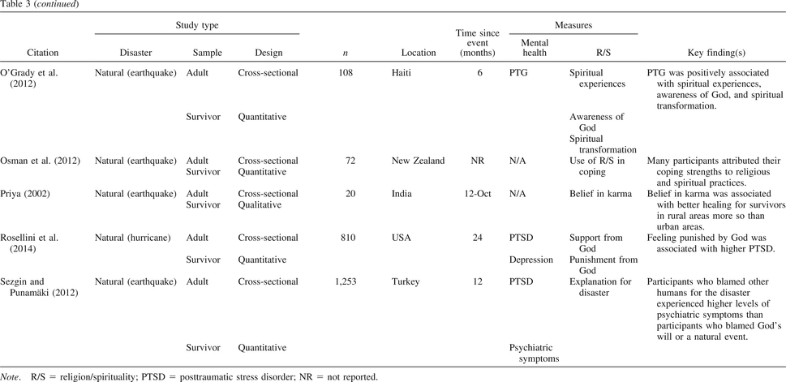Religious Appraisals and Disasters
Religious background
Newton and McIntosh (2009) found that the 2005 hurricane season fostered different understandings of the storms among Christian and Jewish college students. They discovered that although both groups of students related primary appraisals (i.e., interpretation of the stressor as a threat, challenge, loss, and/or benefit) and secondary appraisals (i.e., perception of whether self, others, and God have control of the stressor) to religion, one’s religiousness was positively associated with the interpretation of disaster events as a loss among Christian students and as a benefit for Jewish students. Christians tended to view the hurricanes as harmful, whereas Jewish students held positive perceptions of the storms in regard to God. Furnham and Brown (1992) also found that religious appraisals varied by religious orientation. They presented participants with a number of different “explanations” for suffering along with triggering events such as natural and human-caused disasters. Muslim and Jewish respondents in the United Kingdom were more likely than Christians, agnostics, or atheists to attribute disasters to God. Overall, participants for whom religion provided comfort were more likely to endorse God-type explanations for disastrous events.
Appraisals due to disaster type
Though sparse, there was some evidence that disaster appraisals may differ depending on the type of disaster. For example, Kroll-Smith and Couch (1987) examined appraisals after a decade-long fire in a Pennsylvania mine. They found that residents seemed to foster a belief in God’s irrelevance to the situation, which was largely attributed to the role of human error. This study points to the possibility that reactions may vary depending on the cause of the disaster (human-made vs. natural).
Outcomes
We also found several studies that looked at the relationship between religious appraisals and well-being outcomes. For example, Priya (2002) found that rural Bhuj survivors of the 2001 earthquake appeared to experience greater healing from religious beliefs that encouraged harmony with nature, compared to urban survivors who reported more materialistic appraisals. Similarly, interpreting a large flood in the Midwest U.S. within God’s love, reward, or will was related to positive psychological outcomes (Smith et al., 2000). Sezgin and Punamäki (2012) reported analogous results among South East Anatolian earthquake survivors. Through qualitative interviews, O’Grady and colleagues (2012) also found Haitian earthquake survivors who perceived that God was involved and interacting in their lives tended to experience spiritual growth and renewal despite the degree of the loss experienced. Qualitative interviews found many refugees affected by the Christchurch earthquakes attributed their coping strengths to R/S practices (Osman, Hornblow, Macleod, & Coope, 2012).
Conversely, belief in karma, in addition to a pessimistic explanatory style, resulted in poorer health among Sri Lankan survivors of the 2004 earthquake tsunami (Levy, Slade, & Ranasinghe, 2009). Dawson and colleagues (2014) also found that children who believed that honoring Allah would preclude future harmful events were more likely to develop PTSD after the tsunami. The researchers speculated that this belief was related to feeling vulnerable to harm. Examining the impact of Katrina, Rosellini, Coffey, Tracy, and Galea (2014) found that believing the hurricane was a punishment from God was associated with higher levels of PTSD.

R/S Meaning-Making and Disasters
R/S meaning-making has been argued to be essential to disaster survivors’ spiritual and psychological growth in the midst of disaster (Park, 2010, 2013). Several scholars explored the conditions under which participants incorporated the Sacred during meaning making, and how meaning making was related to personal and relational growth (see Table 4).
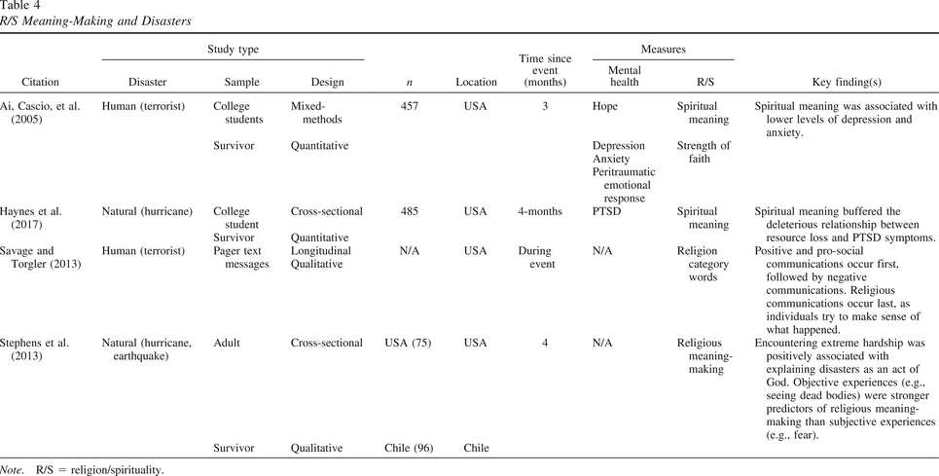R/S Meaning-Making and Disasters
Disaster experience
Savage and Torgler (2013) conducted a qualitative content analysis of pager communications (obtained through WikiLeaks) in and out of the World Trade Towers starting immediately after the 9/11 attacks between colleagues, family members, and friends. Initially, communications generally contained positive and prosocial sentiments. However, as time passed, the communications became more negative in nature and distressful. The final stage of communications moved to more religious sentiments, which the researchers conceptualized as initial steps of R/S meaning making. Stephens and colleagues (2013)conducted qualitative interviews with survivors approximately four months after Hurricane Katrina and approximately four months after a devastating flood in Chile that yielded similar results. They reported that people who personally experienced hardship (e.g., seeing dead bodies) were more likely to engage in R/S meaning-making than those who did not.
Outcomes
We identified two articles that addressed outcomes of meaning making and disaster. Haynes and colleagues (2017) found that spiritual meaning-making helped buffer against PTSD symptoms caused by resource loss within the first few months of Hurricane Katrina. In addition, Ai, Cascio, Santangelo, and Evans-Campbell (2005) found that participants who engaged in R/S meaning-making after 9/11. They found participants who engaged in a search for R/S meaning after 9/11 experienced lower levels of anxiety and depression than those who did not. Furthermore, survivors experienced multidimensional change in personal, relational, political, and worldview domains.

Religious Coping and Disasters
Religious coping is often defined as a “proactive process of searching for significance in times of stress” (Krumrei & Rosmarin, 2012, p. 245); however, individuals’ beliefs and coping behaviors can be both constructive and destructive in times of stress or hardship (see Table 5). It appears that the disaster experience, particularly stress-affiliated experiences, as well as demographic factors (e.g., age, ethnicity, etc.) impacted survivors’ level of religious coping.
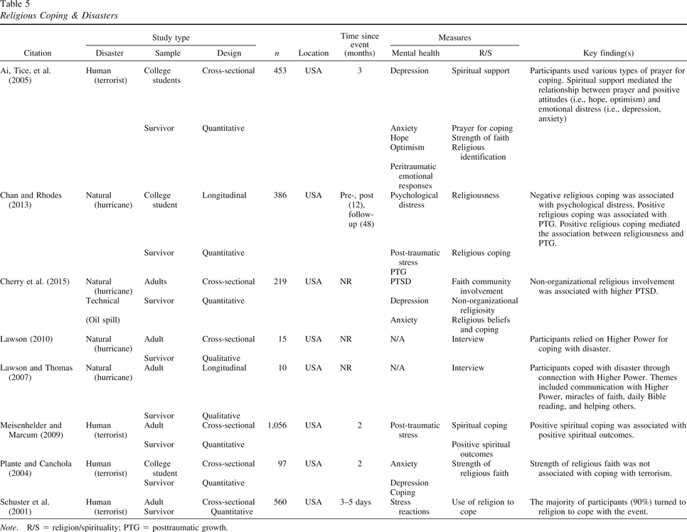Religious Coping & Disasters
Disaster experience
A national survey conducted just days following 9/11 showed that 90% of participants reported turning to religion to cope with the events (Schuster et al., 2001). Ai, Tice, Peterson, and Huang (2005) found that higher levels of negative emotional responses right after 9/11 were associated with higher levels of using prayer as a coping behavior. Similarly, spiritual coping (e.g., seeking God’s support, seeking family and friends, church attendance, prayer) after 9/11 was strongly associated with positive outcomes like feeling closer to family, friends, church and God (Meisenhelder & Marcum, 2009). However, Plante and Canchola (2003) reported that strength of religious faith was not associated with improved coping behavior in a study conducted with students on the West Coast approximately eight weeks post 9/11. The authors suggest that the events may not have been personally stressful enough to trigger a faith component to coping.
Age and race/ethnicity
Cherry and colleagues (2015) conducted a study that suggested there may be differences in religious coping across the life span. They studied a group of Hurricane Katrina and Deep Horizon Oil Spill older adult survivors and found that engaging in nonorganized religious coping behaviors independent of church involvement (i.e., reading religious literature, watching/listening to religious programs) was linked to higher levels of PTSD. However, Lawson and Thomas (2007) found through qualitative interviews that nonorganized religious coping behaviors were helpful among older adult African American Hurricane Katrina survivors. For these survivors, the use of prayer, devotions, recognizing miracles of faith (e.g., “I’ve come this far by faith and trust in God,” p. 345), and helping others were key coping mechanisms. Lawson (2010) further showed that African American men were likely to use inspirational books written by non-African American authors, revealing a cross-cultural aspect to coping.

Discussion

Main Findings
This review revealed several emerging patterns regarding what is known about the psychology of R/S and disasters. People tend to look to R/S during times of crises to make sense of and cope with disasters (e.g., Aten et al., 2012). Several studies suggested that a minimum threshold of personal stress or perceived threat must be experienced to activate R/S resources, appraisals, and meaning-making in the wake of disaster (e.g., Plante & Canchola, 2003; Stephens et al., 2013). A few studies also indicated that religious appraisals vary depending upon the cause or type of disaster. That is, R/S responses may differ following a natural disaster versus a human-made disaster (e.g., Kroll-Smith & Couch, 1987). Further, higher levels of perceived resources loss (especially losses of resources needed to sustain life like water and food) predict more personal and negative religious attributions (e.g., Aten et al., 2012).
On the whole, R/S appears to generally lead to positive outcomes among disaster survivors. However, negative religious coping, as well as certain types of god representations, religious appraisals, and changes in religiosity over time were all associated with more negative mental, physical, and spiritual outcomes (e.g., R/S struggles, God attachment avoidance and anxiety; depressive, anxious, PTSD, or subjective health symptoms), especially for survivors who identified as R/S prior to the disaster (Sibley & Bulbulia, 2012). Several of the studies we reviewed also indicated that various aspects of R/S might moderate the relationship between disaster stimulus (e.g., resource loss) and resilience factors (e.g., physical, emotional, and spiritual well-being). A few studies also suggest that a new search for meaning provoked by disasters may also have a transformative impact on some survivors that leads to posttraumatic spiritual and psychological growth. However, because of the cross-sectional design of these studies it’s unclear whether what was reported was actual or perceived growth or a form of coping.
Several contextual factors were found to affect the relationship between disaster survivors’ experience and outcomes. Individual differences (e.g., ethnicity, gender, and age) and R/S variables (e.g., self–God overlap, God control, R/S attributions, religious orientation) were found to influence (i.e., moderate) or explain (i.e., mediate) spiritual and psychological outcomes (e.g., Feder et al., 2013). Furthermore, social- and community-level variables (e.g., religious involvement); and disaster/stressor-related variables (e.g., resource loss, prior stressful life events) may play an important role in determining outcomes (e.g., Cook et al., 2013).

Recommendations
Although numerous studies have been conducted thus far, more systematic research is needed to understand the complexities of R/S in disaster contexts. As evidenced by this review, studies have often used inconsistent methods and have not consistently built upon each other to expand knowledge. The vast majority of articles used cross-sectional research designs followed by experimental designs. As might be expected, very few longitudinal studies were found. There were more instances of natural disasters than human-made, with Hurricane Katrina and 9/11 receiving the most study. The majority of studies reviewed were conducted with samples from the United States, and predominantly from the Christian religion. College samples were also disproportionately represented among the articles identified. Overreliance on self-report measures that failed to assess several aspects of the respondent’s perceived R/S was common. Considering the total number of articles identified, mixed-method approaches were rare. Overall, researchers need to consider more rigorous hypotheses and methodologies, and they need to work together to develop guiding theories for the future. More is also needed to extend the insights that have been developed thus far in the literature to further explore areas that are not yet clear. Thus, to advance scientific understanding and multilevel theorizing about the psychology of R/S and disasters, we propose six overarching areas of inquiry that need to be addressed to synthesize future research based on our findings. Here are some initial questions for catalyzing future research in the psychology of R/S and disasters:
- Advancing methodology: How do we best measure psychology of R/S variables in disaster contexts? Are the current qualitative, self-report, behavioral, and observational measures adequate? For example, what types of scales might be needed to validate future spiritually oriented disaster psychology interventions? What kinds of disaster training, collaborations, and resources are needed to ensure this work is carried out effectively without causing harm? What current theories or models most readily lend themselves to informing psychology of R/S and disaster research?
- Understanding the nature of disasters: What is the effect of disaster exposure on R/S? That is, how does disaster exposure affect the ways people view and relate to the sacred? Do people engage R/S differently depending on the type, source of the disaster (e.g., natural, human-made, vs. technical disaster), and severity? How does it affect their sense of R/S in life and engagement in R/S-focused coping?
- Identifying mediating mechanisms: What variables mediate the effect of disaster exposure on R/S? Stated differently, what are the causal mechanisms by which disasters affect people’s R/S? What are the underdeveloped or promising variables that warrant further investigation?
- Identifying personal and contextual moderators: Is the effect of disaster exposure on R/S contingent on certain individual-level variables (e.g., individual differences in personality, R/S variables, cultural differences), social- and community-level variables (e.g., perceived social and religious support), and disaster/stressor-related variables (e.g., PTSD symptoms, prior exposure to stressful life events)? That is, do certain contextual factors influence (i.e., moderate) the effect of disaster exposure on R/S? How do such contextual factors influence changes in R/S over time?
- Predicting growth/resilience versus loss/adversity: Does adaptively well-integrated R/S buffer against negative postdisaster spiritual, psychological, and health outcomes? How does adaptively well-integrated R/S promote postdisaster spiritual and psychological growth? What are the processes involved in spiritual resiliency, decline, and growth?
Answering these questions will require a more comprehensive and sophisticated approach to investigating R/S and disasters, including (a) using pluralistic methods, (b) engaging in more theory building, (c) recruiting diverse samples, (d) studying contextual factors, (e) implementing intervention studies, and (f) committing to programmatic lines of research.

Conclusion

Disasters represent an understudied phenomenon that would seem to evoke a wide range of questions often studied in the psychology of R/S. These events are fruitful opportunities that may lead to new advances, insights, and questions into R/S phenomena. We hope others within the psychology of R/S will consider how their current work might be extended to disaster contexts. Indeed, we encourage readers to consider developing ongoing programmatic lines of psychology of R/S and disasters research. Simultaneously, we would also remind readers of the significant potential to cause harm and encourage additional ethical- and disaster-related training. The psychology of R/S and disasters research is poised to be able to make significant contributions to both science and society.

Footnotes
1 Though several meaning-making articles were identified, only those specifically looking RS meaning-making were included in the present review. For a review of meaning-making more generally, refer the reader to Park (2016).

References
Ai, A. L., Cascio, T., Santangelo, L., & Evans-Campbell, T. (2005). Hope, meaning, and growth following the September 11, 2001, terrorist attacks. Journal of Interpersonal Violence, 20, 523–548. 10.1177/0886260504272896
Ai, A. L., Richardson, R., Plummer, C., Ellison, C. G., Lemieux, C., Tice, T. N., & Huang, B. (2013). Character strengths and deep connections following Hurricanes Katrina and Rita: Spiritual and secular pathways to resistance among volunteers. Journal for the Scientific Study of Religion, 52, 537–556. 10.1111/jssr.12043
Ai, A. L., Tice, T. N., Peterson, C., & Huang, B. (2005). Prayers, spiritual support, and positive attitudes in coping with the September 11 national crisis. Journal of Personality, 73, 763–792. 10.1111/j.1467-6494.2005.00328.x
Allport, G. W., & Ross, J. M. (1967). Personal religious orientation and prejudice. Journal of Personality and Social Psychology, 5, 432–443. 10.1037/0022-3514.5.4.432
Aten, J., Bennett, P., Hill, P., Davis, D., & Hook, J. (2012). Predictors of God concept and God control after Hurricane Katrina. Psychology of Religion and Spirituality, 4, 182–192. 10.1037/a0027541
Aten, J., & Boan, D. (2016). Disaster ministry handbook. Downers Grove, IL: InterVarsity Press.
Aten, J., Gonzalez, R., Boan, D., Topping, S., Livingston, W., & Hosey, J. (2012). Church attendee help seeking behavior in Mississippi and Louisiana following Hurricane Katrina. International Journal of Emergency Mental Health, 14, 15–20.
Aten, J., Moore, M., Denney, R., Bayne, T., Stagg, A., Owens, S., . . .Jones, C. (2008). God images following Hurricane Katrina in South Mississippi: An exploratory study. Journal of Psychology and Theology, 36, 249–257. 10.1177/009164710803600401
Aten, J. D., O’Grady, K. A., Milstein, G., Boan, D., & Schruba, A. (2014). Spiritually oriented disaster psychology. Spirituality in Clinical Practice, 1, 20–28. 10.1037/scp0000008
Augustine, J. (2014). Predictors of posttraumatic growth among adult tsunami survivors: The role of employment, religion, and family attributes. Journal of Social Service Research, 40, 491–507. 10.1080/01488376.2014.894368
Briggs, M. K., Apple, K. J., & Aydlett, A. E. (2004). Spirituality and the events of September 11: A preliminary study. Counseling and Values, 48, 174–182. 10.1002/j.2161-007X.2004.tb00244.x
Brown, J. S., Cherry, K. E., Marks, L. D., Jackson, E. M., Volaufova, J., Lefante, C., & Jazwinski, S. M. (2010). After Hurricanes Katrina and Rita: Gender differences in health and religiosity in middle-aged and older adults. Health Care for Women International, 31, 997–1012. 10.1080/07399332.2010.514085
Burnett, H., & Helm, H. (2013). Relationship between posttraumatic stress disorder, resilience, and religious orientation and practices among university student earthquake survivors in Haiti. International Journal of Emergency Mental Health and Human Resilience, 15, 97–104.
Carmassi, C., Stratta, P., Calderani, E., Bertelloni, C. A., Menichini, M., Massimetti, E., . . .Dell’Osso, L. (2016). Impact of mood spectrum spirituality and mysticism symptoms on suicidality in earthquake survivors with PTSD. Journal of Religion and Health, 55, 641–649. 10.1007/s10943-015-0072-z
Centre of Research on the Epidemiology of Disaster (CRED). (2016). The human cost of weather related disasters. Geneva, Switzerland: Author. Retrieved from https://www.unisdr.org/
Chan, C., & Rhodes, J. (2013). Religious coping, posttraumatic stress, psychological distress, and posttraumatic growth among female survivors four years after Hurricane Katrina. Journal of Traumatic Stress, 26, 257–265. 10.1002/jts.21801
Chan, C., Rhodes, J., & Perez, J. (2012). A prospective study of religiousness and psychological distress among female survivors of Hurricanes Katrina and Rita. American Journal of Community Psychology, 49, 168–181. 10.1007/s10464-011-9445-y
Cherry, K. E., Sampson, L., Nezat, P. F., Cacamo, A., Marks, L. D., & Galea, S. (2015). Long-term psychological outcomes in older adults after disaster: Relationships to religiosity and social support. Aging & Mental Health, 19, 430–443. 10.1080/13607863.2014.941325
Cook, S. W., Aten, J. D., Moore, M., Hook, J. N., & Davis, D. E. (2013). Resource loss, religiousness, health, and posttraumatic growth following Hurricane Katrina. Mental Health, Religion & Culture, 16, 352–366. 10.1080/13674676.2012.667395
Coppola, D. (2015). Introduction to international disaster management (3rd ed.). Waltham, MA: Elsevier Inc.
Davis, E. B., Moriarty, G. L., & Mauch, J. C. (2013). God images and god concepts: Definitions, development, and dynamics. Psychology of Religion and Spirituality, 5, 51–60. 10.1037/a0029289
Dawson, K. S., Joscelyne, A., Meijer, C., Tampubolon, A., Steel, Z., & Bryant, R. A. (2014). Predictors of chronic posttraumatic response in Muslim children following natural disaster. Psychological Trauma: Theory, Research, Practice, and Policy, 6, 580–587. 10.1037/a0037140
EM-DAT. (n.d.). The Emergency Events Database. Universite Catholique de Louvain (UCL)–CRED, D. Brussels, Belgium: Author. Retrieved from www.emdat.be
Feder, A., Ahmad, S., Lee, E. J., Morgan, J. E., Singh, R., Smith, B. W., . . .Charney, D. S. (2013). Coping and PTSD symptoms in Pakistani earthquake survivors: Purpose in life, religious coping and social support. Journal of Affective Disorders, 147, 156–163. 10.1016/j.jad.2012.10.027
Fischer, P., Greitemeyer, T., Kastenmuller, A., Jonas, E., & Frey, D. (2006). Coping with terrorism: The impact of increased salience of terrorism on mood and self-efficacy of intrinsically religious and nonreligious people. Personality and Social Psychology Bulletin, 32, 365–377. 10.1177/0146167205282738
Ford, C. A., Udry, J. R., Gleiter, K., & Chantala, K. (2003). Reactions of young adults to September 11, 2001. Archives of Pediatrics & Adolescent Medicine, 157, 572–578. 10.1001/archpedi.157.6.572
Furnham, A., & Brown, L. B. (1992). Theodicy: A neglected aspect of the psychology of religion. International Journal for the Psychology of Religion, 2, 37–45. 10.1207/s15327582ijpr0201_4
Granqvist, P., & Kirkpatrick, L. A. (2013). Religion, spirituality, and attachment. In K. I.Pargament, J. J.Exline, & J. W.Jones (Eds.), APA handbook of psychology, religion, and spirituality: Context, theory, and research (Vol. 1, pp. 139–155). Washington, DC: American Psychological Association. 10.1037/14045-007
Gillard, M., & Paton, D. (1999). Disaster stress following a hurricane: The role of religious differences in the Fijian Islands. The Australian Journal of Disaster and Trauma Studies, 2, 1999–2002.
Hackbarth, M., Pavkov, T., Wetchler, J., & Flannery, M. (2012). Natural disasters: An assessment of family resiliency following hurricane Katrina. Journal of Marriage and Family Therapy, 38, 340–351. 10.1111/j.1752-0606.2011.00227.x
Haynes, W. C., Van Tongeren, D. R., Aten, J., Davis, E. B., Davis, D. E., Hook, J. N., . . .Johnson, T. (2017). The meaning as a buffer hypothesis: Spiritual meaning attenuates the effect of disaster-related resource loss on posttraumatic stress. Psychology of Religion and Spirituality, 9, 446–453. 10.1037/rel0000098
International Federation of Red Cross and Red Crescent Societies. (n.d.). Retrieved from https://media.ifrc.org/ifrc/
Jang, L., & LaMendola, W. (2007). Social work in natural disasters: The case of spirituality and post-traumatic growth. Advances in Social Work, 8, 305–316.
Jang, L., & Wang, J. (2009). Disaster resilience in a Hakka community in Taiwan. Journal of Pacific Rim Psychology, 3, 55–65. 10.1375/prp.3.2.55
Krause, N., & Ellison, C. G. (2009). Social environment of the church and feelings of gratitude toward god. Psychology of Religion and Spirituality, 1, 191–205. 10.1037/a0016729
Kroll-Smith, S. J., & Couch, S. R. (1987). A chronic technical disaster and the irrelevance of religious meaning: The case of Centralia, PA. Journal for the Scientific Study of Religion, 26, 25–37. 10.2307/1385839
Krumrei, E. J., & Rosmarin, D. H. (2012). Processes of religious and spiritual coping. In J. D.Aten, K. A.O’Grady, & E. L.Worthington, Jr. (Eds.), The psychology of religion and spirituality for clinicians: Using research in your practice (pp. 245–273). New York, NY: Routledge/Taylor & Francis Group. Retrieved from https://ezproxy.wheaton.edu/login?url=https://search.ebscohost.com/login.aspx?direct=true&db=psyh&AN=2011-28664-010&site=ehost-live
Lawson, E. (2010). A gender comparison of resiliency among older African American Katrina survivors. The Western Journal of Black Studies, 34, 457–470.
Lawson, E., & Thomas, C. (2007). Wading in the waters: Spirituality and older Black Katrina survivors. Journal of Health Care for the Poor and Underserved, 18, 341–354. 10.1353/hpu.2007.0039
Levy, B. R., Slade, M. D., & Ranasinghe, P. (2009). Causal thinking after a tsunami wave: Karma beliefs, pessimistic explanatory style and health among Sri Lankan survivors. Journal of Religion and Health, 48, 38–45. 10.1007/s10943-008-9162-5
Liang, L., Hayashi, K., Bennett, P., Johnson, T., & Aten, J. (2015). Resource loss and depressive symptoms following Hurricane Katrina: A principal component regression study. International Journal of Behavioral Research & Psychology, 3, 91–98. 10.19070/2332-3000-1500018
Lupfer, M. B., Brock, K. F., & DePaola, S. J. (1992). The use of secular and religious attributions to explain everyday behavior. Journal for the Scientific Study of Religion, 31, 486–503. 10.2307/1386858
McFarlane, A. C., & Norris, F. H. (2006). Definitions and Concepts in Disaster Research. In F. H.Norris, S.Galea, M. J.Friedman, & P. J.Watson (Eds.), Methods for disaster mental health research (pp. 3–19). New York, NY: Guilford Press. Retrieved from http://ezproxy.wheaton.edu/login?url=https://search.ebscohost.com/login.aspx?direct=true&db=psyh&AN=2006-11794-001&site=ehost-live
McGeehan, K. M., & Baker, C. K. (2017). Religious narratives and their implications for disaster risk reduction. Disasters, 41, 258–281. 10.1111/disa.12200
McLeish, A. C., & Del Ben, K. S. (2008). Symptoms of depression and posttraumatic stress disorder in an outpatient population before and after Hurricane Katrina. Depression and Anxiety, 25, 416–421. 10.1002/da.20426
Meisenhelder, J. B., & Marcum, J. P. (2009). Terrorism, post-traumatic stress, coping strategies, and spiritual outcomes. Journal of Religion and Health, 48, 46–57. 10.1007/s10943-008-9192-z
National Consortium for the Study of Terrorism and Responses to Terrorism. (2016). Global terrorism database [Data file]. Retrieved from https://www.start.umd.edu/gtd
Nelson, L., & Dynes, R. (1976). The impact of devotionalism and attendance on ordinary and emergency helping behavior. Journal for the Scientific Study of Religion, 15, 47–59. 10.2307/1384313
Newton, A. T., & McIntosh, D. N. (2009). Associations of general religiousness and specific religious beliefs with coping appraisals in response to Hurricanes Katrina and Rita. Mental Health, Religion & Culture, 12, 129–146. 10.1080/13674670802380400
O’Grady, K. A., Rollison, D. G., Hanna, T. S., Schreiber-Pan, H., & Ruiz, M. A. (2012). Earthquake in Haiti: Relationship with the sacred in times of trauma. Journal of Psychology and Theology, 40, 289–301. 10.1177/009164711204000404
Osman, M., Hornblow, A., Macleod, S., & Coope, P. (2012). Christchurch earthquakes: How did former refugees cope?The New Zealand Medical Journal, 125, 113–121.
Pargament, K. I., Koenig, H. G., & Perez, L. (2000). The many methods of religious coping: Development and initial validation of the RCOPE. Journal of Clinical Psychology, 56, 519–543. 10.1002/(SICI)1097-4679(200004)56:4<519::AID-JCLP6>3.0.CO;2-1
Park, C. L. (2010). Making sense of the meaning literature: An integrative review of meaning making and its effects on adjustment to stressful life events. Psychological Bulletin, 136, 257–301. 10.1037/a0018301
Park, C. L. (2013). Trauma and meaning making: Converging conceptualizations and emerging evidence. In J. A.Hicks, & C.Routledge (Eds.), The experience of meaning in life: Classical perspectives, emerging themes, and controversies (pp. 61–76). New York, NY: Springer Science + Business Media. 10.1007/978-94-007-6527-6_5
Park, C. (2016). Meaning making in the context of disasters. Journal of Clinical Psychology, 72, 1234–1246. 10.1002/jclp.22270
Peterson, C., & Seligman, M. E. (2003). Character strengths before and after September 11. Psychological Science, 14, 381–384. 10.1111/1467-9280.24482
Plante, T. G., & Canchola, E. L. (2003). The association between strength of religious faith and coping with American terrorism regarding the events of September 11, 2001. Pastoral Psychology, 52, 269–278. 10.1023/B:PASP.0000010027.00357.03
Powell, L., Bodon, J., & Hickson, M. (2001). Rejection of crisis information: Public apathy and the macro-crisis of Y2K. Communication Research Reports, 18, 84–92. 10.1080/08824090109384785
Priya, K. R. (2002). Suffering and healing among the survivors of Bhuj earthquake. Psychological Studies, 47, 106–112.
Rose, T., Shields, J., Tueller, S., & Larson, S. (2015). Religiosity and behavioral health outcomes of adolescents living in disaster-vulnerable areas. Journal of Religion and Health, 54, 480–494. 10.1007/s10943-014-9828-0
Rosellini, A. J., Coffey, S. F., Tracy, M., & Galea, S. (2014). A person-centered analysis of posttraumatic stress disorder symptoms following a natural disaster: Predictors of latent class membership. Journal of Anxiety Disorders, 28, 16–24. 10.1016/j.janxdis.2013.11.002
Savage, D. A., & Torgler, B. (2013). The emergence of emotions and religious sentiments during the September 11 disaster. Motivation and Emotion, 37, 586–599. 10.1007/s11031-012-9330-5
Schuster, M. A., Stein, B. D., Jaycox, L. H., Collins, R. L., Marshall, G. N., Elliott, M. N., . . .Berry, S. H. (2001). A national survey of stress reactions after the September 11, 2001, terrorist attacks. The New England Journal of Medicine, 345, 1507–1512. 10.1056/NEJM200111153452024
Seirmarco, G., Neria, Y., Insel, B., Kiper, D., Doruk, A., Gross, R., & Litz, B. (2012). Religiosity and mental health: Changes in religious beliefs, complicated grief, posttraumatic stress disorder, and major depression following the September 11, 2001 attacks. Psychology of Religion and Spirituality, 4, 10–18. 10.1037/a0023479
Sezgin, U., & Punamäki, R. L. (2012). Earthquake trauma and causal explanation associating with PTSD and other psychiatric disorders among South East Anatolian women. Journal of Affective Disorders, 141, 432–440. 10.1016/j.jad.2012.03.005
Shaw, A., Joseph, S., & Linley, P. A. (2005). Religion, spirituality, and posttraumatic growth: A systematic review. Mental Health, Religion & Culture, 8, 1–11. 10.1080/1367467032000157981
Sibley, C., & Bulbulia, J. (2012). Faith after an earthquake: A longitudinal study of religion and perceived health before and after the 2011 Christchurch New Zealand Earthquake. PLOS ONE, 7(12), e49648.
Smith, B. W., Pargament, K. I., Brant, C., & Oliver, J. M. (2000). Noah revisited: Religious coping by church members and the impact of the 1993 Midwest flood. Journal of Community Psychology, 28, 169–186. 10.1002/(SICI)1520-6629(200003)28:2<169::AID-JCOP5>3.0.CO;2-I
Soenke, M., Landau, M. J., & Greenberg, J. (2013). Sacred armor: Religion's role as a buffer against the anxieties of life and the fear of death. In K. I.Pargament, J. J.Exline, & J. W.Jones (Eds.), APA handbook of psychology, religion, and spirituality: Context, theory, and research (Vol. 1, pp. 105–122). Washington, DC: American Psychological Association. 10.1037/14045-005
Spilka, B., Shaver, P., & Kirkpatrick, L. A. (1985). A general attribution theory for the psychology of religion. Journal for the Scientific Study of Religion, 24, 1–20. 10.2307/1386272
Stephens, N. M., Fryberg, S. A., Markus, H. R., & Hamedani, M. G. (2013). Who explains Hurricane Katrina and the Chilean earthquake as an act of God? The experience of extreme hardship predicts religious meaning-making. Journal of Cross-Cultural Psychology, 44, 606–619. 10.1177/0022022112454330
Stratta, P., Capanna, C., Riccardi, I., Perugi, G., Toni, C., Dell’Osso, L., & Rossi, A. (2013). Spirituality and religiosity in the aftermath of a natural catastrophe in Italy. Journal of Religion and Health, 52, 1029–1037. 10.1007/s10943-012-9591-z
Subandi, M. A., Achmad, T., Kurniati, H., & Febri, R. (2014). Spirituality, gratitude, hope and post-traumatic growth among the survivors of the 2010 eruption of Mount Merapi in Java, Indonesia. Australian Journal of Disaster and Trauma Studies, 18, 19–26.
Tran, T., Chan, K., & Nguyen, T. (2011). Reliability and validity of a bilingual measure of religiosity in English and Vietnamese: Preliminary results from a pilot study. Psychological Reports, 108, 756–762. 10.2466/07.17.PR0.108.3.756-762
Uecker, J. E. (2008). Religious and spiritual responses to 9/11: Evidence from the Add Health Study. Sociological Spectrum, 28, 477–509. 10.1080/02732170802206047
Wickrama, K. A. S., & Wickrama, K. A. T. (2008). Family context of mental health risk in Tsunami affected mothers: Findings from a pilot study in Sri Lanka. Social Science & Medicine, 66, 994–1007. 10.1016/j.socscimed.2007.11.012
Submitted: January 29, 2018 Revised: November 13, 2018 Accepted: November 25, 2018

This publication is protected by US and international copyright laws and its content may not be copied without the copyright holders express written permission except for the print or download capabilities of the retrieval software used for access. This content is intended solely for the use of the individual user.
Source: Psychological Trauma: Theory, Research, Practice, and Policy. Vol. 11. (6), Sep, 2019 pp. 597-613)
Accession Number: 2019-05966-001
Digital Object Identifier: 10.1037/tra0000431

