Q1: 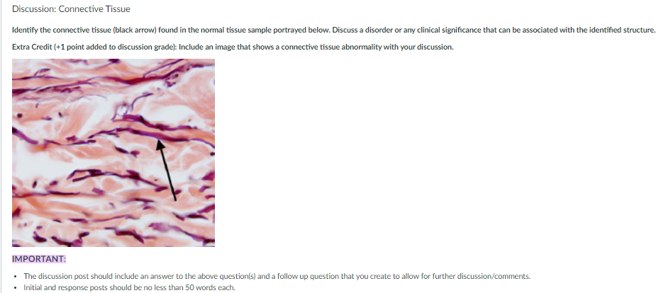
Q2. 2. 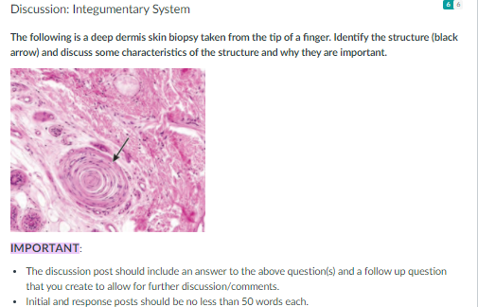
Q3. Please respond to all of the following questions:
1. Describe what you personally believe are features of a good doctor-patient relationship.
2. Interview someone that you know that has had an unsuccessful experience with a doctor and share the features of that doctor-patient relationship.
3. After your description, please share the ethical issue your interviewee had and how that violation should be rectified or should have been addressed.
4. What standards will you implement in your practice of medicine to ensure such violations do not occur within your patient population?
Q4: Please summarize the Ethical Issues Surrounding End of Life Care Download Ethical Issues Surrounding End of Life Care article. Provide your specific viewpoint on the issue - why do you agree or disagree? Also, demonstrate your understanding of possible opposing viewpoints.

Q5: Please summarize the Abortion in Islamic Ethics.pdf article. What is the issue? Highlight the key features. What are the specific ethical issues that must be considered?

Identify two ethical aspects of genetic testing in Medicine mentioned in the article you find intriguing. For each aspect, find a supplemental article that discusses an advancement or solution to that topic.

Q5: Please summarize the Ethical Issues in Predictive Genetic Testing Download Ethical Issues in Predictive Genetic Testing article. What is the issue? Highlight the key features. What are the specific ethical issues that must be considered?

Q6: 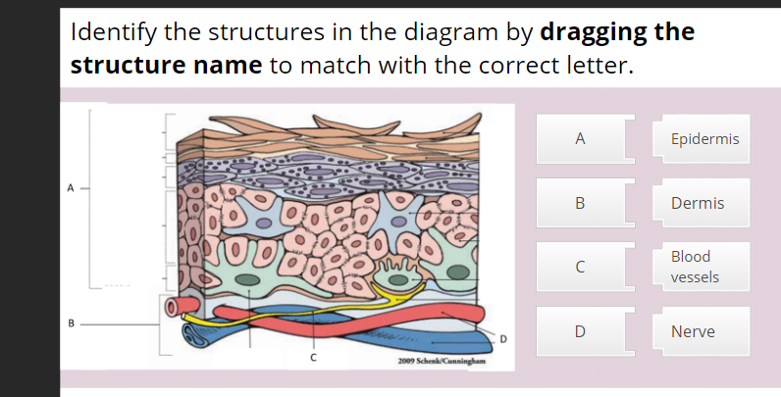

Q7: 