Hooke’s Law Simulation
First Last Name
Name of Institution

Hooke’s law simulation
Introduction
Hooke’s law states that the force required to stretch an elastic material is directly proportional to the extension of the material (Gati et al, 2016). This correlation can be shown using a linear graph of force and extension.
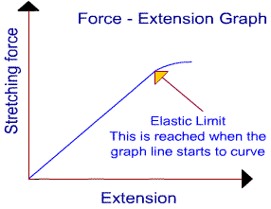
This correlation can be expressed using the formulae: $F=k*x$
Whereby F is the applied force in N, k is the spring constant and x is the extension in meters. This is applicable if the elastic limit is not exceeded.
Objective
- Exploring Hooke’s Law through an online simulation tool developed at the University of Colorado, Boulder.
Equipment
- Computer with internet access.
- Graphing software.

Procedure part 1: Introduction
In this part am supposed to explore how the simulation works, and to experimentally verify that Hooke’s law is accurately simulated by the program.
- Opening of word document to create new document that will be my lab report.
- Visiting the site https://phet.colorado.edu/en/simulation/hookes-law so that one can be able to use the online simulation tool.
- The simulation is in three parts, “Intro,” “Systems,” and “Energy” but am going to tart with the Intro part so that I can be able to do the simulation.
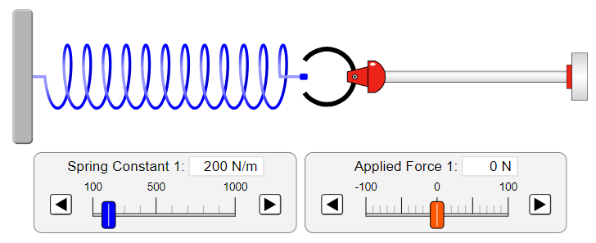
- The spring constant was set to 300N/m and the readings were recorded.
- The applied force was set to 6 different values and for each, the displacement was recorded.
- Using excel, the data collected were graphed and the slope of the graph was determined.
Procedure part 11: Multiple spring systems, in parallel
- On the second part, “Systems,” the controls were played with
- The simulation was set for the two springs connected side by side, and the force constant for spring one to 280 N/m and the spring constant to the second spring to 420 N/m.
- On the second part, “Systems,” the controls were played with
- The simulation was set for the two springs connected side by side, and the force constant for spring one to 280 N/m and the spring constant to the second spring to 420 N/m.
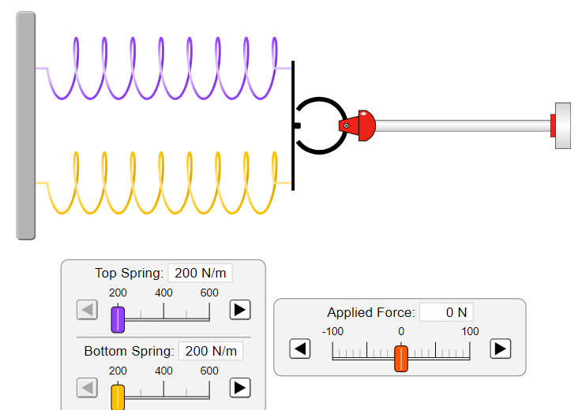
- On the second part, “Systems,” the controls were played with
- The simulation was set for the two springs connected side by side, and the force constant for spring one to 280 N/m and the spring constant to the second spring to 420 N/m.
- A prediction was made and the same procedure for part 1 was done with 6 different measurements of force.
- The combined spring constant was determined and it was graphed.
Procedure part 11: Multiple spring systems in series
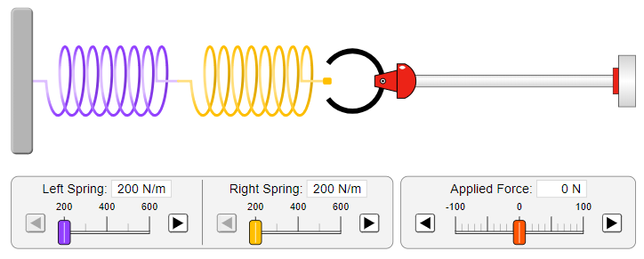
- On the second part, “Systems,” the controls were played with and the springs were connected I series.
- The simulation was set for the two springs connected side by side, and the force constant for spring one to 280 N/m and the spring constant to the second spring to 420 N/m.
- A prediction was made and the same procedure for part 1 was done with 6 different measurements of force.
- The combined spring constant was determined and it was graphed.
Results and Analysis
Part 1
Applied force (N) | Displacement (m)
10 | 0.033
20 | 0.067
30 | 0.100
40 | 0.133
50 | 0.167
60 | 0.200
The graph of force versus the displacement was plotted as shown below.

The graph was a straight-line graph and the slope of the graph was determined using the coordinates: (30, 0.1) and (60, 0.2).
Using the formula: $slope=\frac{change in y-axis}{change in x-axis}$
= (60-30)/ (0.2-0.1)
= 300 N/m
The slope and the spring constant are related in that they give the same result.
Part 11, springs in parallel
For the prediction, combined springs in parallel with spring 1 having 280 N/m and spring 2 with 420 N/m constants. When constant force is exerted on the two springs, the springs will be extended at the same amount. This is because the force applied to stretch the spring was directly proportional to the displacement of the extended spring. The equivalent spring constant k, will be; $k=k1+k2$
Therefore, k = 280+420
=700 N/m
The predicted spring constant is 700 N/m.
Applied force (N) | Displacement (m)
10 | 0.014
20 | 0.029
30 | 0.043
40 | 0.057
50 | 0.071
60 | 0.086

The graph was a straight line graph with the gradient determined as shown below:
Using the coordinates (60, 0.086) and (20, 0.029), we can find the slope using the formula:
$$slope=\frac{change in y-axis}{change in x-axis}$$
= (60 - 20) / (0.086 – 0.029)
= 701.75
The slope was found to be 701.75 which is equivalent to the combined spring constant 701.75 N/m. it deviated from the predicted value 700 N/m which was the predicted value. Hence, it was an effective way of determining combined spring constant of two parallel springs.
Part 11, springs in series
For the prediction, combined springs in series with spring 1 having 280 N/m and spring 2 with 420 N/m constants. The constant force will be applied to spring 2 and so the springs will be extended and the total extension will be the sum of displacement. Therefore, to find the spring constant k, we will use the formula: $k=(\frac{1}{k1}+\frac{1}{k2})$
K = 1/420 + 1/280
= 0.006ˉ¹ N/m
= 168 N/m
Applied force (N) | Displacement (m)
10 | 0.060
20 | 0.119
30 | 0.179
40 | 0.238
50 | 0.298
60 | 0.357

The graph was a straight-line graph with the gradient determined as shown below:
Using the coordinates (60, 0.357) and (30, 0.179), we can find the slope using the formula:
$$slope=\frac{change in y-axis}{change in x-axis}$$
= (60 - 30)/ (0.357 – 0.179)
= 168.5
Therefore, the experimented spring constant is 168.5N/m which is similar to the predicted spring constant. This has proved the Hooke’s law. This clearly indicated the proportionality between the applied force and extension, they are directly proportional.
Conclusion
In conclusion, the spring constants gave the same outcome since from the Hooke’s law, the force applied on a material is directly proportional to the extension. Therefore, in the first part the spring constant was found to be 300 N/m. Besides, when the springs were combined in parallel and in series, the spring constants were different (Surynt, 2018). When connected in parallel, the spring constant was high than when connected in series as shown in the experiment. Hence, the experiment was successful and the stated objectives were met.

Reference
Gati, E., Garst, M., Manna, R., Tutsch, U., Wolf, B., & Bartosch, L. et al. (2016). Breakdown of Hookes law of elasticity at the Mott critical endpoint in an organic conductor. Science Advances, 2(12).
Surynt, M. (2018). Hooke’s Law Experiment. Retrieved from https://msstud2014.wordpress.com/2014/11/14/hookes-law-experiment/

