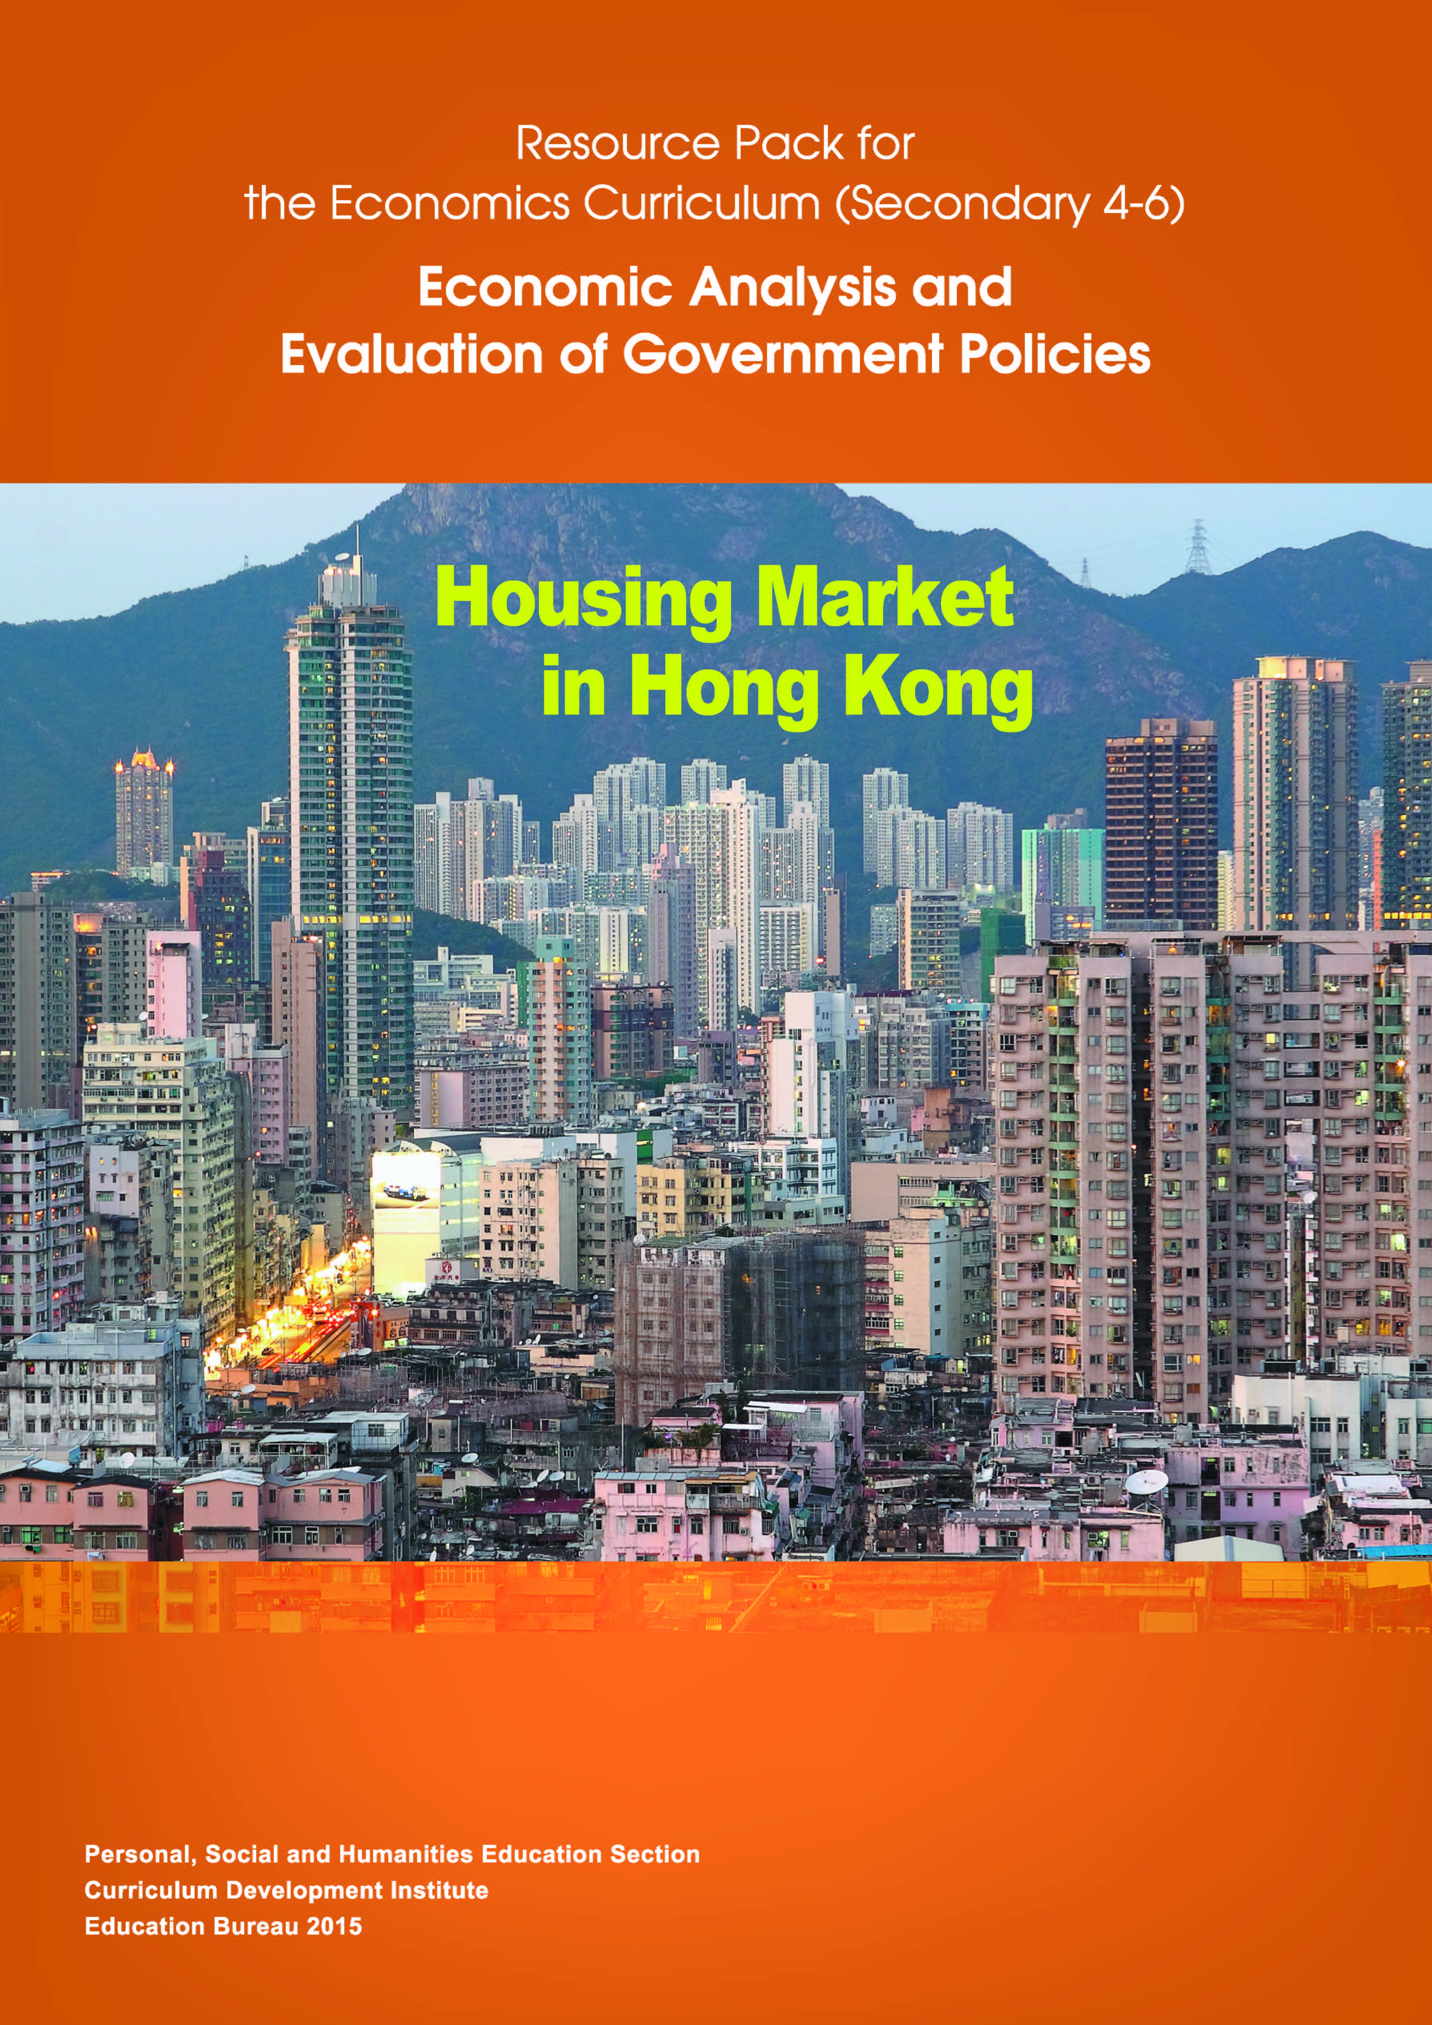

Contents
1. Introduction 1
2. Housing Market and Macroeconomic Performances 2
2.1. Wealth Effect 2
2.2. Effects of Property Price Fluctuations on Macroeconomic Performances through Financial Market 3
2.3. Bank Balance Sheet Effect 5
2.4. Government Financial Position 7
2.5. Inflation 8
2.6. Relationship between Housing Price, Rent and Inflation 10
3. Economic Characteristics of Housing Market 11
3.1. Real Estate Cycle 11
3.2. Real Estate Cycle Characteristics 12
3.3. Imperfect Information 13
3.4. Highly Regulated by the Government 13
4. Microeconomics: Demand and Supply 14
4.1. Factors Affecting Housing Demand 15
4.2. Factors Affecting Housing Supply 19
5. Relevant Data on Housing Market in Hong Kong 21
5.1. Housing Price 21
5.2. Housing Supply 24
5.3. Household income and distribution of types of housing 30
5.4. Summary 34
6. History of Housing Market in Hong Kong 35
6.1. Before the Handover in 1997 35
6.2. After the Handover 36
7. Economic Model of Housing 38
7.1. Overview of Housing Market 38
7.2. Private Primary Flats Markets 41
7.3. Private Secondary Flat Market 42
7.4. Public Flats Market—Home Ownership Scheme 44
7.5. Public Rental Housing Market 45
7.6. Private Rental Flat Markets 47
7.7. Private High Quality Flats Rental Markets 48
7.8. Private Middle Quality Flats Rental Market 49
7.9. Private Subdivided Units Rental Market 50
7.10.Summary 51
8. Policy Analysis and Evaluation 52
8.1. Policy Under Consideration: An Increase in Land Supply in Private Market 52
8.2. Policy Under Consideration: An Increase in Land Supply in Public Market 60
8.3. Summary: Effects of Land Supply Policy 64
8.4. Policy Evaluation Questions 64
9. Policy Conclusion 66
10. Discussion Questions 68
Suggested Answers 79
11. References 90

Introduction
Over the last few years, prices and rents of the housing estates have been rising continuously, different stakeholders from Hong Kong have voiced their opinions. Although there are diverse thoughts on the prices, different parties all agree with the fact that the present housing prices have been too high. The HKSAR Government has also acknowledged this problem. It has stated in the Policy Address 2013 that “Many families have to move into smaller or older flats, or even factory buildings. Tens of thousands of Hong Kong citizens have no choice but to opt for caged homes, cubical apartments and sub-divided flats.”
We will hereby conduct an analysis in the following steps. First, we have to explore the housing market in recent years, its economic characteristics, as well as its relationship with the macroeconomic conditions. Second, we will move on to review a handful of important housing policies in the past decades. Third, we will analyse and evaluate two policies available to the HKSAR Government in adjusting the supply of domestic housing market. We conclude that for the sake of increasing land resources for housing development via releasing land for private developers, HOS (House Ownership Scheme) or PRH units will result in different economic and welfare consequences.

Housing Market and Macroeconomic Performances
The housing market influences Hong Kong’s economy through a number of channels. In particular, we will explore the relationships between the housing market and consumers, banks, government as well as the general price level.

Wealth Effect
- Increasing housing prices will create a positive wealth effect. It leads to a higher amount of consumption by consumers. Since properties are parts of personal wealth, an increase in the property price will add to the wealth of property owners. Property owners can then spend more on non-housing items when they realize that their net wealth is increased. Hence, such wealth effects due to the increase in property value will positively influence the consumption expenditure of the aggregate demand.

Effects of Property Price Fluctuations on Macroeconomic Performances through Financial Market
- Financial institutions provide loans to property owners through different refinancing schemes. Property owners can spend money through refinancing schemes when the property price is rising. Hence, it has a positive impact on the consumption component in its aggregate demand.
- In the monthly residential mortgage survey published by the Hong Kong Monetary Authority (HKMA), we notice that the market of refinancing is specially active when the housing market is performing well. In Table 2-1, between 2007 and 2012, the loans of refinancing makes up the biggest share in new loans approved during the month at around 20%.
- Residential property market was the most active in 2010. Meanwhile, the value of refinancing reached the highest level in the same year.

Table 2-1 The Values of New Loans Approved and Refinancing During the Year and the Total Consideration of Residential Property Market from 2007 to 2012 (HKD Million)
Year | Value of New Loans Approved | Value of Refinancing | The Percentage of Refinancing on Mortgage (%) (new loans approved during the year) | Total Consideration of Residential Market
2007 | 213,884 | 34,669 | 16.2 | 434,031
2008 | 224,287 | 36,643 | 16.3 | 343,825
2009 | 302,042 | 42,880 | 14.2 | 425,838
2010 | 413,863 | 86,144 | 20.8 | 560,686
2011 | 270,300 | 49,607 | 18.4 | 442,523
2012 | 256,890 | 30,256 | 11.8 | 452,276
Source: Residential Mortgage Survey, Hong Kong Monetary Authority, The Land Registry

Bank Balance Sheet Effect
- To maximise the amount of loans a borrower can acquire from the bank, many small to medium size enterprises use their commercial or personal properties as securities or collateral. Banks rely on securities to reduce the risk of money lending because the borrowers often have better information about their ability to repay their loans (i.e. the problem of asymmetric information exists). Higher valuation of the secured properties has two effects. First, it increases the amount of loans that the enterprises can acquire. Second, it raises the bank’s ability to lend. In turn, the enterprises can use the borrowed money for investment. This will bring about a positive effect on the component of investment in the aggregate demand.
- Table 2-2 shows that there are four banks in Hong Kong with close to 70% of loans which are secured.
Table 2-2 Percentage of Secured Advances in Advances to Customers
by Industry Sectors for Selected Hong Kong’s Banks in 2012
Bank | % of Secured Advances in Industrial, Commercial and Financial | % of Secured Advances in Individuals Loans | % of Secured Advances in Total Loans for Use in Hong Kong
The Bank of East Asia | 72.3 | 83.1 | 75.8
Hang Seng Bank | 67.1 | 82.2 | 74.0
Bank of China (Hong Kong) | 50.3 | 91.7 | 69.9
HSBC | 52.2 | 83.0 | 66.6
Source: 2012 annual reports of The Bank of East Asia, Hang Seng Bank, Bank of China (Hong Kong) and HSBC
- In Table 2-3, according to the statistics provided by HKMA, the share of the “Loans and advances for the purchase of other residential properties” is around 23% to 26% of the total loan approvals. Since securities acquired by banks are listed in their balance sheets, a bank’s financial position is directly linked to the secured properties. Hence, any fluctuations in the property prices may destabilize the financial market in Hong Kong.
Table 2-3 Percentage Share of Loans and Advances for the Purchase of Other Residential Properties in Total Loans and Advances by Authorised Institutions in Hong Kong from 2007 to 2012 (HKD Million)
Year | Loans and Advances for Use in Hong Kong | Loans and Advances for the Purchase of Other Residential Properties | Percentage Share of Loans and Advances for the Purchase of Other Residential Properties (%)
2007 | 2,274,284 | 564,127 | 24.8
2008 | 2,524,085 | 592,980 | 23.5
2009 | 2,471,402 | 646,056 | 26.2
2010 | 2,988,375 | 745,169 | 24.1
2011 | 3,360,874 | 804,625 | 23.9
2012 | 3,597,996 | 872,589 | 24.3
Source: Hong Kong Monetary Authority

Government Financial Position
- The financial position of a government depends heavily on her income and expenditure. The government can also influence the economy by changing the pattern of its expenditure and taxation policies. For example, when the economy is slowing down, the government can increase its expenditure or relieve taxpayers’ burden to stimulate the economy.
- According to the Basic Law “Chapter V: Economy” Article 107, “The Hong Kong Special Administrative Region shall follow the principle of keeping the expenditure within the limits of revenues in drawing up its budget, and strive to achieve a fiscal balance, avoid deficits and keep the budget commensurate with the growth rate of its gross domestic product.”
- In the financial year of 2011/2012, the HKSAR Government’s revenue generated from the land premium and property stamp duty were 62 billion and 15.4 billion. The two figures accounted for 16.5% and 4.1% of the total annual income respectively. Similarly, the HKSAR Government had revenue from land premium and property stamp duty in the financial year of 2012/2013 too. 62 billion and 15.4 billion, which amounted 15.4% and 3.8% to the total annual income respectively, were generated. Therefore, the financial position of the HKSAR Government is strongly related to the sale of land and the condition of property market.
- According to the information above, it is not hard to see that when the housing market is doing well, the relevant HKSAR Government revenues will be higher, allowing the HKSAR Government to spend more on aspects that may stimulate the aggregate demand of the macro economy.

Inflation
- Change in Aggregate Demand
- From the discussion earlier, an increase in property price can lead to a higher private consumption, investment and government expenditure through the positive wealth effect, bank balance sheet effect and stronger government financial position. All these items will boost the aggregate demand of the economy, resulting in a higher quantity demanded for good and services and a higher overall price level (i.e. inflation).

Figure 2-1 The Effect of an Increase in Aggregated Demand on
General Price Level and Real GDP
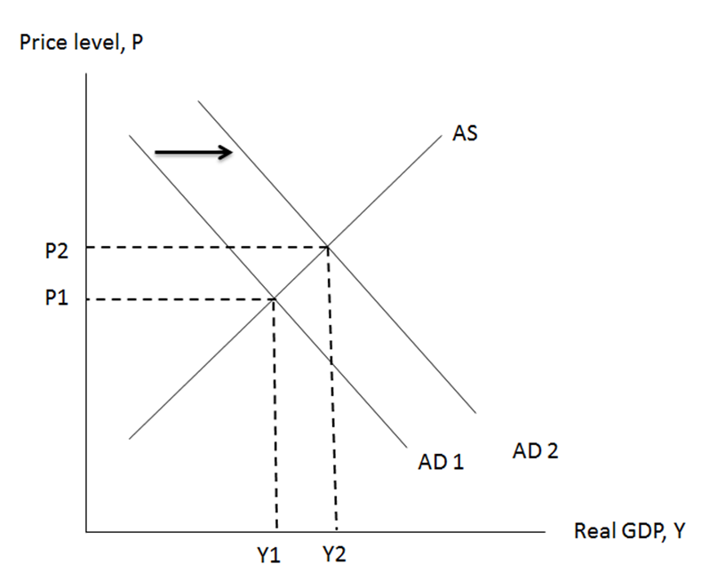

- Change in Aggregate Supply
- If the property prices increase continuously, the general public will revise their expectations on inflation and ask for higher salaries so as to cover the increased cost of living. Assuming that the AD curve remains unchanged, the aggregate supply curve (AS) will shift to the left, which results in inflation (Williamson 2002).

Figure 2-2 The Effect of a decrease in Aggregated Supply on
General Price Level and Real GDP
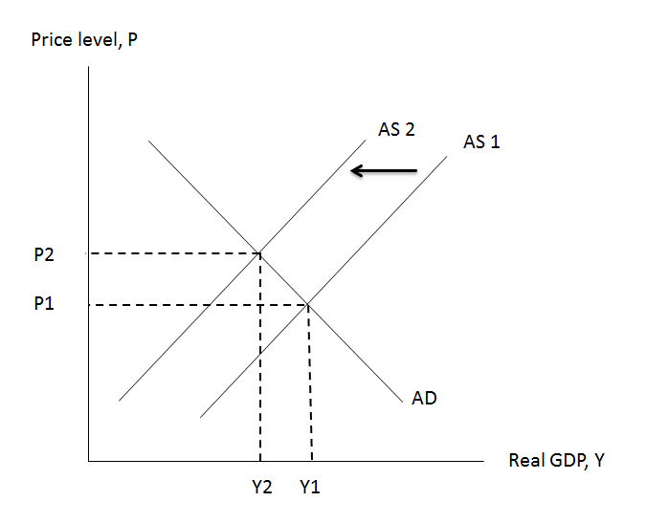

Relationship between Housing Price, Rent and Inflation
- Investors may invest in real estates and other products, such as stocks. Rental incomes from the investment in housing should be comparable to the returns of other investment vehicles after adjusting for the differences in investment risks.
- Suppose property price increases but rent remains unchanged, rental yield will become lower when compared to other investment returns. Hence, investors will raise the rent in order to maintain the value of housing investments.
- Tenants will have to accept a higher rental payment because they may not be able to find other alternatives for accommodation in the near term (Wang, Zhang and Dai 2013).
- Since the Hong Kong Consumer Price Index includes consumption on housing in the formula of calculation, inflation rate increases when rent increases.
Table 2-4 Share of “Housing” in Hong Kong Consumer Price Index in 2012
Types of Consumer Price Index | Share of “Housing” in percentage (%)
Composite | 31.7
Type A | 32.2
Type B | 31.4
Type C | 31.4
Source: Hong Kong Census and Statistics Department, Annual Report on the Consumer Price Index 2012

Economic Characteristics of Housing Market
Real estate is different from other goods and services in many aspects. In particular, it takes time for the property developers to build houses and flats. And thus, the market cycle of real estate and the economic cycle often do not synchronise. Additionally, since every housing unit is uniquely located in different areas, the “search cost” in housing market is higher when compared to other markets. Furthermore, developers are generally more informed than the buyers concerning the whole development project. Hence, information available to the buyers in the housing market is limited. HKSAR Government then has to impose regulations in order to protect public interest and welfare.

  - Real Estate Cycle
- In Figure 3-1, when the scale of economy is expanding, household income increases, which in turn leads to an increase in their housing demand. However, since property stocks might not be able to catch up with the newly added demand, the property price will increase in a short run. To respond to the increased demand, property developers will increase their construction of new houses. Yet, construction of properties takes time and the current expanding economy will eventually reach another recession. Hence, even though the market is going to have an abundant supply of properties, there will not be enough demand for housing when recession arrives. As a result, a surplus in housing will be resulted, making the property prices fall eventually.

Figure 3-1 Business Cycle and Real Estate Cycle
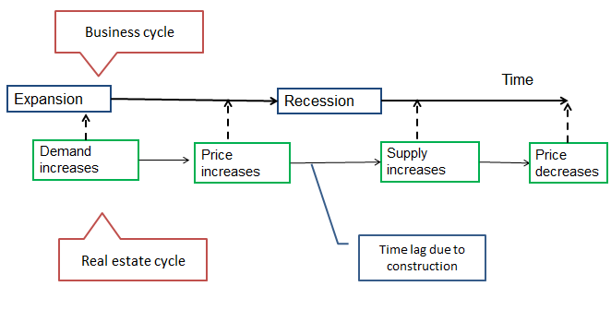
  - Real Estate Cycle Characteristics
- The increase in housing supply takes a long period of time to realize while the stock also has a very slow depreciation rate.
- Changes of demand are faster than changes in supply.
- Real estate cycle and business cycle are desynchronised as a result of the supply time lag.

  - Imperfect Information
- Each flat or housing estate is heterogeneous: They are built in different landscapes and uniquely located, which increases the information cost from the buyer’s prospective. Potential buyers of real estate have to spend more time evaluating a house. Agencies thus research on housing for pairing up buyers and sellers. This helps reduce the transaction costs, raising buyers’ incentives in trading.
  - Highly Regulated by the Government
- In the housing market, property owners or developers are often better informed than property buyers. This phenomenon is so called information asymmetry. To protect public interest, the HKSAR Government has imposed a number of regulations.
- “Town Planning Ordinance” requires developers to submit application to the committees for permission in building, which is to consider the external effects of their development projects. One example would be “Walled Building” which may create problems in air circulation in the real estates nearby, by altering the original landscape. The HKSAR Government has imposed tougher regulations in tackling the “Walled Building”, which in some way has limited the developers from supplying more houses.
- Developers had been providing sales information for buyers that might misinform the flats’ saleable area, price, facilities and other essential information in recent years. The HKSAR Government has implemented the “Residential Properties (First-hand Sales) Ordinance” to ensure the context of the sales brochure is correctly presented and thus buyers can be fully protected.

Microeconomics: Demand and Supply
Information about housing market is asymmetrical among buyers and sellers, hence making the market an imperfect one. Despite so, a standard demand and supply model assumes a perfect market. In the following sections, we will use the standard supply and demand model to explore variables that are influencing the property price.
Figure 4-1 Demand and Supply Curves
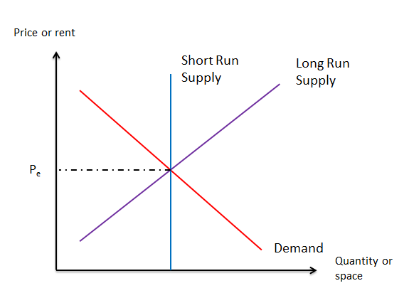
- In the housing market, quantity demanded will fall as price increases. Therefore, the demand curve slopes downwards.
- In a short run, it is difficult for developers to increase the supply of real estate. The current supply of housing depends on the existing stock of that in the market. Short run supply curve appears to be inelastic.
- In a long run, developers can increase housing supply in many ways. Therefore, the long-term quantity of properties supplied increases with the price. The supply curve will therefore be upward-sloping.
  - Factors Affecting Housing Demand
- Demography
  - Including: population, sex, age, birth rate and divorce rate (McKenzie, Betts and Jensen 2010)
  - As population increases, household demand for housing also increases.
  - Local statistics reveal that from 1996, the number of Hong Kong single parents has increased from around 42,000, to 81,000 in 2011, which has almost doubled. The effect of this may have contributed to the increase in demand for small housing units.
- Income
  - Normally, housing demand increases with income (McKenzie, Betts and Jensen 2010).
    - When the household income increases, the demand for housing also increases (McKenzie, Betts and Jensen 2010). Residents living in the developing cities nearby will be attracted to migrate to a more developed region, such as Hong Kong. In recent years, the mainland economy has been blooming. As the income of mainland citizens increases, they can choose to migrate by investment in housing or other permitted industries under the “Capital Investment Entrant Scheme”. Also, there are mainland residents purchasing housing properties in Hong Kong purely for investment’s sake, leading to an overall increase in the demand for housing in Hong Kong.
  - Although Hong Kong has experienced a substantial economic growth over the past few decades and the majority of Hong Kong population has become wealthier, a demand for more affordable but often unsafe or poorly conditioned housing remains. Despite the prosperity of Hong Kong housing market since 2009, the supply of subdivided flats is still on a rise.
    - According to the recent governmental study conducted by Policy 21 titled “Survey of Subdivided Units in Hong Kong” in June 2013 , it was estimated that there were around 66,900 households living in Sub-divided Units (SDU). It was also estimated that there were 171,300 persons living in SDU, accounting for 2.4% of the total population in Hong Kong.
    - In 2011, Hong Kong’s Gini Coefficient has risen from 0.525 to 0.537 over ten years, even though income of the lowest earning groups has increased. Hence, the widening income disparity may contribute to the increasing demand of SDU.

    - A research by Caritas Youth and Community Service shows that most of the residents of subdivided units are from the grassroots level as they are still queuing up for public housing. Due to various reasons, subdivided flats are their only affordable choices.
- Finance
  - Since most property buyers have to rely on external sources of money other than their own income, the availability of financing in the market can affect the buyers’ demand for housing (McKenzie, Betts and Jensen 2010).
  - Credit availability (Loan-to-value ratio,): HKMA would control the loan-to-value ratio to manage the risk that the banks are facing. So if the loan-to-value ratio decreases, potential buyers will find it difficult to finance housing purchases.
  - Interest rate (Prime rate,): Interest payment is a part of the mortgage repayment and the amount depends on the level of interest rate. A contractionary monetary policy will increase interest rate, and thereby mortgage payers will have to bear a larger amount of interest payment, possibly lowering their demand for property.

- HKSAR Government Regulations
  - The HKSAR Government is responsible for introducing a clear, fair and transparent platform for transactions of residential properties.
  - The HKSAR Government can also restrict or relax the housing market conditions in accordance to the market conditions by imposing different regulations.
  - The HKSAR Government has imposed a Special Stamp Duty on housing property investors. As the cost of investment increases, the demand for properties from investors decreases.

Table 4-1 Timetable of HKSAR Government Imposing or Increasing the Stamp Duty
Date | Ad Valorem Stamp Duty | Special Stamp Duty | Buyer’s Stamp Duty
1 April 2010 | Increased from the old rates
20 November 2010 –  26 October 2012 |  | Started to levy (Stage 1)
27 October 2012 |  | Adjusted to Stage 2 | Started to levy
23 February 2013 | Announced for a further adjustment | Adjusted to Stage 2 | Started to levy
Source: GovHK Stamp Duty Rates, Inland Revenue Department: FAQ on Special Stamp Duty and Buyer’s Stamp Duty

  - Factors Affecting Housing Supply
- Supply of Factors of Production
  - Factors of production refer to inputs used in making the final goods and services. These include land, labour, capital (i.e. plant and machine), and such. (McKenzie, Betts and Jensen 2010)
  - As mentioned in the Policy Address 2013, “Hong Kong is hilly and surrounded by water. Land is a scarce resource”. Thus, shortage of available land for development in the long run can raise the price of land, decreasing the housing supply.
- HKSAR Government Legislations and Regulations
  - The HKSAR Government also has responsibility to make the building environment safe and healthy by enforcing or imposing safety, health and environmental standards for buildings.
  - “The Building Ordinance” lays out clearly the standard of quality and construction techniques developers have to follow. To meet the criteria laid out in the relevant regulations, developers are obliged not to cut corners. Hence, as the costs of construction increase, the supply of housing will decrease.
- Policy Risk
  - Real estate construction often takes time. When developers plan to build real estates, they will consider the policies of the HKSAR Government in the near future so as to make adjustments over the volume of real estate construction.
  - For example, Special Stamp Duty is imposed on the selling of a property by residential property owners who have purchased residential properties within 24 months as this act may potentially make the market fluctuate. Developers may delay releasing new residential properties for sale to cause a decrease in supply in the market.
- Price of Factors of Production
  - The price of factors of production will directly affect the quantity supplied by the developers, and the increase or decrease in production cost is reflected on the supply curve shifts.
  - Skilled construction workers are in shortage in Hong Kong. Cheung Kin-chung, Secretary of Labour and Welfare Bureau, had pointed out in the Legislative Council, “At present, the unemployment rate of the construction industry stands at 4.9% and the underemployment rate at 7.4%. The current manpower situation is not as severe as that during the peak period of the Airport Core Programme, with the unemployment rate at 2%. While continual investment in infrastructure as well as public and private housing construction will create more opportunities for the construction industry, it will add further pressure to the manpower situation.” (Official Record or Proceeding on 6/2/2013, LegCo)
  - As a result, developers have to offer higher salaries to attract more construction workers. This will increase the cost of production, lowering the supply of housing units.

Relevant Data on Housing Market in Hong Kong
We now move on to investigate the development of housing market in Hong Kong using local market data.

  - Housing Price
Figure 5-1 Hong Kong Private Domestic Property Price Index by Class from 1990 to 2012 (1990 as base year)
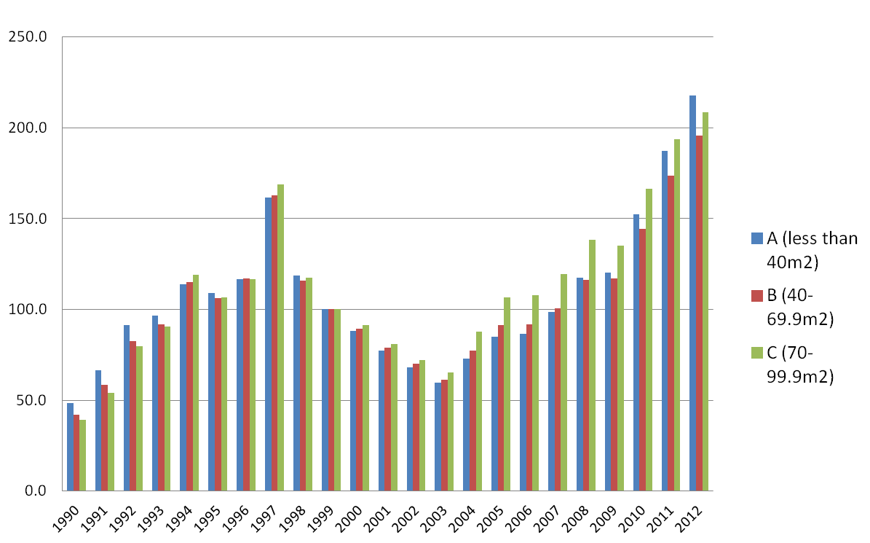
Source: Property Market Statistics, Review Monthly Supplement, Rating and Valuation Department

- According to the data provided by Rating and Valuation Department’s (RVD), local private domestic property price index has significant changes. The three types of housing units of different sizes were at their lowest in 1990, and the peak in 2012. From 2010, the price index of Type A housing units has a higher price index than that of Type C.
Figure 5-2 Hong Kong Private Domestic Property Rental Index by Class from 1990 to 2012 (1999 as base year)
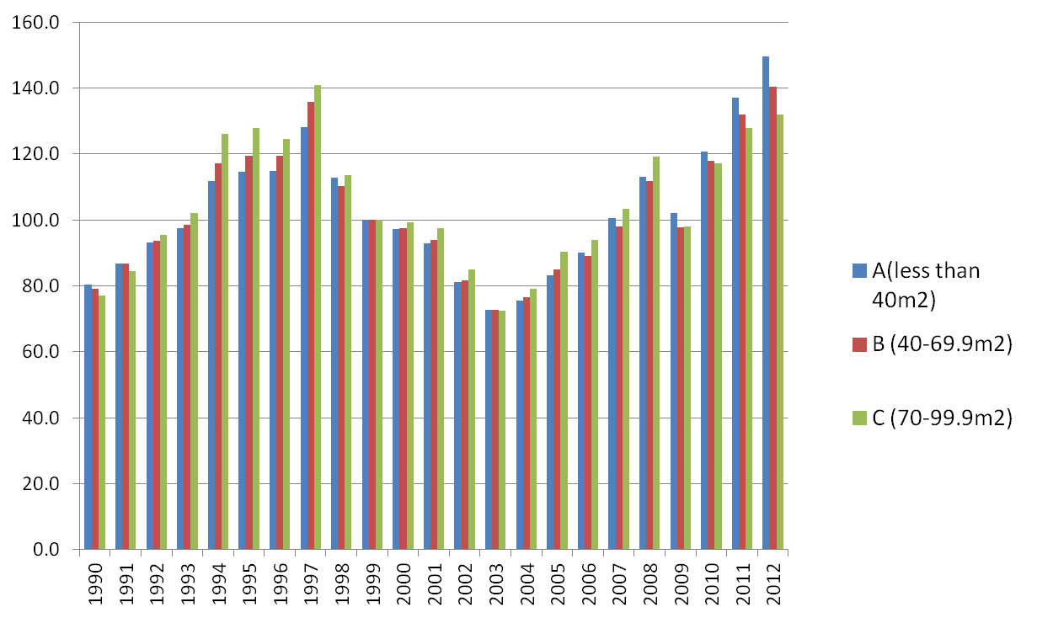
Source: Property Market Statistics, Review Monthly Supplement, Rating and Valuation Department
- As for the rental index, there were also significant changes throughout the period. Type A price index has moved beyond Type C from 2007 onwards. Three types of housing unit price indices were at their lowest in 2004, and their peak in 2012.
Figure 5-3 Hong Kong Private Domestic Property Rental Index by Class and CPI (C) from 1999 to 2012 (1999 as base year)

Source: Property Market Statistics, Review Monthly Supplement, Rating and Valuation Department
- Between 1999 and 2012, the rental index had fallen to the lowest level in 2003, but it then started to keep rising. Particularly between 2009 and 2012, the magnitude was far larger than the increase in CPI(C).

  - Housing Supply
Figure 5-4 Hong Kong Private Domestic Property Stock by Class
from 1985 to 2012
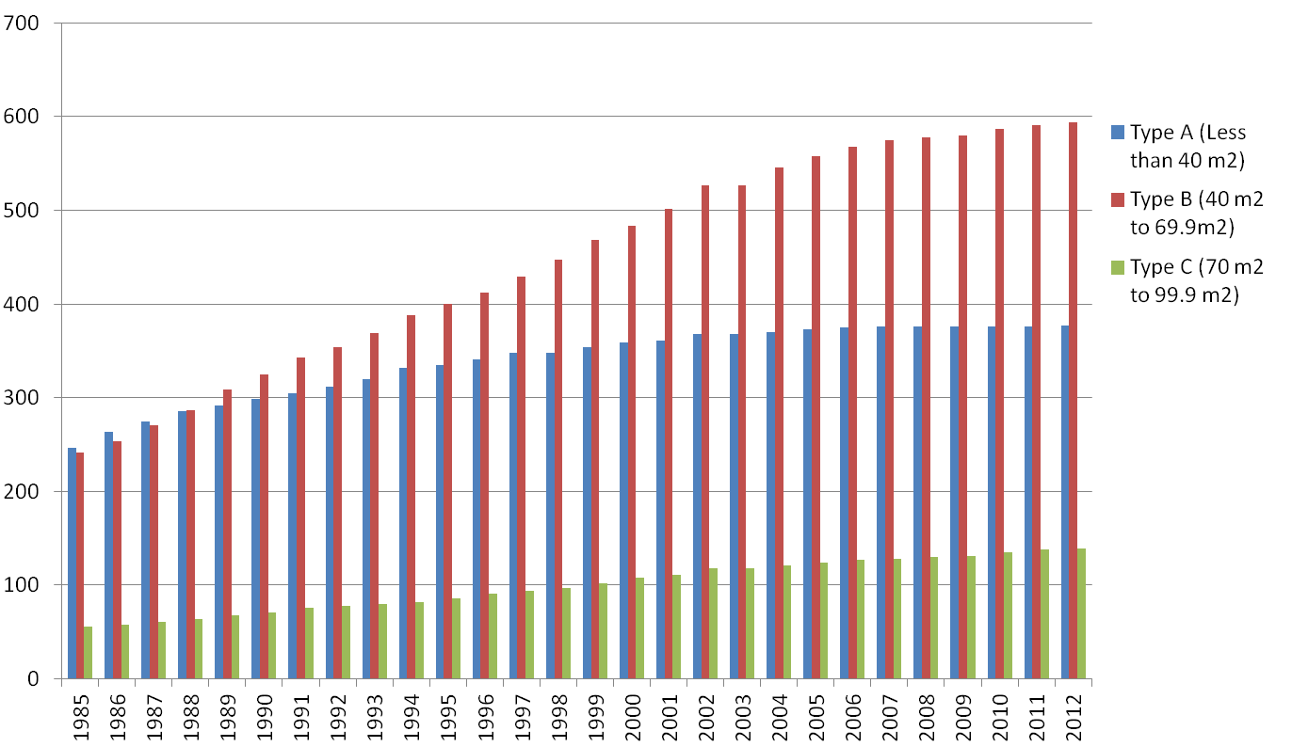
Source: Property Market Statistics, Review Monthly Supplement, Rating and Valuation Department
- From the data of private domestic property stock between 1985 to 2012, Type B housing unit stock has the largest amount of increase, which is followed by Type A. Type C has the smallest amount of increase.

Figure 5-5 Index of Hong Kong Private Domestic Property Stock by Class
from 2003 to 2012 (2003 as base year)
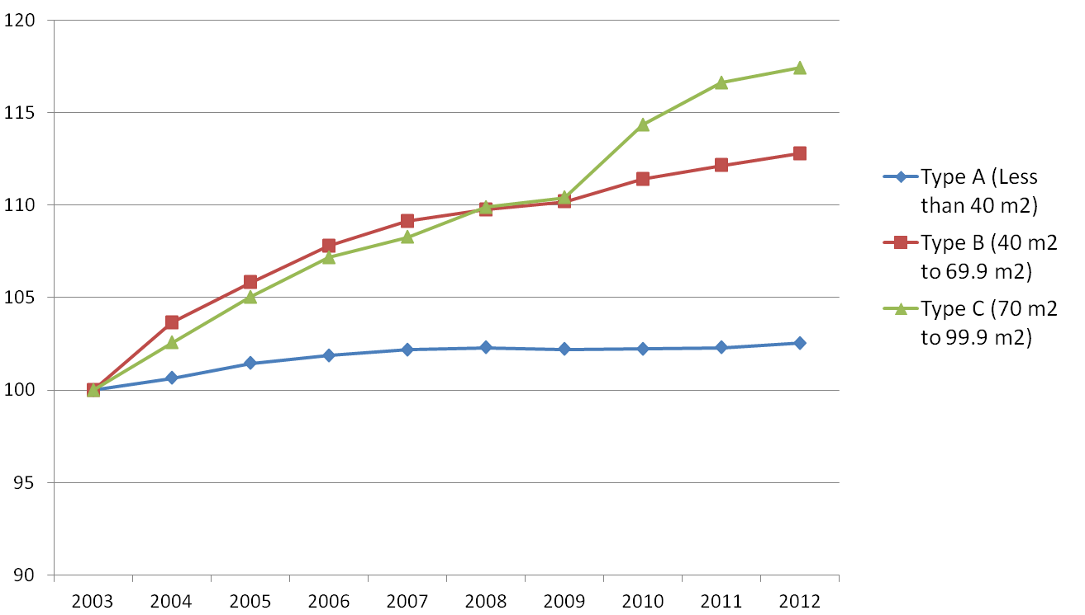
Source: Property Market Statistics, Review Monthly Supplement, Rating and Valuation Department
- However, if we take 2003 as the base year (turning the index into 100 in 2003), another pattern emerges. Compared to our previous observations, Type C housing units had the largest percentage change, which was followed by Type B. The smallest percentage change was of Type A.

Figure 5-6 Cumulative Number of Flats under Home Ownership Scheme
from 1980 to 2002
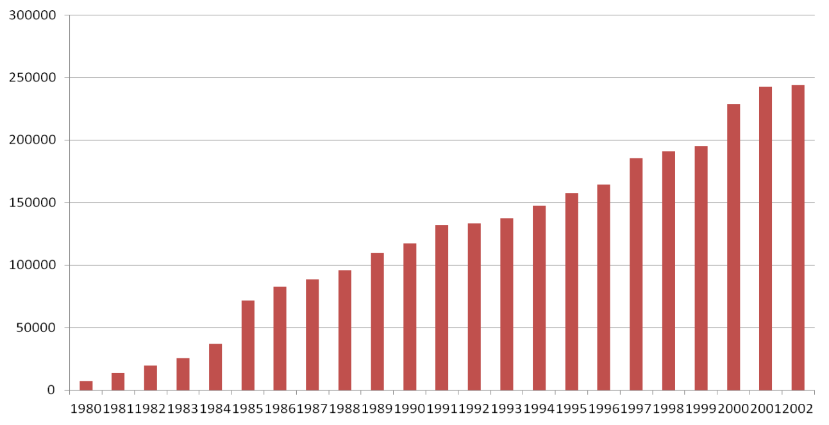
Source: Hong Kong Housing Authority
- According to the Housing Authority, Home Ownership Scheme’s (HOS) annual (use year of completion as standard) cumulative number of sale showed a steady increase from 1980 to 2002.

Figure 5-7 Total Number of Completion of Flats under Home Ownership Scheme from 1980 to 2002
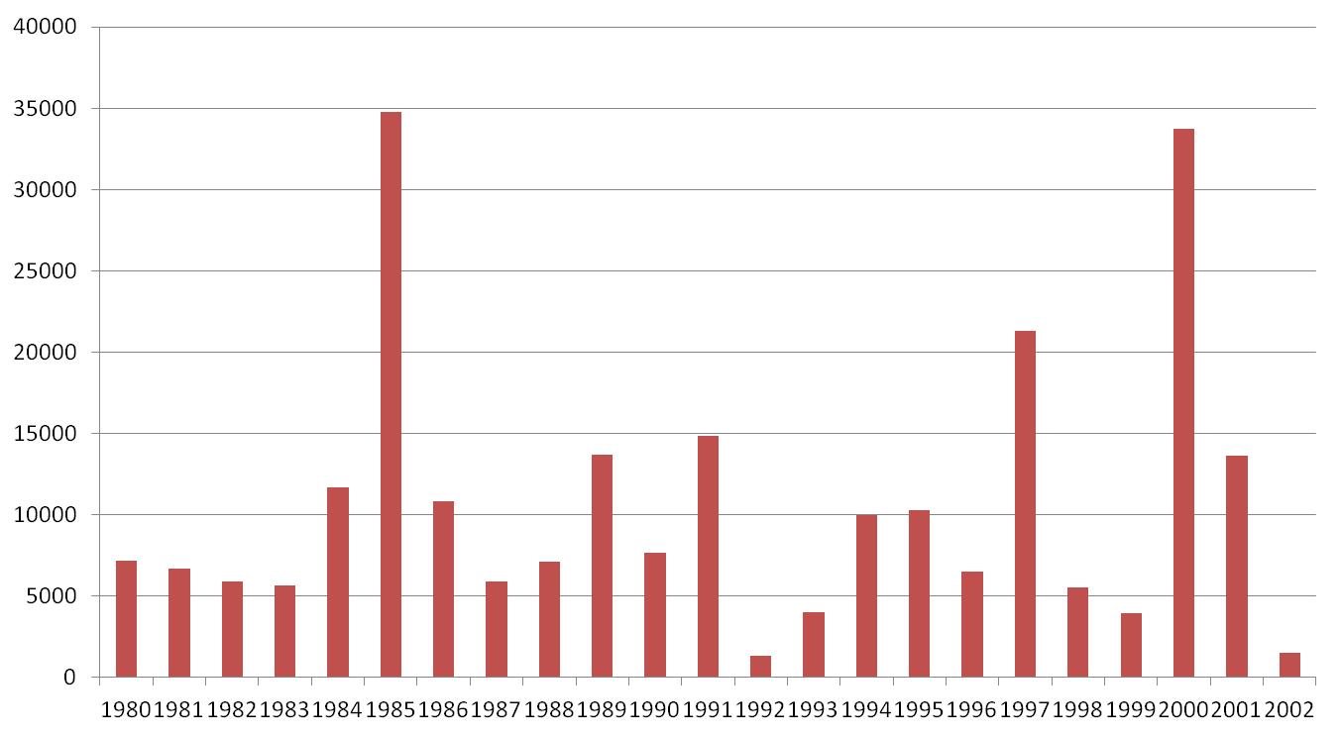
Source: Hong Kong Housing Authority
- If we separate the cumulative numbers of HOS sold with the annual numbers sold, the numbers show a lot of fluctuations.
- From the above diagrams, the number of properties sold under HOS was increasing cumulatively. However, the HKSAR Government did not set a fixed policy for the supply of HOS flats.

Figure 5-8 Stock of Public Rental Flats in 2002, 2007 and 2012
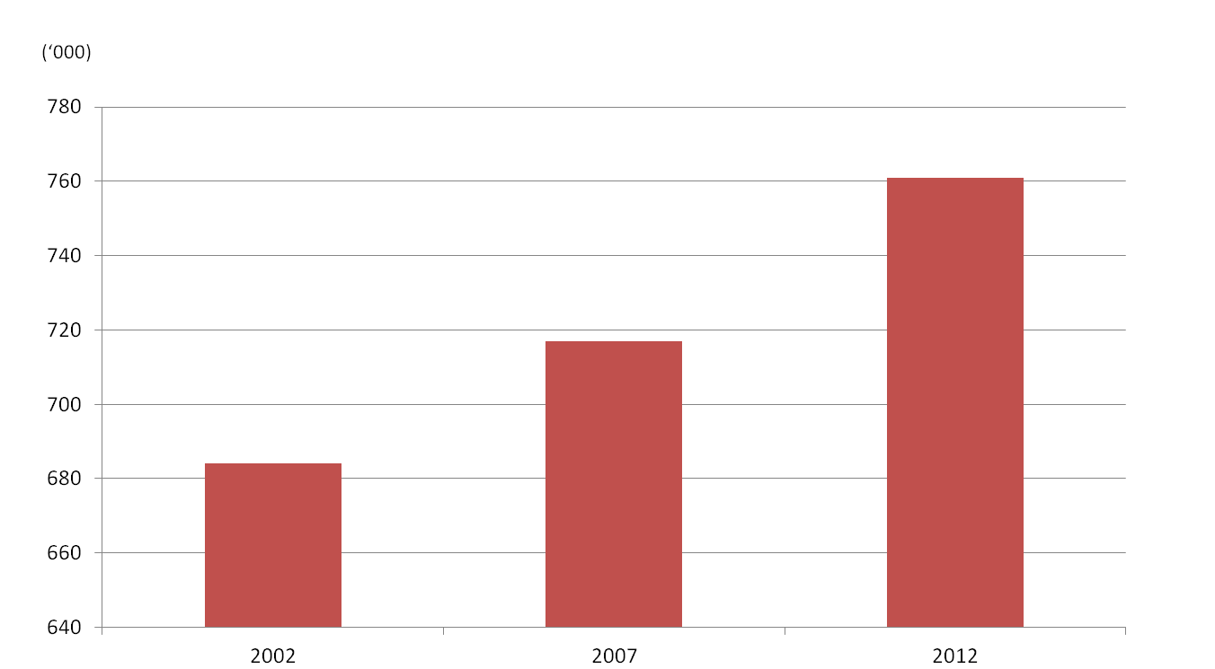
Source: Hong Kong Housing Authority
- From 2002 to 2012, Hong Kong’s public housing stock had been growing continuously, from 680,000 units in 2002 to 760,000 units in 2012.

Figure 5-9 Actual Public Rental Housing Production from FY 2002/03 to 2011/12
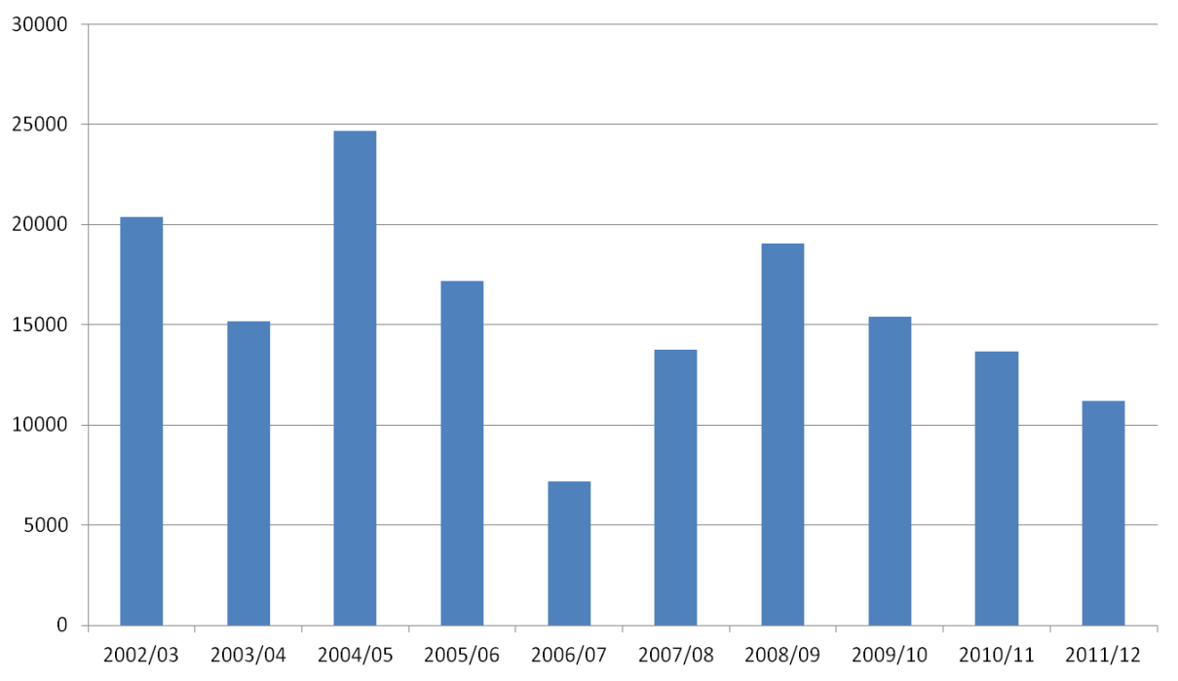
Source: Hong Kong Housing Authority
- However, a very different result emerges by observing the annual stock of completed public housing. Although in year 04/05, there was a large amount of completed housing units which amounted to around 25,000, there was a significant decrease to around 7,000 units in the fiscal year of 06/07. From 07/08 onwards, there was an increase in the stock of public housing, but it decreased again in 09/10. By comparing the figures above, the completion of public housing stock has fluctuated much, as the HKSAR Government had no fixed policies regarding the supply of PRH units to be completed in each year.

  - Household income and distribution of types of housing
Table 5-1 Number of Hong Kong Domestic Household by Type of Housing in 2001, 2006 and 2011
Year  Type of Housing | 2001 |  | 2006 |  | 2011
Year  Type of Housing | Number | % | Number | % | Number | %
Public Rental Housing | 627,339 | 30.6 | 690,788 | 31.0 | 720,892 | 30.4
Subsidized Home Ownership Housing | 320,122 | 15.6 | 362,439 | 16.3 | 377,615 | 15.9
Private Permanent Housing | 1,071,881 | 52.2 | 1,149,952 | 51.6 | 1,242,982 | 52.5
Others | 34,070 | 1.6 | 23,367 | 1.0 | 27,307 | 1.2
Total | 2,053,412 | 100.0 | 2,226,546 | 100.0 | 2,368,796 | 100.0
Source: HK Census and Statistics Department, 2011 Population Census

- According to 2011 Population Census conducted by HKCSD, around 30.4% of domestic household lives in public housing units, around 15.9% lives in Subsidized Home Ownership Housing units, and 52.5% lives in private permanent housing units. The composition has not changed much when we compare censuses in 2001 and 2006.
Figure 5-10 Distribution of Hong Kong Domestic Households
by Tenure of Accommodation in 2011

Source: HK Census and Statistics Department, 2011 Population Census

- Figure 5-10 depicts the distribution of Hong Kong domestic household by tenure of accommodation, based on figures of “Domestic Households by Tenure of Accommodation” in 2011 census. Around 36.14% of household were the living in private housing units (occupier owner), whereas 16.3% were living in rented private permanent housing. At the same time period, 15.9% of households were living in Home Ownership Scheme (HOS) flats, while 30.4% of the household were living in public housing unit (renting).

Table 5-2 Median Monthly Domestic Household Rent and Median Rent to Income Ratios in Hong Kong by Type of Quarters in 2001, 2006 and 2011
Year  Type  of housing | Median Monthly Domestic Household Rent (HKD) |  |  | Median Household Income (HKD) |  |  | Median Rent to Income Ratio (%)
Year  Type  of housing | 2001 | 2006 | 2011 | 2001 | 2006 | 2011 | 2001 | 2006 | 2011
Public Rental Housing Units | 1,300 | 1,390 | 1,210 | 12,500 | 10,296 | 11,415 | 10.4 | 13.5 | 10.6
Private Permanent Housing | 5,300 | 5,100 | 7,500 | 19,413 | 20,238 | 29,182 | 27.3 | 25.2 | 25.7
Source: HK Census and Statistics Department, 2011 Population Census

- The median monthly domestic household income levels in 2001, 2006 and 2011 showed significant changes. Residents of public rental housing have lower household income than the residents of private housing. Growth of income has stagnated over the past ten years. The income of residents in public estates, if compared to 2001, has actually decreased. Meanwhile, the income of residents of private housing units has increased consistently.

- Although the income of private housing households was two times higher than that of the public housing households, the rent for private housing was significantly higher. If we refer to the median monthly domestic household rent for discussion, the private housing rent had increased from $5,300 in 2001 to $7,500 in 2011. Yet, the public housing rent had decreased from $1,300 in 2001 to $1,200 in 2011.
- Median Rent to Income Ratio can reflect the relatively bigger burden of expenses towards private housing households. Throughout the last ten years of censuses conducted, private housing households had a ratio ranging from 25% to 27%. Public housing households’ ratio, however, had been fluctuating between 10% and 13%

  - Summary
            - According to the Composite Consumer Price Index, there has been a very significant increase in the expenses of housing in recent years. Households with the slowest income growth (e.g. tier one Working Population Income) has to cut down other expenses in order to balance out the rising cost of housing, which may affect their quality of living.
            - The slow increase in housing supply causes the housing supply to fall far behind from the already-steadily increasing housing demand. Among the private housing properties, Type C’s (i.e. the relatively larger sized housing units) supply has the largest increase, but the general public finds them hardly affordable.
            - The change of Hong Kong’s demography may also change the demand for housing.
            - An increase in average income has also strengthened the public’s willingness to pay for housing, which in turn stimulates the demand for the real estate market.
            - In recent years, the demand for sub-divided flats from grassroots families has been increasing. There are at least two key reasons behind this phenomenon: First, it shows that the real income growth may not be able to catch up with the growth of housing price. Second, it slows that public housing and those relatively cheaper flats are in shortage. Lower income groups have no choice but to live in the more affordable, yet ill-conditioned sub-divided flats.

History of Housing Market in Hong Kong
The landscape of housing in Hong Kong has experienced phases of changes. The following table introduces the history of the Hong Kong housing market and relevant housing policies briefly.

  - Before the Handover in 1997
Year | Historical Events | Policies/ Policies aims
1950s-1960s | - Large influx of refugees  - Poor hill side shelter  - On the 25th of December 1953, a major fire destroyed the Shek Kip Mei squatter areas | - Emergence public shelters  - Provisional Resettlement units  - Emergency Housing  - Basic Living environment,  PRH by HK Government
1970s – 80s | - As Hong Kong’s economy blooms, the public start to demand for permanent and quality housing units | - Ten years housing programme: New towns, House Ownership Scheme (HOS), Private Sector Participation Scheme (PPS)  - Promotion of Home ownership  - Freezing out the numbers of squatters through a HK Government conducted registry scheme, squatters are only allowed before the land it built on is required for public purposes.
Source: Hong Kong Housing Authority, City University of Hong Kong: Hong Kong Housing Homepage, Consultation Document on Long Term Housing Strategy

  - After the Handover
Year | Historical Events | Policies/ Policies aims
1990s- 2000s | (1997)  - Limited supply of land and housing units could not catch up with the growing demand due to various demographic factors, especially migration.  - Expectation of housing is also rising with growing prosperity. | - From the financial year of 1999 to 2000, HKSAR Government set target of 85,000 flats per year (50,000 public flats and 35,000 private flats).
1990s- 2000s | (After 1997)  - Asian Financial Crisis, bursting of housing market bubble. | Some of Mr Suen Ming Yeung’s polices during that time (孫九招) :  - Regular land auctions and the Application List System were stopped and suspended until the end of 2003. New supply of land would be applied by real estate developers from the Application List.  - Suspension of sale of HOS and PSPS .
Source: Hong Kong Housing Authority, City University of Hong Kong: Hong Kong Housing Homepage, Consultation Document on Long Term Housing Strategy

(Continue with the table)
Year | Historical events | Policies
2010 – present | - Shortages of land supply and housing units have resulted in high housing price. This makes housing more unaffordable than ever. | - The HKSAR Government has increased ad valorem stamp duty as well as levied special and buyer’s stamp duty due to high prices of housing.  - Target of 470,000 flats in ten years (The ratio of public housing to private housing as 60:40).  - Increasing the land supply by exploring opportunity to develop lands in N.T.
Source: Hong Kong Housing Authority, City University of Hong Kong: Hong Kong Housing Homepage, Consultation Document on Long Term Housing Strategy

Economic Model of Housing
Let us consider an economic model for the analysis of housing market in Hong Kong. The model attempts to describe the interactions of different layers of markets of flats in the public and private sectors, which can be a rental market or a buy and sell market. Then, we attempt to study the effects of HKSAR Government policies on these markets. To do so, we employed a linear supply and demand model for our exposition.
- It is important to be reminded that a household values a flat according to its consumption and investment values. It therefore follows that the maximum amount of money a household is willing to spend on a flat or to accept to sell a flat depends on:
  - The subjective value of housing services yielded, and
  - The rate of monetary return of the flat (i.e. rents) as an investment asset.
- A key assumption that will be applied for the whole presentation: An individual household who needs a flat demands only ONE unit of flat.

  - Overview of Housing Market
- A salient feature of the housing market in Hong Kong is the unique role of means-tests of income for the eligibility of public housing application.
- The feature explicitly segments the overall housing market into independent, but inter-related, public and private markets.
- For illustration purpose, consider a starting hypothetical point that the selling prices of flats are zero in both the private and public housing markets.
- And there are 2,000 demanders of private flats at price zero. Among them:

Figure 7-1 Components of Demand for Housing Market

- 1,000 demanders have income lower than the threshold to be eligible for application of public home ownership (HOS) flats.
  - Among these 1,000 demanders, 600 have income level eligible for application for public rental housing (PRH), which has a tighter restriction for application than for the HOS flats.
- It is assumed that these demanders will first bid for a new flat in the private market. If the bidding is not successful, then the residual demanders will move to the second-hand private market to search for a flat. And yet, if they are unsuccessful in obtaining a flat in the new and second-hand market, then they will move on to the rental market. There are high and low end rental markets for flats. The near-lowest band of markets will be the subdivided flats market.
- Some of the demanders can opt for public housing. Again, it is assumed that the eligible demanders will first bid for a home ownership flats. If not successful, they will move to the public rental flats. If they are waiting in line, but have not been allocated a public rental flat, then they will seek for a housing option in the private rental market.
- Hence, the residual demanders who are left empty handed from the private sell and buy market and those who are left empty handed from the public market will meet in the private rental market. To satisfy the diversity of residual demand, the rental market has different layers to accommodate these residual demanders for their housing needs at different costs.

Figure 7-2 Overview of Housing Market Analysis
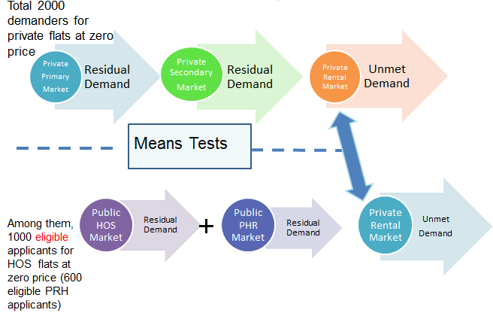

  - Private Primary Flats Markets
- In the private primary flats market, for simplicity, it is assumed that an inelastic supply of flats prevails in the market.
- The demand for private primary flats is mainly determined by the willingness to pay for flats by the individual demanders. The wealthier individuals can afford to bid for a new flat at a higher price.
- Market price is then determined by the force of supply and demand. The resulting unmet demand in this market will move to the private secondary flat market for buying opportunities.

Figure 7-3 Private Primary Flats Market
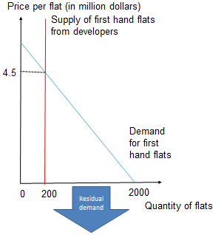

- Demand: Buyers are willing to pay a first-hand flat at different prices
- Supply is fixed at 200
- Under the fixed supply of 200 flats, equilibrium price will be 4.5 million dollars, hence residual demand is 1,800 buyers who cannot buy a first-hand flat.

  - Private Secondary Flat Market
- The supply curve is more elastic, due to the fact that individual sellers of secondary flats have different values for their flats.
- The demand is then made up of the residual demanders from the primary flats, making up a downward sloping demand curve.
- An equilibrium price in the private secondary market is formed based on the force of supply and demand.
- The residual unmet demand should seek opportunities in the rental market.

Figure 7-4 Private Secondary Flats Market
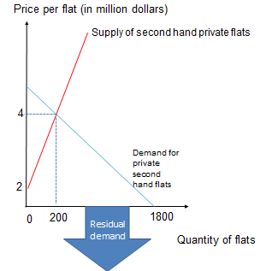
- In this market, the equilibrium price is 4 million dollars, and quantity demanded will be 200 units. 1,600 buyers who fail to buy a private second-hand flat (1,800-200) will move into the private rental market.

  - Public Flats Market—Home Ownership Scheme
- Home Ownership Scheme (HOS) and public flats can only be chosen by residents who pass through the means-tests of income.
- In the public housing market, the Housing Authority is the sole supplier of HOS flats for the people in need who pass the means-tests of income.
- Eligible flats demanders who demand public HOS flats also face an inelastic supply.

Figure 7-5 Public HOS Market
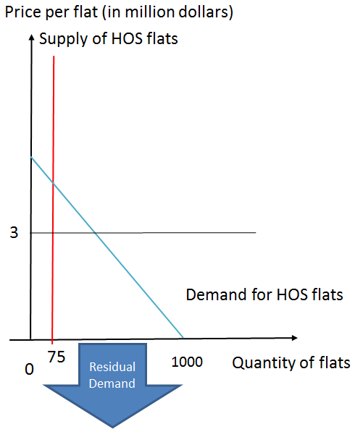

- Since HOS flats are sold at the regulated price, there will be an excess demand for the HOS flats.
- An effective price cap per flat in work, i.e. 3 million dollars as shown in the above figure. A rationing mechanism works by waiting time or random assignment.
- Among 1,000 demanders, only 75 can acquire a HOS unit.

  - Public Rental Housing Market
- Although public rental housing will absorb some of the residual demanders, who fail to obtain HOS flats and yet pass a tighter means-test. Given the heavily subsidized rental rate, there will be an excess demand, resulting in a long waiting list.
- Finally, those who fail to obtain a flat from the public market will eventually seek for private rental flats. But by default, this group of demanders will seek for private rental flats at the lower end, forming the demand for the subdivided accommodation units.

Figure 7-6 Public PRH Market
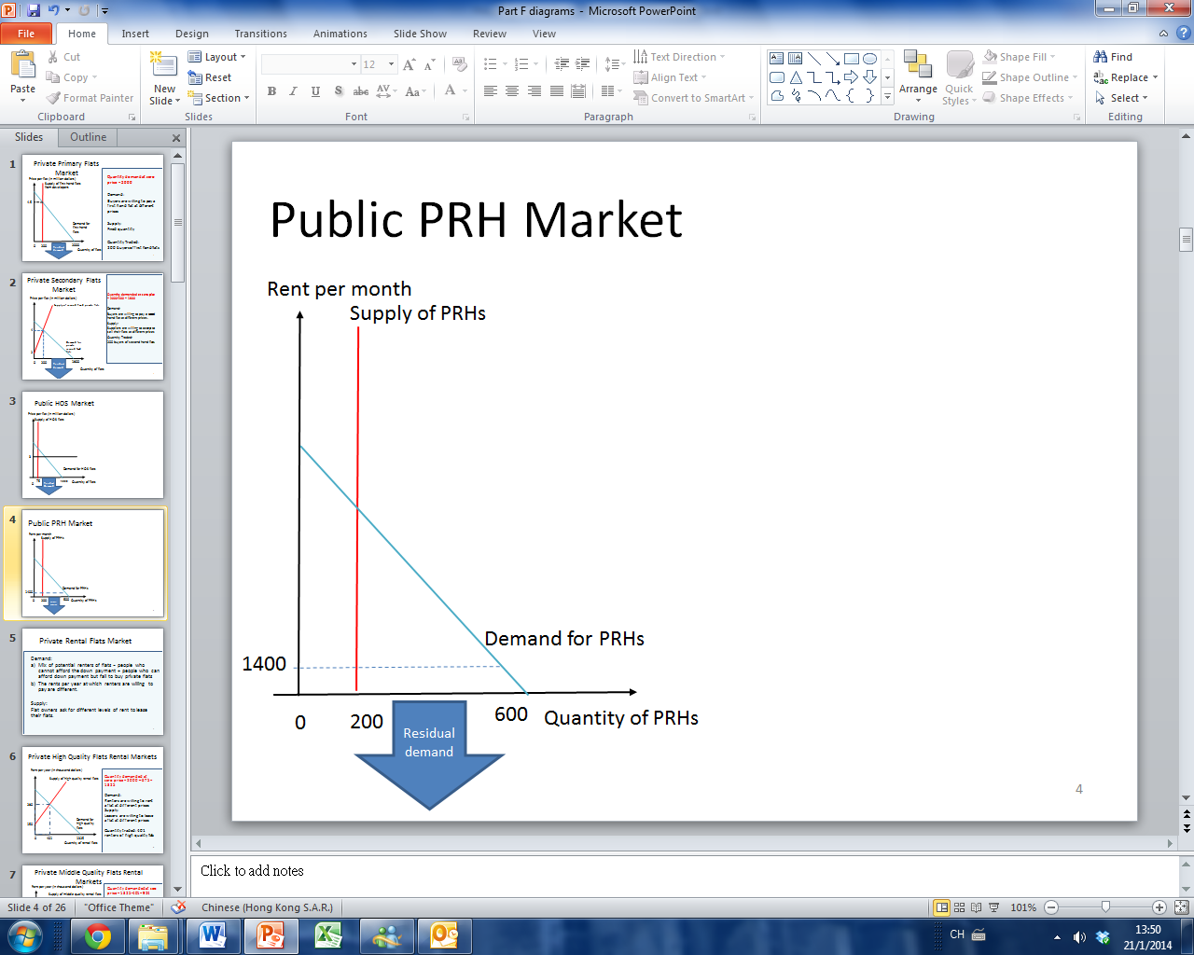
- One characteristic of public housing: Public housing is subsidied abundantly by the HKSAR Government, rationing mechanism by waiting time in work.
- Among the 600 public housing applicants, only 200 will be allocated a unit. Other residual (600 – 200) 400 households can only move down to the private rental housing market to find a flat.

  - Private Rental Flat Markets
- In the private rental flats market, there are three levels of quality of flats: high, middle and low quality flats are rented at different costs.
- The mix of potential renters includes people who cannot afford the down payment and the people who can afford down payment but fail to buy private flats, due to high market prices.
- Due to the fact that individual potential renters have different values over the housing services, the annual rent at which renters are willing to pay is different.
- Concerning the supply of rental flats, owners of flats will ask for different levels of rent to lease their flats. The housing model therefore shows that the rise of the subdivided units in the flats in the private market is to house the residual demanders from the other markets:
  - Those who cannot find anything in both the normal private selling and rental markets, and
  - Those who are not yet housed by the public market.
- The residual flats demanders will seek opportunities from the private rental market of high quality flats. Equilibrium rent will emerge and some flat demanders will fail to be housed. The residual demanders will seek in the rental market of middle quality flats. Similarly, equilibrium rent for middle quality flats will emerge and some flat demanders will fail to be housed. Then, some residual demanders from the middle market will seek out opportunities in the lower end rental market.

  - Private High Quality Flats Rental Markets
Figure 7-7 Private High Quality Flats Rental Markets
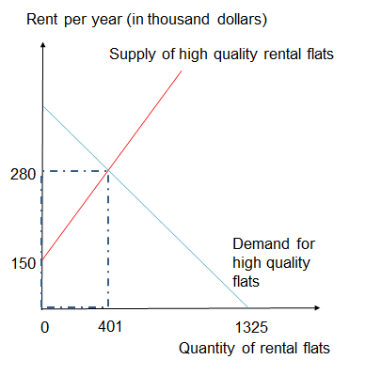
- In private housing market and public housing market, there are 675 people who have successfully acquired a flat, hence in this rent market there is a residual demand of (2,000 - 675) 1,325.
- The market equilibrium rent (annual) will be under $280,000, 401 renters will successfully acquire a high quality housing unit, hence the residual (1,325 - 401) 924 households will move into the middle quality housing market for flats.

  - Private Middle Quality Flats Rental Market
Figure 7-8 Private Middle Quality Flats Rental Markets
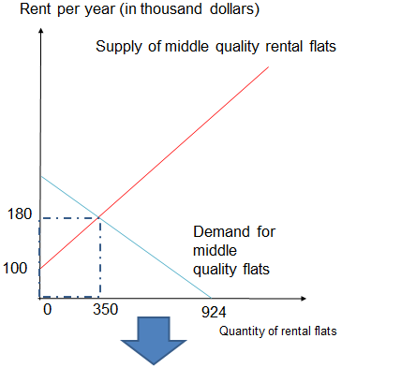
- The market equilibrium rent (annual) will be under $180,000, 350 renters will successfully acquire private middle quality housing flats, hence the residual (924 - 350) 574 households will move into the middle rental housing market for flats.

  - Private Subdivided Units Rental Market
Figure 7-9 Private Subdivided Units Rental Market
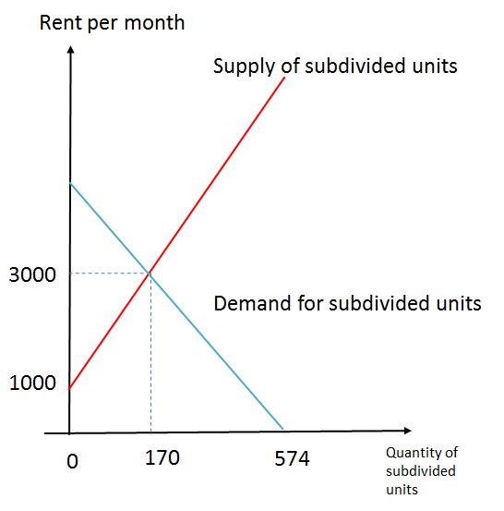
- The market equilibrium rent (annual) will be under $3,000, 170 renters will successfully acquire a subdivided unit, hence the residual (574 - 170) 404 households cannot find a housing unit in the market, they may stay where they live, or become homeless.

  - Summary
- Three key observations from the above analysis:
  - The private market will not fully cover the need of housing demand.
  - There will be excess demand in the subsidized public flat market.
  - Private rental market provides tiers of rental flats to meet the demand, including subdivided rental units.

Policy Analysis and Evaluation
  - Policy Under Consideration: An Increase in Land Supply in Private Market
- If more land resources are released for private flats development, the supply of flats in the private primary flat market will increase. This will create pressure on the price of new flats, causing a fall in price of new flats. Yet, the quantity of flats traded will be increased, meaning more flat demanders will be satisfied. As a result, the residual demand for secondary flats in the private market may shrink, resulting in a decrease in price of secondary flats. And the quantity of flats traded in the secondary market will also be lowered. Similarly, less residual demand for rental flats in the private market in different levels will be caused. Equilibrium rent will fall and the number of rented flats will also be decreased.
- Note that the policy does not have a direct effect on the public housing sector. It is because there is a means-test in work, which separates the public and private sectors. Also, demanders eligible for HOS or PRH flats are more unlikely to afford down payment for buying a new primary flat. Therefore, the policy is unlikely to benefit them directly. They may be benefited because of the lower rent in the private rental market. However, such effect may also be small because they belong to the lower end rental flat users.

Figure 8-1 Private Primary Flats Market
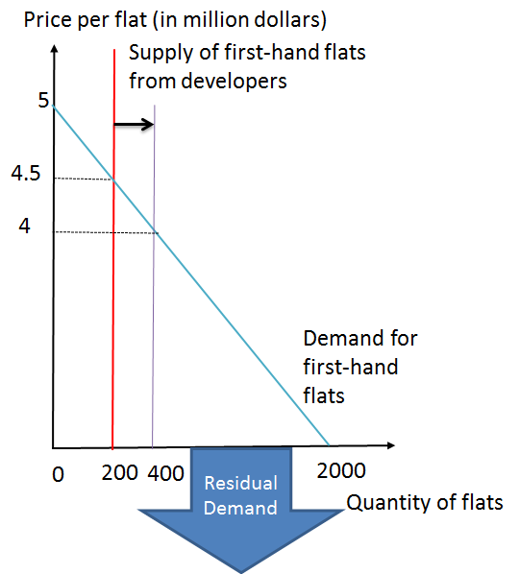
- As land supply increases, quantity of private primary flats also increases, shifting the supply curve to the right. Holding demand constant, the equilibrium quantity will increase from 200 to 400 units, hence residual demand will decrease from 1,800 buyers to the present (2,000 – 400) 1,600 buyers.

Figure 8-2 Private Secondary Flats Market
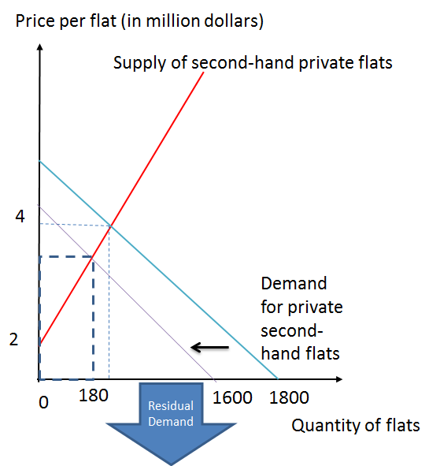
- In the private secondary flats market, demand decreases to 1,600 buyers, hence demand curve shifts to the left. Equilibrium price also decreases, as well as quantity demanded.

Figure 8-3 Public HOS Market
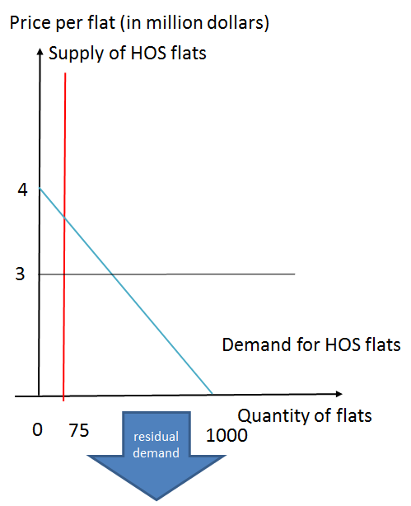
- As for public housing market, the newly added land supply will not invovle in this usage, HOS and public housing supply remain unchanged. Under the current fixed price (i.e. 3 million dollars per flat indicated in the figure above), only 75 demanders will be able to acquire a unit, the residual flat demanders will head to other markets for a flat.

Figure 8-4 Public PRH Market
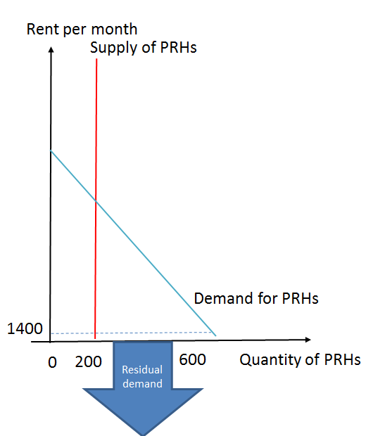
- In the public rental housing market, only 600 applicants can qualify for PRH. However, there are only 200 PRH units of supply, the residual 400 households will have to look for their flats in other housing markets.

Figure 8-5 Private High Quality Rental Flats Markets
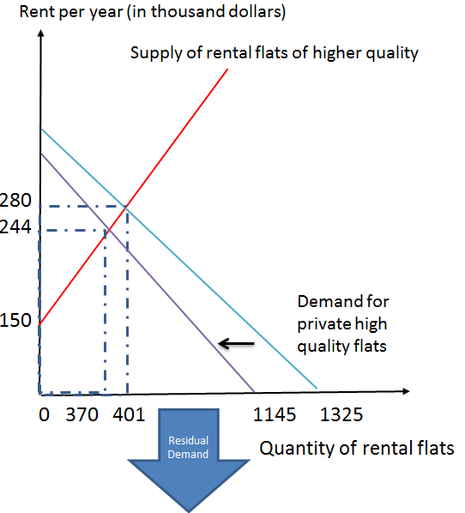
- Residual demand from the above will reduce to (2,000 – 855) 1,145 renters, demand curve shifts to the left. Hence the market equilibrium rent decreases, and quantity demanded decreases to 370 units.

Figure 8-6 Private Middle Quality Rental Flats Markets
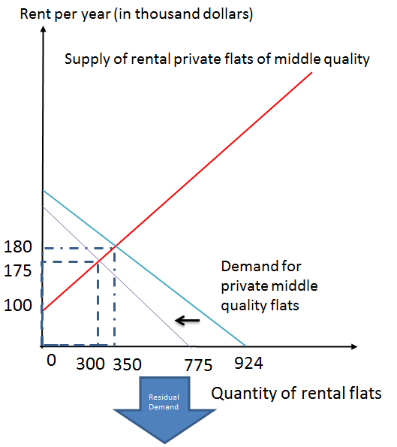
- As shown in the above, the residual demanders will become (1,145 – 370) 775, the demand curve shifts to the left, hence the market equilibrium rent decreases, quantity demanded also decreases to 300 units.

Figure 8-7 Private Subdivided Units Rental Market
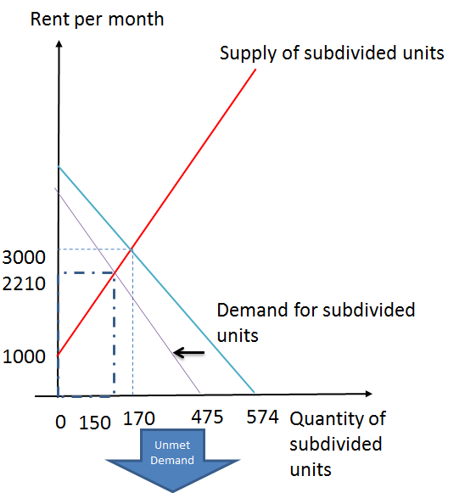
- Demanders who cannot find a flat in two of the above markets will continue their search in the subdivided flat market. Currently there are (775 – 300) 475 demanders, demand curve shifts to the left. Hence the equilibrium rent decreases, quantity demanded also decreases to 150 units.
- The residual (475 – 150) 325 demanders, not only can they not find flats in private housing market, but also they cannot find flats in the public housing market; hence they have no choice but to stay in their current place or become homeless.

- Policy evaluation: Will increasing land supply for private flats improve the living conditions for the grass root households?
  - First, the welfare of grass root households may be improved due to a lower rent of private rental units. However, the effect may not be significant. Second, the welfare effect may also depend on the room it creates in the rental market for renters to move upstream from the lowest tier market. Yet, the unmet demand in the lowest tier quality market still exists. The people who cannot move upstream may be due to low income and/or deposit constrained.

  - Policy Under Consideration: An Increase in Land Supply in Public Market
- If more land resources are provided for public housing development, the supply of HOS flats will increase. The quantity of HOS flats traded will be increased, meaning more HOS flat demanders will be satisfied. However, the effect of the regulated price for HOS flats will be negligible. Normally, it is the current PRH flat users who have the given priority to move into the HOS flats. Then, more PRH flats may be made available for awaiting applicants. As a result, the residual demand for rental flats in the private market, especially the demand for the subdivided units, will be lowered. Equilibrium rent for lower ranked rental market will fall and the number of rented flats will also be decreased.
- Price for new and secondary units may also be adjusted downward in the long run in the private sector.

Figure 8-8 HOS Flats and Subdivided Units Rental Markets
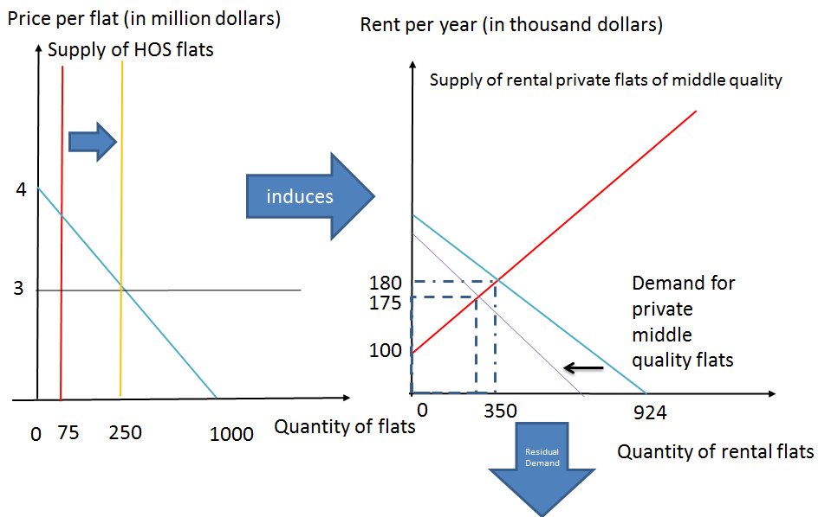
- HOS supply has increased from 75 units to 250 units, meaning more HOS applicants can be allocated a flat. Hence, middle quality private housing demand will decrease, leading to the equilibrium rent to decrease as well.

Figure 8-9 PRH Flats and Subdivided Units Rental Markets
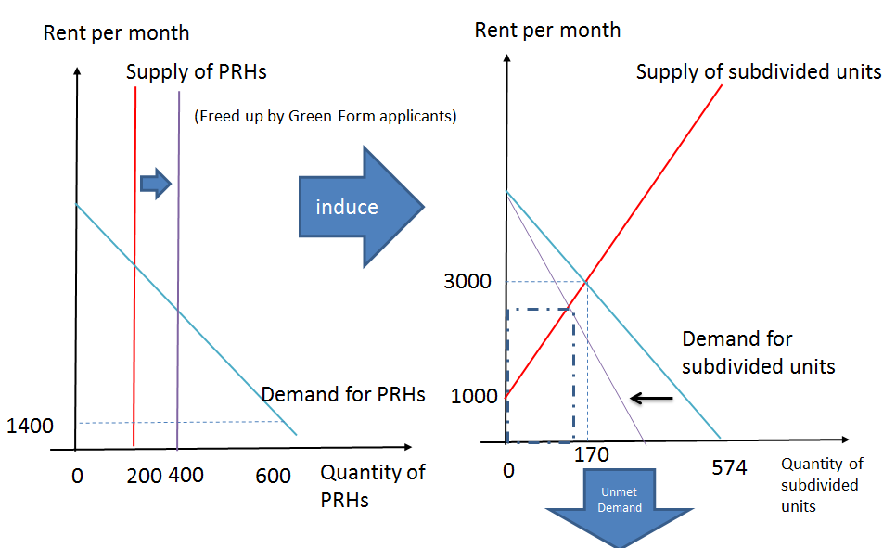
- As shown in the above, public rent houing supply increases from 200 units to 400 units, residual applicants has been reduced, leading to a decrease in demand for subdivided units, hence subdivided units’ equilibrium rent and quantity demanded also decrease.

Figure 8-10 Private Primary Flats and Private Secondary Flats Markets
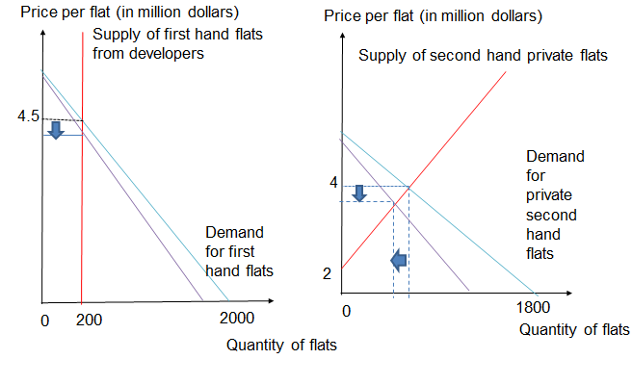
- Note that this policy would have a non-trivial direct effect on the private buy and sell market. It is because when private flat rental rate falls, the rate of monetary return of flats is reduced. As a result, the buying value for the first and second-hand flats will also be adjusted. To restore an equilibrium point in terms of the different rate of returns of housing assets, market prices for first-hand properties and second-hand properties will fall.

  - Summary: Effects of Land Supply Policy
- Increase land supply policies in either the private or the public sectors may:
  - result in a lower price and rent of flats in private markets
  - reduce quantity of flats rented in private markets
  - reduce the number of homeless people, people living in caged homes and young people with housing needs.

  - Policy Evaluation Questions
- Will increasing land supply for HOS improve the living conditions for the grass root households?
  - Answer: Yes, an increase in HOS can increase the number of the people who are currently living in PRH to move upstream in the accommodation ladder, and thereby free up PRH resources to accommodate the applicants in line, and thus improve the grass root household’s living condition. Again, the living costs of the grass root households may be reduced as they may pay lower rents for the lowest tier housing (i.e. the subdivided units).
- Will increasing land for PRH improve the living conditions for the grass root households?
  - Answer: Yes, it can improve the applicant’s living condition by moving them into the newly developed PRH flats. By paying a subsidized rent, their quality of life will also be improved. In addition, the living costs of the grass root households may be reduced as these households may pay lower rents for the lowest tier housing (i.e. the subdivided units).

- Which one is a better policy if a policy objective is to raise the living conditions of the grass root households?
  - Answer: Increasing the land supply for HOS has an effect to create an upstream accommodation ladder, but increasing the land supply for PRH does not. Both policies will improve the living conditions of some grass root households by moving them into the PRH flats. However, the former policy is more dynamic and has the potential to improve the living conditions of those who are currently living in PRHs but wish to own a HOS flat, and thereby freeing up resources.

Policy Conclusion
- To respond to the high housing price, the HKSAR Government has taken up a range of policies to intervene the housing market. Yet, there are two questions that she will need to face with:
  - If the HKSAR Government has decided to push down the housing price, what sort of criterion (/criteria) should be used for accessing a reasonable price level? Such a criterion (/criteria) is/are easy enough to be reached or measured?
  - As we know the demand segment in Hong Kong housing market is also influenced by external factors (such as demand from the mainland, the US’s monetary policies), how may the HKSAR Government push down the housing price to a target price level?
- We conducted analysis of two increasing land supply scenarios: One is to increase land resource for private housing, and second is to increase land resource for public housing. If land resource for private housing increases, the trading price in private housing market will decrease but there may not be any effects on public housing market; if we increase the land supply for public housing, then more applicants can acquire a unit of public housing, also leading to a decrease of rent in the private rental market.
- An increase of public housing supply can improve sub-divided units (SDU) residents with the problem associated with the poor living environment. This is because there are many sub-divided unit residents are also on the public housing waiting list: The official “Survey of subdivided units in Hong Kong” shows that, among the sub-divided unit households who applied for public housing, 97.1% of them are on the waiting list. The “2012/13 Caged Units and Subdivided Units Research Report Press Release” by Society for Community Organization also pointed out that “over 40% of the respondents has been queuing for the public housing for three years or more, i.e. more than the promised waiting time of 3 years by the HKSAR Government.” If the supply of public housing increases, the waiting time will be shortened, and SDU households can be arranged for PRH units of better living environment.
- Yet, an increase in land supply for private housing does not have many significant benefits to the SDU households. It is because they cannot afford a private housing unit and the impact on rental market is also negligible.
- The policies of increasing land supply or housing units can never be perfect in every way. Property owners hope that their housing price to increase as their wealth and rental income will be added up proportionally; a household without a property however will desire a decrease in housing price so they can purchase one at a relatively lower price. Different stakeholders in the housing market often have conflicting interests, as their own interests are essentially different, hence there is no single effective housing policy by the HKSAR Government that can satisfy everyone’s need.

Discussion Questions
Question 1: Opportunity Cost
The Rental Housing Operations of Hong Kong Housing Authority incurred a deficit of $601 million during 2011/12. This shows that the rental income could not cover relevant expenses on rental housing such as management and maintenance expenses.
- What are the explicit costs of the provision of public rental housing by the Hong Kong Housing Authority?
- What are the explicit costs of building new public housing estates?
- Apart from the type of costs mentioned in (ii), what other resources are needed?
- What is the opportunity cost of building new public housing estates?
- (i) State one of the public housing estates located in urban area.
(ii) State one of the public housing estates located in Lantau Island.
(iii) How can the opportunity cost be possibly different when public housing estates are built in the locations stated in part (i) and (ii)? (Assume that construction costs are the same and the land is available for sale to private property developers)
(iv) Suppose occupants of all public housing units have to pay the same amount of rent. Considering the concept of opportunity cost, is it true that the government provides the same amount of subsidy to occupants mentioned in (i) and (ii)?
- Why has opportunity cost occurred when public housing estates are built?

Question 2: Resource Allocation and Economic Efficiency I
“Given the present long waiting list for the Public Rental Housing (PRH), the low-income families, elderly and those inadequately housed such as in SDUs first should be accorded priority in allocation. Non-elderly singletons are put in a different waiting list under the Quota and Points System (QPS) currently. If the QPS is removed, the waiting time for families will increase drastically. However, to reduce the waiting time of non-elderly singletons above the age of 35, the QPS should be improved.” said Professor Anthony Cheung Bing Leung, the Secretary for Transport and Housing Bureau.
Hong Kong Daily News
6 Sept 2013

- Define shortage.
- Draw a supply-and-demand diagram to illustrate the current market situation.
- Suppose the allocation of public rental flats accords to households’ valuation of public rental housings, i.e. the ones who value the most could live in the public rental flats. Define consumer surplus AND indicate the corresponding consumer surplus in the diagram of (b).

- Comparing the consumer surplus stated in (c), comment on the consumer surplus that would be resulted from the existing allocation method: Applicants would be divided into groups according to family size, applied district or other special situations. Then, they would queue up to wait for the available public rental flats. The ones who applied earlier can get the flat sooner.
Question 3: Resource Allocation and Economic Efficiency II
“On the non-elderly one-person applicants, we have conducted a desktop analysis on their profile. According to HA’s 2012 Survey on WL Applicants for PRH, in March 2012, there were a total of 87 800 (46% out of a total of 189 500 applicants on the WL) non-elderly one-person applicants under the QPS. Of these 87 800 applicants, 65% (57 200) were aged 35 or below. Within this group, 34% were students when they applied for PRH, 47% of them had post-secondary or above education attainment and 33% were PRH tenants. However, for those aged above 35, only 7% of them had attained post-secondary or higher education.”
Panel on Housing, Sub-committee on the Long Term Housing Strategy,
Measures to Maximize the Rational Use of
Public Rental Housing Resources

- Draw a supply-and-demand diagram to illustrate the market of public rental flats according to the following table:
[The quantity supplied is 100 units while the rent is $1,400.]
Households | Marginal benefit of renting public flats ($)
Group A | 2,500
Group B | 2,000
Group C | 1,500
Group D | 1,000
(Note: each group of households has 50 family units.)

- Calculate the consumer surplus, if the public rental flats are allocated to
(i) Group A and B households.
(ii) Group A and C households.
(iii) Group A and D households.
- If the rent is reduced to $900, what will be the shortage of public rental flats?
- If the quantity supplied of the public rental flats is increased to 150 units, while the rent remains at $1,400, what will be the shortage of public rental flats?

Question 4: Demand-and-Supply Model
“It was claimed that, in Hong Kong, over 171000 people are living in substandard, subdivided flats.
The Census and Statistics Department estimated only 64900 last October. It is over 2.6 times of this figure.
Since the researchers could not examine illegal homes in industrial buildings, the figure could be even higher.” said Professor Anthony Cheung Bing Leung, the Secretary for Transport and Housing Bureau.
Hong Kong Daily News
28 May 2013

- Why would the short-run supply of subdivided units be relatively elastic comparing to that of public rental flats?
- (i) Give TWO reasons to explain why the demand for public rental flats would increase.
(ii) How would the shortage of public rental flats be affected after the demand increases?
- (i) Give TWO reasons to explain why the demand for subdivided units would increase.
(ii) How would the equilibrium rent of subdivided units be affected after the demand increases?

Question 5: Externality
The figures below provide information of HK International Airport Development:
Figure 10-1 The Traffic Growth of HK International Airport in 15 Years
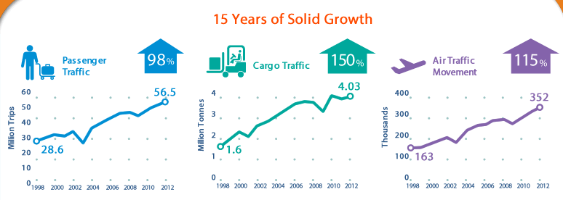
Source: HKIA Three-runway Systems

Figure 10-2 Information about Airport Runway Capacity
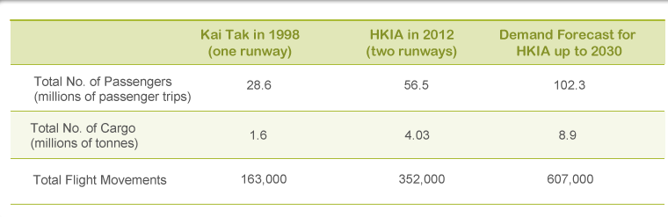
Source: HKIA Three-runway Systems

“The practical capacity of the two-runway system is only 420,000 flight movements. … Under a three-runway system, HKIA will be able to accommodate 620,000 flight movements per year, meeting its demand up to the year 2030.”
Webpage of HK International Airport

- Define externality.
- What externalities will be brought by the construction of third runway in Hong Kong International Airport?
- What are the names of the public housing estate near Hong Kong International Airport?
- What externalities will be brought by the construction of third runway in Hong Kong International Airport to the housing estate mentioned in question (c)?
- Could the government and residents of the housing estate mentioned above solve the external costs in (d) efficiently?

Question 6: AD-AS Model
“We will increase and expedite the supply of subsidised housing –
- As a production target, the total supply of PRH will be at least 100 000 units over the five years starting from 2018;
- I have asked the Transport and Housing Bureau (THB) to review and expedite the construction of public housing flats without compromising quality, and find ways to simplify technical assessments under different regulatory requirements;
- I will invite the HKHS to build more subsidised housing. In view of the very favourable response to the Greenview Villa project, the Government has set aside a site in Sha Tin for the HKHS to develop a similar housing project. Another site in Sha Tau Kok will also be allocated for rental housing development. Together, the two sites will provide about 1 000 units;…”
Paragraph 63, 2013 Policy Address
- If the government decides to increase the supply of public rental flats, how will it affect the short-run aggregate demand in Hong Kong?
- If the government decides to increase the supply of public housing units, how will it affect the long-run aggregate supply in Hong Kong?

Question 7: Income Inequality
Income inequality is one of the major public issues in Hong Kong. With reference to Gini coefficient, one of the popular indicators of income inequality, Hong Kong Census and Statistics Department provided estimates based on original household income, for year 2001, 2006 and 2011, in the following table.
Table 10-1 Gini Coefficient Based on Per Capita Monthly Household Income, 2001, 2006 and 2011 (By using Original Household Income)
All domestic households
Year | 2001 | 2006 | 2011
Gini Coefficient computed by using Original Household Income | 0.525 | 0.533 | 0.537
Source: Population Census 2011, Hong Kong Census and Statistics Department
- What is Gini coefficient?
- What is the implication of an increasing Gini coefficient?
- Describe the changes in Gini coefficient, calculated by using original household income, from 2001 to 2011 as given in the Table 7.1. What is the possible implication of such changes?
- Is Gini coefficient an accurate measure of income inequality in Hong Kong if the measure is computed by using original household income? Why?

According to the definition provided by the Hong Kong Census and Statistics Department, post-tax post-social transfer household income can be computed as follows:
Post-tax Post-social transfer Household Income =
Original Household Income –
Total Tax Payments + Total Public-funded in-kind Social Benefits
Hong Kong Census and Statistics Department has provided estimates using post-tax post-social transfer household income, for year 2001, 2006 and 2011, in the following table .
Table 10-2 Gini Coefficient Based on Per Capita Monthly Household Income, 2001, 2006 and 2011 (By using Post-tax, Post-social Transfer Household Income)
All domestic households
Year | 2001 | 2006 | 2011
Gini Coefficient computed by using Post-tax Post-social Transfer Household Income | 0.470 | 0.475 | 0.475
Source: Population Census 2011, Hong Kong Census and Statistics Department

- Describe the changes in Gini coefficient, calculated by using post-tax post-social transfer household income, from 2001 to 2011 as given in the Table 7.2. What is the possible implication of such changes?
- Comparing Table 10-1 with Table 10-2, what is the effect of using post-tax post- social transfer household income on the value of Gini coefficient?
- Apart from public housing, list out two examples of publicly funded social benefits in Hong Kong.
- What are the possible effects on the value of Gini coefficient if the HKSAR Government decides to increase public housing supply substantially?
- Many stakeholders in the society urge HKSAR government to build more public housing. Is it necessary for the government to respond to this urge?

Suggested Answers
Question 1: Opportunity Cost
- Explicit costs mainly include maintenance, management, and administration costs.
- Explicit costs mainly include construction costs and related administration costs.
- Land resources.
- Opportunity cost is the highest-valued option forgone when making decisions. Considering the land used to develop new public housing estates, the highest-valued option could possibly be the land premium paid by property developers. Otherwise, opportunity cost could also be the benefits brought by building a park or other amenities on the land.
Meanwhile, the opportunity cost of construction expenditure could be the value from spending money in other possible areas of government expenditure (education, healthcare, social welfare, etc) or saving in the fiscal reserve, depending on which choice can bring along the highest value to Hong Kong.
- (i) Upper Wong Tai Sin Estate, or other acceptable answers.
(ii) Yat Tung Estate, or other acceptable answers.
(iii) Building public housing estates in the area stated in (i) has a higher opportunity cost.
Land in urban area generally has a higher commercial value. Private developers are willing to pay a higher price to obtain the land, thus, bringing more revenue to the government. As the opportunity cost of building public housing estates is to give up the highest possible revenue in the sale of land, public housing estates in urban area may incur a higher opportunity cost.

(iv) No, the government provides more subsidies for the public housing occupants living in urban area. Public housing estates in urban area have a higher commercial value and they are located conveniently to other facilities. Hence, the occupants in those estates actually receive more subsidies from the government if we take opportunity cost into consideration.
- Land resources and the fiscal revenue of government are both scarce and limited in Hong Kong. It indicates that the current resources are not able to satisfy the needs of all stakeholders in society, forcing people to make choices in resource allocation. As a result, opportunity cost exists.
If the government decides to put resources in building public housing estates, the opportunity cost would be the highest value among the forgone opportunities. One of the typical examples is the recent debates on whether land of country parks should be used for building new public housing estates.

Question 2: Resource Allocation and Economic Efficiency I
- Shortage is a situation where the quantity supplied in a market falls short of the quantity demanded at a given price.

Figure 10-3 Shortage under Limited Supply of Public Rental Housing
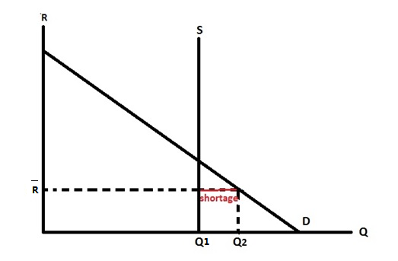
Illustrated by the diagram:
1. Supply curve is perfectly inelastic.
2. The rent is set below the equilibrium level.
3. There is a shortage.

- Consumer surplus is the value (or marginal benefit) of a good minus the price paid for it, summed over the quantity bought.

Figure 10-4 Consumer Surplus under Limited Supply of Public Rental Housing
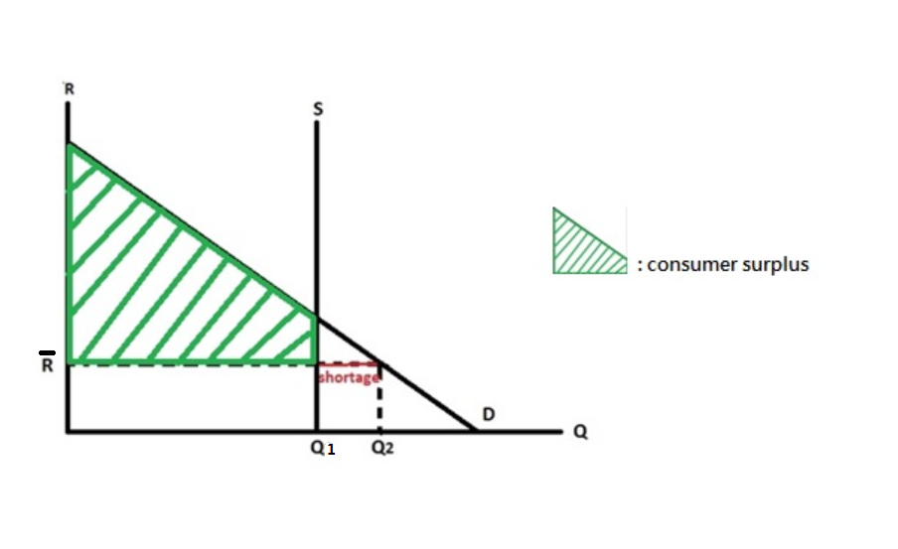

- Under the existing allocation mechanism, the ones who can live in public rental flats may not be those who value the flat the most (i.e. those who could generate the most marginal benefit by living in these public rental flats). Thus, the existing allocation mechanism cannot help maximize consumer surplus effectively, which means the consumer surplus resulted would be smaller than that in (c).

Question 3: Resource Allocation and Economic Efficiency II

Figure 10-5 Supply and Demand Diagram for Question 3(a)
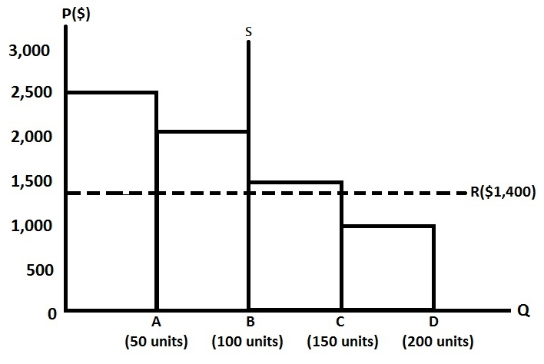

Households | Consumer surplus
Group A | (50 x 2500) – (50 x 1400) + (50 x 2000) – (50 x 1400) = $85,000
Group B | (50 x 2500) – (50 x 1400) + (50 x 1500) – (50 x 1400) = $60,000
Group C | (50 x 2500) – (50 x 1400) = $55,000

- Shortage = 200 – 100 = 100 units
- Shortage = 150 – 150 = 0 unit
Since the rent remains at $1,400, Group D households will not demand the public housings. Thus, the quantity demanded of public rental flats is 150 units (Total quantity demanded of Group A, B and C households).

Question 4: Supply and Demand Model
- For public rental housing, the supply is controlled by the government and it is mapped out under long-run policy. In addition, as the units of vacant public housing flats are limited and building more estates needs time for planning and completion, the short-run supply of public rental flats is very likely to be inelastic.
On the other hand, the supply of subdivided units is controlled by its property owners, who are very likely to adjust the supply in response to the market situation (i.e. changes in demand and government policies). For example, when the rental price of subdivided units increases, owners will have a greater incentive to renovate their current property into subdivided units, thus increasing the quantity supplied of subdivided units. Therefore, the short-run supply of subdivided units is comparatively more elastic than that of public rental flats.
- (i) If the number of low-income households increases, the demand for public rental flats will increase.
If the Housing Authority of Hong Kong raises the limit of income in public rental flat application, the demand for public rental housing may increase.
(ii) If the demand for public rental flats increases, the quantity demanded under the same price level rises. Since the supply of public rental flats remains constant, shortage rises.

- (i) When the supply of public rental flats, which are the substitutes of the subdivided units, decreases, the demand for subdivided units will rise.
When the number of low-income households rises, the demand for subdivided units will rise.
(ii) When the demand increases, the equilibrium rent of the subdivided units will rise.

Question 5: Externality
- A cost or a benefit that arise from production and falls on someone other than the producer, or a cost or a benefit that arises from consumption and falls on someone other than the consumer.
- Building third runway can bring both external benefits and external costs to society.
For external benefits: Building third runway can increase the airport capacity and facilitate the development of tourism and logistics industry. As a result, the efficiency of the airport will be enhanced; the occurrence of flight delays will be lowered and the flight frequencies to/from certain cities will increase. These factors will attract more tourists and cargo coming to Hong Kong by air.
At the same time, relevant organizations need to hire staff to operate such as construction workers, managerial staff etc. during and after the construction. It can lower the unemployment rate in HK.
For external costs: The construction work could bring air and noise pollution, as well as solid waste which can damage the environment and harm residents’ health nearby.

- Yat Tung (1) Estate and Yat Tung (2) Estate.
- This could bring external benefits and external costs to the residents.
For external benefits: The demand for construction workers increases during the construction. After the completion, the demand for airport staff also increases. Also, tourism and logistics sectors will be benefited from the expansion of airport. This will provide more employment opportunities to residents.
For external costs: Apart from the pollution and the damage to the environment and residents’ health brought by the construction of third runway, it will also affect the traffic flows nearby. Assuming that the road capacity and facilities of transportation are the same as before, there will be more traffic congestions. As a result, it will cause inconvenience to residents.
To sum up, the construction of third runway will bring both external costs and benefits to the society. However, Yat Tung (1) Estate and Yat Tung (2) Estate are much closer to the airport than other places; hence the residents of these estates will be subject to such benefits and costs more directly.
- No, the possibility is very low. It is impossible for the government to evaluate the net loss of each resident due to the externalities. It becomes a tough job for the government to decide an appropriate compensation amount. Furthermore, there are a large number of residents (reached 41,200 up to September 2013) living in Yat Tung Estates, which increases the transaction costs during negotiation. Both the lack of objective compensation standard and huge population, therefore, may lead to higher transaction costs and hinder the possibility of an efficient and meaningful negotiation.

Question 6: AD-AS Model
- Aggregate demand includes private consumption expenditure, investment expenditure, government expenditure and net exports.
Firstly, the construction costs of public rental housing are investment expenditure, so aggregate demand of HK would rise. Though the building materials such as concrete are imported from other countries, the values of such materials are included in the cost of building as intermediate inputs.
After the completion, the rent paid by tenants is part of their private consumption expenditure. If most of the tenants can save rental expenses by moving into public rental housing, private consumption expenditure will decrease, hence the aggregate demand will fall. Yet the rental income from tenants cannot cover the daily operating costs of public rental housing, so the Housing Authority has to subsidize a lot. Therefore, government expenditure will increase as well as the aggregate demand.
To sum up, if government subsidizes a lot on the public housing, HK aggregate demand will most likely increase.
- The long-term aggregate supply reflects the potential output level/full-employment output level in the economy. As the potential output level depends on the advancement of infrastructure and productivity in the economy, the long-term aggregate supply can be increased only if the government can improve people’s quality of life and hence their productivities by providing more public housing units.

Question 7: Income Inequality
- Gini coefficient is used as a measure of income inequality. A Gini coefficient of zero may indicate perfect equality, where everyone (or every household) has an exactly equal income. A Gini coefficient of one may indicate maximal inequality, where only one person (household) has all the income.
- Increasing Gini coefficient indicates a worsening income inequality.
- Since 2001, the Gini coefficient has increased. From 2001 to 2006, the value increased from 0.525 to 0.533 and then further increased to 0.537 in 2011. From 2001 to 2011, the Gini coefficient has increased 0.012 in total, which implies a more uneven income distribution.
- If original household income is used in the computation of Gini coefficient, possible effects of government taxations and publicly funded social benefits on income distribution may be neglected. The measure may overestimate the degree of income inequality.
- The Gini coefficient increased by 0.005 from 2001 to 2006 but remained unchanged from 2006 to 2011. It implies that the income distribution became more uneven from 2001 to 2006; however, the income distribution showed no apparent change from 2006 to 2011.
- First of all, the value of Gini coefficient based on post-tax post-social transfer household income is smaller than the one based on original household income.
Also, from 2006 to 2011, the income distribution showed no apparent change with the Gini coefficient based on post-tax post- social transfer household income adjustment data, in comparison to the worsening income inequality shown by the one based on original household income.
- Medical benefits and education.
- Since low income households can enjoy more publicly funded social benefit, the value of Gini coefficient, computed using post-tax post- social transfer household income, may decrease. It indicates a more even income distribution.
- The policy may reduce income inequality but it also incurs economic costs, such as the opportunity costs of land resources and financial resources for alternate uses; and the deadweight loss in the allocation of public rental flats to low income households by non- price mechanism. From the perspective of economics, the government should conduct a detailed cost-and-benefit analysis before making the decision.

References
HK Census and Statistics Department. (2011). 2011 Population Census. Retrieved from
http://www.census2011.gov.hk/en/index.html
Jowsey, E. (2011). Real Estate Economics. Palgrave Macmillan.
McKenzie, D., Betts, R. and Jensen C. (2010). Essentials of Real Estate Economics (6th edition). Cengage Learning.
Miller, N. and Geltner, D. (2005). Real Estate Principles for the new Economy. Cengage Learning.
Wang, H., Zhang, C. and Dai, W. (2013). Rental Adjustment and Housing Prices: Evidence from Hong Kong’s Residential Property Market. Hong Kong Institute for Monetary Research Working Paper No. 01/2013.
Williamson, S. (2002). Macroeconomics. Pearson Education Inc.
Hong Kong Monetary Authority. (2013). Residential Mortgage Survey Results. Retrieved from
http://www.hkma.gov.hk/chi/key-information/press-release-category/residential-mortgage-survey.shtml
Policy 21. (2013). Survey of Subdivided Units in Hong Kong. Retrieved from
http://www.thb.gov.hk/tc/policy/housing/policy/lths/sdurpt2013.pdf
HKSAR Government. (2013). Policy Address 2013. (2013). Retrieved from
http://www.policyaddress.gov.hk/2013/chi/index.html
Rating and Valuation Department. (2013). Property Market Statistics. Retrieved from
http://www.rvd.gov.hk/tc/property_market_statistics/index.html
香港明愛青少年及社區服務—九龍社區中心. (2013). 關注住屋權益工作小組基層租客租住狀況調查簡報.
Retrieved from
http://klncc.caritas.org.hk/private/document/747.pdf
City University of Hong Kong. (2013). Hong Kong Housing Homepage. Retrieved from
http://www.cityu.edu.hk/hkhousing/
Long Term Housing Strategy Steering Committee. (2013). Long Term Housing Strategy Consultation Document.
Retrieved from
http://www.thb.gov.hk/tc/policy/housing/policy/lths/lthb_consultation_doc_201309.pdf
Information Services Department. (2013). 行政長官出席「行政長官午餐講座：長遠房屋策略」致辭全文.
Retrieved from
http://www.info.gov.hk/gia/general/201309/11/P201309110555.htm

See Figure 5-1 and 5-2 (HK Rating and Valuation Department).
Refinancing (Transfer Mortgage): A new residential mortgage loan which pays off an existing mortgage loan and is secured by the same mortgaged property. (HKMA) Refinancing (Cash out Mortgage): When refinancing, take a loan with the amount more than you owe for your existing mortgage. Your existing mortgage is paid off and you will receive an additional payment for the balance of the new loan. You might do this if you want to make home improvements or pay for a child's education. Cash-out refinancing removes some of the equity you have built up in your home. (Federal Reserve)
Data is from Annual Reports of Land Registry. These figures only include private residential properties market (one-hand and second-hand), excluding non-property market.
Same as 3.
This includes the sector of property development, property investment, financial concerns, stockbrokers, wholesale and retail trade, manufacturing, transport and transport equipment, recreational activities, information technology and others.
This includes loans for the purchase of flats in the Home Ownership Scheme, Private Sector Participation Scheme and Tenants Purchase Scheme, Loans for purchasing other residential properties, Credit card advances and others.
Example: Subprime mortgage crisis in 2008, bubble of the US housing market busted, which is followed by a rapid falling of price of housing prices, the financial position of the banks hence significantly weakened; in addition the banks cannot determine borrowers’ repayment ability, they can only stop lending or charge a very high interest rate to reduce the risk of bad debt. Hence, it will decrease the investment component of the aggregate demand.
Loans and advances do not include housing units purchase of “Home Ownership Scheme”, “Private Sector Participation Scheme” and “Tenants Purchase Schemes”.
Data taken from “2011-2012 Budget - Briefing for Legislative Council” and “2012- 13 Budget - Briefing for Legislative Council”.
In Figure 2-1, after the shift of aggregate demand curve to the right, price level increases from P1 to P2, and Real GDP increases from Y1 to Y2
In Figure 2-2, after the shift of aggregate supply curve, price level increases from P1 to P2, and Y (real GDP) decreases from Y1 to Y2.
Housing supply takes time, for details please refer to Section 3.
Housing types include rentals for private housing, rentals for public housing, management fee and other housing fee. Additionally, CPI (C)’s housing types does not include rentals for public housing (HKCSD 2012).
「因應市民關注屏風樓效應，政府與港鐵檢討後，建議降低南昌站及元朗站的發展項目密度。原擬興建十幢高層住宅大廈及一幢寫字樓的南昌站上蓋，將會減建一座住宅大廈及寫字樓，整體總樓面面積會減少一成八，地積比率由八倍減至六點六倍，而住宅單位減少九百二十六個... 」星島日報(2008)南昌及元朗站上蓋物業發展方案檢討 (立法會 2008)
The Residential Properties (First-hand Sales) Ordinance (2013) https://www.srpe.gov.hk/opip/ordiance_and_guidelines.htm
Single Parents: Single parents are defined as mothers or fathers who are never married, windowed, divorced or separated, with child(ren) aged under 18 living with them in the same household. (HKCSD 2012).
Numbers of Single Parents: 1996: 42,316 , 2001: 61,341, 2006: 76,423, 2011:81,705 (HKCSD 2012).
Mainland’s GDP annual growth has been maintaining at around 7% or above in the recent ten years (World Bank).
“After 2010, Capital Investment Entrant Scheme has been amended and real estate is no longer counted as a class of permissible investment, threshold of investment for admission to Hong Kong under CIES is also raised from HK$6.5 million to HK$10 million. Since the start of the scheme in 2003, there have been 29,604 applications, in which 25,906 applicants are “Chinese citizens with permanent residence overseas.” The total volume of investment up until 2013 is 147,818.89 million, in which 42,403.78 million were real estate investment (HK Immigration Department 2013).
Survey of Subdivided Units in Hong Kong (2013)
According to the report, “SDU (sub-divided units) is commonly used in the community where a domestic quarter is subdivided into two or more smaller units for rent. Generally, the original non-structural partition walls are removed while the new ones are erected; new toilet and kitchens are installed, and internal drains are added or altered.”
Gini Coefficient: A summary measuring if the extent to which the actual distribution of income differs from a hypothetical distribution in which each person receives an identical shares (HKCSD 2012).
According to HKCSD 2001 Population Census thematic report Household Income Distribution in Hong Kong, it shows that the lowest decile group who receives the lowest income has only seen their media income raised by merely 2.3%, even though the highest income decile group has seen their income increased by 22.2%
The ratio o money borrowed to fair market value of collateral usually with reference to real property. Since November 1991, the banking sector has voluntarily adopted a 70% loan-to-value ratio for residential mortgage lending. This was subsequently endorsed by Government and incorporated into the HKMA’s guideline on property lending (HKMA 2010).
“The lowest rate of interest that banks charge their best customers for loans over a short period and that is used for calculating the interest rates on other types of loan.”(Cambridge Dictionary)
From the Sales of First-hand Residential Properties Authority, welcome message (2013) “To further enhance the transparency and fairness of the sales arrangement and transactions of first-hand residential properties … The objectives of the Ordinance are to create a clear, fair, balanced, practical and efficient mechanism to regulate the sales of first-hand residential properties, and to protect the interest of residential property buyers through enhancing transparency and making contravention on the mandatory requirements criminal offences. Also, the Ordinance provides a level playing field for vendors of first-hand residential properties.”
“Land shortage has seriously stifled our social and economic development and smothered many opportunities for people to start and expand their businesses. High housing prices and rents also affect young couples’ plans to marry and start a family. This undermines family harmony and can cause potential safety and health hazards.” (65, Policy Address 2013) The above statement may reflect that the lack of land for development can have a negative effect towards Hong Kong’s long term development.
Commitment of HK Buildings Department (2013).
Record of proceeding (6/2/2013 Wednesday) http://www.legco.gov.hk/yr12-13/english/counmtg/hansard/cm0206-translate-e.pdf
The rental and price indices are derived from the same data that are used to compile average rents and prices. The indices measure value changes by reference to the factor of rent or price divided by ratable value of the subject properties rather than by reference to the rent or price per square meter of floor area.
Private Domestic units are defined as independent dwellings with separate cooking facilities and bathroom (and/or lavatory). They are sub-divided by reference to floor area as follows: Class A - saleable area less than 40 m2; Class B - saleable area of 40 m2 to 69.9 m2; Class C - saleable area of 70 m2 to 99.9 m2; Class D - saleable area of 100 m2 to 159.9 m2; Class E - saleable area of 160 m2 or above
See 30.
The figures from 2003 have been adjusted as the original figures from 2003 onwards exclude village houses in the source.
Same as 33.
2003/2004 – 2012/2013 Hong Kong Housing Completion (Housing Authority 2013)
Including all public rental housing units (HKCSD 2011).
Others include non-domestic quarters and temporary housing (HKCSD 2011).
The figures were estimated based on the data from Table E102 and E103 of 2011 Population Census Office. The figures exclude domestic households living on board vessels.
Median monthly domestic household income refers to the average monthly domestic household income so calculated that 50% of the total number of domestic households had incomes above that figure and the other 50% had incomes below it (HKCSD 2011).
Median Monthly domestic household income for residents of public rental housing units: 2001: $12,500; 2006: $10,296; 2011: $11,415
Median Monthly domestic household income for residents of private permanent housing: 2001: $19,413; 2006: $20,238; 2011: $29,182
Median monthly domestic household rent refers to the average monthly rent so calculated that 50% of the total number of domestic households renting the accommodation they occupy paid more than that amount and the other 50% paid less than that. Households with zero rent are excluded in the calculation (HKCSD 2011).
43 Median rent to income ratio refers to the average percentage of monthly household income paid on monthly household rent so calculated that 50% of domestic households renting the accommodation they occupy paid more than that percentage and the other 50% paid less than that. Households with zero income and/or zero rent are excluded in the calculation.
Within the CPI Index 2012, housing has an increase of 7.2% (HKCSD 2012).
In 2011 Census, section of Household Income distribution, CSD has categorise households into twelve decile groups, the lowest group’s income is lower than $2,000 (Table 2.2, 2011 Population Census – Thematic Report Household Income Distribution in Hong Kong, HKCSD 2011).
GovHK Press Release (1/3/2006) of Legislative Council LCQ5: Policy on Squatter Control
A New, Long Term Development Framework for Hong Kong: A Response to Change and Challenges, A consultative Digest on the Review 1996 Territorial Development Strategy.
http://www.cityu.edu.hk/hkhousing/pdoc/1998_%20LTHS-c.pdf
http://www.legco.gov.hk/yr03-04/chinese/sec/library/0304fs01c.pdf
http://www.info.gov.hk/gia/general/201309/11/P201309110555.htm
See Table 4-1 in Section 4.
Paragraph 4.32 in THB Consultation Document of Hong Kong’s Long Term Housing Strategy
This figure is calculated as: the number of all residents (i.e. 2,000) minus the number of residents who could find a place to live (private market: 580 owners, public market: 275 residents).
Because all applicants have to qualify the means test.
http://webcache.googleusercontent.com/search?q=cache:ko-DGujrFfkJ:www.soco.org.hk/publication/press_release/privatehousing/2013/pr_2013_9_1.pdf+&cd=3&hl=en&ct=clnk&gl=hk
According to Population Census 2011 by HKCSD, about 16% of households are living in owned properties while 31% of households are living in public rental housing. (See Figure 5-10)
Hong Kong Housing Authority Annual Report 2011/12
Hong Kong Housing Authority: http://www.housingauthority.gov.hk/tc/common/pdf/about-us/policy-focus/policies-on-public-housing/A01/A01.pdf
http://www.threerunwaysystem.com/en/Growth/Economic_contribution.aspx
http://www.threerunwaysystem.com/en/Growth/demand_forecast.aspx
Hong Kong 2011 Population Census - Thematic Report : Household Income Distribution in Hong Kong (p.107)
Hong Kong 2011 Population Census - Thematic Report : Household Income Distribution in Hong Kong (p.4)
Hong Kong 2011 Population Census - Thematic Report : Household Income Distribution in Hong Kong (p.107)
Michael Parkin, Economics, 8th edition, p.344.
http://www.housingauthority.gov.hk/tc/global-elements/estate-locator/detail.html?propertyType=1&id=2838 http://www.housingauthority.gov.hk/tc/global-elements/estate-locator/detail.html?propertyType=1&id=7178
Under the classification of HKCSD, the construction costs of buildings belong to gross domestic fixed capital formation (本地固定資本形成總額).

