Name________________________________
Section 1.1 HW
Probability

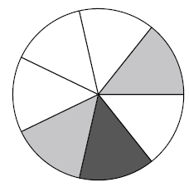
Use the spinner to answer the following questions.

1. How many pieces total are that on the spinner?

2. What is the probability of landing on a gray piece?

3. What is the probability of landing on black piece?

4. What is the probability of landing on a white or black piece?

5. Which color do you have the greatest probability of landing on?

6. If you roll a die what is the probability it will land on a 3?

7. If you roll a die what is the probability it will NOT land on a 2?

8. If you roll a die what is the probability it will land on an even number?

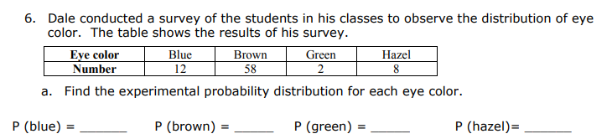
9.

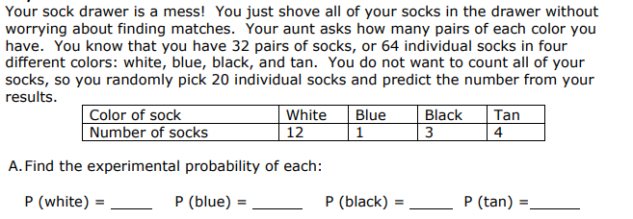
10.

Section 1.2 HW
Compound Probability

You spin a spinner that has 12 equal-sized sections numbered 1 to 12. Find each probability

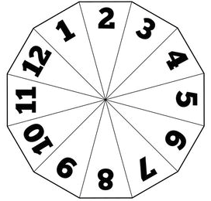
1. Find the probability of landing on a 3 or 4

2. Find the probability of landing on an even number or 7

3. Find the probability of landing on a multiple of 3 or an odd number.

4. Find the probability of landing on a multiple of 2 or a multiple of 3

You roll a red die and a blue die. Find each probability

5. Find the probability of rolling a red 2 and a blue 2

6. Find the probability of rolling a red odd and a blue even

7. Find the probability of rolling a red odd and a blue less than 4.

8. You’re given a bag containing 3 blue marbles, 5 red marbles, and 2 green marbles. You choose a marble, then replace the marble and choose again.

a. What is the probability of picking a red both times

b. What is the probability of picking a red and then a green.

9. What is the probability of choosing a face card or a club from a deck of cards?

10. What is the probability of choosing a king or an ace from a deck of cards?

11. What is the probability of rolling a number that is not 3 on a die?

12. What is the probability of choosing a card that is not diamond from a deck of cards?

Review
1.3-1.4 HW
1. A box contains a red pen, a blue pen, and a green pen. You take a pen out of the box one at a time. Create a tree diagram to show all of the different ways of taking a pen out of the box and state the total number of ways of doing so.

2. Megan went shopping and bought a pair of black pants, a pair of jeans, a pair of shorts, and a red, white, and floral shirt. Make a tree diagram showing all possible outfits she has to wear. Then state the number of outfits.

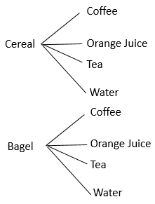
3. The tree diagram below shows the breakfast options you have at home.

a. How many total options are there?

b. How many options are there if you realize you have eggs?

c. If you also have to choose between plain and vegetable cream cheese on your bagel, how many options would you have?

4. How many passwords can be made if you need to have 3 uppercase or lowercase letters followed by 2 digits followed by one of the following symbols: ! ? #

5. When making your schedule for next year you can choose from 4 math classes, 12 electives, 2 language, 3 history, and 5 science classes. How many different schedules can be made?

6. You go to Wal-mart to buy batteries. You can choose from EverReady, Duracell, or Ray-OVac. Once you decide on the brand you then have to decide whether to get alkaline or nonalkaline batteries. Finally you must decide between AAA, AA, C, or D batteries. How many different kinds of batteries are available for you to buy?

7. How many different ways are there to arrange the letters in MINDSET?

8. The math club needs to choose a president and vice president from a group of 15 students. How many different ways are there to assign these roles?

9. How many more ways are there to hang 7 posters on the wall than there are to choose 4 of the 7 posters to throw out?

10. The menu at a restaurant consists of 13 appetizers. You and your friend decide you want to order 4 of them. How many ways are there to order the appetizers?

11. Marshalls has received 23 applications. They are only hiring 4 people. How many ways can they hire 4 people?

12. Macy is taking a road trip with her family. They told her she can only bring 4 books and 2 movies. She has 8 books and 13 movies. How many options does she have when choosing what to bring?

Section 1.4 HW
Permutations and Combinations

Determine if the problem is a permutation, combination, or counting principle. Then solve the problem.

1. A girl has 5 skirts, 8 shirts, and 6 pairs of shoes. How many outfits can she wear?

2. How many different ways can a committee of 5 students be selected from a class of 25?

3. A car dealer sells 4 makes of cars in 5 colors with either standard or automatic transmissions. How many variations does the dealership offer?

4. There are 9 students running for president, vice president, and secretary. How many ways can the 3 officers be selected?

5. A briefcase lock has 3 rotating cylinders, each containing 10 digits. How many numerical codes are possible?

6. Eight toppings for pizza are available. In how many ways can Jim choose 3 of the toppings?

7. How many ways can 8 cans of soup be displayed in a row on a shelf?
8. A box contains 12 black and 8 green marbles. In how many ways can 3 black and 2 green marbles be chosen?

9. You are asked to list, in order of preference, the three best movies you have seen this year. If you saw 20 movies, in how many ways can the 3 best be chosen and ranked?

10. How many pizzas are possible if you can choose from 3 sizes, 3 crusts, and 5 toppings?

