Homework 2

Write a phrase/sentence and draw the trees that could be generated by each of the following phrase structure rules:

  - S NP (Aux) VP
I have laughed.

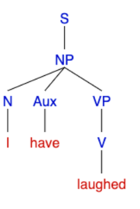
The colorful plant might produce fruit.
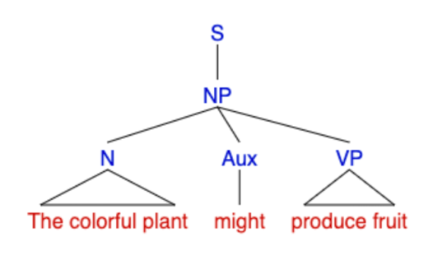
  - S NP VP
I laughed.
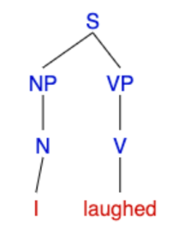
The colorful plant produced fruit.
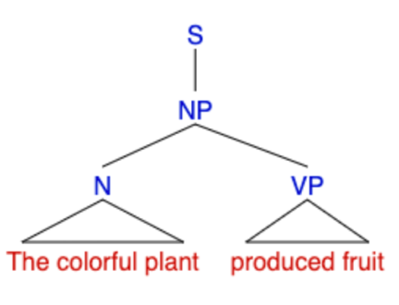
  - NP → (Art) (Adv) (Adj) N
The very happy kitten
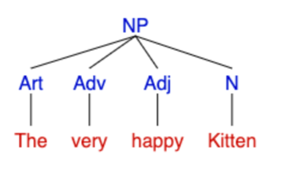

  - NP → {(Art) (Adv) (Adj) N, Pro}
A skillful carpenter
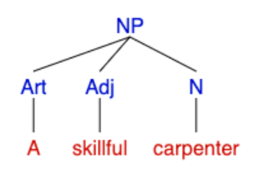
She
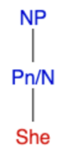
  - VP V (NP) (PP)
dilly-dally
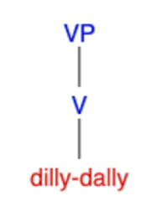
Broke the vase
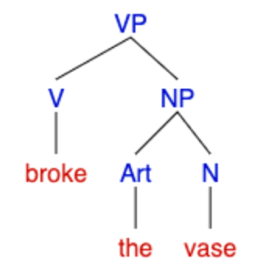
  - PP P NP
during the apocalypse
