- Due Nov 29 by 11:59pm
In this assignment, you are asked to provide a multithreaded solution to solving the circuit-satisfiability problem. Circuit-satisfiability computes whether a given circuit is satisfiable; that is, for what combinations of input values (if any) will the circuit output the value 1?
An example circuit is given is the following figure. The circuit contains AND, OR, and NOT gates. It has 16 inputs from left side, each of which can take either 0 or 1. So there are 2^16=65,536 different combinations of inputs. The output on the right side indicate whether a given combination satisfies the circuit. A sequential program is given (under the hw5 directory untar’d from the file cop4338-module5-code.tgz in Module 5 Resources).
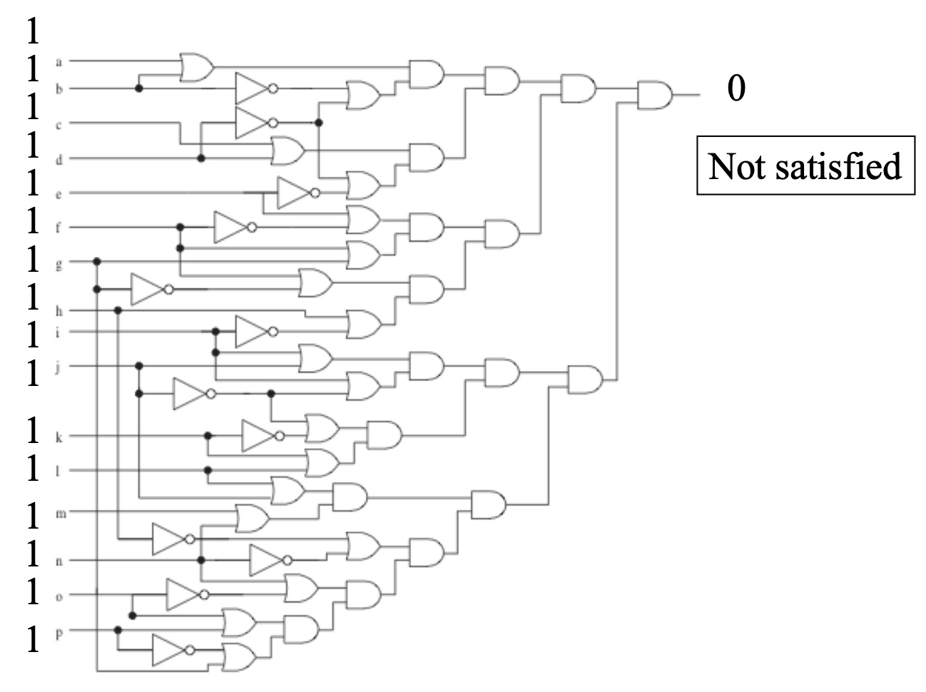
Your task is to convert this program to a multithreaded version. Your program should take an integer p>0 as the command-line argument (do sanity checks, please). You are going to create p threads (in additiona to the main thread) that divide the 65,536 number of combinations among them (more or less). For example, if p=3, each thread would be responsible for roughly 65,536/3 number of iterations (if it's not divisible, some threads can end up with one more iteration than the others).
If a thread finds a combination that satisfies the circuit, it should print out the combination (like in the given sequential version), along with the thread id (a number between 0 and p-1). In the end, the main thread should print out the run time and the total number of combinations that satisfy this circuit (like in the given sequential program). An example output of the program is shown below:
% ./thdcircuit 3
0) 0110111110011001
0) 1110111111011001
2) 1010111110011001
1) 1110111110011001
1) 1010111111011001
1) 0110111110111001
0) 1010111110111001
2) 0110111111011001
2) 1110111110111001
Execution time 0.002780s
There are 9 solutions
To complete this homework assignment, following the following steps:
- Create a directory for this homework and name it “hw5”. Copy the files from the hw5 directory untar’ed from the file cop4338-module5-code.tgz (provided in Module 5 Resources).
- Add or modify source files to implement the necessary functions.
- One should be able to compile your programs by typing ‘make’, which will generate the executable file (call it 'thdcircuit').

Submission Instructions
Please submit your work through Canvas as a single gzipped tar file. Follow the instructions below carefully (to avoid unnecessary loss of grade):
To prepare for the final gzipped tar file for submission, change the current directory to the parent directory of hw5 and run the following command to create the file for submission:
% tar czvf firstname-lastname-hw5.tar.gz hw5
You should put your true first name and last name in the command. You're only allowed to submit one .tar.gz file via Canvas.
Please make sure you submit the homework before the deadline. Late submissions will incur penalties as specified in the syllabus.
Be aware: All homework assignments are expected to be individual work. No code sharing or co-development is allowed. Refer to the code of conduct stated in the syllabus. There will be zero tolerance for violations in this course.

Grading Criteria
- The submitted .tar.gz file can be expanded successfully to the directory tree structure as outlined in the Description section (with hw5 directory containing source code files and the Makefile). 5%
- Makefile works as expected, able to compile the program and to clean up (removing the generated object files and the executable file) as needed. 5%
- Successful compilation. 20%
- Successful run with correct output: 70%
a. Correct command-line processing and sanity checks with useful error messages: 10%
b. Correct use of threads to divide the iterations (combinations): 20%
c. Successfully printing out the satisfiable solutions: 20%
d. Successfully accumulating the number of solutions (with correct use of mutex): 20%

