HW 6
Part 1
As English speakers, we sometimes come across names of places that can be confusing to pronounce if we are unfamiliar with them. In the recordings I have given you, there are two pronunciations: the first is a common attested mispronunciation, and the other is the closer to how a person from that place would pronounce it. Please provide a transcription in IPA for each one.
Example:
Oaxaca
a. [wɑkzəkə] b. [waxaka]

1. Berkeley (California vs UK)
a. b.
2. Budapest (Hungary)
a. b.
3. Cannes (France)
a. b.
4. Edinburgh (Scotland)
a. b.
5. Kiev (Ukraine)
a. b.
6. La Jolla (California)
a. b.
7. Melbourne (Australia)
a. b.
8. Phuket (Thailand)
a. b.
9. Reykjavík (Iceland)
a. b.
10. Seoul (Korea)
a. b.
11. Spokane (Washington)
a. b.
12. Thames (The River Thames in England)
a. b.
13. Tijuana (Mexico)
a. b.
14. Worcestershire (England)
a. b.
15. Yosemite (National Park in CA)
a. b.
16. Zzyzx (California)
a. b.

Part 2
Label the vocal tract using the provided word bank.
Back of tongue | Alveolar ridge | Vocal folds | Nasal cavity | Tip of tongue | Front of the tongue | Root of tongue | uvula | trachea
teeth | pharynx | Velum | glottis | Hard palate | epiglottis | lips | larynx

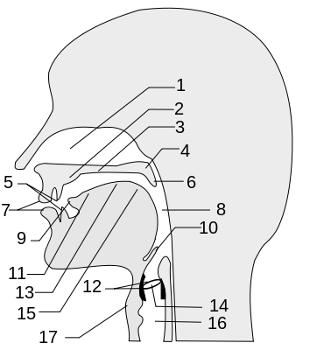

Part 3
