TARGET PROFILE DEMOGRAPHICS/PSYCHOGRAPHICS: potential customers
PRODUCT/FACT: promotion of the new product buy one and get one free.
BENEFIT: increased customer base and loyalty.
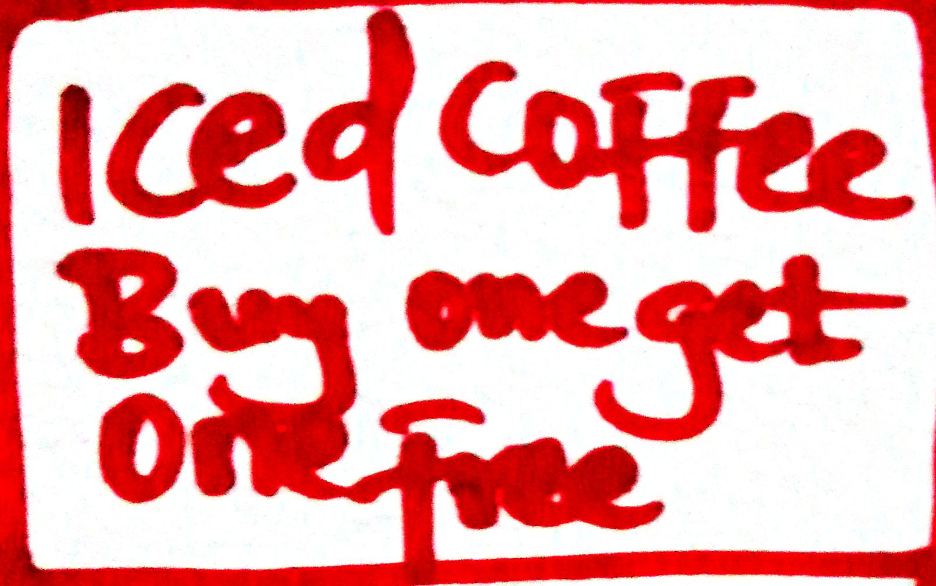
VISUAL EXPLANATION
This is a promotional strategy that aims at ensuring the product market entry is easy.

