Portfolio Assignment

Author
Institutional Affiliation
Instructor
Course code
Date of submission

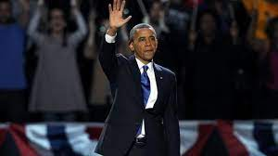
Caption: President Barack Obama has been re-elected to a second term, defeating Republican challenger Mitt Romney.
https://www.bbc.com/news/world-us-canada-20233064

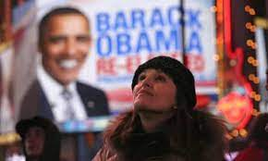
Caption: People watch election results in Times Square after television networks called the election in favor of President Barack Obama. Photograph: John Moore/Getty Images
https://www.theguardian.com/world/2012/nov/06/us-election-2012-results-live-blog

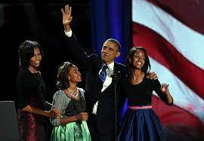
Caption: President Obama appears with his family at an election night rally at the McCormick Place convention center in Chicago.
https://www.washingtonpost.com/politics/decision2012/after-grueling-campaign-polls-open-for-election-day-2012/2012/11/06/d1c24c98-2802-11e2-b4e0-346287b7e56c_story.html

Obama Re-election
The guardian reported on Obama’s win referring to the to the night as a wonderful night for the democrats. According to this publication President Obama indicated that he was more hopeful on his reelection than ever before; and for this reason, he congratulated the American voters regardless of their sexual orientation, race or gender. In his victory speech, he went ahead to reiterate his vision for the American people particularly on education. He believed that his reelection was an inspiration about the future and what lay ahead. The Washington post on the other hand reported Obama’s victory stating that it was only possible after a grueling campaign against his main opponent Mitt Romney. The Washington post observed that America’s first African American president scored a decisive victory after winning some of the seven major battlegrounds. The BBC also reported similar sentiments as that of the Guardian. Focusing on Obama’s reentry into the second term, highlighted Obama’s win as a great victory after garnering over 270 electoral votes. Additionally, the BBC also reported on the Democrat’s continued grip over the senate since 2007. According to this publication, Mr. Obama congratulated his opponent for the hard-fought campaign and stated that it was now to put politics aside and concentrate on building a united nation.

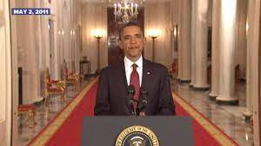
Caption: Obama announces death of Osama bin Laden
https://www.firerescue1.com/terrorism-wmd-response/articles/obama-announces-death-of-osama-bin-laden-bs4h2cNBY32gQ9sQ/

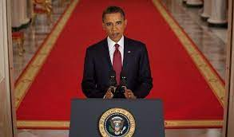
Caption: President Obama addresses the Nation to announce that the United States has killed Osama bin Laden, the leader of al Qaeda.
https://obamawhitehouse.archives.gov/blog/2011/05/02/osama-bin-laden-dead

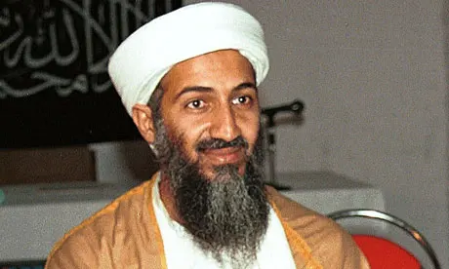
Caption: Osama bin Laden was killed by US special forces at a compound in Abbottabad, near the Pakistani capital, Islamabad
https://www.theguardian.com/world/2011/may/02/osama-bin-laden-dead-pakistan

The capture and death of Osama
The Firerescue1 reported that Americans had killed the Al Qaida leader in ground operation in Pakistan and that the US was in possession of his body. The news highlighted the dead terrorist as a glowering mastermind behind the September 11 attacks in the United States that claimed lives of thousands of Americans. In this piece, it was reported that a small team of Americans killed bin Laden in a firefight at a compound in Pakistan. The president announced Osama’s death in a televised speech that was received by a lot of jubilation stating that at last justice had been done an that America had sent an unmistakable message regarding its commitment against terror. The president however noted that even though Osama’s death was a major achievement in the fight against terror, it didn’t mark the end of potential Al Qaida attacks on the US; and for this reason, he insisted on the country’s continued vigilance against terror. The Whitehouse blog also reported on Obama’s supposedly victory speech against terror. The president referred to Osama as not only the leader of the Al Qaida but also a terrorist who was responsible for the murder of thousands of American men, women and children. According to this blog, the President indicated that nearly ten years ago, the Osama-led terrorist group had committed what remains to be one of the deadliest attacks on the American soil. He stated that the war against Al Qaida was particularly aimed at protecting innocent citizens, American friends and allies from terror-related activities. The Guardian paper reported that American had achieved victory in the war against terror after killing Osama bin laden and burying his body at sea. Even though other sources indicate that the terrorist was unharmed during the attack on his highly guarded compounded, the Guardian however stated that Osama resisted the capture and was thus killed in a fierce firefight; however, no American was hurt during the whole incident. The paper also reported that Osama’s body was buried within the 24-hour period as provided by the Islamic traditions.
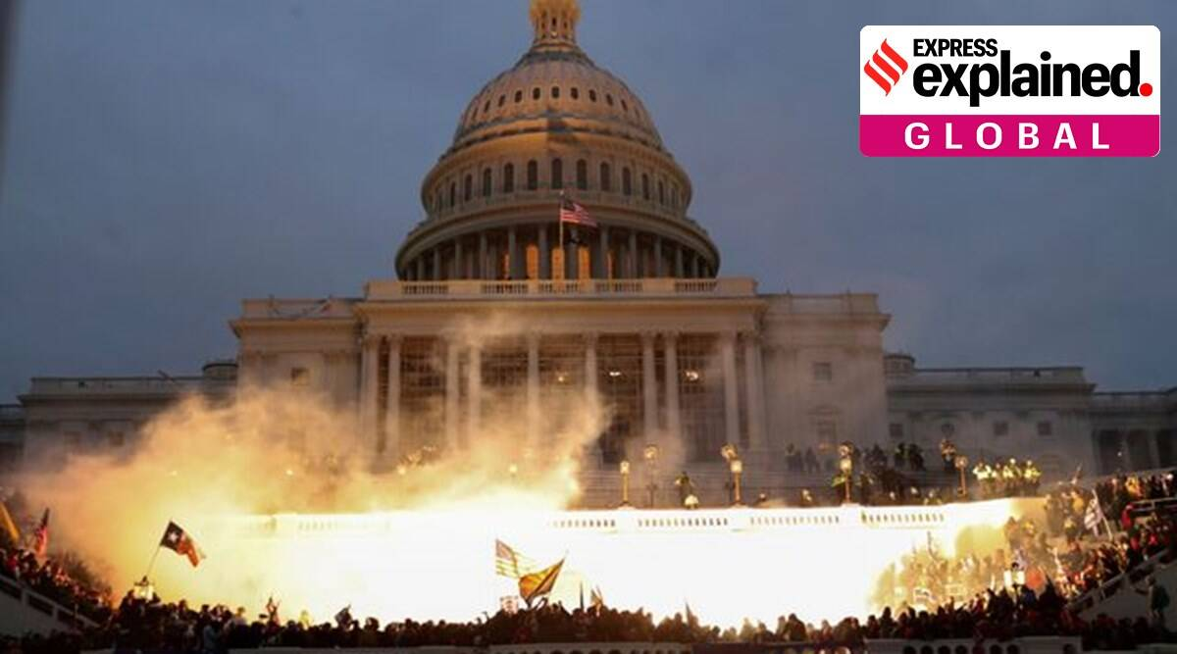
Caption: An explosion caused by a police munition is seen while supporters of US President Donald Trump gather in front of the Capitol Building in Washington, U.S., January 6, 2021
https://indianexpress.com/article/explained/us-capitol-hill-siege-explained-7136632/

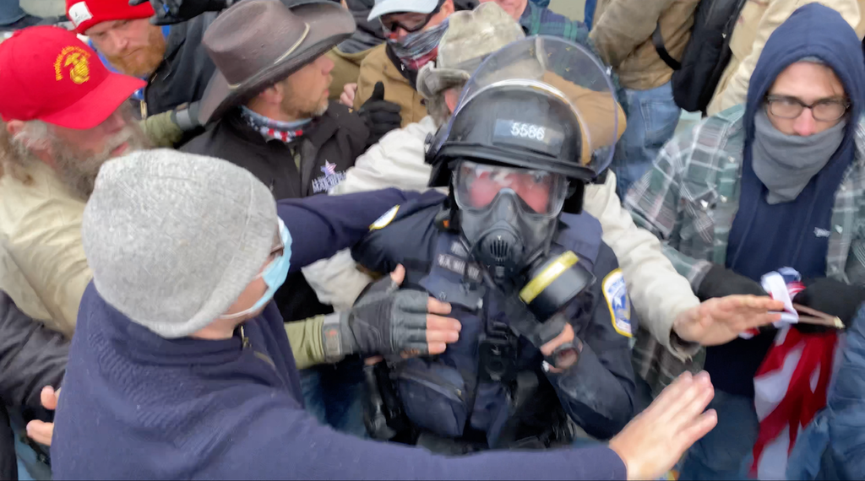
Caption: Rioters attempt to protect a Metropolitan Police officer from other members of the mob after they dragged him down stairs and beat him.
https://www.nytimes.com/2021/01/11/us/capitol-mob-violence-police.html

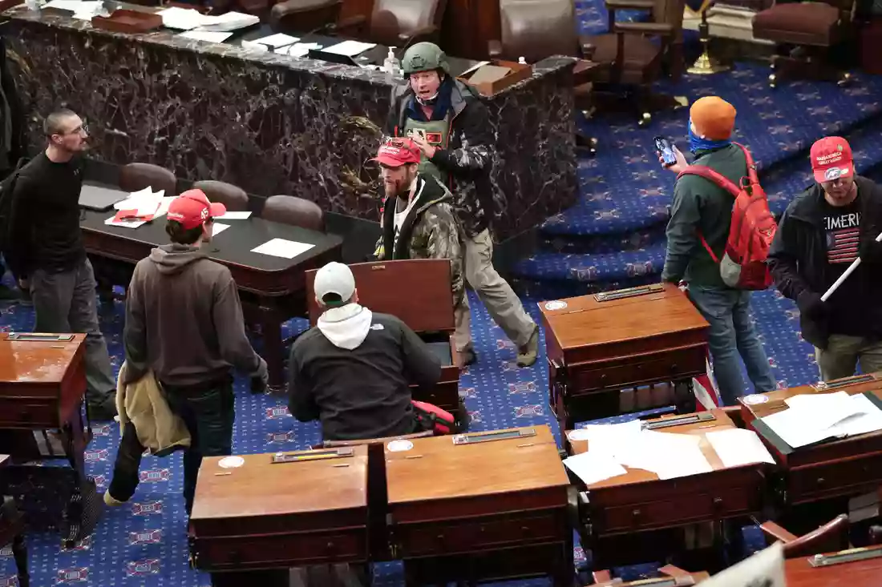
Caption: Senate Chamber of the U.S. Capitol on Jan. 6 with a handful of rioters.
https://www.npr.org/sections/insurrection-at-the-capitol

The attack on the US Capitol
Regarding the US Capitol siege, the Indian Express reported that angry and armed mob of Trump supporters stormed the capitol building protesting against the just concluded general election. This news piece reported that the police and the supposedly Trump supporters repeatedly clashed in front of the Capitol Building. It is indicated that these efforts were primarily meant to reverse the outcome of the 2020 election. These supporters brawled with the police, smashed the building windows and a woman was fatally shot in the ensuing clashes with the law enforcers. According to the Indian Express, the attack on the Capitol Building remains to be one of the worst security breaches in the history of the United States. The NPR News however referred to the attack on the Capitol building as the Capitol insurrection. According to this news outlet, a handful of pro-Trump rioters stormed the Capitol Building consequently overpowering the Capitol police to gain access to the building. The NPR News reported that the Capitol Building attackers had since been charged by federal prosecutors. Described as the Capitol Riot Fallout, the New York Times reported how angry mob dragged and beat a police officer at the Capitol. Information reported by this newspaper indicates that the angry mob violently attempted to breach the building. In numbers, the attack left a police officer and a rioter dead with a handful of capitol police officers injured. Images drawn from the footages would believably help the police in identifying and prosecuting the rioters.

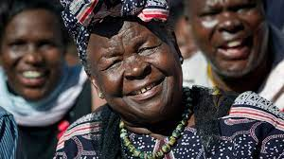
Caption: Obama family matriarch has died in a Kenyan hospital at 99
https://abcnews.go.com/International/wireStory/obama-family-matriarch-died-kenyan-hospital-99-76743640

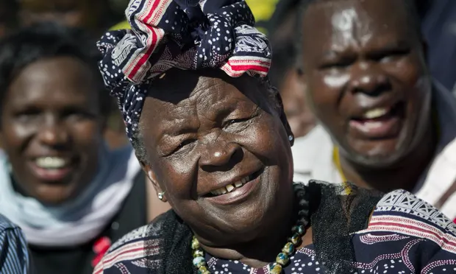
Caption: Barack Obama's 'beloved grandmother' dies in Kenya aged 99
https://www.theguardian.com/us-news/2021/mar/29/barack-obama-step-grandmother-sarah-obama-dies-kenya

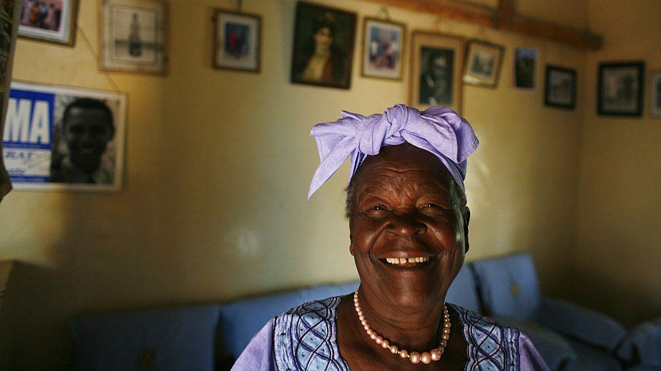
Caption: Barack Obama's step-grandmother, Sarah Obama, has died at a hospital in Kenya at the age of 99.
https://www.bbc.com/news/world-africa-56563179

The death of Sarah Obama
The ABC News reported the death of Obama’s step-grandmother referring to her as the Obama family matriarch. The ABC News focused so much on the late Sarah Obama’s achievements particularly her actions to promote education for girls in her rural home in Kenya. According to the family, the old woman had died of normal sickness and not Covid-19 as had been speculated earlier. The president condoled with his family stating that as a family, they will surely miss her. The Guardian news on the other hand referred to Sarah Obama as Barack Obama’s beloved grandmother who was largely known for her social activism. This paper also talked so much on Obama’s though limited engagement with his grandmother before and after the presidency. It is essential to note that even though the other sources have conspicuously omitted the information regarding Sarah’s visit to the US, the Guardian news has clearly captured this information. The BBC News gave an insight into the role Sarah Obama played in the life of her grandson Barack Obama before her death particularly in the run up to the 2008 elections. The BBC notes that Sarah refuted claims that her grandson was not born in the US alongside claims that he had been raised a Muslim. The BBC also noted that Obama visited mama Sarah in 2018 after leaving office in her village home in western Kenya.

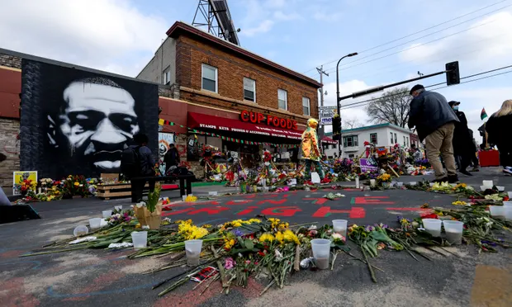
Caption: Derek Chauvin, Thomas Lane, J Kueng and Tou Thao charged Quartet accused of violating Floyd’s constitutional rights
https://www.theguardian.com/us-news/2021/may/07/george-floyd-death-murder-police-officers-civil-rights-charges

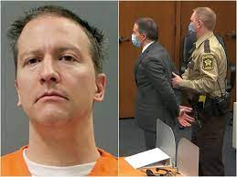
Caption: Derek Chauvin and three others are accused of "willfully" depriving Floyd of the Constitutional right "to be free from an unreasonable force by a police officer."
https://www.nbcnews.com/news/us-news/derek-chauvin-three-other-ex-minneapolis-police-officers-indicted-federal-n1266671

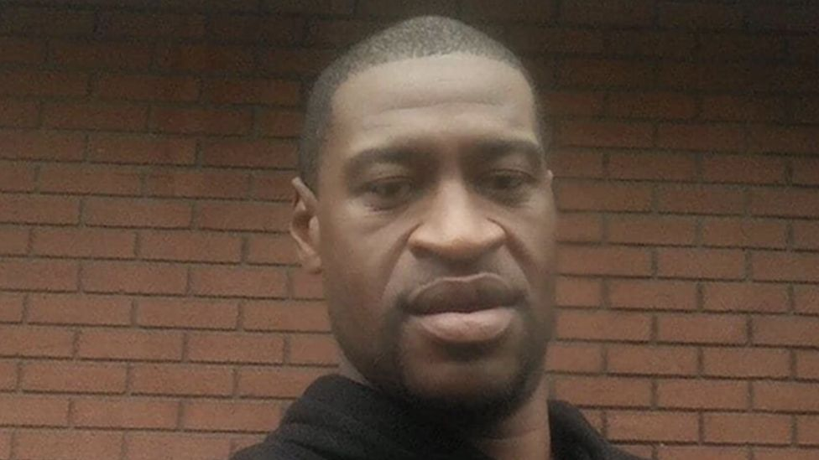
Caption: George Floyd repeatedly told the police officers who detained him that he could not breathe
https://www.bbc.com/news/world-us-canada-52861726

The death of George Floyd
According to the BBC News, George Floyd died moments after being arrested by the police outside a shop in Minneapolis. Evidence drawn from recordings indicate that he died from the effect of the force exerted on him by a white police officer, Derek Chauvin. Bodycam footage showed Mr. Floyd saying he couldn’t breathe for over 20 times. The BBC notes that Floyd was a friendly face who never caused trouble. The moments leading to his death were captured on multiple mobile phones according to this publication. He begged for his life before dying in the hands of the observably ruthless police. Consequently, his death sparked a lot of protests not only in America, but across the world. According to the NBC News, Derek Chauvin and three other ex-police officers willfully deprived George Floyd his constitutional right be free from unreasonable force by a police officer. From this source, according to indictment revealed recently, the four ex-police officers significantly violated Floyd’s civil rights consequently leading to his death. It’s the deadly pressure applied by Derek Chauvin that caused his death. From this incident due to widespread protests, Derek Chauvin has since been charged with second-degree murder. Similar sentiments were also captured in the Guardian news. The paper noted that the four ex-police officers were indicted on civil rights related charges. Derek Chauvin’s actions as he restrained George Floyd face-down on the pavement and he gasped for air are believed to be what caused his death. This is according to this source. Additionally, this source also notes that the four ex-officers were charged for their failure to provide Floyd with immediate medical care. This information is consciously missing from the other sources.

