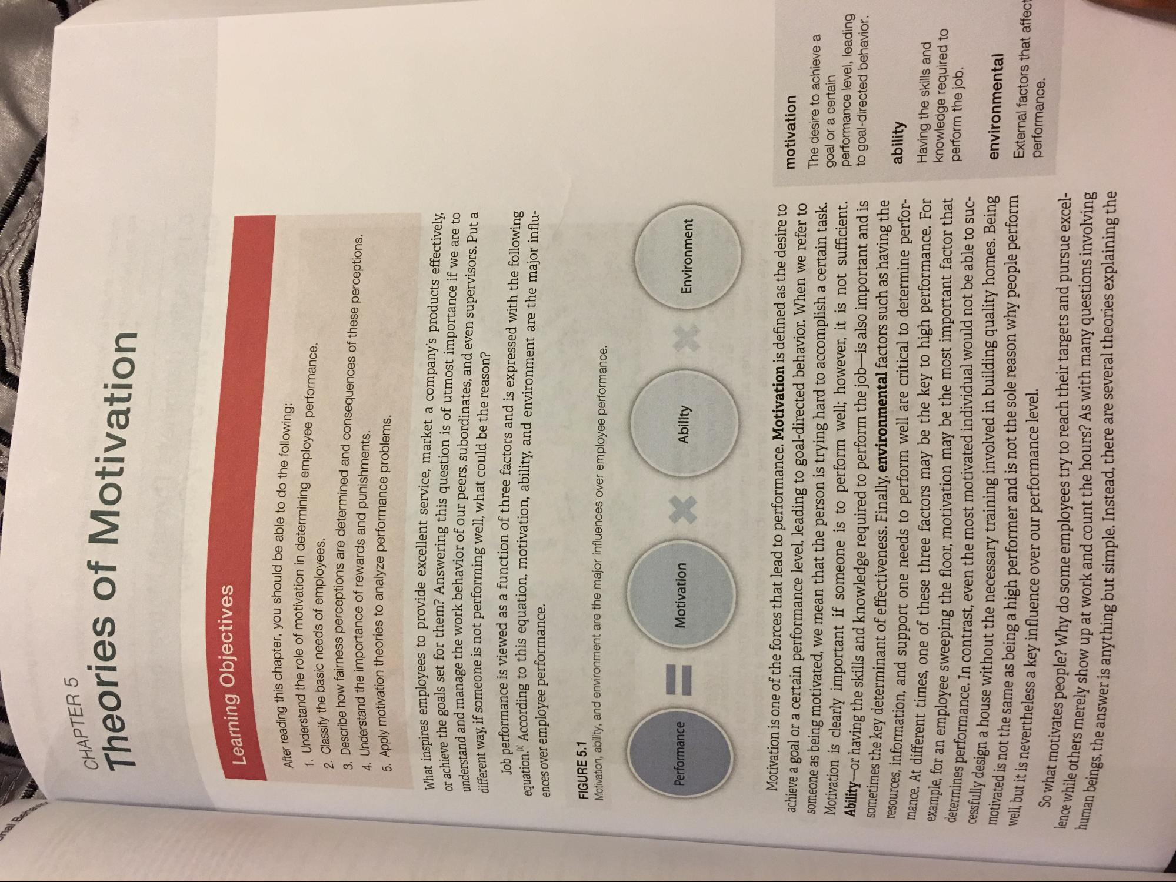
CHAPTER 5 The
eories of Motivation
Learning Objectives
After reading this chapte 1. Understand the role of m
a this chapter, you should be able to do the following:
the role of motivation in determining employee performance.
Classify the basic needs of employees.
ass perceptions are determined and consequences of these perceptions.
3. Describe how fairness pe 4. Understand the import 5. Apply motivation theories
and the importance of rewards and punishments. otivation theories to analyze performance problems.
What inspires employees to provide or achieve the goals set for them? A understand and manage the work h different way, if someone is not perform
molovees to provide excellent service, market a company's products effectively, set for them? Answering this question is of utmost importance if we are to
e work behavior of our peers, subordinates, and even supervisors. Put a omeone is not performing well, what could be the reason?
mance is viewed as a function of three factors and is expressed with the following W According to this equation, motivation, ability, and environment are the major influ
equation." According
ences over employee performance.
FIGURE 5.1
on ability, and environment are the major influences over employee performance.
Environment
Ability
Motivation
Performance
motivation
The desire to achieve a goal or a certain performance level, leading to goal-directed behavior
Motivation is one of the forces that lead to performance. Motivation is defined as the desire to achieve a goal or a certain performance level, leading to goal-directed behavior. When we refer to someone as being motivated, we mean that the person is trying hard to accomplish a certain task. Motivation is clearly important if someone is to perform well; however, it is not sufficient. Ability-or having the skills and knowledge required to perform the job-is also important and is sometimes the key determinant of effectiveness. Finally, environmental factors such as having the resources, information, and support one needs to perform well are critical to determine performance. At different times, one of these three factors may be the key to high performance. For
ple, for an employee sweeping the floor, motivation may be the most important factor that ermines performance. In contrast, even the most motivated individual would not be able to sucdesign a house without the necessary training involved in building quality homes. Being
the same as being a high performer and is not the sole reason why people perform
eless a key influence over our performance level. ivates people? Why do some employees try to reach their targets and pursue excelmerely show up at work and count the hours? As with many questions involving answer is anything but simple. Instead, there are several theories explaining the
ability Having the skills and knowledge required to perform the job.
cessfu
environmental External factors that a performance.
motivated is not the same as being an well, but it is nevertheles
So what motivates people? Why do lence while others merely show up human beings, the answer is anythin

