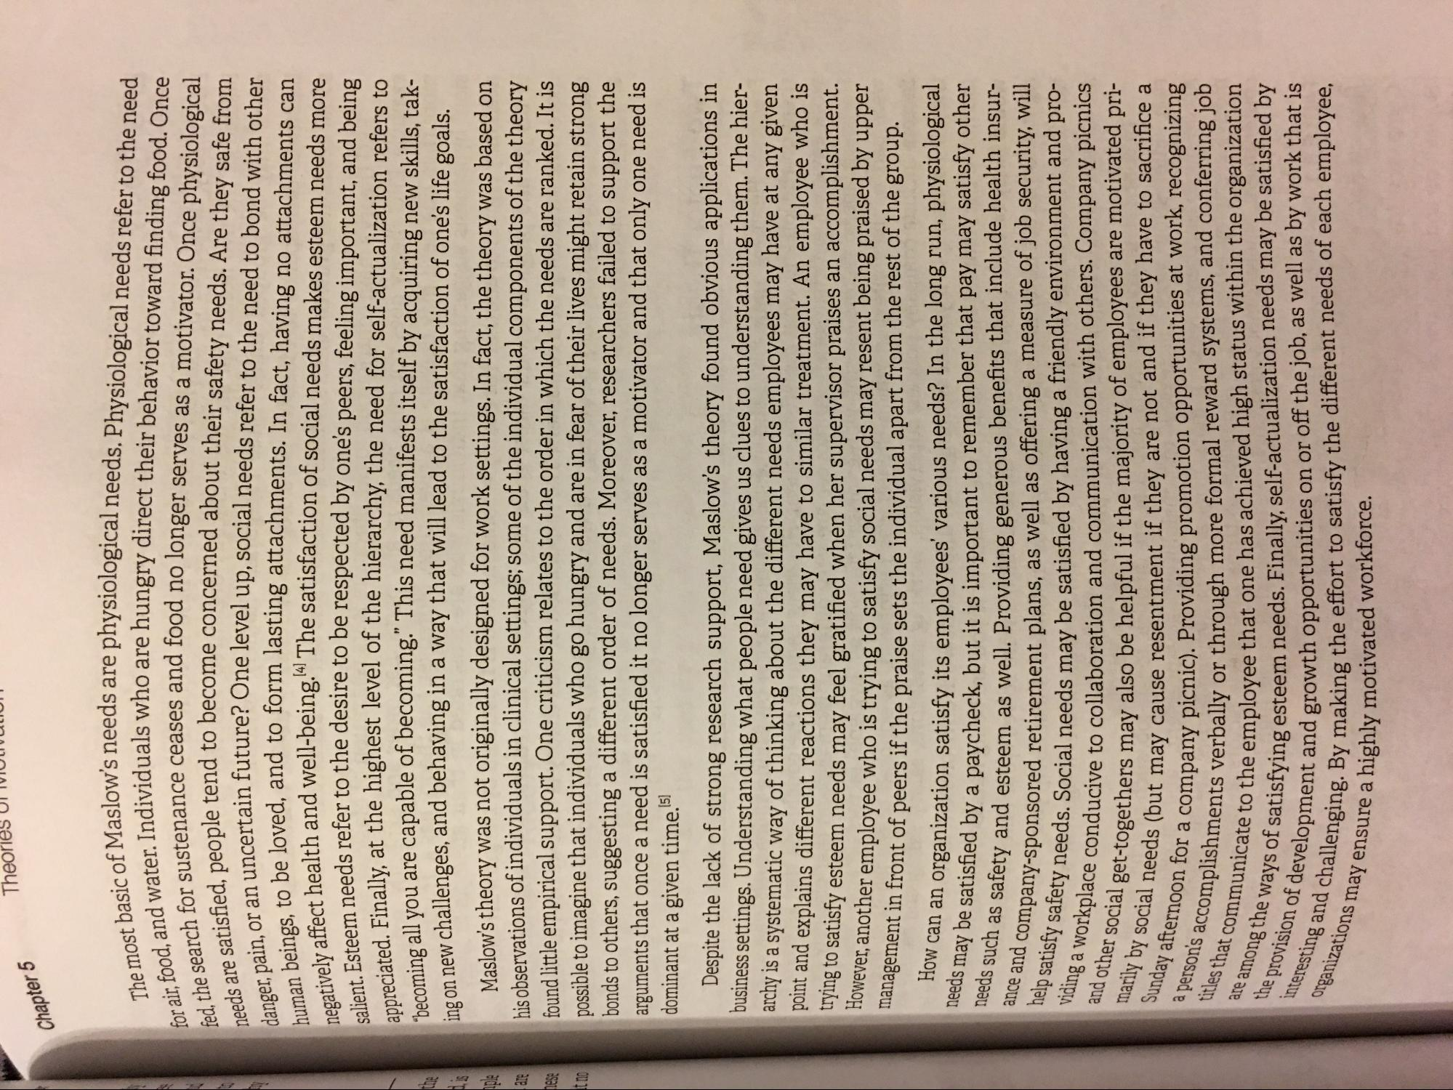
Theories UI IULIULUI
Chapter 5
The most basic of Maslow's needs. for air, food, and water. Individu fed, the search for sustenance needs are satisfied, people tend to danger, pain, or an uncertain futur human beings, to be loved an negatively affect health and wel
Steem
appreciated. Finally, at the hio
slow's needs are physiological needs. Physiological needs refer to the need Individuals who are hungry direct their behavior toward finding food. Once onance ceases and food no longer serves as a motivator. Once physiological
ople tend to become concerned about their safety needs. Are they safe from suncertain future? One level up, social needs refer to the need to bond with other
in he loved, and to form lasting attachments. In fact, having no attachments can
at health and well-being.!4 The satisfaction of social needs makes esteem needs more ***tom needs refer to the desire to be respected by one's peers, feeling important, and being
Finally at the highest level of the hierarchy, the need for self-actualization refers to
call you are capable of becoming.” This need manifests itself by acquiring new skills, takon new challenges, and behaving in a way that will lead to the satisfaction of one's life goals.
Maslow's theory was not originally designed for work settings. In fact, the theory was based on his observations of individuals in clinical settings; some of the individual components of the theory found little empirical support. One criticism relates to the order in which the needs are ranked. It is possible to imagine that individuals who go hungry and are in fear of their lives might retain strong bonds to others, suggesting a different order of needs. Moreover, researchers failed to support the arguments that once a need is satisfied it no longer serves as a motivator and that only one need is dominant at a given time. 5)
Despite the lack of strong research support, Maslow's theory found obvious applications in business settings. Understanding what people need gives us clues to understanding them. The hierarchy is a systematic way of thinking about the different needs employees may have at any given point and explains different reactions they may have to similar treatment. An employee who is .: 343 to satisfy esteem needs may feel gratified when her supervisor praises an accomplishment.
1, another employee who is trying to satisfy social needs may resent being praised by upper management in front of peers if the praise sets the individual apart from the rest of the group.
How
AMIN
can
needs may be satisfied by a pa
han organization satisfy its employees' various needs? In the long run, physiological
satisfied by a paycheck, but it is important to remember that pay may satisfy other such as safety and esteem as well. Providing generous benefits that include health insur
pany-sponsored retirement plans, as well as offering a measure of job security, will nety needs. Social needs may be satisfied by having a friendly environment and prolace conducive to collaboration and communication with others. Company picnics get-togethers may also be helpful if the majority of employees are motivated pri
eas (but may cause resentment if they are not and if they have to sacrifice a or a company picnic). Providing promotion opportunities at work, recognizing iments verbally or through more formal reward systems, and conferring job ate to the employee that one has achieved high status within the organization
satisfying esteem needs. Finally, self-actualization needs may be satisfied by lopment and growth opportunities on or off the job, as well as by work that is
enging. By making the effort to satisfy the different needs of each employee, y ensure a highly motivated workforce.
ance and company-spons help satisfy safety needs. viding a workplace condu and other social get-together marily by social needs (but I Sunday afternoon for a com a person's accomplish titles that communicate to the te among the ways of satisfying the provision of developmen Interesting and challenging.
C
organizations may ensure

