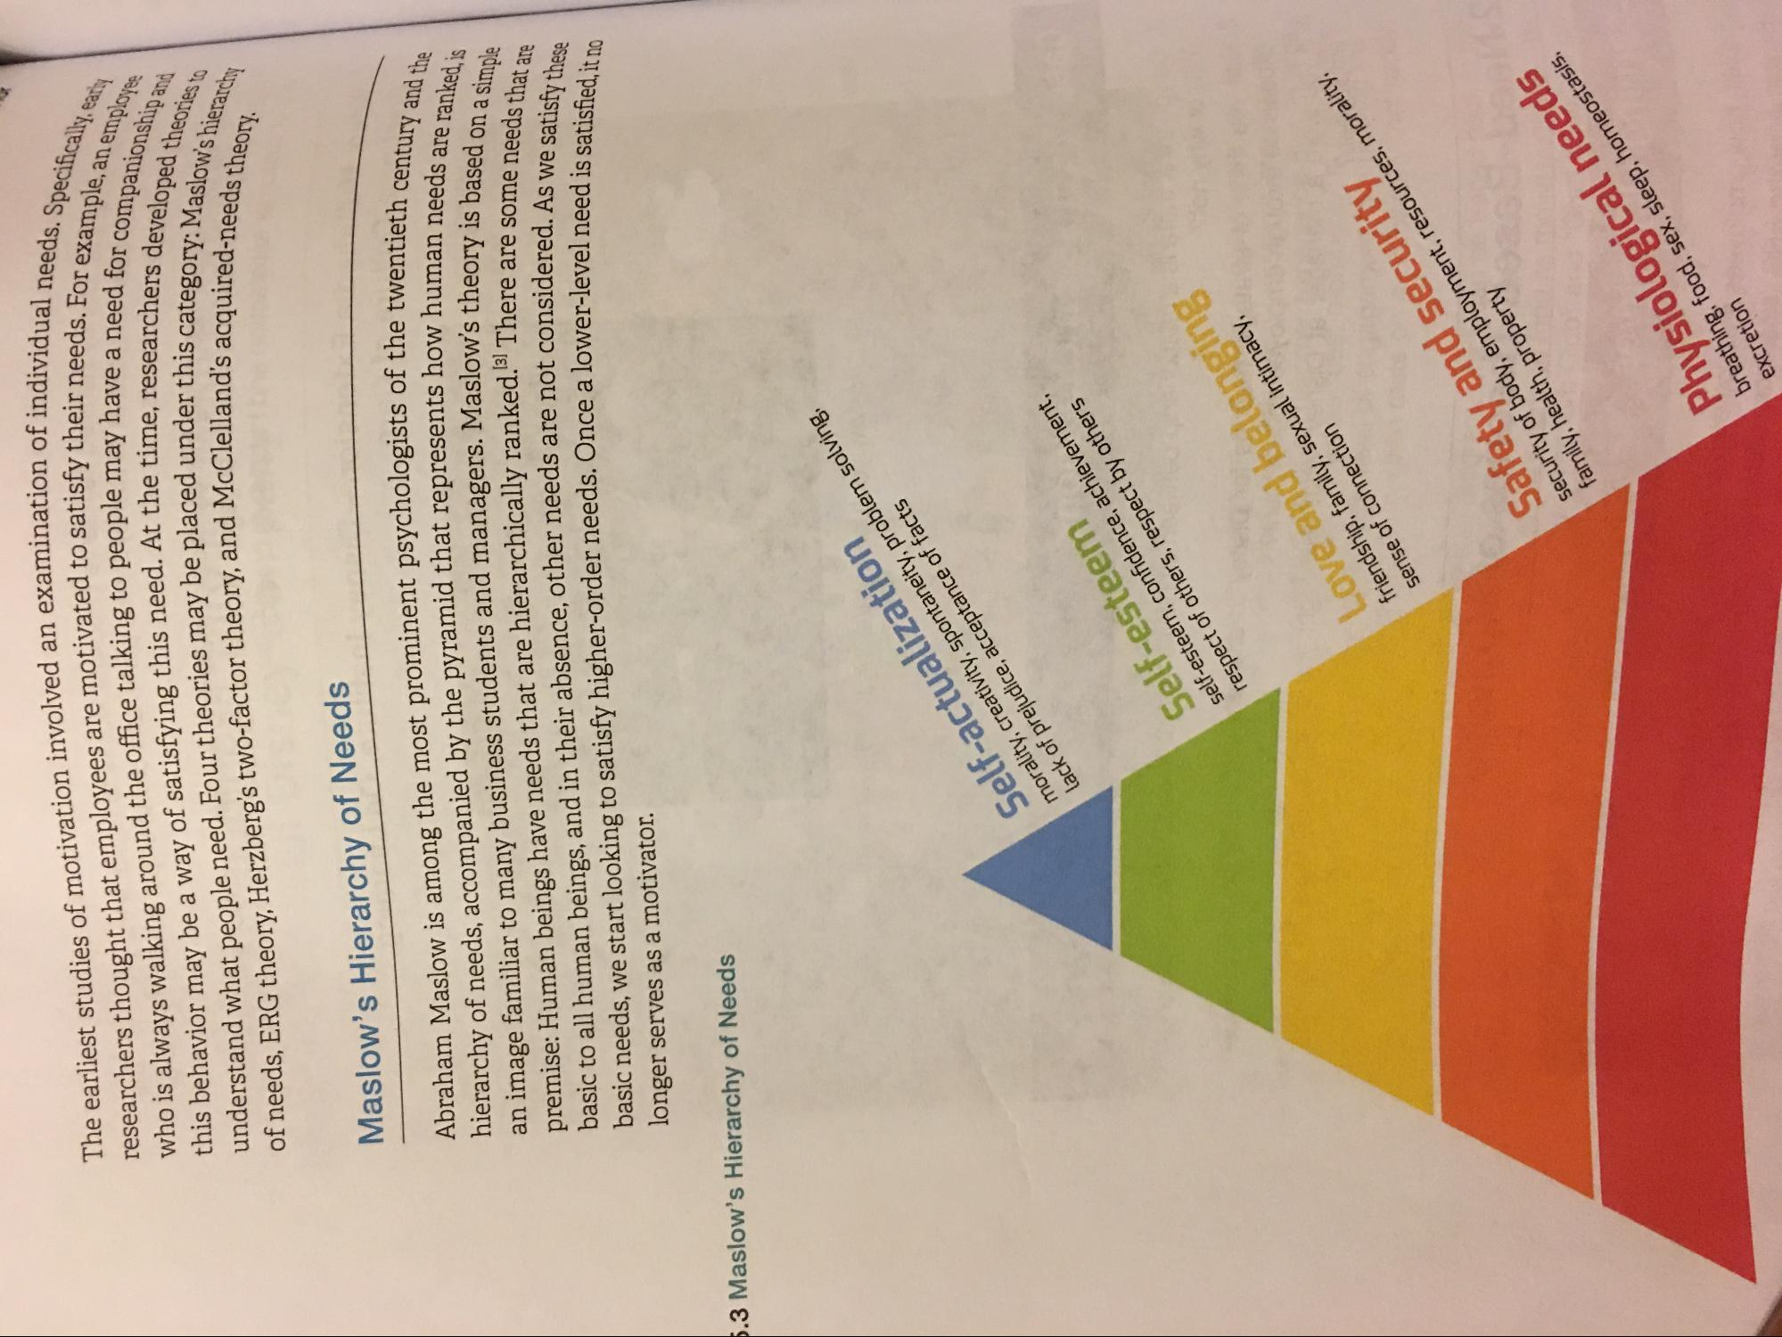
al needs. Specifically, eam
their needs. For example, anem
The earliest studies of motivation involved an examination of individu researchers thought that employees are motivated to satisfy their ne who is always walking around the office talking to people may have this behavior may be a way of satisfying this need. At the time, researchers understand what people need. Four theories may be placed under this ca of needs. ERG theory, Herzberg's two-factor theory, and McClelland's aca
e an employee
need for companionship an
ers developed theories to category: Maslow's hierarches
land's acquired-needs theory.
Maslow's Hierarchy of Needs
Abraham Maslow is among the most prominent psychologists of the twentiet hierarchy of needs, accompanied by the pyramid that represents how human neede an image familiar to many business students and managers. Maslow's theory is based on premise: Human beings have needs that are hierarchically ranked. 3) There are son basic to all human beings, and in their absence, other needs are not considered Acum basic needs, we start looking to satisfy higher-order needs. Once a lower-level need is cst: longer serves as a motivator.
he twentieth century and the
van needs are ranked, is heory is based on a simple There are some needs that are nsidered. As we satisfy these
vel need is satisfied, it no
5.3 Maslow's Hierarchy of Needs
morality, creativity, spontaneity, problem solving, Self-actualization
lack of prejudice, acceptance of facts
self-esteem, confidence, achievement, Self-esteem
respect of others, respect by others
Love and belonging friendship, family, sexual intimacy, sense of connection
Safety and security security of body, employment, resources, more family, health, property
Physiological needs breathing, food, sex, sleep, homeostasis.
excretion

