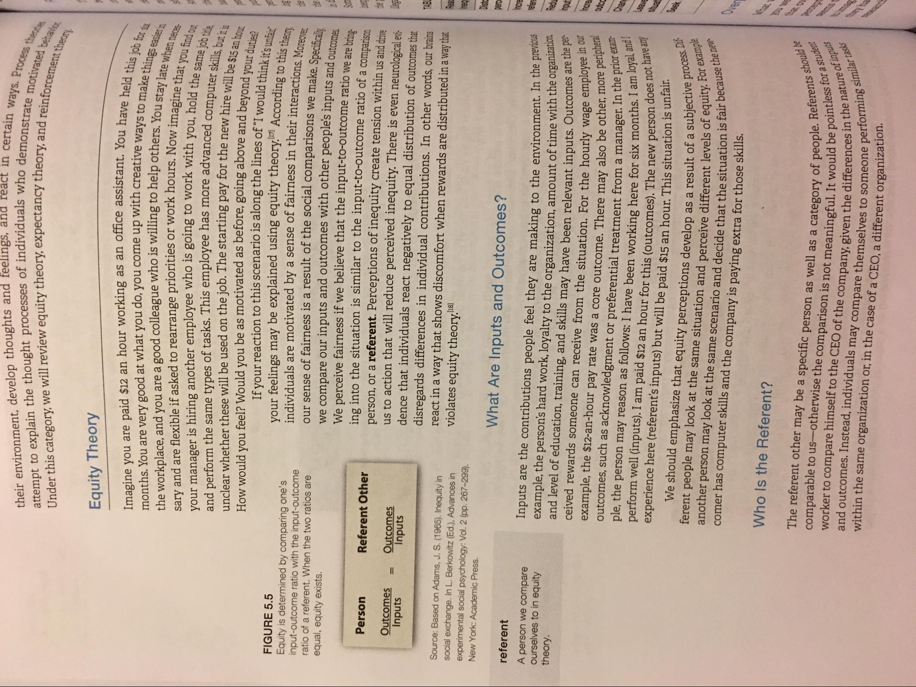
their environment, develop thoughts and feelings, and react in attempt to explain the thought processes of individuals who demo Under this category, we will review equity theory, expectancy theory an
in certain ways. Process
demonstrate motivated be eory, and reinforcement the
Equity Theory Imagine you are paid $12 an hour working as an office assistant. You months. You are very good at what you do, you come up with creative work the workplace, and you are a good colleague who is willing to help others to sary and are flexible if asked to rearrange priorities or work hours. Now ima your manager is hiring another employee who is going to work with you h and perform the same types of tasks. This employee has more advanced come unclear whether these will be used on the job. The starting pay for the new hire How would you feel? Would you be as motivated as before, going above and bevona
If your reaction to this scenario is along the lines of “I would+hi FIGURE 5.5
your feelings may be explained using equity theory..71 According to Equity is determined by comparing one's input-outcome ratio with the input-outcome
individuals are motivated by a sense of fairness in their interactions ratio of a referent. When the two ratios are
our sense of fairness is a result of the social comparisons we make some equal, equity exists.
we compare our inputs and outcomes with other people's inputs and out
We perceive fairness if we believe that the input-to-outcome ratio we are hain Person Referent Other
ing into the situation is similar to the input-to-outcome ratio of a comparica
person, or a referent. Perceptions of inequity create tension within us and drive Outcomes Outcomes Inputs Inputs
us to action that will reduce perceived inequity. There is even neurological evidence that individuals react negatively to equal distribution of outcomes that
disregards differences in individual contributions. In other words, our brains Source: Based on Adams, J. S. (1965). Inequity in
react in a way that shows discomfort when rewards are distributed in a way that social exchange. In L. Berkowitz (Ed.), Advances in violates equity theory.18) experimental social psychology: Vol. 2 (pp. 267-299). New York: Academic Press. referent
What Are Inputs and Outcomes?
tant. You have held this job er
te ways to make things easier in
ors. You stay late when neces. Now imagine that you find out ith you, hold the same job title
ced computer skills, but it is
ow hire will be $15 an hour ve and beyond your duties?
fat would think it's unfair 171 According to this theory heir interactions. Moreover,
ons we make. Specifically
A person we compare ourselves to in equity theory.
input
Inputs are the contributions people feel they are making to the environment. In the prevac example, the person's hard work, loyalty to the organization, amount of time with the organic and level of education, training, and skills may have been relevant inputs. Outcomes at ceived rewards someone can receive from the situation. For the hourly wage empoyo example, the $12-an-hour pay rate was a core outcome. There may also be other, more outcomes, such as acknowledgment or preferential treatment from a manager. In the ple, the person may reason as follows: I have been working here for six months. perform well (inputs). I am paid $12 an hour for this (outcomes). The new person des experience here (referent's inputs) but will be paid $15 an hour. This situation is un
We should emphasize that equity perceptions develop as a result of a subject ferent people may look at the same situation and perceive different levels of equ another person may look at the same scenario and decide that the situation is to comer has computer skills and the company is paying extra for those skills.
are the per
yee in our o be other, more peripheral
ager. In the prior exam months. I am loyal, and I person does not have any
incre Outca
bjective process. Dif of equity. For example n is fair because the new
Who Is the Referent?
ople. Referents should be abe pointless for a student
in the nature of inputs
The referent other may be a specific person as well as a category of people. comparable to us-otherwise the comparison is not meaningful. It would be po and outcomes. Instead, individuals may com worker to compare himself to the CEO of the company. given the differences in
ividuals may compare themselves to someone perform within the same organization or, in the case of a CEO, a different organization
orming similar tasks

