Discussion 9: Core Beliefs and Cognitive Behavioral Therapy with Families
RONALD MOSS
1616 unread replies.1616 replies.

Think About What You Think

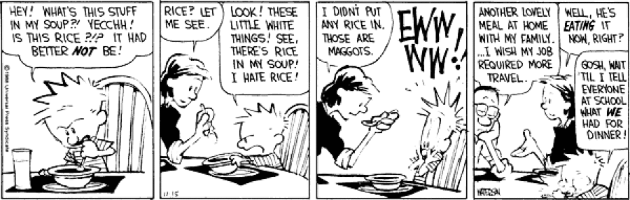
“After a good dinner one can forgive anybody, even one's own relations.” ~ Oscar Wilde

Food For Thought...
Being aware of unhealthy patterns of interaction means that there is room to disrupt unhealthy cycles and create healthier ones.
Think about this statement as you watch the video and complete the rest of the assignment. Make sure you follow "the instructions."

The Prompt
Behavioral family therapy (BFT) or cognitive behavioral family therapy is a form of family therapy (Links to an external site.) based on the application of the principles of cognitive behavior therapy (Links to an external site.) and learning theory (Links to an external site.) to the family (Links to an external site.) setting. Cognitive behavioral family therapy posits that the thoughts, emotions, and behaviors of each family member impact each other in a cyclical way leading to negative core beliefs. Core beliefs can be both conscious and unconscious negative beliefs that each family member holds true about themselves. These core beliefs can create problems that are often the result of operant conditioning. (Links to an external site.) Operant conditioning reinforces negative behaviors within the family’s interpersonal social exchanges that extinguish desired behavior and promote incentives toward unwanted behaviors, which can lead to irrational beliefs and faulty family schemas (Links to an external site.).

The Instructions
- Watch the "What Is CBT?" video here.
- Referencing the video, your textbook, and other resources (Links to an external site.) discuss the advantages and limitations of cognitive behavioral therapy with families.
- What are schemas (Links to an external site.) (pg. 134) and how might they impact a family member's core beliefs (Links to an external site.)?
- Reference your source(s) of information in your reply.
- Respond to at least two of your classmates.
- Word count is 300 - 500 words.

