Think About What You Think

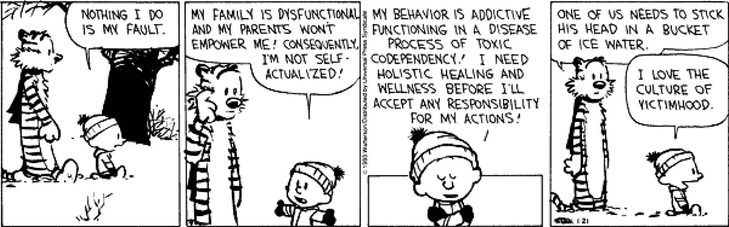
"If you are stuck with a person who is infected with perpetual victimhood, no matter how much you try to help them, you will always be projected as the oppressor.” ~ Shunya

Food For Thought...
Can someone develop a new group identity that causes conflict with the group and / or one’s original cultural identity?
Think about this question as you watch the video and complete the rest of the assignment. Make sure you follow "the instructions."

The Prompt
Membership has it privileges. Think of high school and jocks, nerds, stoners, drama clubbers, and even mean girls. Each clique has its own uniform, expressions, and cultural identity markers. Consider other cultural identities such as religion, socioeconomic status, regional locale, and all of the possible intersections. These "universal" cultural groupings may have fuzzy boundaries that render group inclusion criteria messy and unclear.
The Instructions
- Watch Jessica Dere's TedTalk video, "Challenges and Rewards of a culturally-informed approach to mental health," here.
- Using the video, your textbook, and other resources discuss whether you think it is or is not important for a group to develop its own cultural identity during the storming / norming phase. Why? Why not?
- What is empathizing, and what is its importance to group development and norming?
- Reference your source(s) of information in your reply.

Your Response
- Your response should be a minimum of two complete paragraphs.
- The assignment due date is Sunday, March 7, 2021 at 11:59 pm.

