FALL 2020 ART 275 – CERAMICS (TRADITIONAL & CONTEMPORARY) RESEARCH PAPER

TRADITIONAL CERAMICS

- CLAYAKAR: https://www.clayakar.com/pages/creators
- The Archie Bray Foundation: http://archiebray.org/residence_program/past_residents.html
- Northern Clay Center: https://www.northernclaycenter.org/exhibitions
- The Clay Studio: https://www.theclaystudio.org/artists-index
- Red Lodge Clay Center: https://www.redlodgeclaycenter.com
- Santa Fe Clay: https://fireboxstudios.co
- Ferrin Contemporary: https://ferrincontemporary.com/artists-2/
- Schaller Gallery: https://www.schallergallery.com

Please Define “Traditional Ceramics” and You Will Choose A Total of 5 Artists/Works/Images (EACH FROM DIFFERENT SITES):

- 3 that are inspiring to you
- 1 that you would like to replicate it
- 1 that you do not like it

Each work image should include the artist's name, work information, and idea, material, process, concept; if that information is not readily available on the site, you must research the artist by visiting their website and making your best educated guess, otherwise you will not receive full credit.

You should describe why it is inspiring to you, you would like to replicate, and you do not like it. BE SPECIFIC and use ceramic vocabulary to articulate appreciation despite your preferences.

CONTEMPORARY CERAMICS

- CLAYAKAR: https://www.clayakar.com/pages/creators
- The Archie Bray Foundation: http://archiebray.org/residence_program/past_residents.html
- Northern Clay Center: https://www.northernclaycenter.org/exhibitions
- The Clay Studio: https://www.theclaystudio.org/artists-index
- Red Lodge Clay Center: https://www.redlodgeclaycenter.com
- Santa Fe Clay: https://fireboxstudios.co
- Ferrin Contemporary: https://ferrincontemporary.com/artists-2/
- Schaller Gallery: https://www.schallergallery.com

Please Define “Contemporary Ceramics” and You Will Choose A Total of 5 Artists/Works/Images (EACH FROM DIFFERENT SITES):

- 3 that are inspiring to you
- 1 that you would like to replicate it
- 1 that you do not like it

Each work image should include the artist's name, work information, and idea, material, process, concept; if that information is not readily available on the site, you must research the artist by visiting their website and making your best educated guess, otherwise you will not receive full credit.

You should describe why it is inspiring to you, you would like to replicate, and you do not like it. BE SPECIFIC and use ceramic vocabulary to articulate appreciation despite your preferences.

EXAMPLE: CERAMICS (TRADITIONAL & CONTEMPORARY) RESEARCH PAPER: Traditional Ceramics

ART 275 00 – Student Name

I’m defining “traditional” ceramic works in a broad sense, because I thought, what really defines this line? There seems to be various overlaps where more than often a piece can be both contemporary and traditional. In some ways, I think traditional ceramics can be defined by which historical moments it connects to: how the piece is made or what it looks like. But pieces are made all the time that reference art history (I think that’s the case for all art actually) and they can still be considered contemporary. Function sometimes defines traditional works, because in many institutional standards, it draws the line between high and low art: but this all depends on how you define the purpose of art. Is it to be untouched, and viewed only in a sterile, white-walled gallery, or is it handled and cared for, communally with others?

So for the purpose of this assignment, I’m going to define traditional as: work which draws upon ancient ways of making and styles of ceramics and is not outwardly interested in making social or political conceptual commentary about the modern world.

Traditional 1: Inspiring

This bowl by Bede Clarke was made with hand-building techniques in earthenware clay body, and decorated with hand drawn
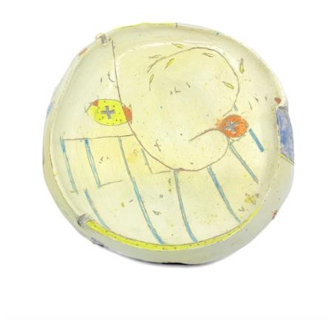
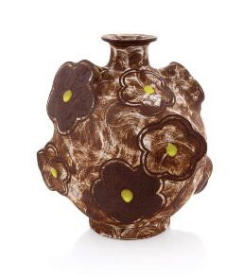
sgraffito drawings. The piece isn’t so concerned with looking perfect, and therein has this innate charm to it.

Clarke describes his earthenware pieces: “Pots and the vessel have held the center but there has been a strong overlay of interest in drawing, color and leaving a trace of the hand. In this work I am trying to occupy the world that has always made the most sense to me, the little world, which paradoxically holds such huge potential for joy.” On his website, Clarke also discusses his relationship to art and philosophy and art and poetics: how these connect art to our daily lived ideas.

I’m inspired by it’s overall humbleness and softness. It is playful, unconcerned and childlike. It’s traditional to me, because it doesn’t overtly reference the modern world in terms of technology, imagery, or contemporary social and political views.

Bowl by Bede Clarke. 13” x 13” x 3” Earthenware, porcelain slip, glaze.

Traditional 2: Inspiring

This piece by Sam Chung is actually kind of different from what he’s known for, which Is white cloud-like vases with graphic lines. This piece still as similar construction, but its color and subject matter is different. He explains that he works with the vessel form “...to exploit its universal identity and impart my own vision of merging historical, contemporary and cultural influences.” Chung say that he is curious “...about finding relationships between various forms of creative expression ranging from art, traditional craft to design.” So this piece could be both traditional and contemporary, in my eyes, given his description of the ideas that inform his works.

Sam Chung, Flask with Green Dots. Stoneware, slip, sgraffito, glaze, 8.5 x 6 x 9.5” H

His recent pieces draw from Korean art and design influence, with clouds being a symbol traditionally depicted in Korean art. So, in many ways he is talking about his cultural histories but talking about them with the contemporary world in mind. Chung’s process for these vases is mostly wheel thrown. “My current work is wheel-thrown...,which is then cut, altered, and assembled from parts.” He says once the clay is leather hard, he lightly sketches the cloud shapes to cut them later. For decoration he uses slip, various glazes and sgraffito techniques.

This piece is inspiring to me because I like the ways it merges contemporary and traditional. It has some pop element as well, that play along well with this idea of merging old and new. And overall, I like the balance of graphic and painterly glaze application.

Traditional 3: Inspiring

I’m inspired by the simplicity of this design, and its reference to both folk and the black-figure style Greek pottery. I think there’s something that also reference expressionism, and maybe even printmaking techniques. All of this in the extremely universal form of a jar. After looking at his other works, too, I just really enjoy this artist’s style: he has other pieces that I like much better than this one, even.
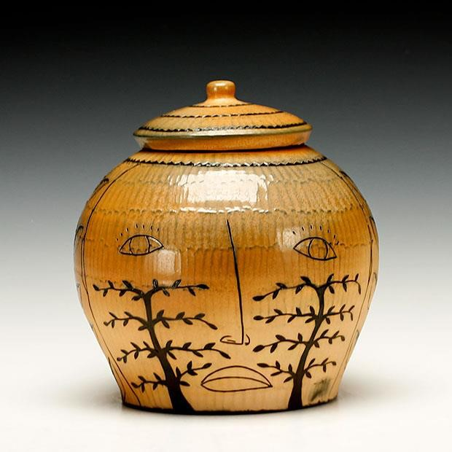
Matthew Metz describes in his website bio his concepts and thoughts behind his work, which are straightforward and makes a lot of sense to me: “Our culture tends to look at decoration as embellishment without meaning- frosting on the cake. While I resist applying direct narrative and literal definition to my iconography, the patterns and images I choose come from my life and experience. Interest in the natural sciences (evolutionary biology, ethology) and history
(archaeology, physical culture) find there way, obliquely, into the work. A coffee cup has as much capacity to carry meaning as any other form of expression.” I think it’s important to be thinking about the life of the object you created and I think he does that. Partly why I find his work traditional is because of what he says: he’s working with the medium in a way that is intuitive and the meaning and concept comes naturally---while he is using traditional vessel forms as a blank canvas, almost.

Metz’s process is working with a black stained porcelain claybody, then adding slip, drawing with sgraffito technique. This piece in particular was salt fired.

Jar by Matthew Metz. Salt Fired, black stained porcelain with slip.
7.75x7”

Traditional 4: One to replicate

This piece by Kurt Weiser does a similar thing to Sam Chung’s piece, it dances the line on what you could call contemporary and traditional. It definitely contains elements of both, but what I think makes this piece verge on the traditional side is not just its teapot form but its narrative nature. The piece is asking you to decode some meaning, and that element is in so many very very early ceramic works. I also think it references many other moments in art history, like old etchings or even surrealism. This feels like a long lost Albrecht Durer etching but maybe a bit more schizophrenic looking.

Weiser’s conceptual framework is built around his perspective of, consciousness, for lack of better word, he says “the ideas and subjects of these paintings on the pots are for the most part just a collection of my own history of fantasy and view of reality. They are built the same way we dream: around a central idea, a cast of characters and environments just seem to show up to complete the picture.”

The process of making his pieces is with a porcelain clay body, the decoration requires careful planning of the order and placement of the china paint colors and then overglazing. This takes multiple firings.

I’d like to recreate this because I enjoy this very sensorial overload of visual information. I’d also like to consider the surface of a vessel the way Weiser does, almost as if it were a painting.

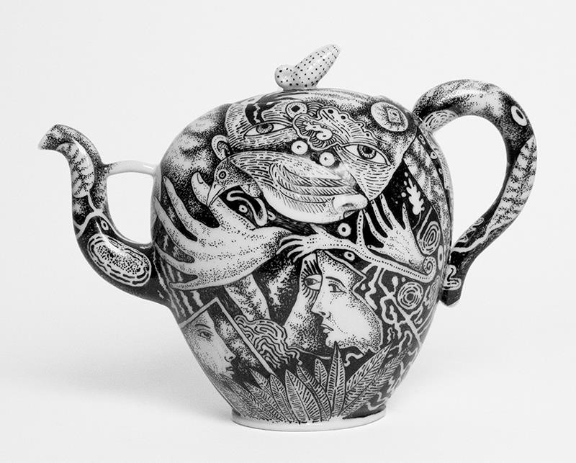
Kurt Weiser, “Teapot (Illustrated Black & White) 2017, porcelain, china paint, 8.5 x 11.5 x 4.5”.

Traditional 5: One I don’t like as much

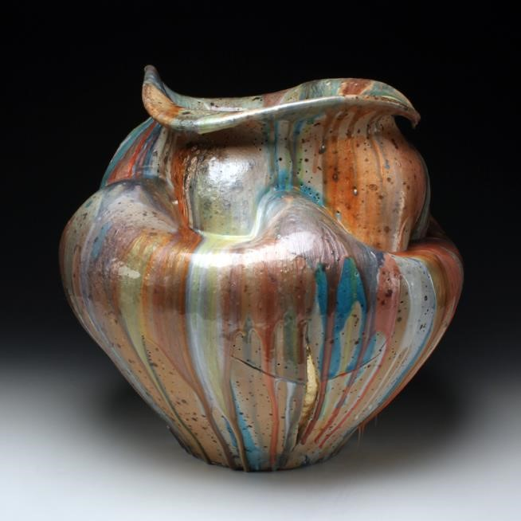
It was really hard to find something I actually dislike, and I think this is as close as I could find to disliking something. This is a piece by Perry Haas, Large moon Jar with Resin. I tried to find information about this artist’s conceptual interests but I really couldn’t find anything! I think the form is unique, and sometimes the resin or glaze drips in a pleasing way. Other than that, I feels to me that these were made from a lack of inspiration for the sole reason that all his works look so similar. Perhaps his intentions were more for commodity than for art-making. I’m sure I am pretty uneducated on how this form was made, and it’s simplicity is likely very difficult to accomplish.

I think this piece is traditional because it doesn’t really do much else than exist as a decorative vessel, and really has no conceptual influence that I could find. If anything, the artist says he is interested in how working with a wood kiln makes his pieces surface unpredictable. Haas also explains how “his work expands with movement and fluidity, and how these two interact with one another.”

Large Moon Jar with Resin, 16.75 x 16.25", porcelain, wood fire, electric fire with glaze, resin, and gold leaf

For the process Haas wood fires as porcelain clay body to get varying surface details, I’m not sure how incorporates resin, as his process is not articulated anywhere on the site. I’m guessing that he pours it on afterwards and likewise with the gold leaf.

References:

- https://fireboxstudios.co/bowl-bede-clarke/
- http://www.bedeclarkestudio.com/bedeclarkestudio.com/paper.html
- https://www.clayakar.com/collections/artist-sam-chung/products/chung2009
- https://ceramicartsnetwork.org/daily/pottery-making-techniques/wheel-throwing- techniques/sam-chungs-wheelthrowing-and-altering-process/
- https://www.clayakar.com/pages/artist-matthew-metz
- https://www.schallergallery.com/exhibition-detail/604/29/40/198/Ron-Meyers-Student-Support- Fund-An-EndowmentFund-at-the-University-of-Georgia/Matthew-Metz/Jar
- https://ferrincontemporary.com/portfolio/kurt-weiser/#jp-carousel-8835 https://store.redlodgeclaycenter.com/collections/perry-haas/products/large-moon-jar-with-resin https://www.perryhaasceramics.com/process

