Difference between takaful and conventional insurance

Name of Student
Institution Affiliation
Course
Date

Basic insurance is a contract the insurer has agreed to, hence deciding to pay a sum of money to a policyholder on the occurrence of a specific event. Therefore, a conventional insurance policy is an insurance policy that offers plans such as returns that are guaranteed at the maturity time by the policyholders. That is investing in avenues that offer risk, which is low in returning risk. At the same time, takaful insurance is Islamic insurance whereby the members decide to contribute money into a system known as the pool, which guarantees the members of damage or loss against each other. Even though both conventional and takaful insurance companies have the same goal of protecting the members, there are differences which are discussed below.
The sharing of profit and loss is the first difference between takaful and conventional insurance whereby, the members of takaful are allowed to retain the ownership interest in the takaful fund. Moreover, the members’ contributions are invested in Sharia’s complaints fund to derive the income of an investment. In case there is a surplus generation, the members get to share the revenue and other times, the members do charity work. However, in conventional insurance, the generated surplus belongs to the shareholders.
Investment is the second difference between takaful and conventional insurance, whereby investment units in traditional insurance is based on what fits the profiles in the evaluation. In contrast, investment in takaful goes after strict ethics. Also, anything that has the basics of ambiguity, gambling or lending money on a high-interest rate, takaful cannot invest in them. Another difference is that the established insurance company purchases personal financial security. At the same time, in takaful, an individual enters the contract to give a fund to facilitate the people going through an unpleasant time.
The basis of conventional insurance in the contract is not for mutual help; the members decide to contribute money to help a member when needed. Instead, the insured person transfers their risk to the insurer, which is transferred to the reinsurance operators. Hence, the conventional insurance company gives a selfish atmosphere since there is no support. While in takaful insurance, the risk is shared among the members. Takaful promotes solidarity by cooperating in the community by setting aside financial gains.
Another difference that makes conventional and takaful insurance differ is that the payments for the agents are paid from the paid premiums of the insured in traditional insurance. In contrast, the company pays the agents since they work for the company in the takaful. Also, in an established company, there are no rights for the policyholders to vote in the choosing of directors of the company or even get the chance to see the company's annual accounts. Whereas in takaful insurance, all the facilities, including the voting of the company's directors and seeing the company's annual reports, are available to everyone who pays the given amount of premiums.
In Takaful insurance, in a situation where the assured has died before the maturities policy, the entitlement of the whole amount of the premiums, bonus, dividend, confirmed part of the share of the profits made overpaid premiums and, a donation from the contribution of the policyholders, given on the tabarru basis form the company is given to the beneficiary. The contribution is treated as an agreed contribution for the helpless in society. But if the insured is still alive, then the entitlement goes to them. While conventional insurance, the interest is given to the policyholder, that is, if the insured is still alive. But if they are dead, then the beneficiaries, that is, company, trustee, family get the payment, as seen in the image below.
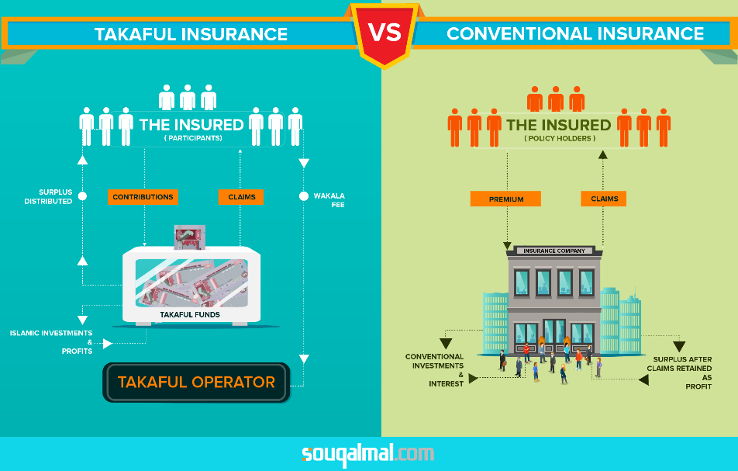
The desire of making a profit is the motivation of the established insurance company. In contrast, in Islamic, the insurance companies do not make profits and the shareholders are not allowed to share the profits from the business even though the shareholders are allowed to charge for the services they offer and, in return, share in the recovery of funds in investment which they manage.
Conventional insurance has the characteristics of gambling which makes the insurance uncertain. A tremendous amount of money is received from the insurer to the insured, informed of premiums paid. So, after filling a few claims, the insured loses the bonuses while the insurer wins, but when there are more fillings of shares, then some payback for their premiums is issued to the insured thereby, the insurer gets in trouble.
Takaful companies are governed by a board known as the shariah board, which is in charge of supervising the companies' operations and, therefore, improving the development of new products. Products use the relationship of the principal-agent, the partnership model and the combination of both partnership model and principal-agent. The takaful is then in charge of taking care of the funds based on the wakala contract, and the latter investing the funds based on the mudharabah contract, as shown in the image below.
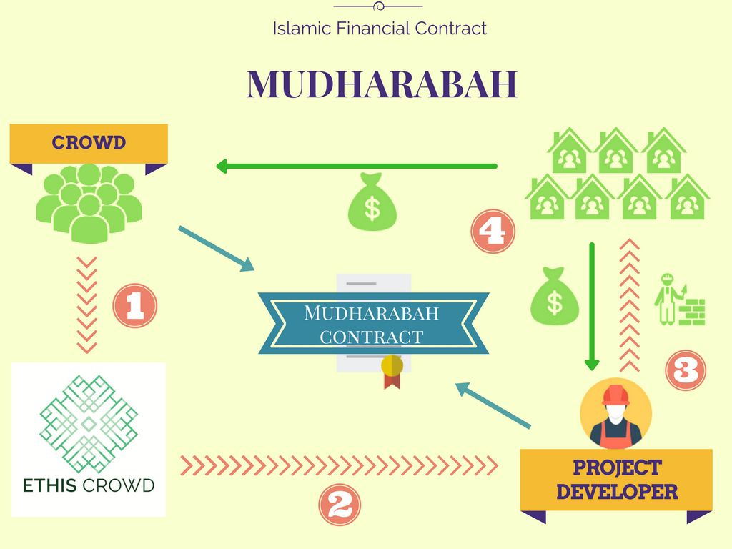
The relationship between the risk and the return in conventional insurance is inverse in that the higher the chance is equal to the higher in return and vice versa. Since the insurance business is risky, the person should be qualified and skilled staff to run the company. Moreover, huge profits are made through managing the risk of loss. The government supports four types of insurance policy: the agricultural policy that covers the perils that threaten the national plant's factories, the banking insurance policy in charge of the dangers that threaten the banking industry, and the private insurance policy and the terrorism policy.
To be free from the Gharar, the contract in takaful insurance should be full disclosure to the subject to have complete clarity, even at that, the exchange is Gharar is avoided since it is not practicable among the parties making the contract. Gambling, therefore, is a form of Gharar whereby it does not allow the transfer of risk based on speculative. Also, equal participation is circumvented from the extra amount payable by Riba. Also, following the Shariah principles, the collected funds should be managed and invested.
The form of conventional insurance known as they buy and sell is not the same as the selling and buying that is found under shariah. In the state of convention, lopsidedness is seen, resulting in an advantage known as contractual injury. The contractual damage is against the excellent virtue and fairness doctrine, while takaful insurance is in charge of cooperating the principles found in the joint help, solidarity and cooperation. Takaful ensures working together with a common goal through donations, which serves as the need’s requirement.
Takaful involves the evaluation of loss and the determination in the premium's contribution commensurate with the total risk, thereby exposing the pool for the provision from the disproportionate losses. While the conventional model, the premium is risk-based since the takaful insurance envisages sharing the pooled risk equally, which is in the principles of cooperation.
There is no transfer of risk in takaful insurance, whereas conventional insurance deals with the exchange of uncertainty for certainty. The relation of tension is whether a loss will occur or not, and in a case where the failure occurs, when and how the loss will occur, then how many casualties will occur within a specified period. Moreover, conventional insurance foresees in the payment of premiums fixed by the insurance to the insurance company who is in charge of paying the loss if it occurs, which is within the policy terms of the ambit.
Therefore, takaful always makes sure to avoid risk by the insured participants to the operator, thus facilitating risk sharing among the participants under the scheme of mutual agreement. The operators in takaful merely act as participant’s agents, ensuring that the payment contribution is made equally and that the victims from the loss are compensated with the right amount, which is also referred to as the Iqbal.
Conventional insurance, which is non-mutual, makes sure that the premium is calculated, covering the profits and claims speculated as akin to maisir in shariah. Therefore, the insured pays the premium considering the insurer indemnifies those insured against risks that may or may not occur. The uncertainty makes it Gharar is Islam and, therefore, cannot be included in any activities. However, the insurer is in charge of investing the premium collected for interest and the industries prohibited by Islam.
Ta-awum, the mutual assistance that is supposed to be voluntary, also known as the Tabarru, is almost like the conventional mutual insurance whereby the members pool their funds to insure each other. The losses made is made out of the funds that the policyholders donate. Thereby, the burden is on to the insured. The policyholders become owners of the funds and are eligible to participate in the profits in a proportion that would vary from one model to another through donating the contributions.
In summary, although both conventional and takaful insurance share the same objective, the difference is seen in the distribution of surplus and the allocation of investments. Also, in the performance, conventional insurance performs better than takaful insurance in terms of performing financially and efficiently in managerial.

Reference
Rubio-Misas, M. (2020). Ownership structure and financial stability: Evidence from Takaful and conventional insurance firms. Pacific-Basin Finance Journal, 62, 101355.
Alshammari, A. A., Alhabshi, S. M. B. S. J., & Saiti, B. (2019). The impact of competition on cost efficiency of insurance and takaful sectors: Evidence from GCC markets based on the Stochastic Frontier Analysis. Research in International Business and Finance, 47, 410-427.
Nobanee, H., & Ellili, N. (2020). Anti-bribery information: extent and impact on banking performance of UAE Islamic and conventional banks. Journal of Financial Crime.
Ellili, N., & Nobanee, H. (2017). Corporate risk disclosure of Islamic and conventional banks. Ellili, N, Nobanee, H.(2017) Corporate Risk Disclosure of Islamic and Conventional Banks. Banks and Bank Systems, 12(3).

