Name:

Ionic vs. Covalent Virtual Lab
Essential Question: How can electrical conductivity be used to identify type of bond?

Reading Questions (6 points):
- What is conductivity? How can electrical conductivity be measured?
Conductivity is the measure of dissolved material in aqueous media, which denotes the ability of that solution to conduct an electric current. It can be measured using a probe or a meter.

- What does an electrical conductivity probe consist of?
A probe is made up of two electrodes that are placed 1 cm apart

- How does an electrical conductivity probe work?
The probe is supplied with a constant voltage across the two electrodes, which allows an electric current to flow through the aqueous solution.

- What is current flowing through the water proportional to?
The amount of current flowing through the solution is proportional to the concentration of dissolved ions.

- What happens when there is a higher dissolved salt/ion concentration?
More current will conducted and thus recording a higher electrical conductivity.

- What is an electrolyte?
An electrolyte is any substance that can dissociate into ions when dissolved in water to give the solution an electrical conductivity.

Go to the following link to download the virtual lab: https://phet.colorado.edu/en/simulation/legacy/sugar- and-salt-solutions (or google search “Sugar and Salt Solutions phet”)
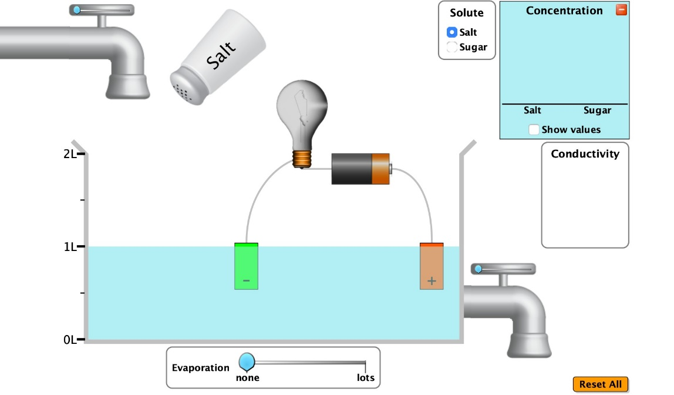
Evaporate Water
Reset Button
Conductivity
Meter
Release water
Concentration
Change solute type

Part 1: “Macro” Tab (5 points) – FOR ALL SECTIONS, IF YOU CANNOT DRAW A MODEL THAT IS OKAY. YOU WILL NOT BE MARKED DOWN FOR LEAVING THE DRAWINGS BLANK
- Drag the conductivity meter and place the positive (+) and negative (-) ends in the water. Click on “show values” in the concentration section.
- Draw a model to illustrate what happens with just pure water in the model section.
- Use the “solute” section to add salt to the water. Observe what happens to the conductivity meter

- Change evaporation to “lots” until you have reduced the water to approximately 0.50 L solution. Observe what happens to the conductivity meter.

Conductivity Model Pure Water | Questions
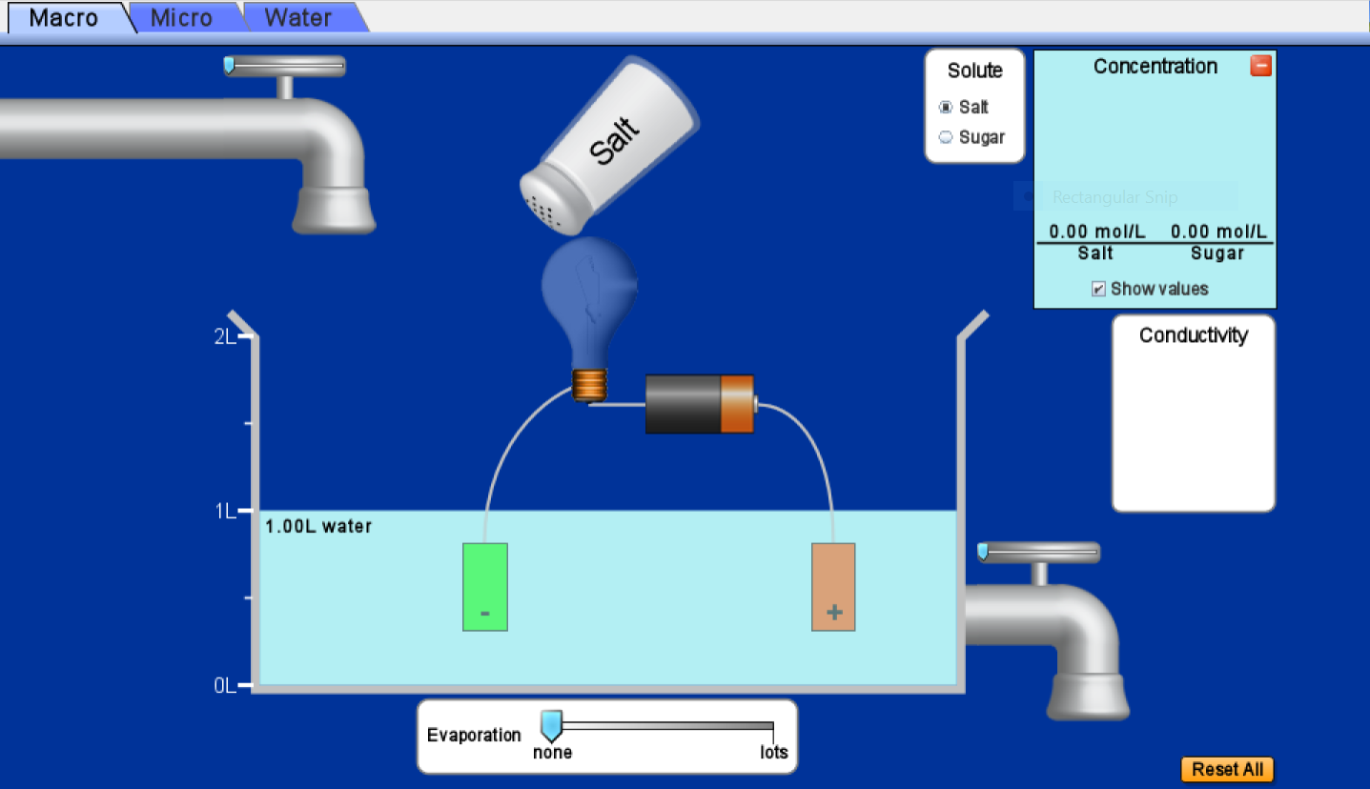 | What happens to the conductivity meter?  It does not change at all  Does this solution conduct electricity?  No  Does changing the amount of water aﬀect conductivity?  No

Conductivity Model Salt Water (not evaporated) | Questions
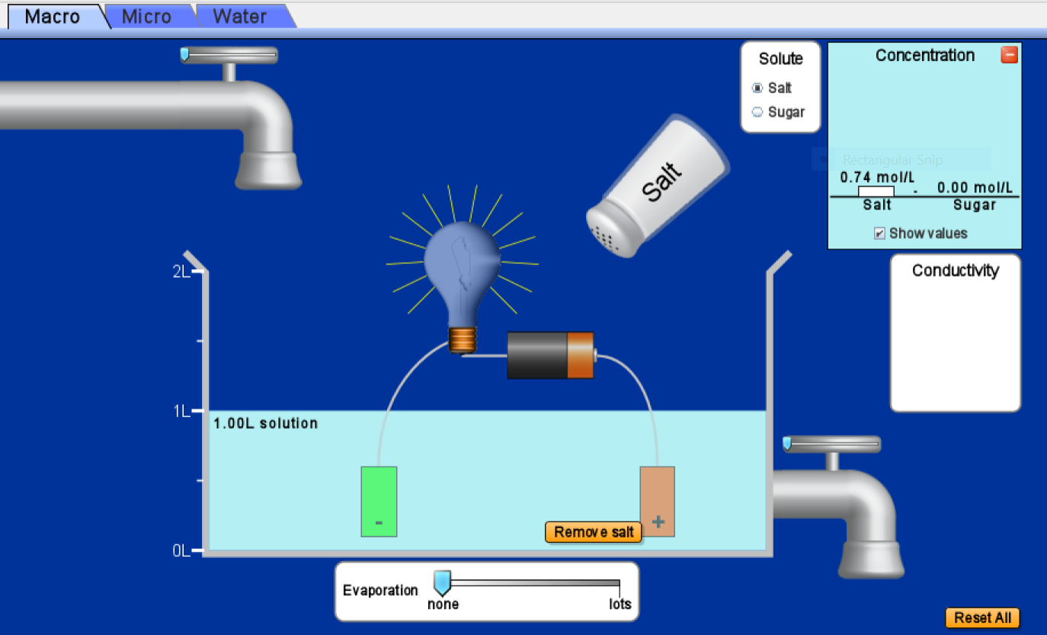 | What happens to the conductivity meter as salt is added?  It begins to record some current and increases as more salt is added.  Does this solution conduct electricity?  Yes  Does changing the amount of salt aﬀect conductivity?  Yes

Conductivity Model Salt Water (evaporated) | Questions
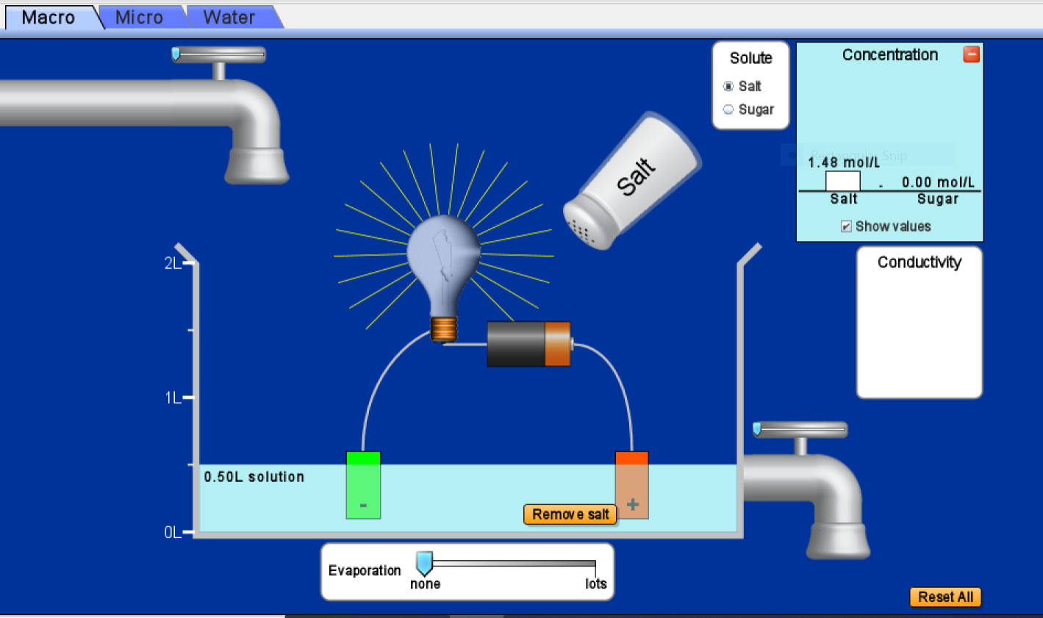 | What happens to the conductivity meter as water is evaporated?  The conductivity increases  Does this solution conduct electricity better or worse?  It conducts better  Does changing the amount of water aﬀect conductivity?  Yes

- Click “Reset All”, drag the conductivity meter into the solution again. Select “Sugar” as your solute and add the container of sugar to the solution. Draw a model in the next section to illustrate your observations.
- Change evaporation to “lots” until you have reduced the water to approximately 0.50 L solution. Observe what happens to the conductivity meter. Draw a model in the next section to illustrate your observations.

Conductivity Model Sugar Water (not evaporated) | Questions
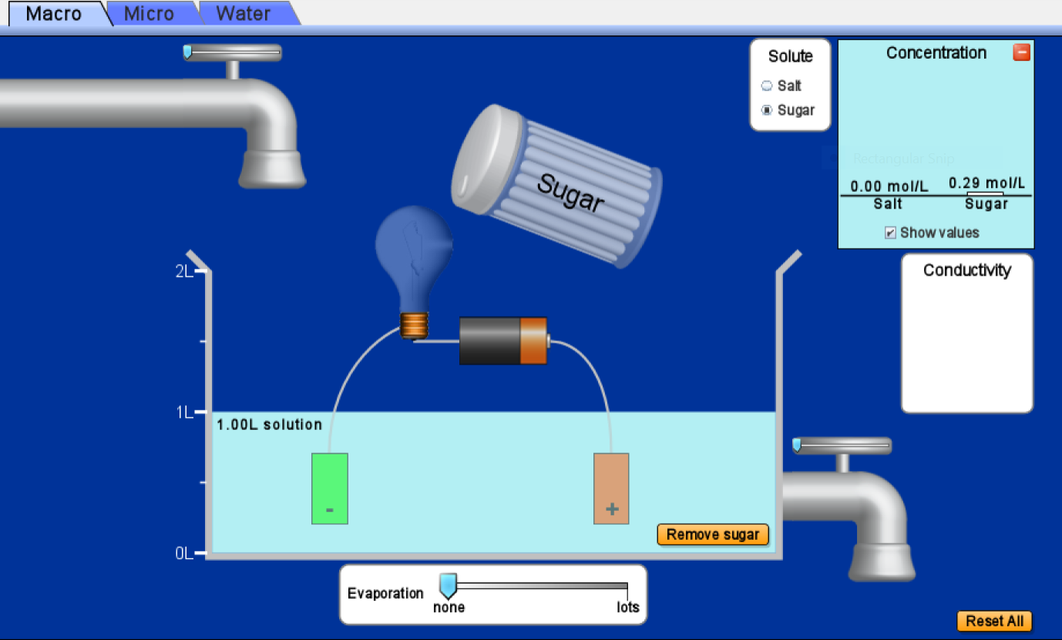 | What happens to the conductivity meter as sugar is added?  The conductivity does not change  Does this solution conduct electricity?  No  Does changing the amount of sugar aﬀect conductivity?  No

Conductivity Model Sugar Water (evaporated) | Questions
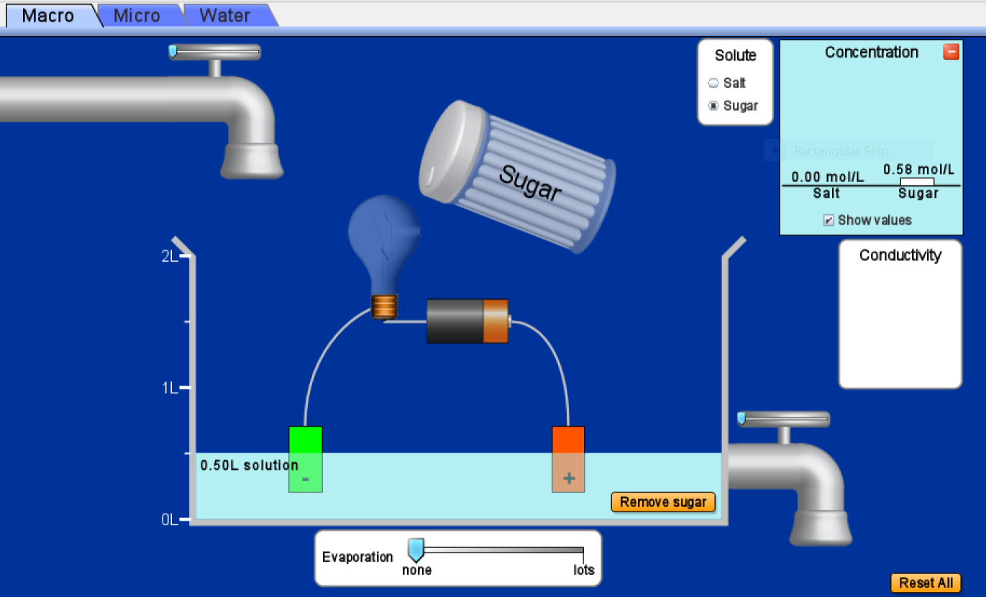 | What happens to the conductivity meter as water is evaporated?  The conductivity meter remains the same. No visible change  Does this solution conduct electricity?  No  Does changing the amount of water aﬀect conductivity?  No

Part 2: “Micro” Tab (5 points)
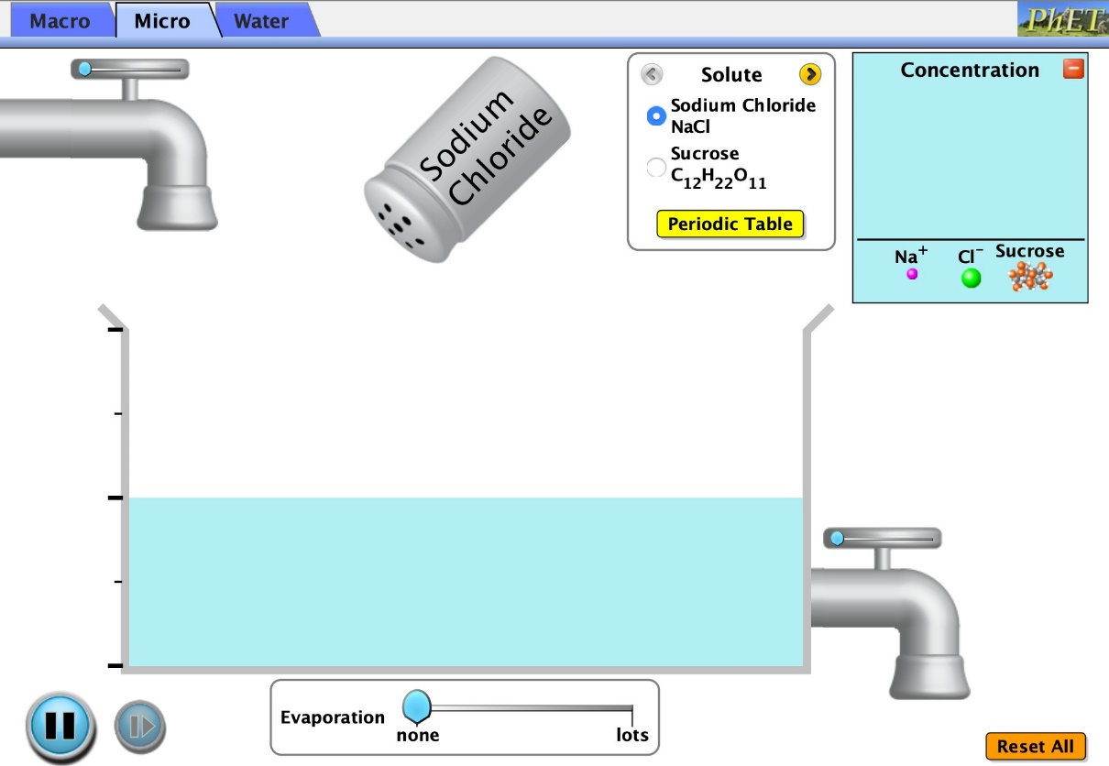
Reset Button
Periodic Table
Solute Type

- Click on the “Micro” tab. Add sodium chloride (NaCl) to the water. Switch the solute to sucrose (C₁₂H₂₂O₁₁) and add this to the same solution. Draw a model illustrating the diﬀerence and similarities of these two solutes below.

Sodium Chloride and Sucrose Dissolving | Questions
How are the two solutes similar? Different? (You can draw or write an answer in this box)  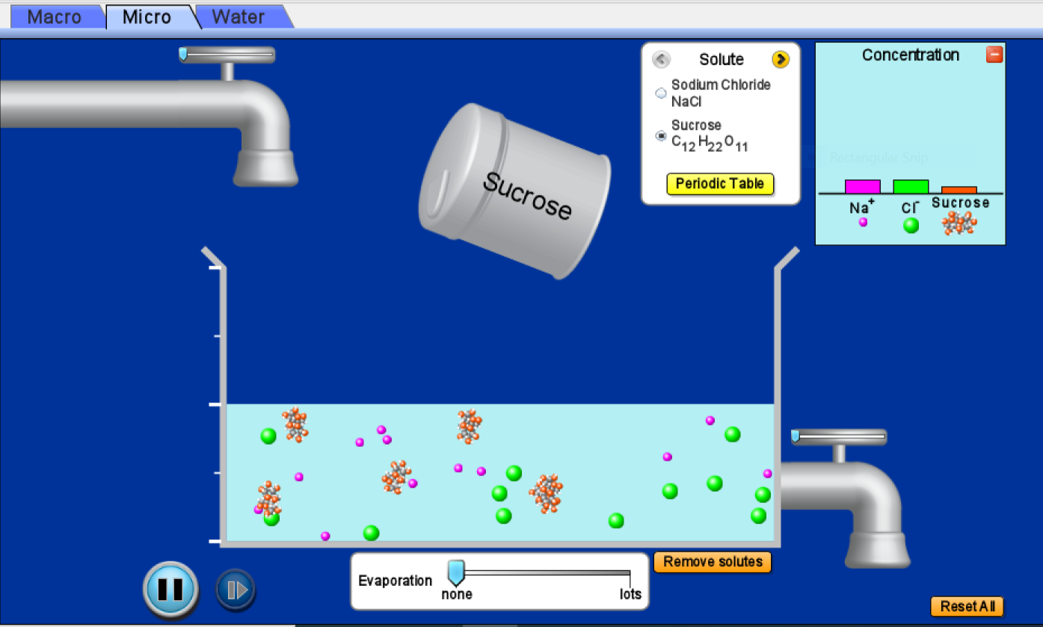 | What happens when sodium chloride is added to water?  It dissociates into sodium and chloride ions.  What happens when sucrose is added to water?  It remains as the full compound as added. It does not get affected by water.  Why do you think the molecules move in a random motion (instead of straight lines)  Because they are being bombarded unevenly by the water molecules.

- Click on the “Periodic Table” button for each solute.
  - What kind of atoms make up NaCl? Sodium, which is a metal and Chlorine, which is a nonmetal.
  - What kind of atoms make up C₁₂H₂₂O₁₁? hydrogen, carbon and oxygen

Part 3: “Water” Tab (5 points)
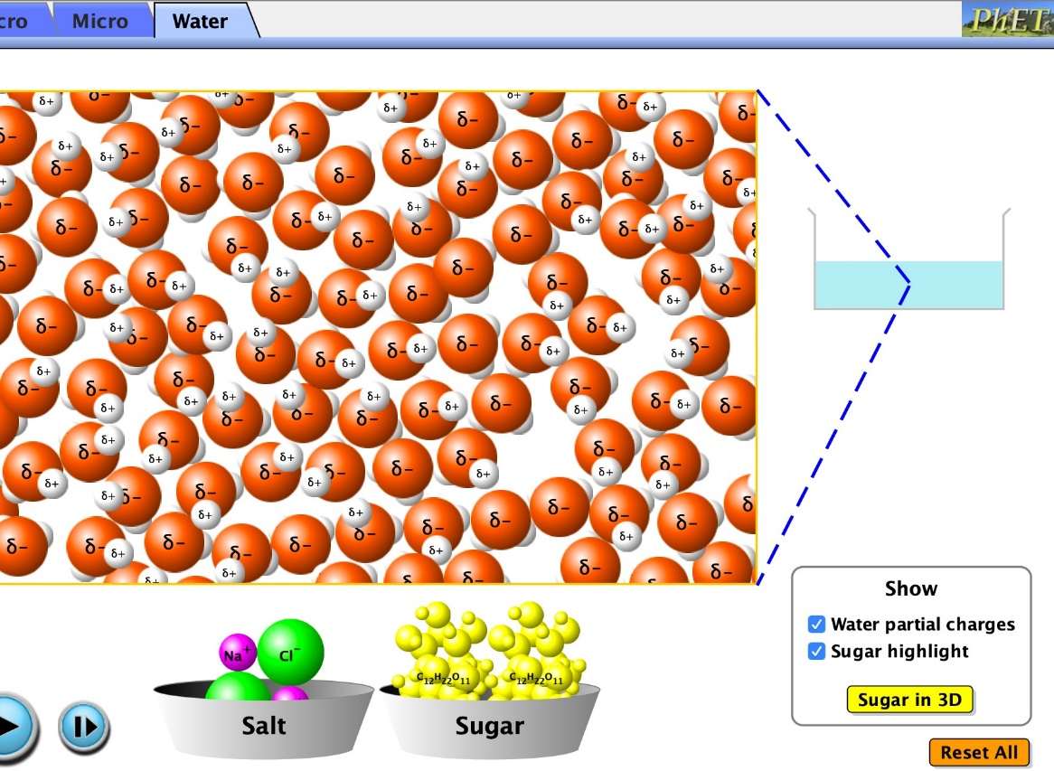
Salt
Sugar
Water Partial
Water Tab

- Click on the “Water” tab and click “water partial charges”.
  - What is the partial charge on Oxygen (larger red one)? negative (-)
  - What is the partial charge on Hydrogen (smaller white one)? Positive (+)

- Add salt to the water, wait a few seconds, click pause, and draw what happens in the space below and record 3 observations.
- Click the “reset” button. Add sugar to the water, wait a few seconds, click pause, and draw what happens in the space below and record 3 observations.

Sodium Chloride in Water (with charges) | 3 Observations
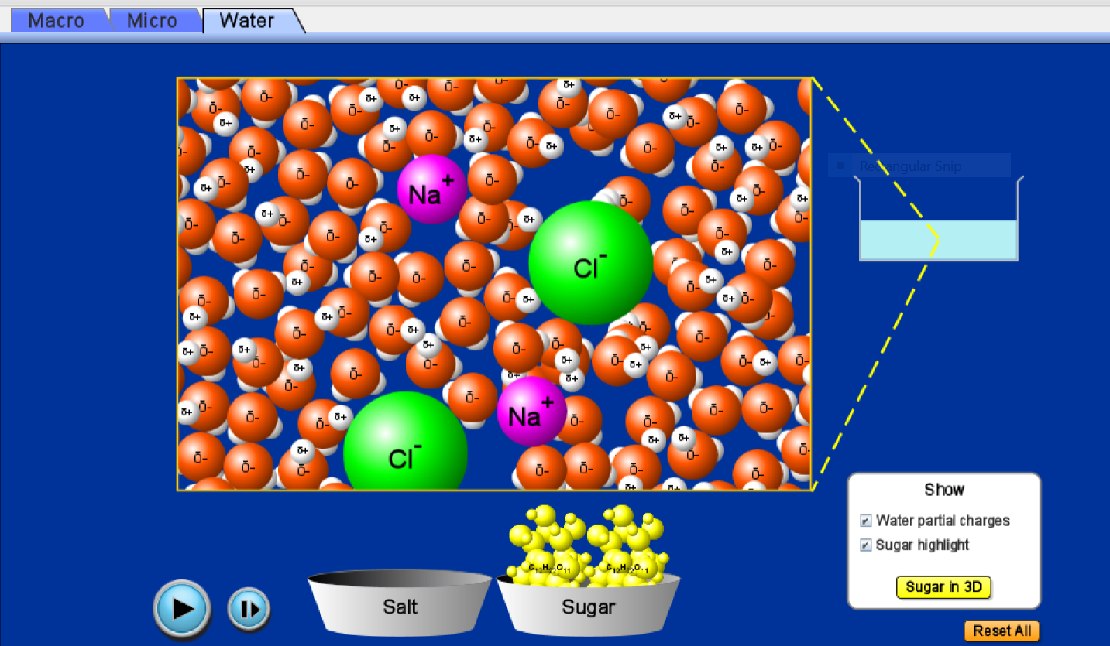 | 1. The salt dissociates into sodium and chloride ions  2. sodium ions (+) interact with the partial negative charge of water (oxygen)  3. Chloride ions (-) adhere to the partial positive charge of water (hydrogen)

Sucrose in Water (with charges) | 3 Observations
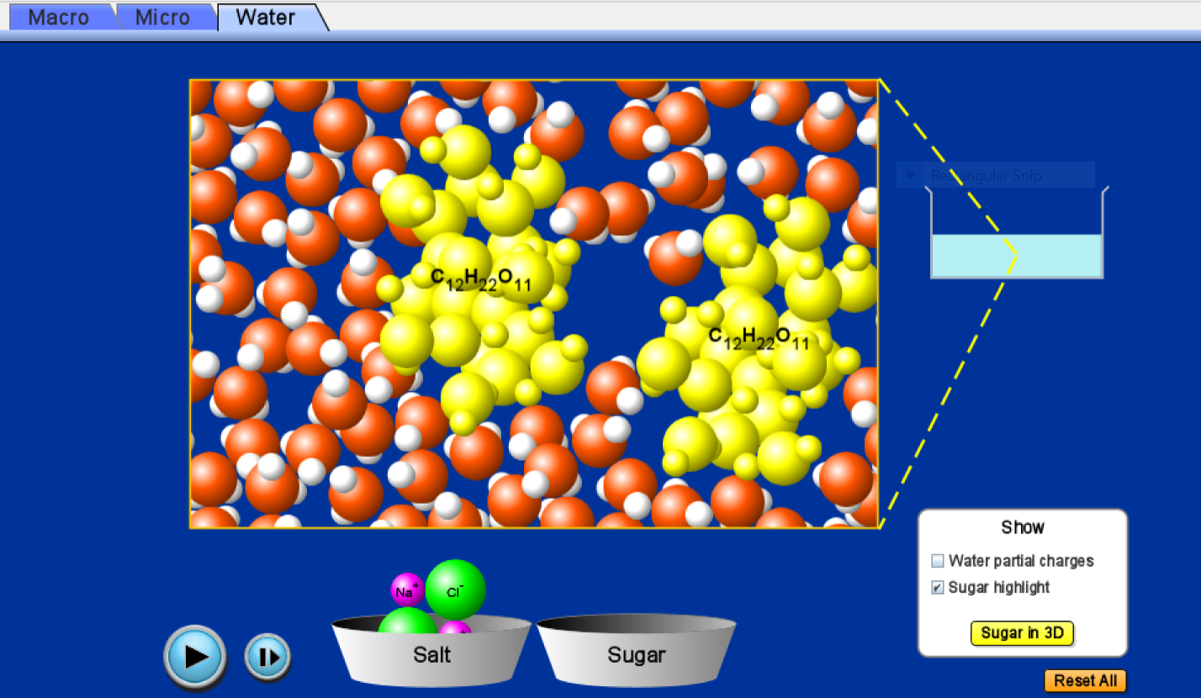 | 1. Sucrose molecules do not dissolve  2. Sucrose molecules remain attached to other.  3. The sucrose molecules appear neutral (no charge on them)
- POST LAB (7 points): Make a Claim, supported by evidence and reasoning to answer the following question:
Question: How can electrical conductivity be used to determine bond type? (In your CER make sure to also explain why diﬀerent bonds behave diﬀerently)
Electrical conductivity can be used to determine bond type in that only ionic bonds conduct current while covalent bonds do not conduct electric current. ionic bonds dissociate when such compounds are placed in ionic or polar solvents thus allowing individual ions to become mobile, thereby facilitating movement of current across. This is not possible in covalent compounds whose bonds remain in place even when placed in water and thus cannot facilitate electrical conductivity.
Claim: Salts have electrical conductivity due to the presence of ions and ionic bonds while sugars lack electrical conductivity to the absence of ionic bonds and presence of covalent bonds.

Evidence 1:  The conductivity meter recorded more current as more salt was added into the set up while sugar did not affect the conductivity meter | Evidence 2:  Salt dissociated into individual ions when placed in water while sugar did not. | Evidence 3:  Salt ions could move individually in the water while sugar molecules stayed together with relatively little movement.
Reasoning 1:  Salt had the capability to draw electrical current. | Reasoning 2:  The individual ions could adhere to the ions making up the water and thus facilitate current flow. | Reasoning 3:  The dissociated ions became mobile and thus could move an electric current across them.

