Name:

Ionic vs. Covalent Virtual Lab
Essential Question: How can electrical conductivity be used to identify type of bond?
Close Reading: Read, Annotate, and Answer Questions about the following reading section.

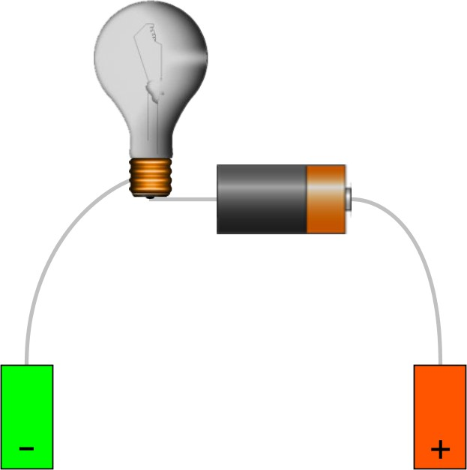
What is Electrical Conductivity?
Electrical conductivity (EC) is a measurement of the dissolved material in an aqueous solution, which relates to the ability of the material to conduct electrical current through it. Electrical conductivity can be measured using a meter or probe. The probe consists of two metal electrodes spaced 1 cm apart. A constant voltage is applied across the electrodes resulting in an electrical current flowing through the aqueous sample. Since the current flowing through the water is proportional to the concentration of dissolved ions in the water, the electrical conductivity can be measured. The higher the dissolved salt/ion concentration, the more conductive the sample and hence the higher the conductivity reading.

What Conducts Electricity?
An electrolyte is any salt or ionizable substance that, when dissolved in solution, will give that solution the ability to conduct electricity. This is because when a salt dissolves, its dissociated ions can move freely in solution, allowing a charge to flow.

Reading Questions (6 points):
- What is conductivity? How can electrical conductivity be measured?

- What does an electrical conductivity probe consist of?

- How does an electrical conductivity probe work?

- What is current flowing through the water proportional to?

- What happens when there is a higher dissolved salt/ion concentration?

- What is an electrolyte?

Go to the following link to download the virtual lab: https://phet.colorado.edu/en/simulation/legacy/sugar- and-salt-solutions (or google search “Sugar and Salt Solutions phet”)
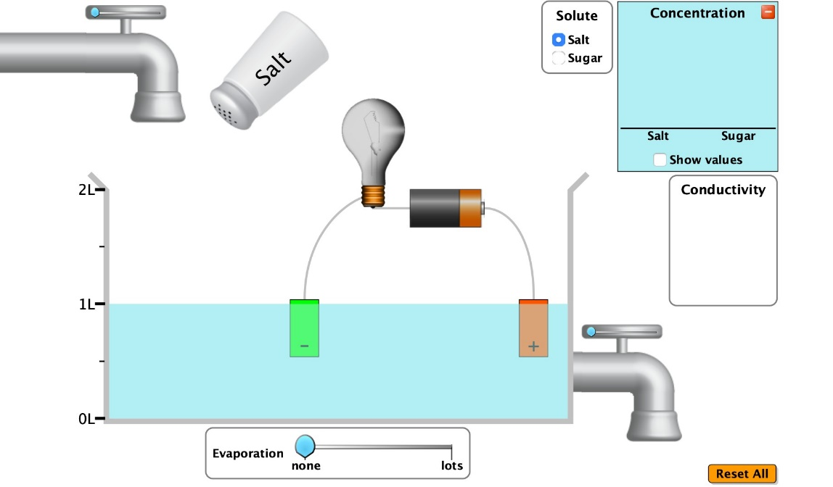
Evaporate Water
Reset Button
Conductivity
Meter
Release water
Concentration
Change solute type

Part 1: “Macro” Tab (5 points) – FOR ALL SECTIONS, IF YOU CANNOT DRAW A MODEL THAT IS OKAY. YOU WILL NOT BE MARKED DOWN FOR LEAVING THE DRAWINGS BLANK
- Drag the conductivity meter and place the positive (+) and negative (-) ends in the water. Click on “show values” in the concentration section.
- Draw a model to illustrate what happens with just pure water in the model section.
- Use the “solute” section to add salt to the water. Observe what happens to the conductivity meter

- Change evaporation to “lots” until you have reduced the water to approximately 0.50 L solution. Observe what happens to the conductivity meter.

Conductivity Model Pure Water | Questions
What happens to the conductivity meter?

Does this solution conduct electricity?

Does changing the amount of water aﬀect conductivity?

Conductivity Model Salt Water (not evaporated) | Questions
What happens to the conductivity meter as salt is added?

Does this solution conduct electricity?

Does changing the amount of salt aﬀect conductivity?

Conductivity Model Salt Water (evaporated) | Questions
What happens to the conductivity meter as water is evaporated?

Does this solution conduct electricity better or worse?

Does changing the amount of water aﬀect conductivity?

- Click “Reset All”, drag the conductivity meter into the solution again. Select “Sugar” as your solute and add the container of sugar to the solution. Draw a model in the next section to illustrate your observations.
- Change evaporation to “lots” until you have reduced the water to approximately 0.50 L solution. Observe what happens to the conductivity meter. Draw a model in the next section to illustrate your observations.

Conductivity Model Sugar Water (not evaporated) | Questions
What happens to the conductivity meter as sugar is added?

Does this solution conduct electricity?

Does changing the amount of sugar aﬀect conductivity?

Conductivity Model Sugar Water (evaporated) | Questions
What happens to the conductivity meter as water is evaporated?

Does this solution conduct electricity?

Does changing the amount of water aﬀect conductivity?

Part 2: “Micro” Tab (5 points)
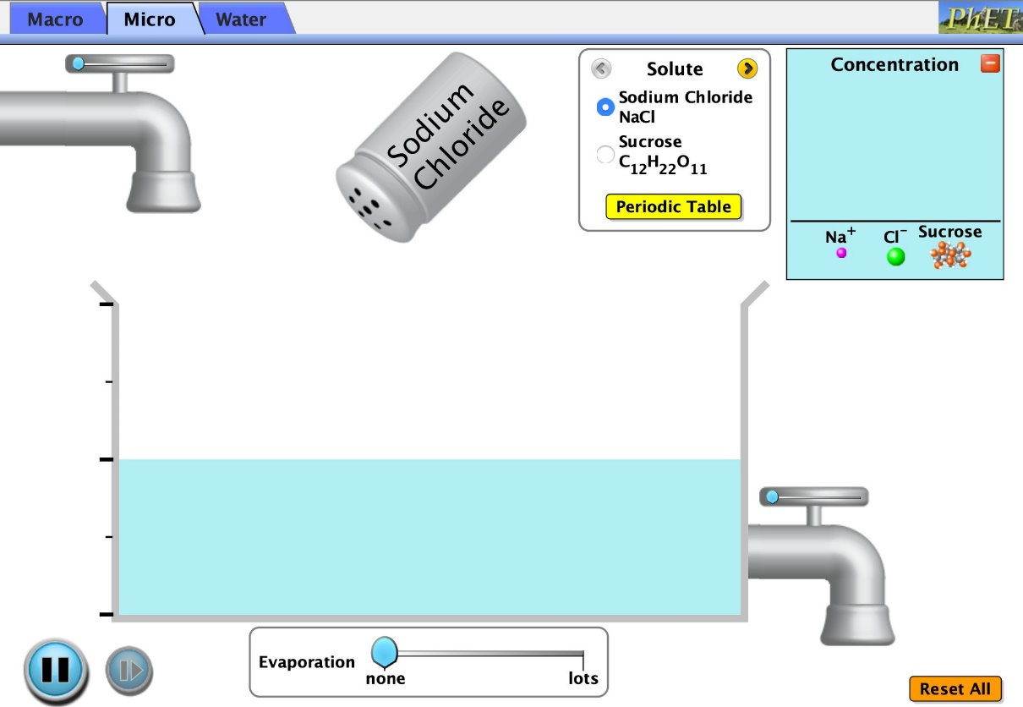
Reset Button
Periodic Table
Solute Type

- Click on the “Micro” tab. Add sodium chloride (NaCl) to the water. Switch the solute to sucrose (C₁₂H₂₂O₁₁) and add this to the same solution. Draw a model illustrating the diﬀerence and similarities of these two solutes below.

Sodium Chloride and Sucrose Dissolving | Questions
How are the two solutes similar? Different? (You can draw or write an answer in this box) | What happens when sodium chloride is added to water?  What happens when sucrose is added to water?  Why do you think the molecules move in a random motion (instead of straight lines)

- Click on the “Periodic Table” button for each solute.
  - What kind of atoms make up NaCl?
  - What kind of atoms make up C₁₂H₂₂O₁₁?

Part 3: “Water” Tab (5 points)
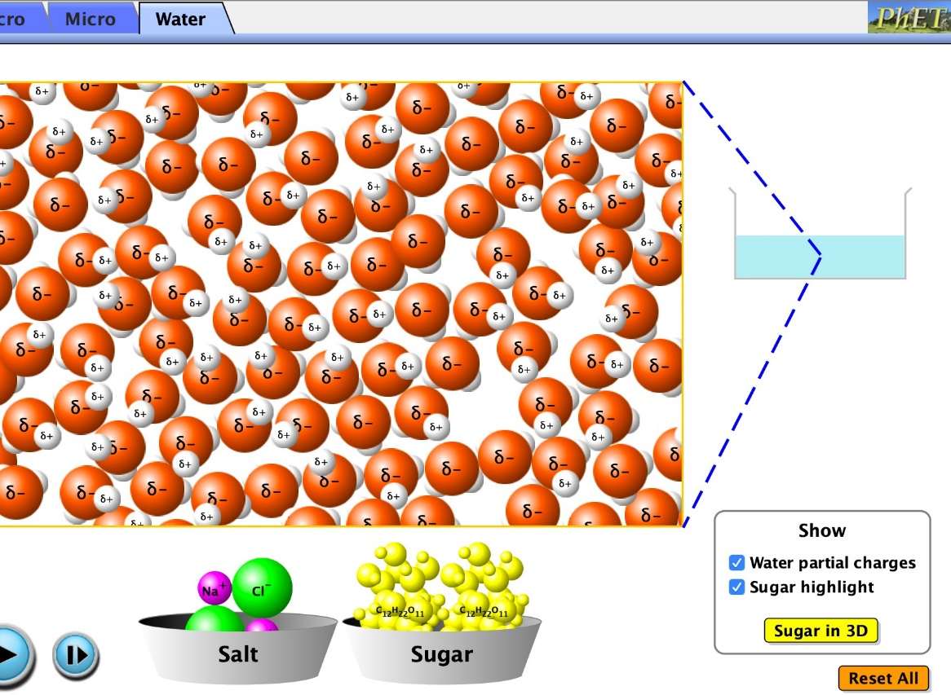
Salt
Sugar
Water Partial
Water Tab

- Click on the “Water” tab and click “water partial charges”.
  - What is the partial charge on Oxygen (larger red one)?
  - What is the partial charge on Hydrogen (smaller white one)?

- Add salt to the water, wait a few seconds, click pause, and draw what happens in the space below and record 3 observations.
- Click the “reset” button. Add sugar to the water, wait a few seconds, click pause, and draw what happens in the space below and record 3 observations.

Sodium Chloride in Water (with charges) | 3 Observations
1.

2.

3.

Sucrose in Water (with charges) | 3 Observations
1.

2.

3.
- POST LAB (7 points): Make a Claim, supported by evidence and reasoning to answer the following question:

Question: How can electrical conductivity be used to determine bond type? (In your CER make sure to also explain why diﬀerent bonds behave diﬀerently)
Claim:
Evidence 1: | Evidence 2: | Evidence 3:
Reasoning 1: | Reasoning 2: | Reasoning 3:

