Author’s Name
Institutional Affiliation
Date

Tesla Motors
Tesla Motors is an energy and automotive company that manufactures electric cars and solar panels. It was founded in 2003 by a group of engineers who wanted to compare the effectiveness of electric cars with gasoline cars and prove that electric cars are better. The company is based in Palo Alto in California.

Tesla Model X
Question One: Ethics are moral principles that govern someone’s behavior and how they conduct their activities. Most companies including Tesla motors has a code of ethics that every employee is supposed to adhere to. Tesla has a mission that emphasizes on social responsibility and it usually strive to come manufacture products that has both societal and economic benefits and their code of ethics help them build a positive corporate culture and also boost consumer confidence. It reduces potential lawsuits and financial liabilities.
Question Two: Information management examines and regulates its definitions, uses, value and distribution of data and information to function and grow effectively. On the other hand, governance is a method in which a government does information management and control. Compliance is the act of conforming or yielding information.
Question Three: E-policies are policies and procedures in a company and in a company like Tesla, they help address information management along with ethical use of computers and the internet in the business environment like for example the ethical is of computers, information privacy and monitoring of the workplace.
Question Four: Privacy is the right to be left alone when you want to be, to have control over your personal possessions, and not to be observed without your consent confidentiality is the assurance that messages and information remain available only to those authorized to view them.
Question Five: Spyware works almost similar to Adware but it is usually a separate program installed unknowingly when you install another freeware type program or application while the spyware monitors user activity on the internet and transmits hat information in the background to someone else.

Question Six: the positive effects of monitoring employees in a company is that it boosts the productivity of the employee. The employer is able to evaluate the employee’s performance for giving rewards and increments. It is also useful for maintaining a peaceful environment within the workplace and also knowing the whereabouts of one’s staff is important.
The negative effects are that the employees may feel pressured and under stress. It reduces the trust levels of the employees. It also costs a substantial amount to install a complete monitoring system.
Question Seven: hackers are experts who use their knowledge to break into computers and computer networks, for either profit or the challenge. A virus is a software written with malicious intent to cause damage and/or annoyance. viruses spread when a hacker attaches it to a program, document, or website.
Question Eight: Security is a business issue in my company because users entrust us with their data. If this data was to be breached, or used for malicious activities, the company would not only face law suits but would lose the trust of the customers. Losing trust from customers would mean that the company would stop making profit. The company’s reputation would also be at risk and potential customers would hesitate in trusting the company with their data again.

Question Nine: Use of emails has no privacy or individuality, an email can be received by all employees, if one employee deletes the email, other employees would still have access to the email. The best way to protect the company from this would be to have an email privacy policy.
Question Ten: The company can protect itself by creating policies that would address information management. They can also create policies that would ensure ethical use of the internet and computers in the company.
Question Eleven: The company can use authorization and authentication to protect data. Two factor-authentication can be used to safeguard information. This kind of authentication uses instant messages to confirm that the person trying to access the information is authorized. Tesla can also use something that is part of the user such as voice confirmation or fingerprints to unlock offices or the cars.
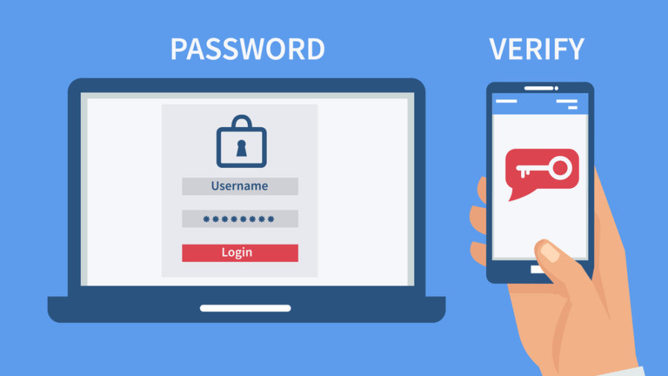
Question Twelve: e Discovery is important at Tesla because it provides concrete details of statements made, pictures and documents, agreements and change orders, inappropriate language and state of mind.
Question Thirteen: Tesla might experience downtime's due to hackers trying to breach the company’s servers, server overload, corrupted data and source code, natural disasters like fires in the server rooms, theft and vandalism or even power outages in cases where there are no power backups.
Question Fourteen: Downtime is expensive because law suits would ensue, customers would not be able to access their data on time which would inconvenience them, this would damage the reputation of the company. Damaged reputation of the company would lead to customers finding other companies with better services, leading to low revenue for Tesla.

References
Tesla Motors Documentary, retrieved from https://youtu.be/rD9PGi8hHvY
Tesla Products and Company Profile, retrieved from http://testa.com
Van den Steen, E. (2015). Tesla Motors. Harvard Business School Publishing.
Chen, Y., & Perez, Y. (2018). Business model design: lessons learned from Tesla Motors. In Towards a Sustainable Economy (pp. 53-69). Springer, Cham.

