(1)
The diagram shows a kite
Calculate the size of the angle marked x.
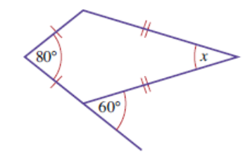 (2 marks)

(2)
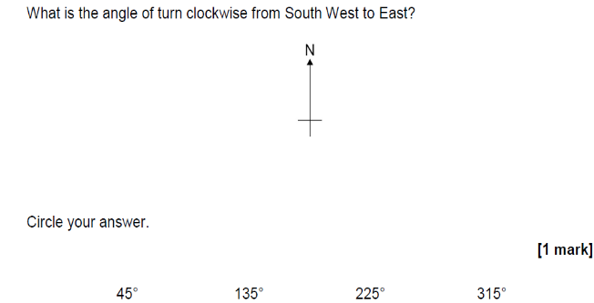

(3)

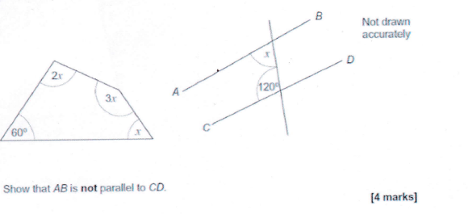

(4)
