Lab-4
Factorial and Performance Testing of a Chevrolet
4.3 liter V-6 Engine
ME-159 MECHANICAL ENGINEERING DESIGN LAB
Date Performed:
Due Date:

By:
Group Members:

Instructor:

California State University, Fresno
Department of Mechanical Engineering

TABLE OF CONTENTS
Page

LIST OF TABLES
LIST OF FIGURES
INTRODUCTION 1
Purpose of the Experiment 1
Objective of the Experiment 1
PROCEDURE 2
Analytical Procedure 2
Numerical Procedure 2
Experimental Procedure 3
DATA AND RESULTS 4
Inputs 4
Outputs: 5
Error analysis 8
Discussion 8
CONCLUSION 8
Future work 8
REFERENCES 9
APPENDICES 9

LIST OF TABLES
Table 1 Fuel Consumed by Engine…………………………………………………………...4
Table 2 Power and Torque…………………………………………........................................5
Table 3 M-fuel-SFC-thermal efficiency……………………………………............................5

LIST OF FIGURES
Figure 1 Chevrolet Engine………………………………………………………2
Figure 2 Taking numerical data…………………………………………………..3
Figure 3 Chevrolet 4.3 liter Engine throttled……………………………………..4
Figure 4 Power and Torque Curve…………………………………………………7
Figure 5 m-fuel-SFC-thermal efficiency graph……………………………………..8
Figure 6………………………………………………………………………………8
Figure 7 Maximum load and Maximum Temperature………………………………9
Figure 8 Fuel consumption thermal efficiency and power relationship……………..9

INTRODUCTION
A vehicles performance is dependent on various factors, while at that the main common feature in vehicles is the engine. Its main power being on the engine type. For this reason, when the engine is in good condition, it means that the car or vehicle will not only operate well but can comfortable reach its maximum speed. With a good engine comes good fuel consumption, and therefore being highly beneficial to the user. An engine is basically the heart of any car. Torque is known to be work generated by an engine. And for this experiment fuel consumption is equated to mass flow rate, to allow analysis. The method known as Latin Square is also employed in the collection and analysis of data. Latin Square Method is a statistical method whose concept is used in experimental designs, when the experimenter desires to control two sources of variation. This gives room for prediction of car performance which is the main objective of this experiment.

Purpose of the Experiment
This Experiment’s purpose was to familiarize students with the concept of Latin Squares Method and how to use it to make varied calculations and manipulation of figures. In the process the students were to observe the relationship of Torque, Speed, Temperature and power to fuel consumption of an Engine while drawing conclusions on how this relates to the vehicles performance.

Objective of the Experiment
- Determining the fuel consumption of Chevrolet 4.3 Liter Engine
- Prediction of the characteristics of a fictitious vehicle based on performance characteristics
- Calculating the fuel consumption of the engine in relation to coolant temperature, load, and speed using the Latin Square Method.

PROCEDURE

Analytical Procedure
- The following was the relationship of Torque and Engine Speed that was used to find torque:
Torque = 3 X 10⁻⁹ rpm³ – 5 X 10⁻⁵ rpm² + 0.22 rpm - 40.974
- High Heating Value (HHV) = 20,100 Btu/lbm for gasoline was given as a guideline.
- Fuel consumption for the following given Torques were measured; 40,80,120,160, ft-lbf
- Engine speeds of,1800,2400,3000,3600 rpm, were also taken
- Coolant temperatures of, 175,185,195 and 205⁰ F were also measured in accordance to Factorial testing procedures.
- Not included in the Latin Square Arrangement, an extra point for the fuel consumption rate was measured.
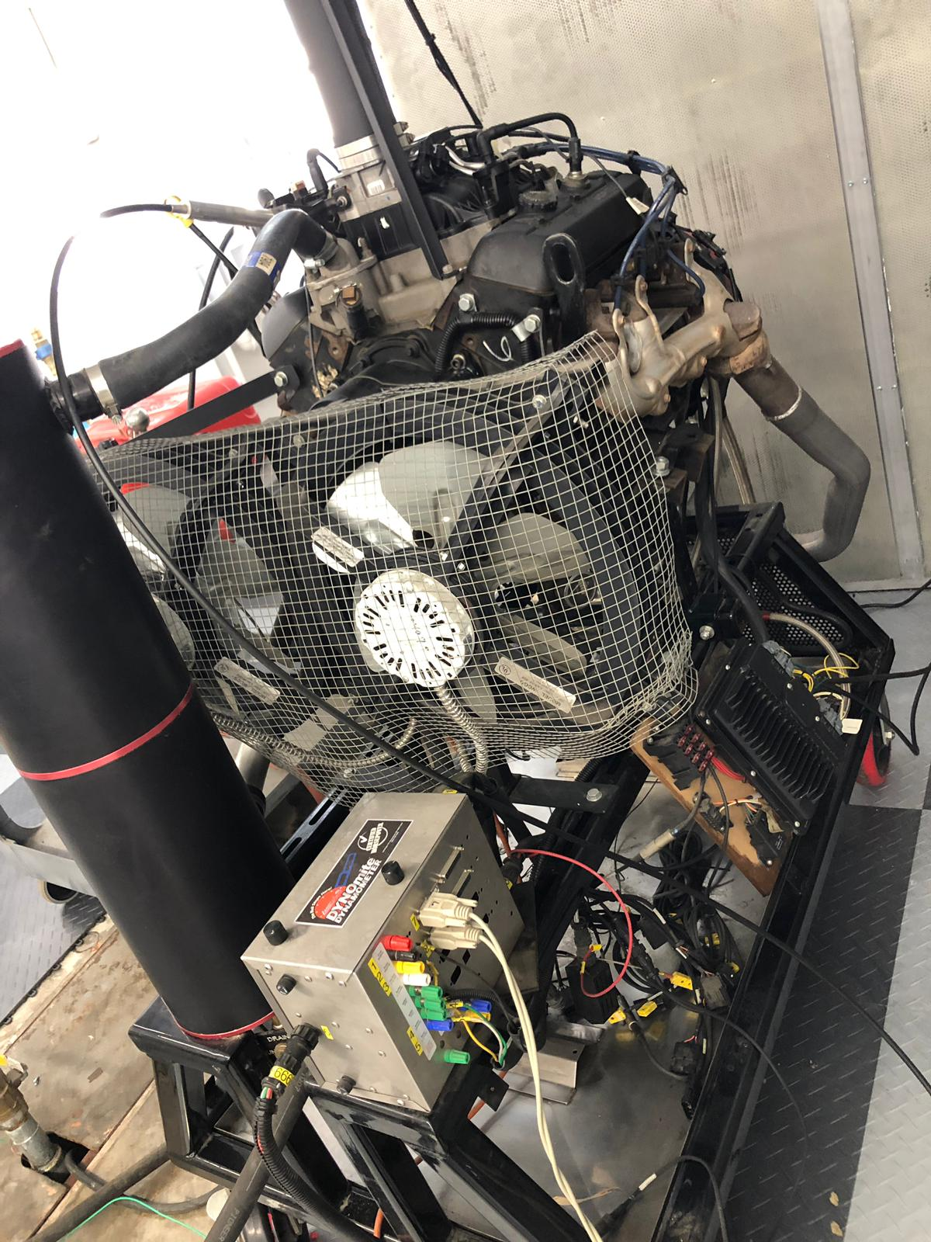
Figure-1: Chevrolet Engine

Numerical Procedure
- Drawing or coming up with a Latin Square Arrangement for fuel consumption.
- For a complete test, there are four different temperatures that are run.
- To find mass flow rate:
R_{Li} = K’f₁ (L_{i})
Where,
- K = constant
- R_{L} = known from experimental data
- f₁ = a function of L
- L = load = Torque values
- To obtain constant K:

f₁ (L_{i}) = R_{Li} / K’
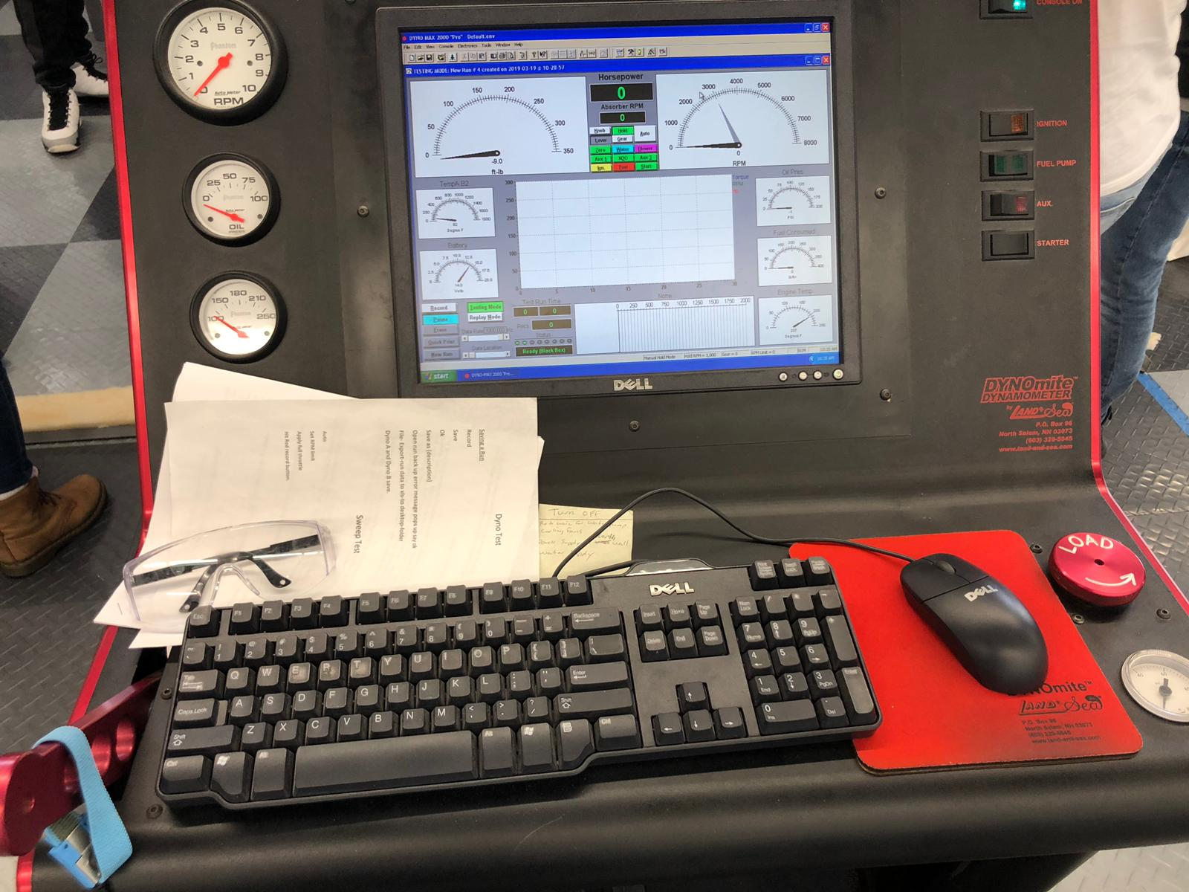

Figure-2: Taking of Numerical data.

Experimental Procedure
- A sweep function which allowed the dyno operator to select a pre-programmed load that allowed the engine to operate through allowable engine speeds was used.
- The maximum safe speed that was allowed for the test was 4000 rpm, while, that allowed for the minimum speed was 1600 rpm, and tis limits were set on the engine.
- The rate of engine increase was 200 rpm/sec.
- Once the lower limit was set, the engine speed was increased slowly, allowing the dyno increase and maintain its speed.
- Once the throttle setting was finalized the sweep test was engaged.
- Obtained data was recorded and tabulated appropriately in a Latin Square.
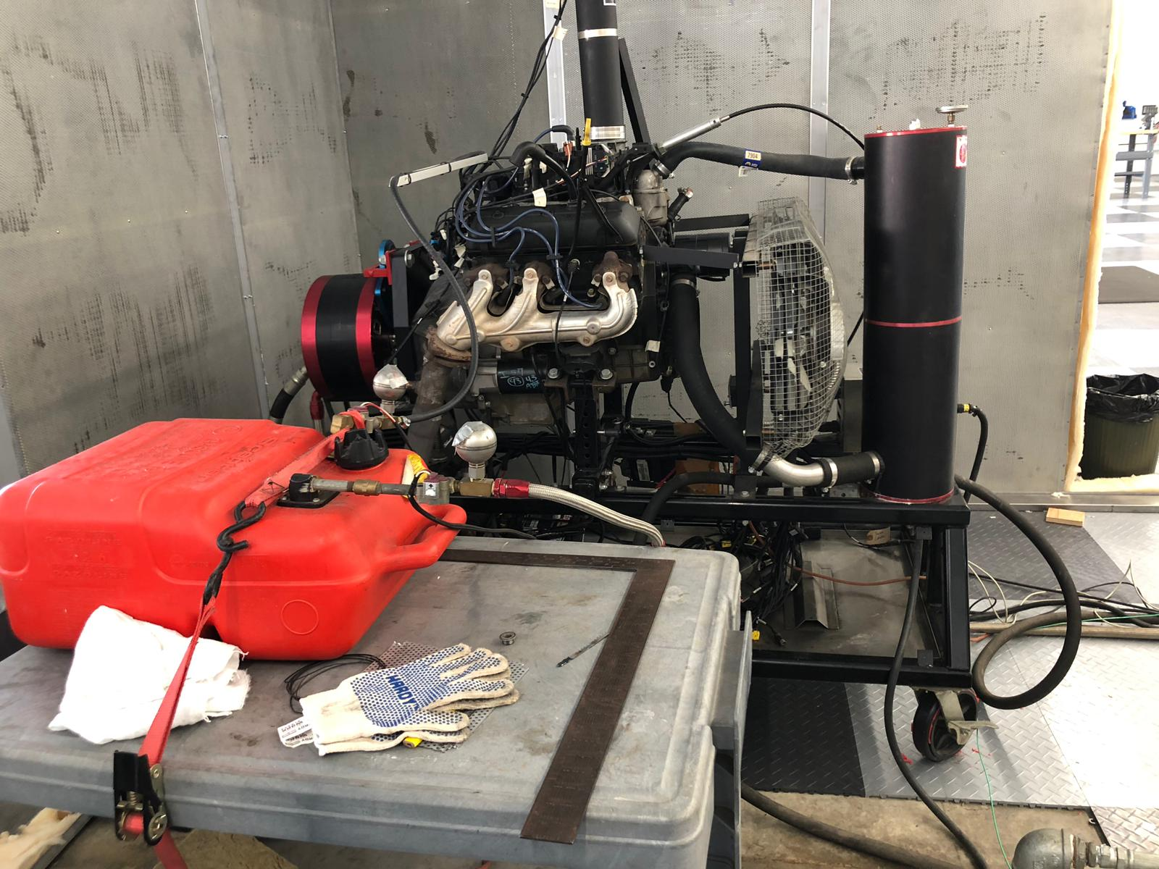

Figure -3: Chevrolet 4.3 liter Engine throttled

DATA AND RESULTS
In the experimental method the fuel consumed by the engine was equated to mass flow rate, this also applied for both the analytical and numerical methods.

Inputs
This table contains calculated Mass flow rate using the Latin square method, obtained from Load which is equated to Torque denoted L, Speed denoted S and Temperature denoted F

Table-1: Fuel consumed by Engine
L S | 1800 rpm | 2400 rpm | 3000 rpm | 3600 rpm
160 ft-lbf | 175⁰F  688.39 | 185⁰F  545.80 | 195⁰F  460.24 | 205⁰F  403.20
120 ft-lbf | 205⁰F  604.82 | 175⁰F  409.36 | 185⁰F  327.49 | 195⁰F  287.66
80 ft-lbf | 195⁰F  383.57 | 205⁰F  302.43 | 175⁰F  206.54 | 185⁰F  181.95
40 ft-lbf | 185⁰F  181.92 | 195⁰F  143.81 | 205⁰F  120.95 | 175⁰F  86.04

Power for the respective Torques was calculated and tabulated as below. The power was in horse power, and is obtained by multiplying speed by Torque.

Table-2: Power and Torque
Torque | Power
160 | 3617280
120 | 2712960
80 | 1808640
40 | 904320

From the numerical and experimental method, a graph of fuel consumption, brake specific fuel consumption and brake thermal efficiency versus power was tabulated from the following inputs.

Table-3: m-fuel-SFC-thermal efficiency
Torque | m fuel | power (hp) | SFC | thermal efficiency
160 | 672.4266923 | 3617280 | 6.134466 | 0.182072
120 | 456.0896007 | 2712960 | 5.547799 | 0.201326
80 | 485.0099481 | 1808640 | 8.849372 | 0.126214
40 | 487.9817257 | 904320 | 17.80719 | 0.062723

Outputs:
In the experimental method, one of the outputs was the Power and Torque curve, this curve was the basis of prediction for the Car’s performance. From the graph which showed a linear relationship, the power of the car engine is directly proportional to Torque applied to it or on it.

Figure 4 Power and torque curve

From the Experimental and Numerical method, the following outputs were obtained.
From the drawn curves it is clearly conclusive that fuel consumption varies inversely with thermal efficiency which means that, as fuel consumption increases, thermal efficiency decreases. On the other hand as speed increases, the fuel consumption is constant, then decreases and finally increases continuously.

Figure 5 m-fuel-SFC-thermal efficiency graph.
At maximum load and minimum temperatures, the fuel consumption values give a sinusoidal curve while the speed and thermal efficiencies are inverses of each other.

Figure 6 fuel consumption-SFC-thermal efficiency graph.

Figure 7 Maximum Load and Minimum Temperature

Figure 8 thermal efficiency fuel consumption and power

Error analysis
- Human errors when taking readings were the courses for inconsistent figures
- Another error arose from throttling when finding lower and upper limits of speed

Discussion
From the experiment carried out, it is clearly evident that analysis and actual prediction of the performance of any vehicle can be done provided that the engine can be accessed. Though the Latin Square method is not only involving but quite hectic, it gives almost accurate results.

CONCLUSION

Future work
This results can lead to a sufficient way of predicting different vehicles performances without having physical contact with the vehicles. More research should be conducted on the Latin Square method to make it less demanding but still as effective.

REFERENCES

Abdel Rahim, D. (n.d.) Transport Engineering

APPENDICES

