COMP 1536 – Lab 3

Due: Following week, at the beginning of class, for marks!
This assignment must be done individually.

Objective
Explore CSS’ features for creatively expressing typography choices.
This lab exercise requires you to become familiar with the types of things that you can and can’t do – or can’t do as easily using CSS.

Note: There are always interesting hacks that clever web developers and designers will come up in order to solve a particular problem. For now, we’re interested in the basics.
Using the CSS properties that we’ve gone over, create the following layouts and font choices displayed in the following figures. Create the same sort of layout and typography to the closest you can.
Once you have completed, ensure that your document is valid. It is suggested that you use Brackets and the “Nu Markup Checker for Brackets” as it catches all HTML and CSS errors. You code (HTML, CSS, JavaScript) must all be free of all syntax errors regardless of what validation tools you use (online, editor plugins, reading manually, etc.)

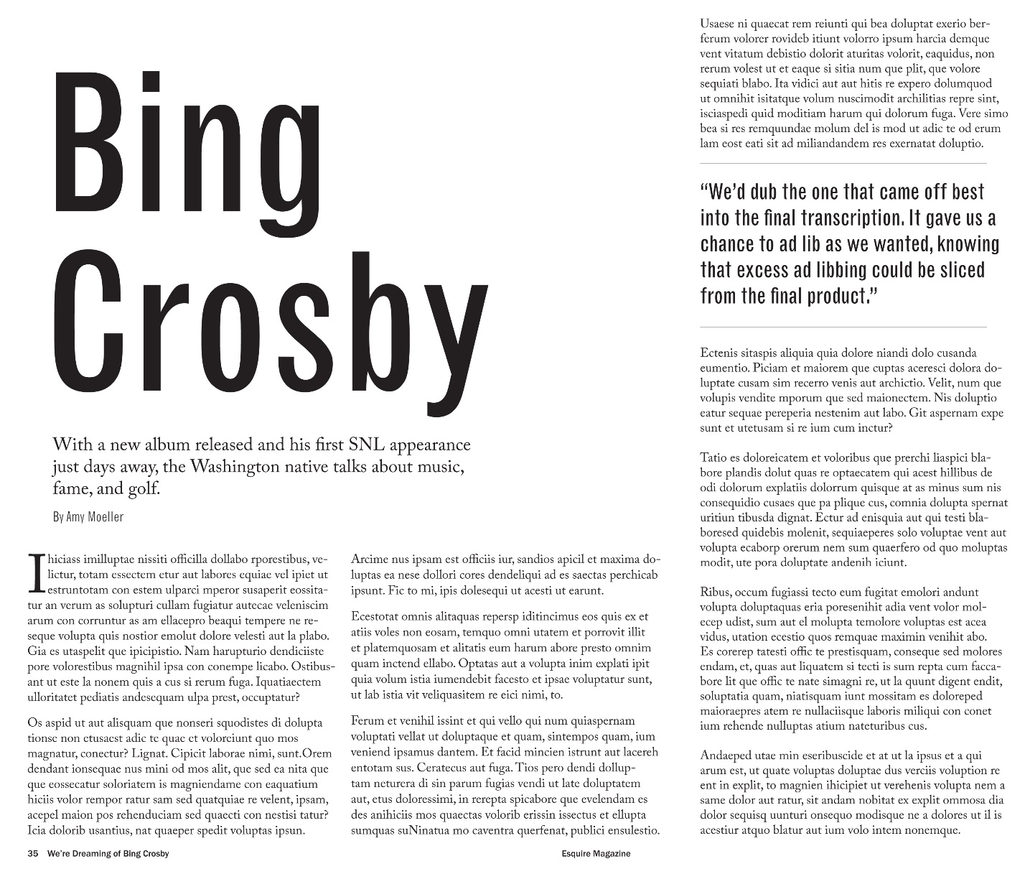
Figure 1

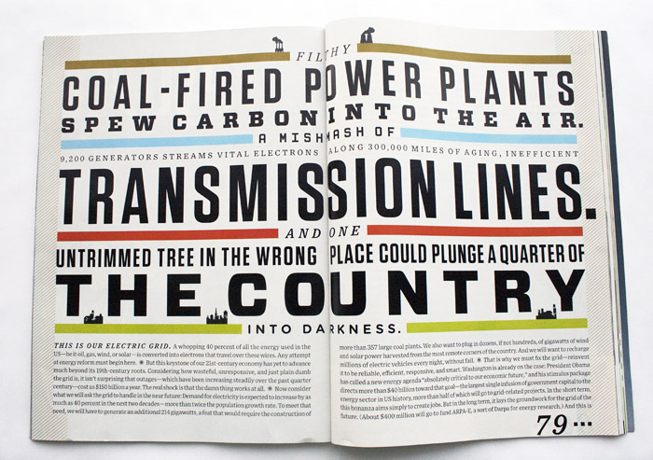
Figure 2
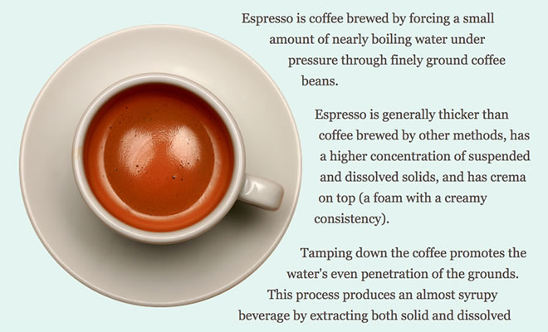
Figure 3

Note: You can replace the images and the textual content with something else (e.g., your resume, a project that you’re working on, etc.)

