COMP 1536 – Lab 4

Due: One week from when it’s assigned, at the beginning of class, for marks!
This assignment must be done individually.

Objective
Again, using the display property, float, clear, and media queries, create an initial prototype design of what you want your overall layout to look like.
Create the following containers using most of the following elements:
- footer
- header
- section
- aside
- div
When using the div elements, use the id attribute to uniquely select them with CSS. Make your layout look like figure 1.
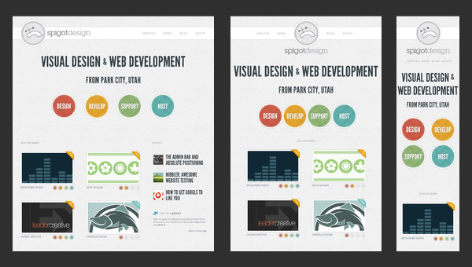
Figure 1

Note that you don’t have to use the colors in figure 1 but you do have to lay your content out as such. You can use images or text for them. If you use images, use www.dummyimage.com for your placeholders.
Again, adjust to the different resolutions of:
- 600 pixels
- 1080 pixels
- 1280 pixels
Also note that the layout changes for each of the resolutions shown. Make yours do the same.
You can use float/clear or grid for this.

Requirements
Submit to the learning hub before next class.

Once you have completed, ensure that your document is valid. It is suggested that you use Brackets and the “Nu Markup Checker for Brackets” as it catches all HTML and CSS errors. You code (HTML, CSS, JavaScript) must all be free of all syntax errors regardless of what validation tools you use (online, editor plugins, reading manually, etc.).

Submission
Rename the provided project folder to follow the format SurnameFirstnameCOMP1537Lab4. My folder would be FergusonArronCOMP1537Lab4, for instance.
Zip this folder (using same name as the folder) and submit it to the learning hub in the folder labeled “lab4”.

