Laboratory Work - Part 1
(Due Week 7, Sunday 23:55)
- Laboratory work forms an essential part of the Unit, and as such, students are expected to complete and submit the reports on time.
- You should maintain an up-to-date laboratory log book in which you are to document your circuits, explanations, comments and answers to questions posed, in a logical and easily referable manner.

Getting Started in Labs

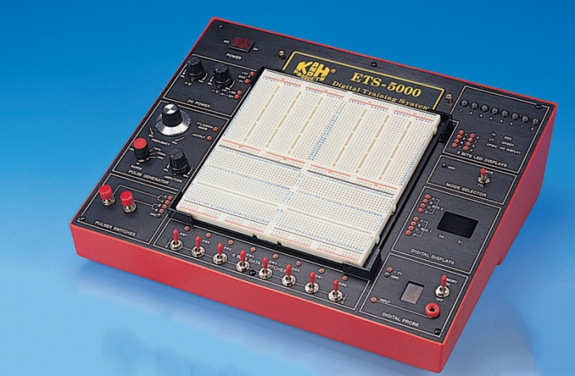
During the lab sessions, you will be designing, constructing and modifying many digital circuits. It is essential for the systematic construction and de-bugging of these circuits that circuit diagrams be drawn and fully labelled before beginning construction work. This is the most important design requirement and will be insisted upon throughout.
Figure 1: DT-500 Logic Trainer
All the necessary material to conduct the experiments will be provided during the lab session. However, you should try to become familiar with the technical aspects of the experiments before coming to the laboratories. We will be using the ETS-5000 Digital Training System for building and testing the various circuits.
Data sheets and user manuals for all the Integrated Circuits (IC), other components and equipment could be found over the Internet and will also be posted on the resources section of the Moodle site.
Some of the projects described in this Lab Work is based on the experiments presented by Buchla[1], Kumar[2] and the prescribed text book [3]. These projects are designed to introduce you to a number of devices and subsystems that are frequently encountered in digital instruments. The notes provided with each experiment, together with the manufacturer’s data sheets, contain all relevant details and thus supplement the topics covered in lectures. The aim of the projects is to assist you in gaining familiarity with standard digital techniques and circuits that may be generally applied.
Reference:
[1] D. M. Buchla, Experiments for Digital Fundamentals: Pearson/Prentice Hall, 2008.
[2] V. Kumar, Digital Electronics : Theory And Experiments: New Age International (P) Limited, 2007.
[3] Tocci, Widmer and Moss, Digital Systems Principles and Applications: Pearson, 11e, 2014.

Lab Report

Students are required to document each project in the form of a lab report. The format of the Lab Report is as follows (Following the MIT format as discussed in the lectures). Use this as guideline in documenting your projects. Not all items may be needed in documenting the projects you undertake.
Project Name | Lab Work – Part 1 | Project x |Student_number
Purpose/Objective(s) | Why are we doing the lab? What questions are you trying to answer?
Hypothesis | What do you expect the results to be?  This should relate directly to the problem
Materials | List of all the Materials you will use during the lab
Procedure | Steps should be listed and numbered.  Steps should be clearly written, detailed, and brief  It must indicate HOW data will be taken
Tabulated Data | Must be in the form of a table  Be sure to use units
Analysis | Graphs, calculations, important observations
Conclusion | A good conclusion answers 3 questions:  What did you do in the lab?  Restate the purpose/problem  A brief description of how you tested it  What you used to gather data  What does your data say?  Look at your data table or sketch and turn it into a sentence or two.  What did you learn?  This should answer the question posed in the purpose/problem.

Lab Report Submission and Grading
Once all the projects are completed, compile the corresponding reports into a single Word document (Name the file studentNumber_LabWork1.doc replacing studentNumber with your own student number) and submit by the deadline for marking.
Submissions to be made through Moodle (Learnonline) under the appropriate Assignment section in Week 7 and are due by the Sunday, 23:55 of week 7. The reports will be marked according to the marking guidelines set out in this documentation. A total of 50 marks is available and carries a 15% weight towards your final grade.

Project A: Basic Electronics and Lab Skills (Week 4 | 10 Marks)

In order successfully complete these projects, a basic ability to read electronic schematics, data sheets, and skills in implementing these circuits is required. In this first project you will build and test a simple circuit to gain familiarity.
Objective: To build a simple electronic circuit and debug it.
Materials Required:
- ETS-5000 Logic Trainer
- Selection of resistors including one 470Ω
- Potentiometer (10k)
- Red LED
- Multimeter
Procedure:
- Collect three resistors from the given selection. Using the resistor colour code chart decipher their values.
- Then measure their actual values using the multimeter (set the range switch to the appropriate resistance scale).
Record your findings in Table 1. (3 marks)

No. of colour bands in the resistor/colours | Nominal Value of the Resistor (Ω) | Measured Value of the Resistor (Ω)
Table 1: Resistor Measurements

- Using the nominal values, workout the resultant resistance if these resistors were to be connected in; (1 mark)
  - Series
  - Parallel

- On the ETS-5000 Logic trainer, connect these resistors in (1 mark);
  - Series
  - Parallel

- Measure the actual values of these configurations and record your findings in Table 2. (2 marks)

Table 2: Resistor Networks
 | Nominal Value (Ω) | Measured Value (Ω)
Resistors in parallel
Resistors in Series

- Excluding the power source, now connect the circuit shown in Figure 3. You may use the wiring diagram shown in Figure 2 as an aide. Note that the LED has polarity and turns only if corrected in the right way. The long lead usually connects to a positive source and is called the anode, the other is called the cathode.
- Check the wiring with your tutor before connecting power.
- Connect the power and using the potentiometer, identify the point at which the LED changes its state (i.e turn on/off).
- Measure the voltage across the LED at this point and record it in your report. (3 marks)
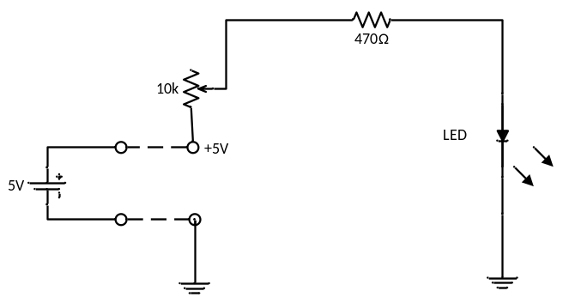

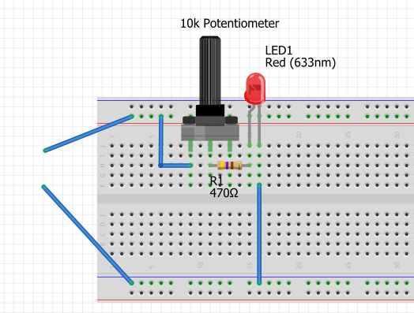
Figure 2: LED Dimmer Wiring Diagram
Figure 3: Simple LED Dimmer

Project B: Basic Gate Functions (Week 5-6 | 15 Marks)

Logic circuits are basically of two types: decision-making circuits and memory circuits. Their operation depends upon the binary inputs they receive to produce binary outputs.
After you have become familiar with the basic logic elements, common configurations of these devices and their characteristics, you will be in a position to evaluate the operation of digital equipment in common use and also acquire capability to design digital devices.
In this project we will explore the operation and characteristics of AND and OR gates.

  - Experiment 1: Two-input AND gate
Objective: To verify the operation and characteristics of a two-input AND gate.
Materials Required:
- ETS-5000 Logic Trainer
- TTL IC 7408: Quad 2-input AND gates
Procedure:
- Connect the circuit shown in Figure 4. The IC used in this experiment contains four identical and independent AND gates and only one of them is used.
- The input for the AND gate is obtained through logic switches Sw0 and Sw0.
- The output of the AND gate is connected to a Logic monitor (LED) which lights up red (logical 1) when there is a high output condition and green (logical 0) when there is a low output condition.
- Connect pin 14 of the IC to V_{cc} (+5V) and pin 7 to ground (GND).
- Now, with all possible combinations of Sw0 and Sw0 (high and low input states), record the output voltages in the truth table provided in Table 3. (4 marks)
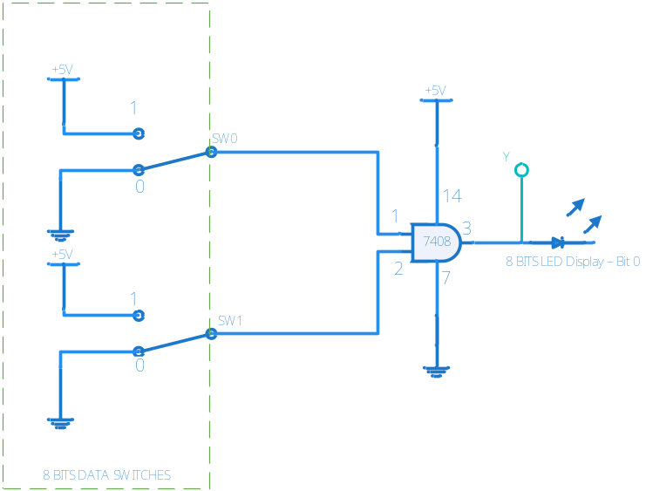

Figure 4: Circuit for AND Gate

Table 3: Output voltages for a 2-Input AND Gate
Switch Setting |  | Output
S_{w0} | S_{w1} | Y (V)
0 | 0
0 | 1
1 | 0
1 | 1

- Using positive logic assignments convert the voltage levels in above table into logic 1s and 0s and enter your results in Table 4. (3 mark)
Table 4: 2-Input AND Gate with Positive Logic Assignments
Switch Setting |  | Output
A (=S_{w0}) | B (=S_{w1}) | Y
0 | 0
*First two columns of the first row is done as an example

  - Experiment 2: Three-input AND gate
Objective: To build a 3-input AND gate using two 2-input AND gates.
Materials Required:
- ETS-5000 Logic Trainer
- TTL IC 7408: Quad 2-input AND gates
Procedure:
- Connect the circuit shown in Figure 5. Only two AND gates from the IC are used.
- The AND gate inputs can be connected through logic switches Sw1, Sw2, and Sw3.
- The output of the AND gate is connected to a Logic monitor (LED) which lights up red (logical 1) when there is a high output condition.
- Connect pin 14 of the IC to V_{cc} (+5V) and pin 7 to ground (GND).

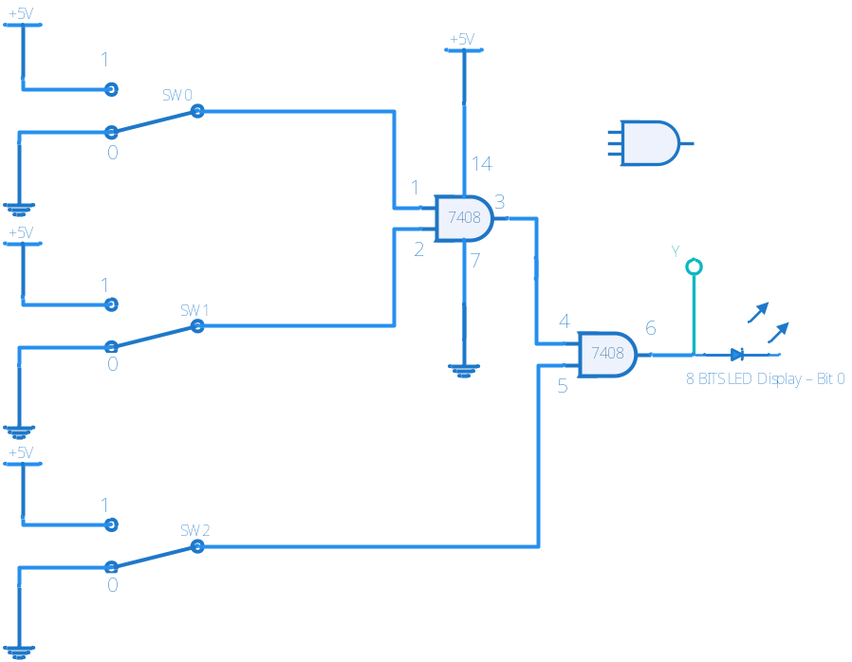
Figure 5: 3-Input AND Gate

- Connect switches Sw0, Sw1, and Sw3 to the logic levels shown in the eight sets of inputs in truth Table 5 and fill it up with the outputs obtained for each given combination. (Remember Red LED = Logic 1, Green LED = Logic 0) (8 marks)

Table 5: 3-input AND Gate with Positive Assignment
Inputs |  |  | Output
A (=S_{w0}) | B (=S_{w1}) | C (=S_{w2}) | Y
0 | 0 | 0
0 | 0 | 1
0 | 1 | 0
0 | 1 | 1
1 | 0 | 0
1 | 0 | 1
1 | 1 | 0
1 | 1 | 1

Project C: An Industrial Alarm (Week 6-7 | 25 Marks)
Objective:
- Derive simple combinational logic circuits from problem description.
- Simplify and construct simple combinational logic circuits.

Materials Supplied:
- ETS-5000 Logic Trainer
- TTL IC 7408: Quad 2-input AND gates
- TTL IC 7432: Quad 2-Input OR Gate
Problem Description:
A manufacturing plant needs to have an alarm to indicate the time for the operators to leave. The alarm should sound when either of the following conditions is met:
- It’s after 5 o’clock and all machines are shut down.
- It’s Friday, the production run for the day is complete, and all machines are shutdown.
If you carefully look at the problem, there are four input conditions. Let’s call them inputs A, B, C, and D such that:
A - It's 5:00pm or later;
B - All machines are shut down;
C - It's Friday
D - Production run for the day is complete

Let’s assume that each input becomes HIGH (1) when the respective condition is met (e.g. input A will be HIGH only when the time of day is 5:00pm or later).
Also assume that any variables/combinations that are not mentioned in the conditions above must be zero to sound the alarm.

Procedure:

- The truth table below has been constructed to understand the problem. The alarm will sound when the output (X) is HIGH. Half of input/output combinations are already done for you. For example, D=0, C=0, B=1, A1 X=1 satisfies the first condition mentioned in the problem description. Complete rest of the truth table. (Hint: there are altogether 5 instances/combinations in which the alarm will sound – i.e. X=1) (5 marks)

Table 6: Truth table for Project C
D | C | B | A | X
0 | 0 | 0 | 0 | 0
0 | 0 | 0 | 1 | 0
0 | 0 | 1 | 0 | 0
0 | 0 | 1 | 1 | 1
0 | 1 | 0 | 0 | 0
0 | 1 | 0 | 1 | 0
0 | 1 | 1 | 0 | 0
0 | 1 | 1 | 1 | 1
1 | 0 | 0 | 0 | ?
1 | 0 | 0 | 1 | ?
1 | 0 | 1 | 0 | ?
1 | 0 | 1 | 1 | ?
1 | 1 | 0 | 0 | ?
1 | 1 | 0 | 1 | ?
1 | 1 | 1 | 0 | ?
1 | 1 | 1 | 1 | ?
- Derive the resulting Boolean expression corresponding to Table 6. (2 marks)
- Simplify the above expression using Boolean algebra (Hint: X=AB+BCD). You will need to show the intermediate steps and the corresponding theorems used in the simplification process (3 marks).
- Design the logic circuit corresponding to the simplified Boolean expression X=AB+BCD. (5 marks)
- Now, if you only have access to the following logic chips
  - 7408: Quad 2-input AND gates
  - 7432: Quad 2-Input OR Gate
How would you modify the logic circuit designed in the previous step? Design the new logic circuit using only the gates available (Hint: remember the three input AND gate in Project B, Figure 5.) (3 marks)
- Construct the modified circuit you designed in previous step using the ETS-5000 Logic Trainer. You will have access to the 7408 and 7432 logic chips as well as any other ancillary components, wires you may need. Connect the four inputs (A, B, C, and D) to the first four switches (8 Bits data switches) on the digital trainer. Connect the output (X) to one of the LEDs (8 Bits LED Display). See Figure 6 for details. Connect Vcc (=+5V) and GND pins of the chips to Digital trainer’s power supply. Verify that your circuit operates according to the original requirements set out in the problem description by varying the input switches and recording the behaviour of the output LED (i.e X=1 LED is RED and X=0 when LED is GREEN). You may construct a truth table similar to the one in Table 6. (7 marks)

Note: When writing up the report you may use a tool such as Logisim to draw the logic circuits. You can use the export function (File>Export Image) to save the circuit diagram as an image file and then insert it into your report.

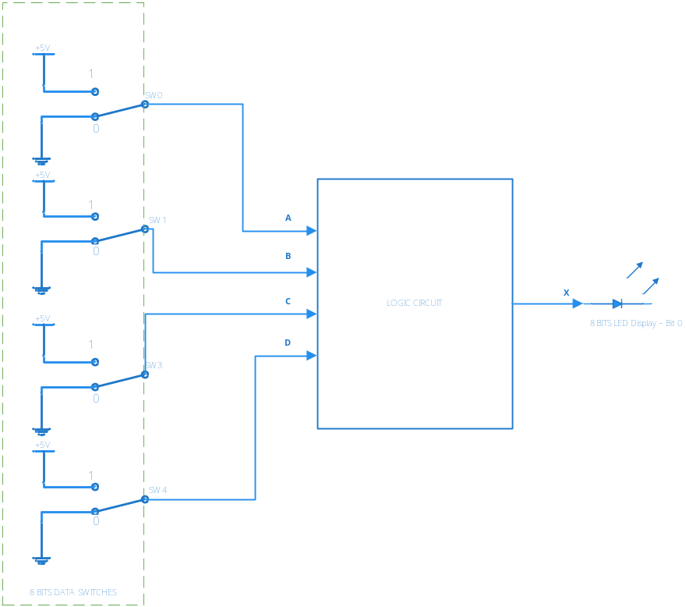

Figure 6: Connecting your logic circuit to external components

http://www.cburch.com/logisim/

