NAME: ______________________________________ Date: ________________________

Lab Partner’s: ____________________________________________

This lab’s simulations are the University of Colorado’s PhET:

Pendulum Lab
Waves Intro

Part I: Pendulum

PROCEDURE:
1.) Click on the “Intro” window.
2.) Check the ‘Stopwatch’ box, on the lower-left corner of the screen. Make sure that the speed is set to ‘Normal’ (radio button) and the ‘Friction’ (slider) is set to ‘None’.
3.) Throughout the experiment, do not increase the amplitude beyond 30 degrees.
4.) Choose ‘Earth’ in ‘Gravity’ window for Parts 1, 2, and 4.

Part 1: Time Period vs. Mass – Length, Gravity, & Amplitude constant
1. Choose constant values for ‘Length’ and ‘Gravity’ (Earth). Choose the mass of the pendulum to be 0.1 kg, displace the pendulum to an initial angular position (amplitude, no more than 30º), start the animation and measure the total time for 10 oscillations. Note: One oscillation is the swing of the pendulum along an arc and back to its initial position. Record your values in Table I.
2. Keep length, gravity, and amplitude the same. Change the mass to 0.4 kg and measure the time again for 10 oscillations. Repeat this for a total of 6 readings. Record your values in Table I.
(Mass values in kg: 0.1, 0.4, 0.7, 1.0, 1.3, 1.5)
3. Calculate the Period of oscillation for each of the cases above (divide the total time by 10). Record the values in Table I.
Part 2: Time Period vs. Amplitude – Length, Gravity, & Mass constant
3. Choose constant values for length, gravity, and mass. Choose the amplitude of the pendulum to be 5 degrees and measure the time for 10 oscillations. Record your values in Table I.
4. Keep length, gravity, and mass the same. Change amplitude to 10 degrees and measure again the time for 10 oscillations. Repeat this for a total of 6 readings. Record your values in Table I.
(Amplitude values in degrees: 5, 10, 15, 20, 25, 30)
Part 3: Time Period vs. Gravity – Amplitude, Length, & Mass constant
5. Choose constant values for amplitude, length, and mass. Choose Moon from the Gravity drop down menu and measure the time for 10 oscillations. Record your values in Table I
6. Keep amplitude, length, and mass same. Change gravity location to Earth and measure again the time for 10 oscillations. Repeat this for a total of 3 readings. Record your values in Table I.
(Gravity locations: Moon g = 1.62 m/s², Earth g = 9.81 m/s², Jupiter g = 24.8 m/s²)
Part 4: Time Period vs. Length – Amplitude, Gravity, & Mass constant
7. Choose constant values for amplitude, gravity, and mass. Choose the length of the pendulum to be 0.2 m and measure the time for 10 oscillations. Record your values in Table I.
8. Keep amplitude, gravity, and mass the same. Change length to 0.4 m and measure again the time for 10 oscillations. Repeat this for a total of 6 readings. Record your values in Table I.
(Length values in meters: 0.2, 0.4, 0.6, 0.8, 0.9, 1.0)
GRAPHS:
Use Excel to plot the following graphs and insert them below Table I. All graphs must have a title, and labels, scales, and units on axes.
a) From Part 1: Period vs. Mass (T vs. M)
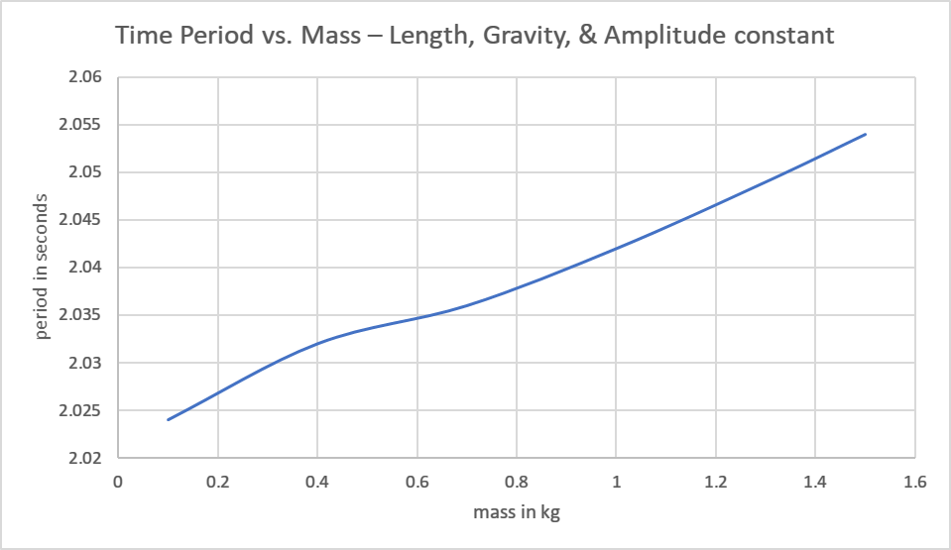
b) From Part 2: Period vs. Amplitude (T vs. A)
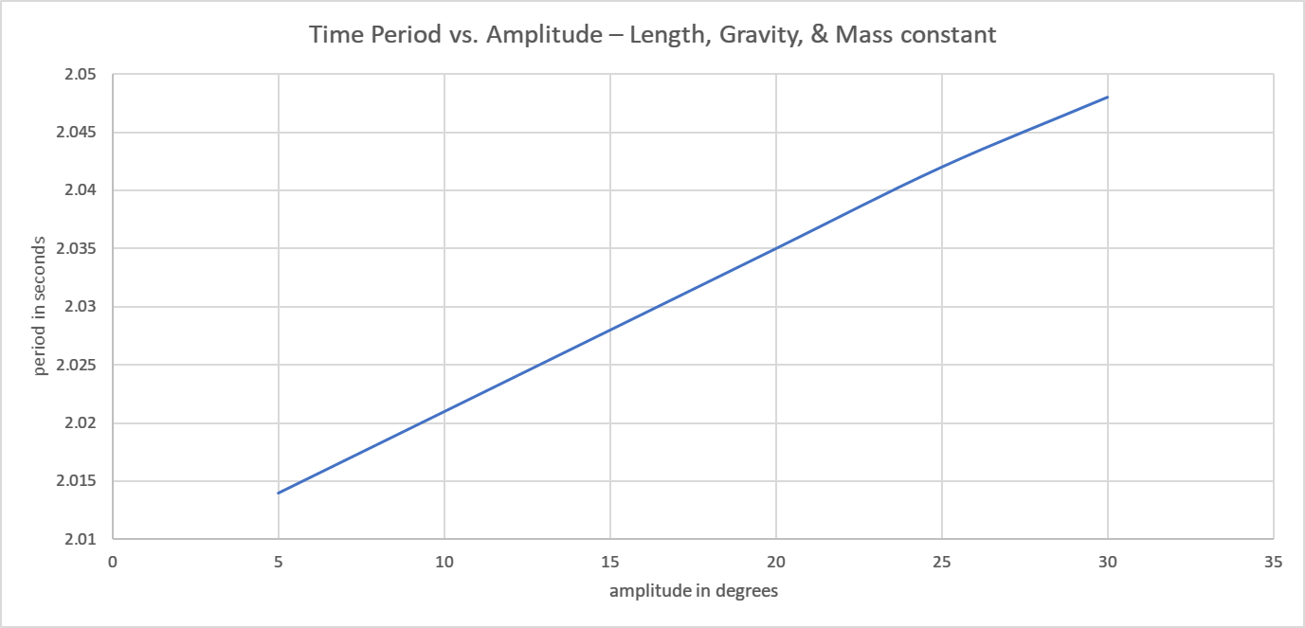
c) From Part 3: Period vs. Gravity (T vs. g)
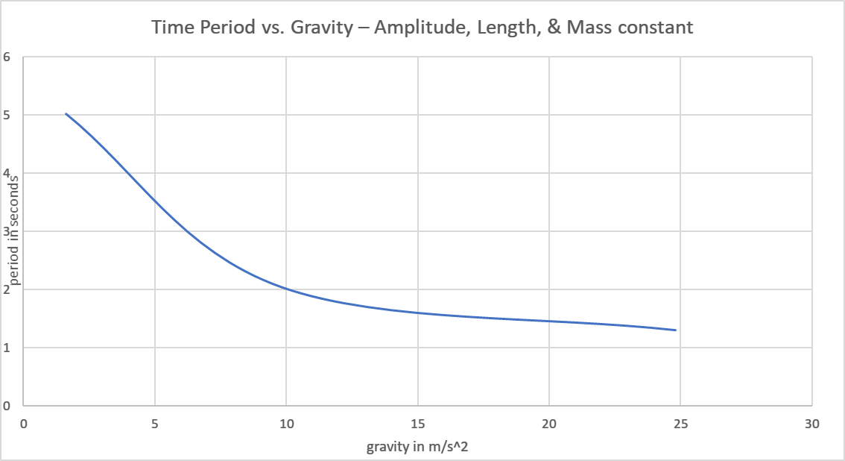
d) From Part 4: Period vs. Length (T vs. L)
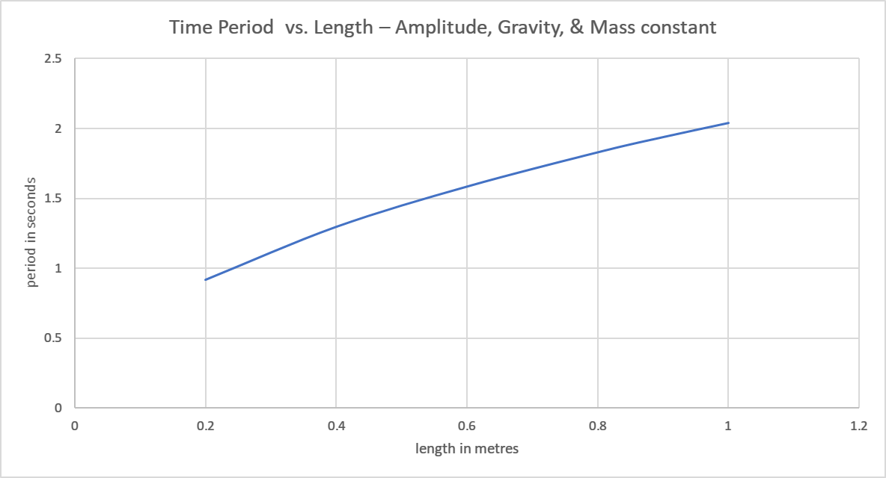
e) From Part 4: Period² vs. Length (T² vs. L)
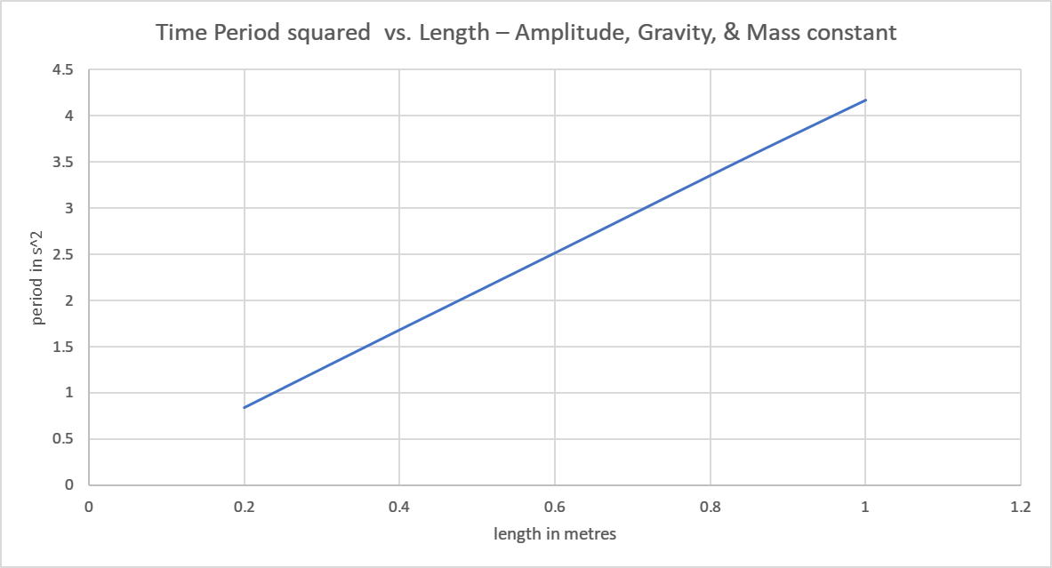
Note: Remember that y vs x means that the y values are plotted on the vertical axis and the x values on the horizontal axis.
TABLE I:
Part # | Run # | Length (m) | Mass  (kg) | g  (m/s²) | Amplitude  (degrees) | Time for 10 oscillations  (s) | Time Period  (s)
1 | 1 | 1 | 0.1 | 9.81 | 29 | 20.24 | 2.024
1 | 2 | 1 | 0.4 | 9.81 | 29 | 20.32 | 2.032
1 | 3 | 1 | 0.7 | 9.81 | 29 | 20.36 | 2.036
1 | 4 | 1 | 1.0 | 9.81 | 29 | 20.42 | 2.042
1 | 5 | 1 | 1.3 | 9.81 | 29 | 20.49 | 2.049
1 | 6 | 1 | 1.5 | 9.81 | 29 | 20.54 | 2.054
2 | 1 | 1 | 1.0 | 9.81 | 5 | 20.14 | 2.014
2 | 2 | 1 | 1.0 | 9.81 | 10 | 20.21 | 2.021
2 | 3 | 1 | 1.0 | 9.81 | 15 | 20.28 | 2.028
2 | 4 | 1 | 1.0 | 9.81 | 20 | 20.35 | 2.035
2 | 5 | 1 | 1.0 | 9.81 | 25 | 20.42 | 2.042
2 | 6 | 1 | 1.0 | 9.81 | 30 | 20.48 | 2.048
3 | 1 | 1 | 1.0 | 1.62 | 29 | 50.18 | 5.018
3 | 2 | 1 | 1.0 | 9.81 | 29 | 20.41 | 2.041
3 | 3 | 1 | 1.0 | 24.8 | 29 | 13.00 | 1.300
4 | 1 | 0.2 | 1.0 | 9.81 | 29 | 9.19 | 0.919
4 | 2 | 0.4 | 1.0 | 9.81 | 29 | 12.98 | 1.298
4 | 3 | 0.6 | 1.0 | 9.81 | 29 | 15.86 | 1.586
4 | 4 | 0.8 | 1.0 | 9.81 | 29 | 18.31 | 1.831
4 | 5 | 0.9 | 1.0 | 9.81 | 29 | 19.40 | 1.940
4 | 6 | 1.0 | 1.0 | 9.81 | 29 | 20.41 | 2.041

Based on your graphs, answer and explain the following questions:
1. From the Period vs. Mass graph, does the period appear to depend on mass?
yes, period is directly proportional to mass, the larger the mass the higher the period of oscillation.
2. From the Period vs. Amplitude graph, does the period appear to depend on amplitude?
yes, the larger the amplitude the longer it takes to oscillate for a full swing and thus they are directly proportional.
3. From the Period vs. Gravity graph, does the period appear to depend on gravity? What is the relation between Period and Gravity (directly related or inversely related)?
They are inversely related, the lower the gravity the higher the period of oscillation.
4. From the Period vs. Length graph, does the period appear to depend on length? What is the relation between Period and Length (directly related or inversely related)?
yes, the period is dependent on the length. The two are directly related.
5. Explain how you can graphically determine g of Earth using the Period² vs. Length graph? Obtain the value of g by doing a curve fitting and compare it with the known value of 9.81 m/s². Show the Trendline on your Excel graph and calculations.
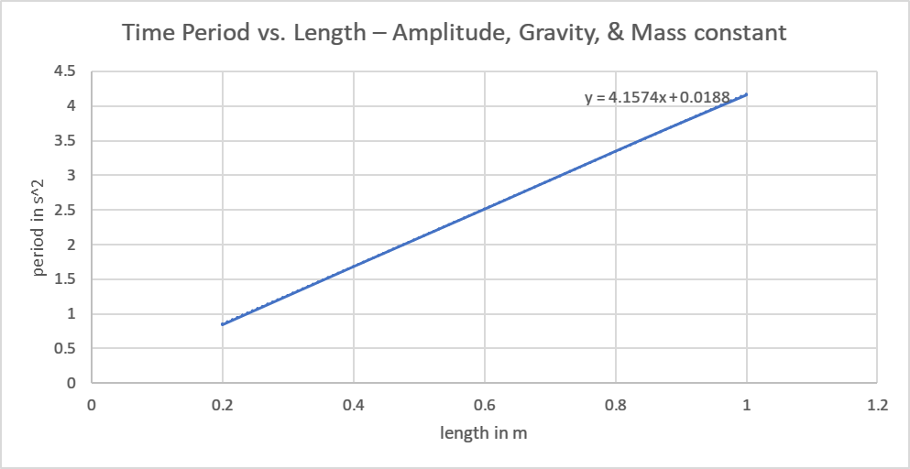
$$slope of the graph=4.1574\frac{s^{2}}{m}$$
$$\frac{4π^{2}}{g}=4.1574$$
$$gravity=\frac{4π^{2}}{4.1574 }=9.49\frac{m}{s^{2}} \\ 6. Explain how you can graphically determine$$the length of a pendulum using Period² vs. 1/g graph?

The length of the pendulum is the slope of the Period² vs. 1/g graph

Part II: Waves Introduction

Choose the “Water” option
Find all of the following settings/switches and become familiar with the operation of the simulation:

- Water on/off
- Continuous Wave (CW) or Pulse
- Top/Side Views
- Pause and Playback Speeds
- Ruler
- Stopwatch
- Dual Water-level Probe (DWL)
- Frequency/Amplitude Sliders

Procedure:
- Set the water to produce a CW.
- Set the frequency slider in the middle, use the stopwatch feature to determine the period of the waves (time for one complete oscillation).
- From the period value, calculate both the frequency and angular frequency of the waves.
- Using the ruler feature, determine the wavelength of the wave. Convert your measurement to meters.
- From the wavelength value, calculate the wave number.
- Using the ruler feature, determine the amplitude of the wave.
- Write down an equation for the wave with the values found/calculated above. (Let the phase term, φ, be zero.)
Period, T (s) | Frequency, f (Hz) |  | Angular Frequency, ω (rad/s) | Wavelength, λ (m) | Wave number, k (rad/m) | Amplitude, A (m) | Phase Velocity, v_{p} (m/s)
2.25 | 0.444 |  | 2.792 | 0.027 | 232.7 | 0.012 | 0.012
Equation: |  | $f=\frac{1}{T}$ $w=2πf$ $k=\frac{2π}{λ}$ $Vp=\frac{λ}{T}$

Show all your calculations:

$$f=\frac{1}{T}=\frac{1}{2.25}=0.444Hz$$
$$w=2π×0.444=2.792\frac{rads}{s}$$
$$k=\frac{2π}{0.027}=232.7\frac{rad}{m}$$
$$Vp=\frac{λ}{T}=\frac{0.027}{2.25}=0.012\frac{m}{s}$$

Determine the frequency, wavelength and phase velocity when you change the slider to “min” and then “max.”

 | “min” | “max”
f = | 0.2564 | 0.6494
λ = | 0.05 | 0.016
v_{p} = | 0.0128 | 0.0104

Knowing the angular frequency and the amplitude, what is the maximum speed of the surface of the water as it moves up and down? v_{max} = __0.0104 m/s____________________

Show all your calculations:
For “min”
$$f=\frac{1}{T}=\frac{1}{3.9}=0.2564 Hz$$
$$vp=λf=0.2564×0.05=0.0128 m/s$$

For “max”
$$f=\frac{1}{T}=\frac{1}{1.54}=0.6494 Hz$$
$$vp=λf=0.6494×0.016=0.0104 m/s$$

Practice: For the following wave equations, determine the values for the different variables.
 | ω | f | T | k | λ | A | v_{p}
$$y_{1}\left(x,t\right)=10 sin⁡(5x-3t)$$ | 3 | 0.4775 | 2.094 | 5 | 1.257 | 10 | 0.6002
$$y_{2}\left(x,t\right)=0.5 sin⁡(2x+6t)$$ | 6 | 0.9549 | 1.047 | 2 | 3.142 | 0.5 | 3.00955
$$y_{3}\left(x,t\right)=4 sin⁡(x-8t)$$ | 8 | 1.273 | 0.7854 | 1 | 6.284 | 4 | 8

Show your calculations for the calculated values:

$$f=\frac{w}{2π}=\frac{3}{2π}=0.4775 Hz$$
$$T=\frac{1}{f}=\frac{1}{0.4775}=2.094 s$$
$$λ=\frac{2π}{k}=\frac{2π}{5}=1.257 m$$
$$Vp=\frac{λ}{T}=\frac{1.257}{2.094}=0.6002 m/s$$

Phase:

Set the frequency to be somewhere near the middle, then determine the value of the frequency and wavelength. (Keep that frequency setting constant for the rest of the activity.)
f = ___0.455 ______Hz; ω = ___2.855_______rad/s; λ = _____0.026______m,
k =_____241.66____ rad/m

- Pause the simulation and retrieve the DWS.
- Put the sensors at the locations of peaks – but not the same peak.
- Play the simulation and describe what the sensors are recording.
The sensors record the water displacement at the peaks. The two are clearly in phase with each other.
- Measure the distance $∆x$ between the two sensors, and calculate:
$$k ∆x=241.66×0.027=6.52482$$
$$\frac{∆x}{λ}=\frac{0.027}{0.026}=1$$

- Pause the simulation.
- Place one sensor at a peak and the other at a trough.
- Play the simulation and describe what the sensors are recording.

The sensors are recording the water displacement changes. The displacements are clearly observed to be out of phase with each other since one sensor measures the peak and the other measures the trough of the displacement.

- Measure the distance between the two sensors and calculate:
$$k ∆x=241.66×0.017=4.108$$
$$\frac{∆x}{λ}=\frac{0.017}{0.026}=0.7$$

- Verify that every time $\frac{∆x}{λ}=n$ that the sensor outputs are synchronized. (n = 1, 2, 3…) What does this mean?

The sensors measure the peaks of the water displacement at the crests and therefore are in phase with each other.

- Verify that every time $\frac{∆x}{λ}=n+1/2$ that the sensor outputs are completely out-of-phase. What does this mean?

The sensors measure the peaks of the water displacement at the crest and the trough and therefore are out of phase with each other.

CONCLUSION

The period of the oscillation of the pendulum is dependent on several factors among them the length of the pendulum, the mass and the amplitude of the oscillation and the gravitational field strength. some of these factors are either inversely related while others are directly related to the period of oscillation.
The phase of the water displacement on the wave experiment is dependent on where the sensors are placed either on the crests or the troughs which ultimately determine whether they are in phase or out of phase with each other.

