E-11-OL: Equilibrium of a Rigid Body Online Version

OBJECTIVE

The purpose of this experiment is to study the conditions that must be satisfied for a rigid object to be in static equilibrium. This is done by computing the total torque acting on a meter stick by means of weights placed at specific locations on the ruler.

you need to use the recorded video to obtain the required values for the procedures. Show your calculations detail.

Link to video: https://youtu.be/sIKJoZrhEqo

Part 1

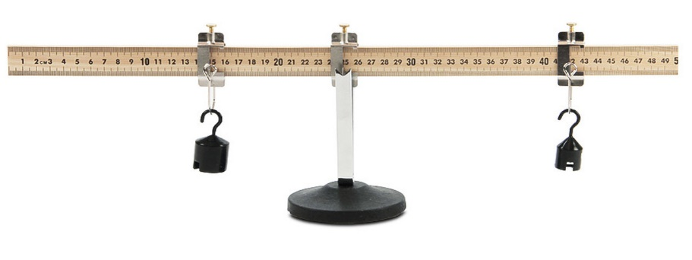
MATERIALS
Clamp
Clamp

Meter stick
Support stand
weights
Unknown weight
balance

(equipment used in the video is different from shown here)

INTRODUCTION

The torque τ exerted by a force F on a rigid object able to rotate about an axis is given as τ = F d, where d is the lever or moment arm of F about axis. It is equal to the perpendicular distance from axis to F. Torque is a vector quantity that is perpendicular to the plane made by F and d. For rigid bodies in equilibrium, they should not have neither linear nor angular acceleration. This means that two conditions must be satisfied simultaneously; the total force acting on the object is zero and the total torque should also be zero. Hence
Σ τ = 0 (1)
and Σ F = 0

By convention, the torque is positive if the force tends to rotate the object counterclockwise and
negative if it ends to rotate clockwise. The apparatus consists of a meter stick balanced about a pivot. The torques are created by weights hung at different locations along the ruler by means of clamps.

EXPERIMENTAL PROCEDURES
- Using the balance, measure the mass of the meter stick and ‘unknown mass’. Obtain the average values and record them.

2) Ideally, the center of gravity of the stick should be at the 50 cm mark. However this is not true in most situations. To find its correct location, balance the stick on the support stand until it is horizontal. Record this position of the center of gravity.

- Place a 100-g weight from a clamp centered at the 10 cm mark and slide the meter stick until the stick is balanced on the support stand. Record the position of the point of support.

- Keeping everything as in procedure 3, place a 200-g centered at the 90 cm mark and slide the meter stick until it is balanced on the support stand. Record the new position of the point of support.

- Remove the weights. Balance the meter stick at its center of gravity as in procedure 2 and place an unknown mass (e.g. your keys, or a solid mass) at the 90 cm mark. Place the 200-g mass on the meter stick at a location until equilibrium is reached. Record this position.

CALCULATIONS
- From procedure 3, compute the mass of the meter stick by the method of torques. Find the percent error between the computed and the actual mass of the meter stick.

- In procedure 4, choose an appropriate axis of rotation and compute the torque for each force acting on the stick. Since the object is in equilibrium, ascertain that the sum of the torques is zero.

- From procedure 5, compute the weight of the unknown mass by the method of torques. Find the percent error between the computed and the actual mass of the unknown mass.

ADDITIONAL RESOURCES

http://hyperphysics.phy-astr.gsu.edu/hbase/handb.html

Equilibrium of a Rigid Body DATA REPORT FORM

Procedure 1
True mass of meter stick: __________ True mass of unknown mass: _______

Procedure 2
Center of mass of meter stick: ________

Procedure 3
Position of the 100-g mass: __________ Position of equilibrium: __________
Mass of the stick from method of torques: __________ percent error: __________

Procedure 4
Position of the 100-g mass: _________ Position of the 200-g mass: __________
Position of equilibrium of meter stick: __________
Torques calculation: Torque found at (position): ___________
Torques due to:
Meter Stick: ___________ 100 g mass: _________ 200 g mass: ___________
Sum of the three torques: ___________

Procedure 5
Position of unknown mass: __________ Position of the 200-g mass: __________
Weight of unknown mass from method of torques: __________
Percent error between calculated and actual mass: ________

Your Lab Report Should Include the Following

Show your calculations details for procedures 3,4, and 5.

QUESTIONS
- Can the meter stick be balanced if a mass is attached on one side only?
- In each of the procedures of this experiment, are the forces also balanced?
- How do the different masses being balanced show the properties of a lever?
- What are the sources of error in this experiment?
- Why does a tight rope walker carry a long, horizontal bar to keep him balanced?

