Name:__________________

Understanding Molarity and Parameters affecting Molarity Remote Lab
This lab uses the Concentration and Molarity simulations from PhET Interactive Simulations.
https://phet.colorado.edu/sims/html/concentration/latest/concentration_en.html
https://phet.colorado.edu/sims/html/molarity/latest/molarity_en.html

You may type out your calculations or upload scans/photos of your work. If you upload scans/photos of your calculations, please ensure that your problems are in the correct order and your writing is legible. Finally, please place a box around your final answer to ensure that it is clearly indicated.

Learning Goals
- Describe the relationships between volume and amount of solute to solution concentration.
- Predict how solution concentration will change for any action (or combination of actions) that adds or removes water, solute, or solution, and explain why.

Develop your understanding: Explore the Concentration simulation. Try to find all the ways you can change the concentration of the solution in the beaker.
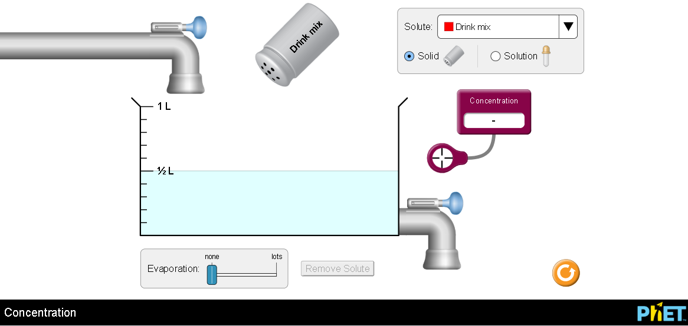

Explain your understanding:
- Mole calculation review. Show your work:
  - How many moles is
55 g of NaCl?
Moles = mass/ molar mass
Moles = 55/(23 + 35.5)
Moles = 55/58.5
= 0.9402 moles

0.025 g of Na₂CO₃?
Moles = mass/ molar mass
Moles = 0.025/(23 x 2 + 12 + 16 x 3)
Moles = 0.025/106
= 0.0002358 moles
  - How many grams is
0.5 moles of NaCl?
Mass = moles x molar mass
Mass = 0.5 x 58.5
Mass = 29.35 g

2.11 moles of NaCO₃?
Mass = moles x molar mass
Mass = 2.11 x 106
Mass = 223.66 g

- There are several ways to measure Concentration. This simulation uses Molarity (mol/L).
  - What does mol/L mean?
Mol/L means the number of molecules contained in one liter of a given solution.

  - Describe in your own words how mol/L compares to grams/liter. (similarities and differences)
Both are units used to refer to concentration of a solution.
Mol/L explains the number of moles of solute contained in a liter of solution whereas grams/L indicates the mass of solute in grams contained in one liter of solution.

- Describe at least 2 ways in the simulation to change each of the parameters:
  - Volume of solution
Open the tap above to increase volume of solution and the tap below to reduce the volume of solution.
  - Amount of solute
To add the amount of solute, shake the ‘drink mix’ apparatus and tap the button ‘remove solute’, to remove the solute.
  - Concentration of solute in solution
Add the amount of solute to increase the concentration and remove solute to reduce the concentration.
- Volume effects on concentration:
  - Is dilution directly or indirectly related to Molarity?
Explain how you used the sim to determine the relationship and give evidence of measurements you made to support your ideas.
Dilution is indirectly related to molarity. Dilution leads to decrease in molarity. As more solvent is added to a solution, it becomes more dilute hence lowers the concentration or molarity.

  - How is evaporation related to Molarity? Use your own words to describe why the relationship makes sense based on the data you used to support the dilution relationship.
Evaporation is directly related to molarity. As evaporation increases, molarity also increases and vice versa. Evaporation lowers the amount of solvent in a solution, hence the amount of solute per given volume of solution increases. This increases molarity.

  - What is one way to change the volume without changing the concentration? Describe why the concentration doesn’t change.
Volume of a solution can be changed without changing the concentration by adding a similar solution with same concentration.
- Does the concentration change in the same way if you used solid or liquid to add solute? Explain why your observation makes sense using things from your everyday life like table salt.
Concentration or molarity is the same regardless when a solid or liquid added. The number of molecules per volume of solution is the same for equal quantity of solid or liquid added.

Summarize your understanding:
- What are all the things that affect Concentration measured in mol/L (parameters in the sim).
List here and identify if the variable is directly or indirectly related to the concentration:
Amount of solute. Directly related to concentration
Amount of solvent. Indirectly related to concentration
Temperature. Directly related to concentration

- Explore the Molarity simulation and consider how it compares (similarities and differences) to Concentration. Write down your observations.

Both are units used to refer to concentration of a solution.
Mol/L explains the number of moles of solute contained in a liter of solution whereas grams/L indicates the mass of solute in grams contained in one liter of solution.

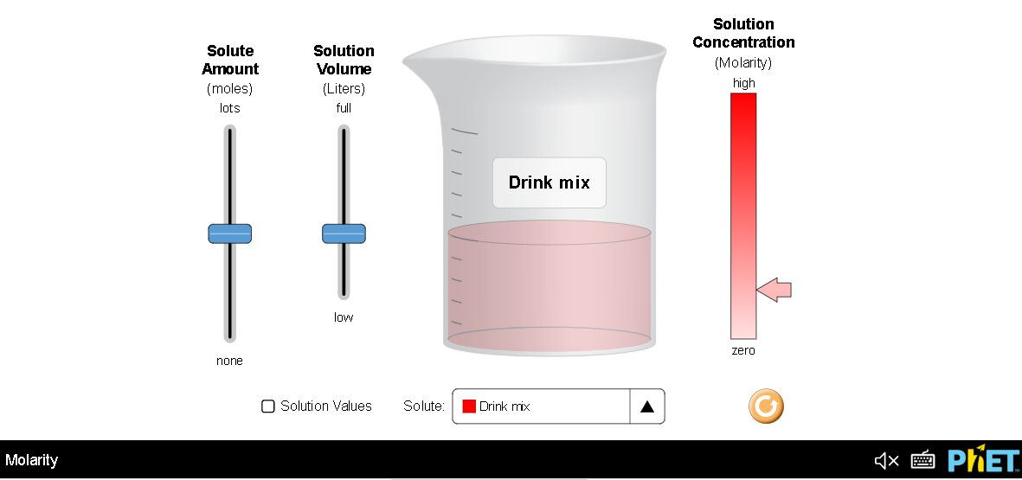

Test your understanding:
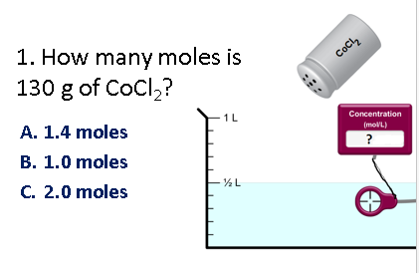1. Show your work: Moles = mass/ molar mass
Moles = 130/(59 + 35.5 x 2)
Moles = 130/130
= 1.0 mole

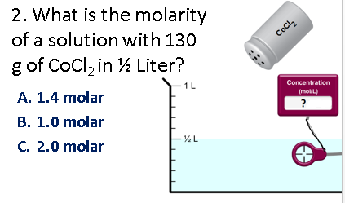2. Show your work: molarity = (moles x 1000 mL)/1000
Molarity = (1.0 x 1000 mL)/ 500 mL
Molarity = 2.0 M

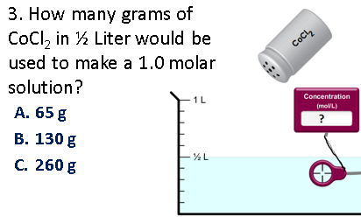3. Show your work:
Moles = (molarity x volume)/1000
Moles = (1.0 x 500)/1000
= 0.5 moles
Mass = moles x molar mass
Mass = 0.5 x 130
Mass = 65 g

For #4-8, predict your answer and support your answer with an explanation.
Then use the Concentration simulation to verify and add screen captures to your explanation.

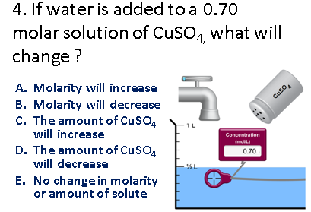
4. Prediction and explanation with support
B. Molarity will decrease. Increase in water increases the volume of solution with decrease in the number of moles per volume of the solution. Molarity is lowered.
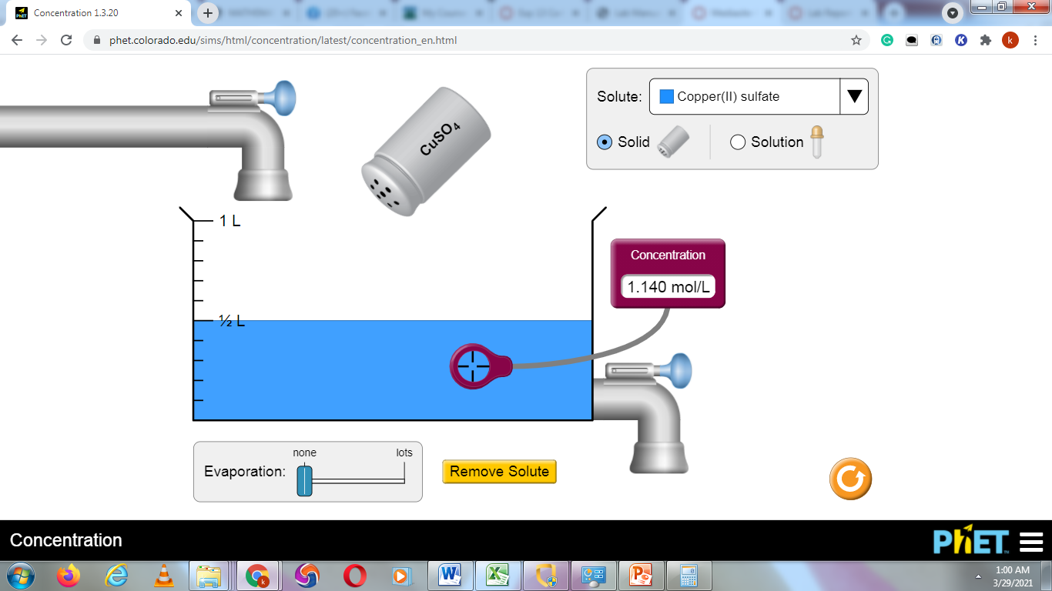
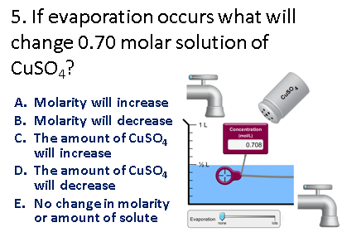
5. Prediction and explanation with support

A. Molarity will increase. . Evaporation lowers the amount of solvent in a solution, hence the amount of solute per given volume of solution increases. This leads to increase molarity.
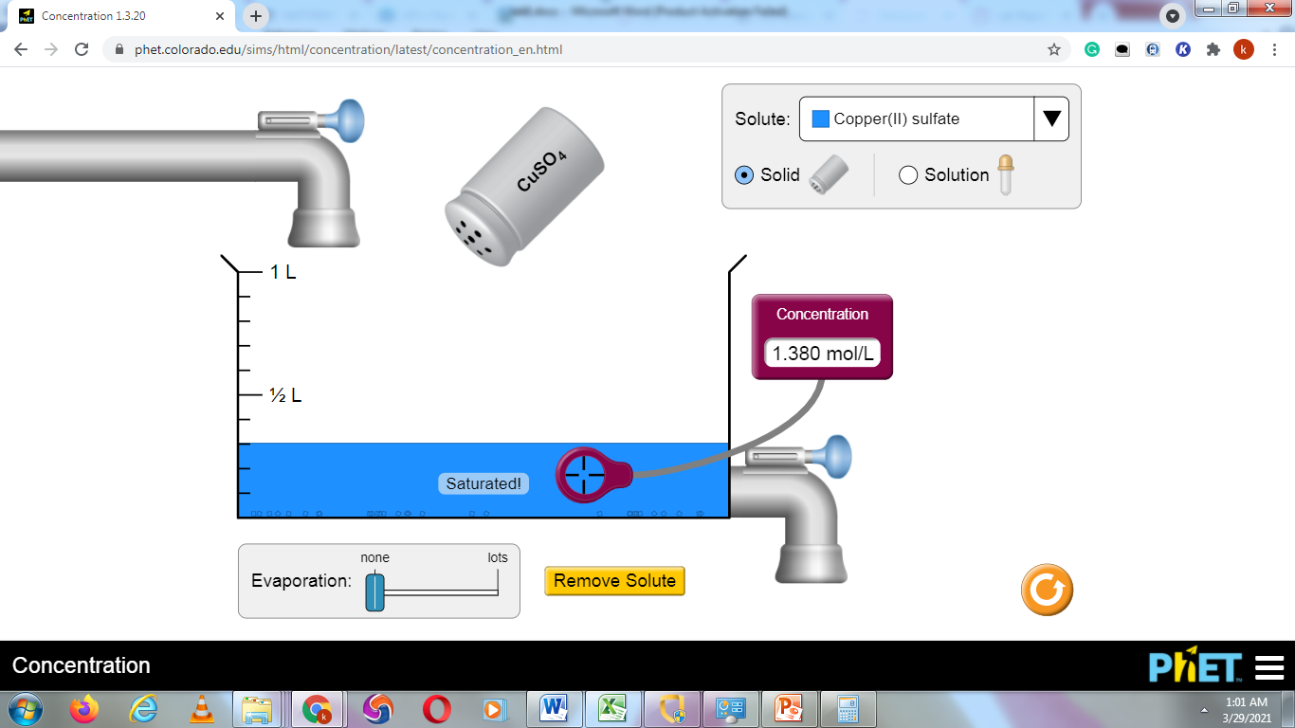
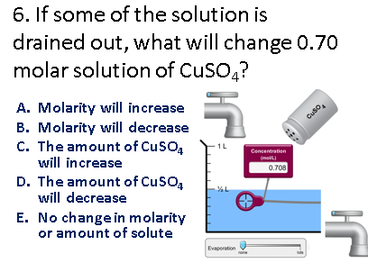

6. Prediction and explanation with support
E. No change in molarity or amount of solute. Decrease in volume of a solution does not affect the concentration of the same solution.
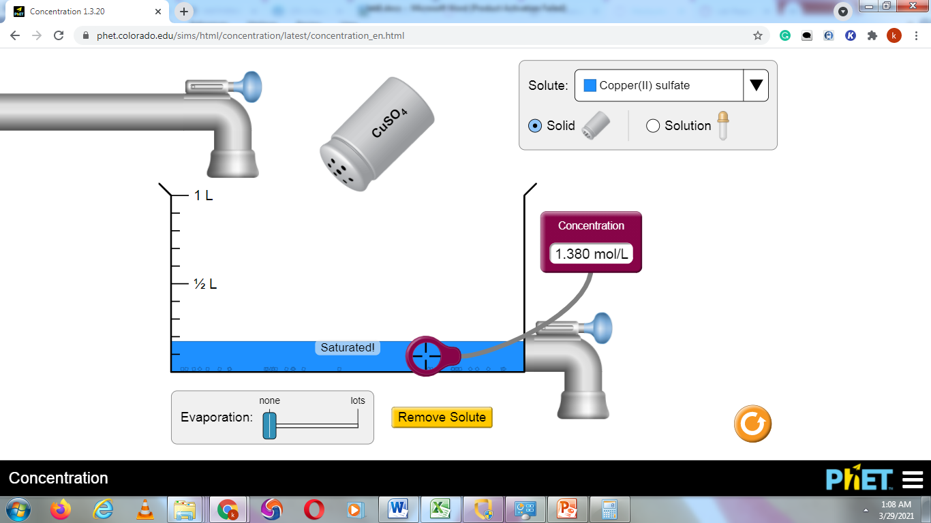

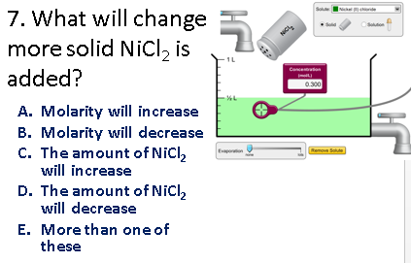
- Prediction and explanation with support

Both molarity and the amount of NiCl₂ will increase. Addition of more solute increase the number of moles of NiCl₂ in the solution, hence increase in molarity.
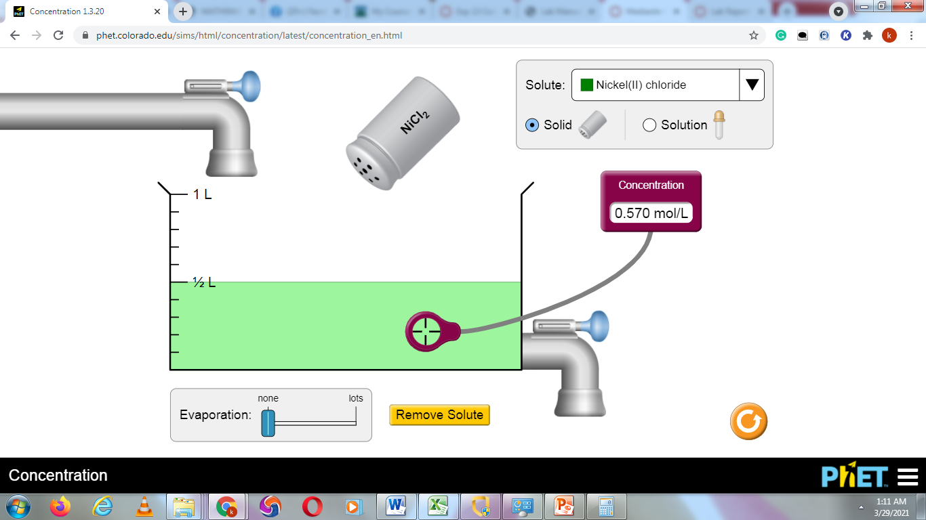
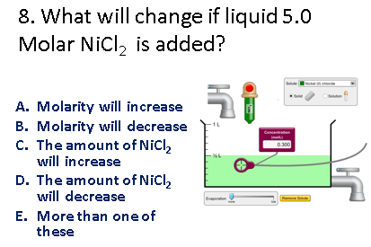
- Prediction and explanation with support

Both molarity and volume increases.
