For the first part of this lab, you will be using the Wave Interference simulation created by the Phet organization, which can be found here:
https://phet.colorado.edu/sims/html/wave-interference/latest/wave-interference_en.html
Once you open the simulation, you will see the following screen
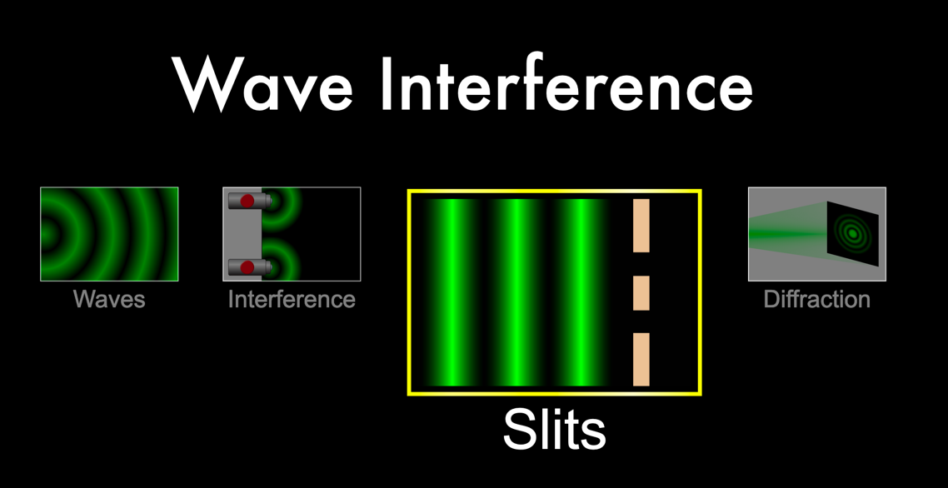
We will be using the “slits” part of this simulation, in order to examine single slit and double slit diffraction.
Once you choose this option, your screen will show you the following choices:
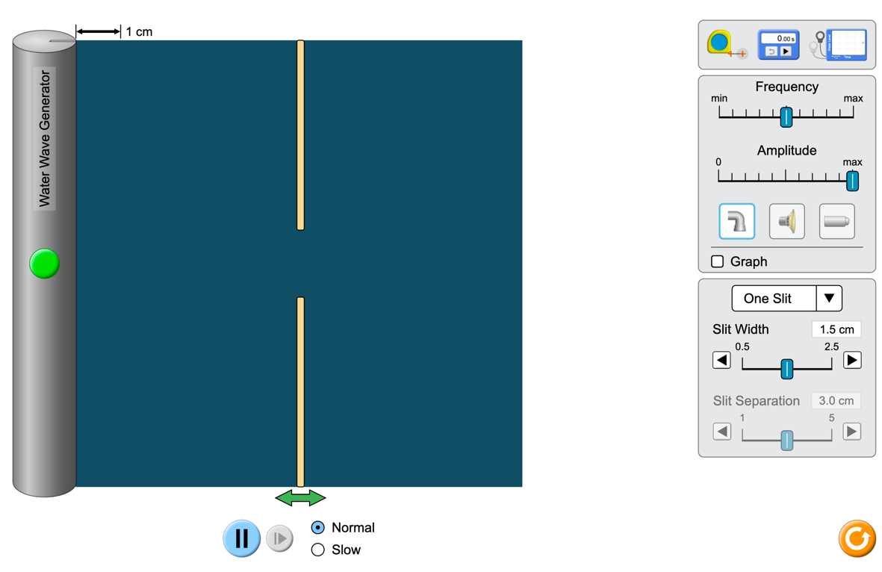
Choose light sources
Once you switch your source to light sources from the water source that the simulation defaults to, you will now see the following:
Tape measure allows you to measure either horizontal or vertical distances.
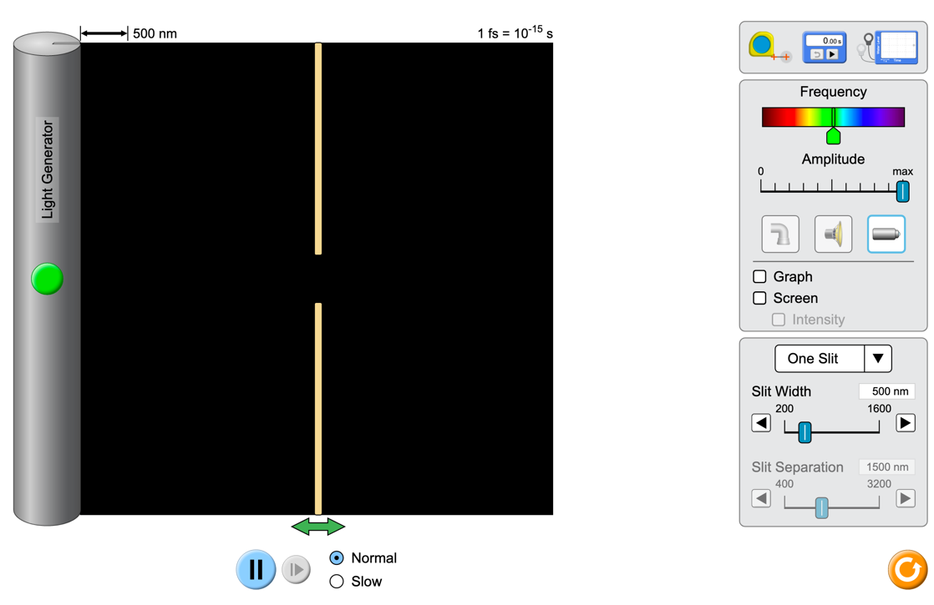
Click Screen, and then Intensity
For this lab, you will be given information about the number of slits to use, and the slit width and slit separation, as well as the distance to the screen you should use. You will be measuring distances between bright fringes or dark fringes, and then using that data to calculate wavelengths.
Double slit diffraction – qualitative exploration.
Varying wavelength
- First, set your simulator to Two Slits, then grab the slits themselves and slide them to the left so that they are very close to the light source.
- Next, slide the frequency slider so that it is on a red wavelength, and turn on the light generator. (Use the pre-set values for slit width and slit separation.) Changes to the setup take time to propagate to the screen, so be patient. Take a screenshot that includes the screen with bright and dark fringes as well as the intensity graph, and attach it here.
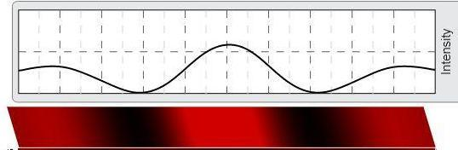

- Move the frequency slider so that it is on a green wavelength, without changing anything else. Take a screenshot that includes the screen with bright and dark fringes as well as the intensity graph, and attach it here.

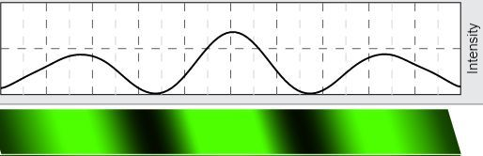

- Move the frequency slider so that it is on a purple wavelength, without changing anything else. Take a screenshot that includes the screen with bright and dark fringes as well as the intensity graph, and attach it here.
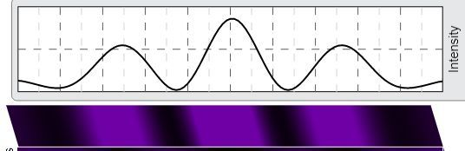

- NOTE: Screenshots must be right side up, not sideways or upside down, for credit. Include all screenshots in your lab report, NOT as separate attachments.
- Look up values for wavelengths for red, green and purple. Which has the largest wavelength?
Ans: Red has the largest wavelength.

- Looking at the interference patterns for the different colors, which one has the largest distance between bright fringes? How does the trend in interference patterns compare to the trend in wavelengths?
Ans: Red color has the largest distance between bright fringes.
The larger the wavelength is the larger is the distance between the bright fringes.

Varying slit separation
- Move your frequency slider back to the red frequency you were using initially.
- Keep the value for slit width (500 nm) but change the slit separation to 1000 nm. Take a screenshot that includes the screen with bright and dark fringes as well as the intensity graph, and attach it here.
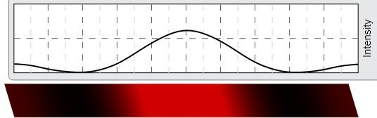

- Now change the slit separation to 2000 nm. Take a screenshot that includes the screen with bright and dark fringes as well as the intensity graph, and attach it here.
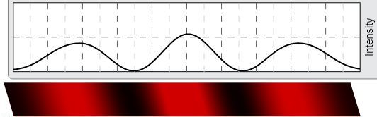

- Now change the slit separation to 3000 nm. Take a screenshot that includes the screen with bright and dark fringes as well as the intensity graph, and attach it here.
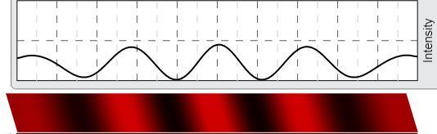
- Which of the screenshots allows you to see the largest number of bright fringes?
Ans: The screenshot with sleet separation of 3000 nm allows us to see the largest number of bright fringes.

Varying screen distance
- Keep your frequency of light the same, and keep the slit width the same as in your last exploration.
- Change the slit separation back to 2000 nm. With the slits as close to the light source as the simulation allows, take a screenshot that includes the screen with bright and dark fringes as well as the intensity graph, and attach it here.

- Move the slits a bit closer to the screen, so that they are about a third of the way from the light source to the screen. Take a screenshot that includes the screen with bright and dark fringes as well as the intensity graph, and attach it here.
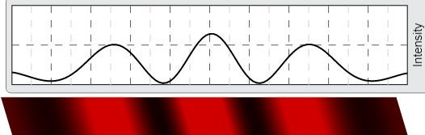
- Move the slits a bit closer to the screen again, so that they are about halfway between the light source and the screen. Take a screenshot that includes the screen with bright and dark fringes as well as the intensity graph, and attach it here.
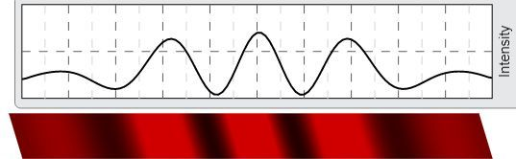

- Which of these screenshots allows you to see the largest number of bright fringes?
Ans: The screenshot with the slit halfway the light source and the screen allows us to see the largest number of bright fringes.

- Which one has the brightest central maximum?
Ans: The screenshot with the slit halfway the light source and the screen has the brightest central maximum.
Single slit diffraction – qualitative exploration.
Varying wavelength
- First, set your simulator to One Slit, and slide the slit so that it is very close to the light source. Use a slit width of 1600 nm.
- Next, slide the frequency slider so that it is on a red wavelength, and turn on the light generator. Adjust the intensity zoom factor to look for any bright fringes aside from the central maximum. (They will be significantly smaller.)Take a screenshot that includes the screen with bright and dark fringes as well as the intensity graph, and attach it here.

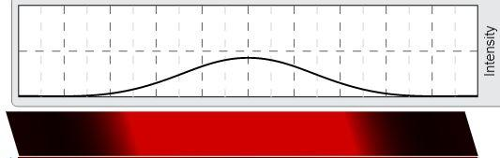

- Move the frequency slider so that it is on a green wavelength, without changing anything else. Take a screenshot that includes the screen with bright and dark fringes as well as the intensity graph, and attach it here.
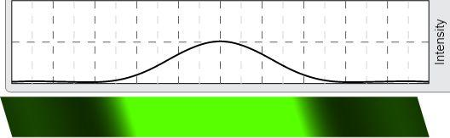

- Move the frequency slider so that it is on a purple wavelength, without changing anything else. Take a screenshot that includes the screen with bright and dark fringes as well as the intensity graph, and attach it here. Include all screenshots in your lab report, not as separate attachments.
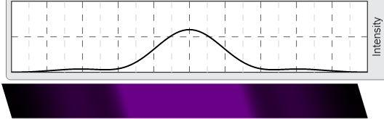

- Looking at the interference patterns for the different colors, which one has the widest central maximum?
Ans: The red color pattern has the widest maximum.

Varying slit width
- Make sure your frequency slider is still set to the purple frequency you were just using.
- Set the slit width to 500 nm. Maximize the zoom on the intensity graph. Take a screenshot that includes the screen with bright and dark fringes as well as the intensity graph, and attach it here.
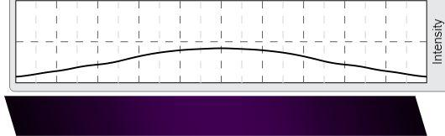

- Now change the slit width to 1000 nm. Take a screenshot that includes the screen with bright and dark fringes as well as the intensity graph, and attach it here.
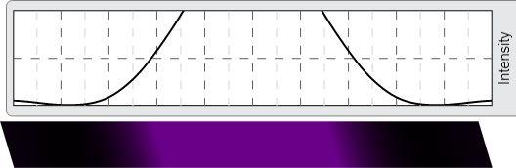

- Now change the slit width to 1500 nm. Take a screenshot that includes the screen with bright and dark fringes as well as the intensity graph, and attach it here. Include all screenshots in your report.
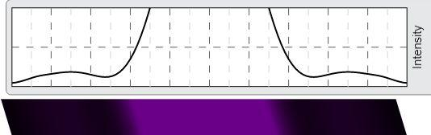

- Which of the screenshots has the widest central maximum?
Ans: The screenshot with slit width of 500 nm has the widest central maximum.

- Which of the screenshots has the brightest central maximum?

Ans: The screenshot with slit width of 1500 nm has the brightest central maximum.

Varying screen distance
- Keep your frequency of light the same (the purple), and keep the slit width at 1500 nm.
- With the slit as close to the light source as the simulation allows, take a screenshot that includes the screen with bright and dark fringes as well as the intensity graph, and attach it here.
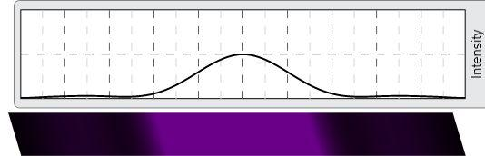
- Move the slits a bit closer to the screen, so that they are about a third of the way from the light source to the screen. Take a screenshot that includes the screen with bright and dark fringes as well as the intensity graph, and attach it here.
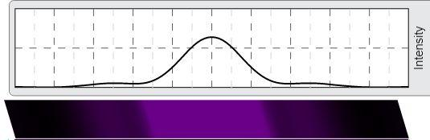

- Move the slits a bit closer to the screen again, so that they are about halfway between the light source and the screen. Take a screenshot that includes the screen with bright and dark fringes as well as the intensity graph, and attach it here.

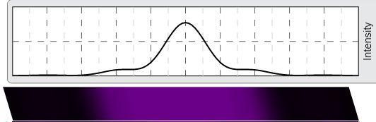

- Describe the changes you see as you change the distance between the slits and the screen.
Ans: As the distance between the slit and the screen decreases the intensity of the principal maximum increases, that is principal maximum gets brighter but the principal maximum gets narrower with decreasing distance of the slit from the screen.

Double Slit Diffraction – calculation
- You have a double slit diffraction pattern, and you are measuring the bright fringes you observe. For all of the measurements you do, you have a slit separation of 0.25 mm, and your screen is exactly 1.00 m from the double slit. If you are using a laser with a wavelength of 450 nm, calculate the following:
  - The angle θ for the first order bright fringes =θ = $\frac{450 nm}{0.25 mm}$ = $\frac{{450×10}^{-9} m}{{0.25×10}^{-3}m}$ = 0.0018 radian (since θ=λ/d , here, d =0.25 mm, λ=450nm)
  - Sin θ = $\frac{450 nm}{0.25 mm}$ = $\frac{{450×10}^{-9} m}{{0.25×10}^{-3}m}$ = 0.0018 (since dsinθ=mλ, here, d =0.25 mm , m=1, λ=450nm)
  - Tan θ = tan(0.0018 rad) = 0.001800001
  - Compare the values for sin and tan. Are these approximately equal? Can we use the small angle approximation?
Ans: Yes, the values of sin and tan are almost equal and we can safely use the small angle approximation.

- For the parameters above, calculate the angle and the distance from the central maximum for the first four bright fringes:
Ans: θ (radians) = m λ/d where m is the order number.
And : θ (radians) = (θ$×$180/ π) degree
And θ (radians)=(y_{m}/D) where D is the distance from the slit to the screen.
m | θ (degrees) | θ (radians) | y_{m} (mm)
1 | 0.10313 | 0.0018 | 1.8
2 | 0.20626 | 0.0036 | 3.6
3 | 0.30939 | 0.0054 | 5.4
4 | 0.41252 | 0.0072 | 7.2

- Next, you change lasers, so that you are now using a laser with a wavelength of 750 nm.
m | θ (degrees) | θ (radians) | y_{m} (mm)
1 | 0.171887 | 0.003 | 3
2 | 0.34377 | 0.006 | 6
3 | 0.51566 | 0.009 | 9
4 | 0.68755 | 0.012 | 12

- Finally, we are going to use data to calculate the wavelength of light that is diffracting through a double slit. For all of the measurements you do, you have a slit separation of
0.50 mm, and your screen is exactly 1.00 m from the double slit.
Ans: θ (radians) = (y_{m} /D) where D is the separation of screen from double slit.
And, θ (radians) = m λ/d where m is the order number.
m | y_{m} (mm) | θ (radians) | λ (nm)
1 | 1.36 | 0.00136 | 680
2 | 2.72 | 0.00272 | 680
3 | 4.09 | 0.00409 | 681.67
4 | 5.43 | 0.00543 | 678.75
- What color should the light be in this experiment?

Single Slit Diffraction – calculation
- You have a single slit diffraction pattern, and you are measuring the dark fringes you observe. For all of the measurements you do, you have a slit width of 0.16 mm, and your screen is exactly 1.00 m from the single slit. If you are using a laser with a wavelength of 450 nm, calculate the following:
  - The angle θ for the first order dark fringes. θ=sin⁻¹(0.0028125) rad = 0.0028125 rad
  - Sin θ = $\frac{450 nm}{0.16 mm}$ = $\frac{{450×10}^{-9} m}{{0.16×10}^{-3}m}$ = 0.0028125 (since, wsinθ=mλ, here, w =0.16 mm , m=1, λ=450nm)
  - Tan θ = tan(0.0028125 rad) = 0.0028125075
  - Compare the values for sin and tan. Are these approximately equal? Can we use the small angle approximation?
Ans: Yes, the values of sin and tan are almost equal and we can safely use the small angle approximation.

- Now, using the same parameters, calculate the angle and the distance from the central maximum to each of the first four dark fringes.
p | θ (degrees) | θ (radians) | y_{m} (mm)
1 | 0.161144 | 0.0028125 | 2.8125
2 | 0.322288 | 0.0056250 | 5.6250
3 | 0.483431 | 0.0084375 | 8.4375
4 | 0.644576 | 0.01125 | 11.250

- Next, you change lasers, so that you are now using a laser with a wavelength of 750 nm.
p | θ (degrees) | θ(rad) | y_{m} (mm)
1 | 0.71622 | 0.0125 | 12.5
2 | 1.43244 | 0.025 | 25.0
3 | 2.14866 | 0.0375 | 37.5
4 | 2.86488 | 0.05 | 50.0

- Finally, we are going to use data to calculate the wavelength of light that is diffracting through a single slit. For all of the measurements you do, you have a slit width of 0.02 mm, and your screen is exactly 1.00 m from the double slit.
p | Y_{p} (mm) | θ(rad) | λ (nm)
1 | 20.03 | 0.02003 | 400.6
2 | 39.98 | 0.03998 | 399.8
3 | 60.00 | 0.06000 | 400.0
4 | 80.10 | 0.0801 | 400.5
- What color should the light be in this experiment?

Ans: The color of the light is violet or purple.

