Student’s Name
Instructor’s Name
Course
Date
10 Min aloft Assignment: An LED as a Light Sensor Craft Project
Problem Statement
According to a study carried out on September 13, 2017, by a team from the University of California, and the report released on March 2018, research shows that more than 25% of the total power generated by the United States goes to waste or rather are not utilized. 38% of this wastage is due to the fact that most Americans leave their lights on during the day when they go to work. This costa the Americans over $200 million on an annual basis according to the report. Due to this reason, it is, therefore, a high time that we engage in research which will help reduce the wastage of power. A solution needs to be determined that will ensure that lights during the day in households remain switched off.
Variables
There are two variables in this project; the dependent and independent variables. The independent variable is time and the fixed cost of power which does not change. The dependent variables include the number of bulbs one has in their households and the wattage rating of each one of them.
Constraints
The solution to this problem has been explained below. The major constraint with the solution which I have tried is that it cannot be used in heavy loads like microwaves, televisions, radios and other consumer electronics. It can only be used in switching off the lights. If one always leaves his or her electric shower on when he or she leaves for work, this solution is not convenient for them. The solution is also only convenient to a specific type of bulbs which are LEDs. Any other bulb cannot be used when this solution needs to be employed.
Observations
I conducted a small research across my neighborhood during the day just to see whether the results obtained by the report released by the team at the University of California was true. I recorded some observations I made. One of the observations I made is that more than half of homesteads in my neighborhood leave their lights on during the day. More so, they leave their security lights on. The security lights bulbs have a very high wattage of over 30 watts. This is the reason why they waste power and incur a lot of cost for the power they do not use. The results in the report were therefore true.
Data
No of Homesteads | Average number of bulbs left on during the day | Total average Wattage of the bulbs (Watts) | Amount Lost per day (12 cents per KWh)
Home A | 5 | 150 | $18
Home B | 0 | 0 | $0
Home C | 3 | 90 | $10
Home D | 8 | 240 | $28
Home E | 0 | 0 | $0

Progress So Far
So far I have seen that there are no forms of circuits used to switch off power automatically during daytime in any household setting. However, the technology is being applied in street lighting. I have tried to develop a circuit that can be used to automatically switch off the lights when there is light during the day. The circuit uses the same principle as that of street lighting only that the diodes and transistors used are of lower ratings. I have seen that it is working and it can be used in a household setting. It can be connected to the mains in the control box and feed via the HDMR to ensure efficient functioning.
The following photos show that the circuit works and when there is light, the LED which functions as the bulb, in this case, turns off and when there is darkness, it turns on. This is ideal in saving the energy lost during the day when lights are left on.
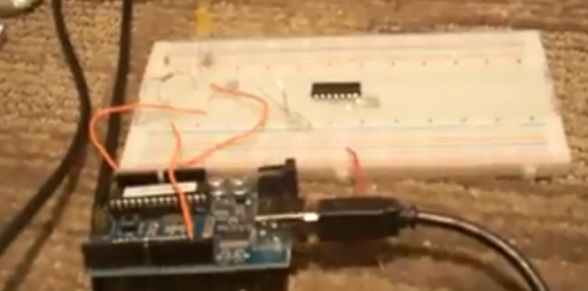
Diagram 1: The Light Sensor Circuit when there is Light
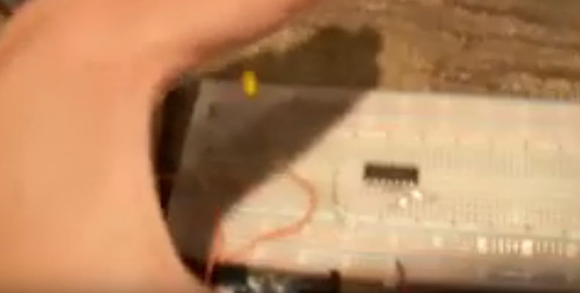
Diagram 2: The Light Sensor Circuit when there is no Light (When covered)
How to Resolve the Problem
Possible solutions
The possible solution has been presented above. This is the use of a Light Sensing Circuit connected to mains in the control box and feed via the HDMR to ensure efficient functioning. By doing this, it will help in switching off the lights automatically when lights come in the morning just like it does in street lighting. By using a smaller transistor (having a lower rating) in the circuit we will be able to make this solution real.
The other solution also might be educating members of the public on the importance of switching their lights off when they leave the house in the morning or when they are not using them. They should know the cost they will be saving on an annual basis when they switch off their lights during the day. I have however not tried this solution.
Limits and /or Constraints
The major constraint with the first solution which I have tried is that it cannot be used in heavy loads like microwaves, televisions, radios and other consumer electronics. It can only be used in switching off the lights. If one always leaves his or her electric shower on when he or she leaves for work, this solution is not convenient for them. The solution is also only convenient to a specific type of bulbs which are LEDs. Any other bulb cannot be used when this solution needs to be employed.

Work Cited
Campbell, R. J. (2018, March).A Study on the Major Ways of Power Loses and Wastages in The
United States. Washington, DC Congressional Research Service, University of California, Library of Congress.

