Lesson 9 Assignment:

Turning Electricity into Chemistry
1.a.
True. Slat bridge maintain the electrical charge balance of the cell, because while the cell operate electrons are move anode to cathode.
b.
True. When cell operate anode material get oxidize and therefore, oxidation number gets increase.
c.
True. Always reduction potential of the cathode (place where reduction taken place) has a higher value than the reduction potential of the anode (place where oxidation taken place). If not, electron can’t move from anode to cathode.
d.
True. To occur this Cd needs act as cathode.
e.
False. Br_{2(g)} is produce at the anode therefore, anode get darker, but mass of the cathode not get increase. Because hydrogen is produced at the cathode.
f.
True. In cathode Co²⁺ gets deposited but Na⁺ not going to deposit on the cathode.
g.
False. Reduction potential of Li is 3.05 V.

2.
Anode equation
Fe_{(s)} Fe²⁺_{(aq)} + 2e⁻
Cathode equation
Cu²⁺_{(aq)} + 2e⁻ Cu_{(s)}
Net equation
Fe_{(s)} + Cu²⁺_{(aq)} Cu_{(s)} + Fe²⁺_{(aq)}
b. E_{cell} = E_{cathode} – E_{anode}
= 0.34 – (-0.44)
E_{cell} = 0.78 V
c. 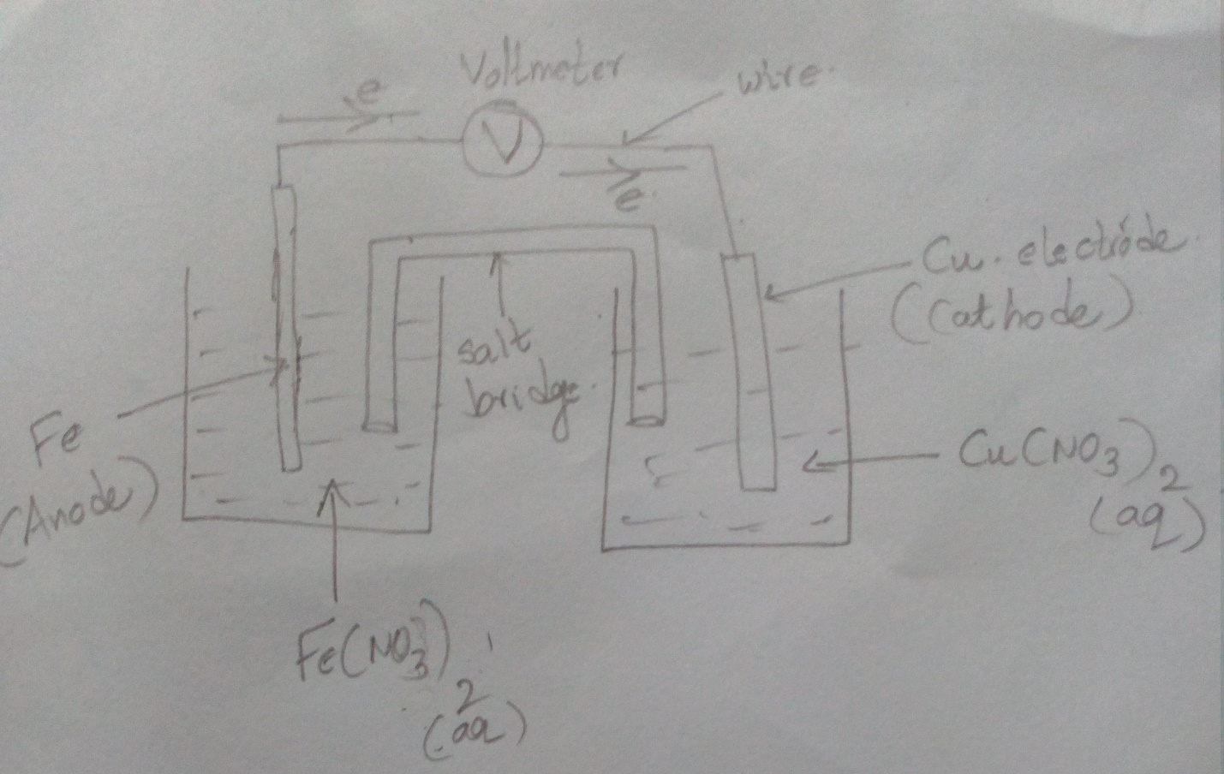

d. Cathode is electrode A, because when cell operates Cu²⁺ ions get deposited on the cathode.

3. a.
Cathode equation
Pb²⁺ _{(aq)} + 2e⁻ Pb_{(s)}
Anode equation
Cu_{(s)} Cu²⁺_{(aq)} + 2e⁻
Net equation
Pb²⁺ _{(aq)} + Cu_{(s)} Cu²⁺_{(aq)} + Pb_{(s)}
E_{cell} = E_{cathode} – E_{anode}
= -0.31 – (0.34)
E_{cell} = -0.65 V
This cell cannot proceed spontaneously because E_{cell} value is larger negative. Therefore, We need to supply external voltage to occur ethos reaction. We can predict the spontaneity by following equation
∆G = -n F E_{cell}
When E_{cell} become negative value ∆G become positive, therefore, this reaction cannot proceeds spontaneously

b.
Cathode equation
Ca²⁺ _{(aq)} + 2e⁻ Ca_{(s)}
Anode equation
2I⁻_{(aq)} I_{2(g)} + 2e⁻
Net equation
Ca²⁺ _{(aq)} + 2I⁻_{(aq)} Ca_{(s)} + I_{2(g)}
E_{cell} = E_{cathode} – E_{anode}
= -2.87 – 0.53
E_{cell} = -3.4 V

This reaction also has a larger negative E_{cell} value therefore, this also not proceeds spontaneously.

4.
Cathode equation
Cr³⁺ _{(aq)} + 3e⁻ Cr_{(s)}
Anode equation
2Br⁻_{(aq)} Br_{2(g)} + 2e⁻
Net equation
2Cr³⁺ _{(aq)} + 6Br ⁻_{(aq)} 2Cr_{(s)} + 3Br_{2(g)}

Charge = 2.5 * (45 * 60) = 6.75 * 10³ C
1 mole e⁻ = 96,500 C and 3 mol e⁻ are required to reduce 1 mole of Cr³⁺
ions,
Cr deposited in at the anode
Mass of Cr = (6.75 * 10³/96500) * (52/3) = 1.21 g

5. a.
Oxidizing agent – NO₃⁻_{(aq)}
Reducing agent – Sn_{(s)}
Electron flow – Sn to Cu
Reducing agent are get oxidize, in here there are two reducing agents those are Sn and Cu. Due to the higher electrode potential of the Sn, it gets oxides and make Sn²⁺_{(aq)} ions. Oxidizing agents are get reduced. There are two oxidizing agents Mg²⁺_{(aq)} and NO₃⁻_{(aq)}, in here NO₃⁻_{(aq)} has higher reduction potentials compared to the Mg²⁺_{(aq)} ions hence, NO₃⁻_{(aq)} ions get reduce.
b.
Cathode equation
NO₃⁻ _{(aq)} + 4H⁺_{(aq)} + 4e⁻ NO_{(g)} + H₂O_{(aq)}
Anode equation
Sn_{(s)} Sn²⁺_{(aq)} + 2e⁻
Net equation
NO₃⁻ _{(aq)} + 4H⁺_{(aq)} + 2Sn_{(s)} 2Sn²⁺_{(aq)} + NO_{(g)} + H₂O_{(aq)}

Mass change in anode (Sn electrode) = 3.0 g
Molar mass of Sn = 118.71 g/mol
Charge = {(3 * 2)/118.71}* 96500 = 4.876 *10³ C
Time = (4.876 *10³)/ 0.275 = 17733 s
Time in hours = 4.92

