Aspen Falls Parks and Recreation
Take a Hike!
Aspen Falls Parks and Recreation promotes a healthy active lifestyle by offering several hikes in natural areas near the city. We offer guided outings for hikers of all abilities and ages. This year’s line-up includes:
Hike | Length | Difficulty | Description
Aspen Falls GeoTour | 5 miles | Easy | A geocaching walking tour of Aspen Falls. Can you find the caches and sign the logs without being spotted?
Aspen Mountain | 10.5 miles | Strenuous | This is a steep and difficult trail with rewarding views from the top.
Chemise Mountain | 6.2 miles | Moderate | More songbirds and wildflowers per mile than any other hike in the area.
Hidden Valley | 2 miles | Easy | A relatively flat trip with several stops to enjoy waterfalls and wildlife
Lost Coast Trail-North | 12 miles | Flat, but long | A hike along the coast line. Your feet will be wet at times.
Rattlesnake Ridge | 8 miles | Moderate | An evenly paced climb along a ridge with views on both sides.

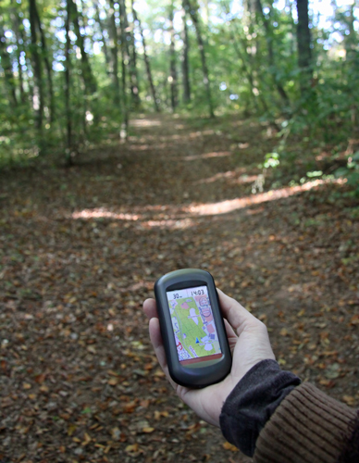
For the more adventuresome, the following climbing classes are scheduled. Each class begins at 8:00 am and meets in the Climbing Center.
Class | Date
Intro to Rock Climbing | March 22
Fitness through Climbing | March 29
Family Vertical Climbing | April 5

The climbing center is open for general use during the following hours:
Friday 5:00 p.m. to 10:00 p.m.
Saturday 4:00 p.m. to 9:00 p.m.
Sunday 1:00 p.m. to 5:00 p.m.

