1
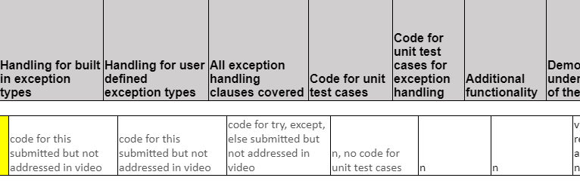

2
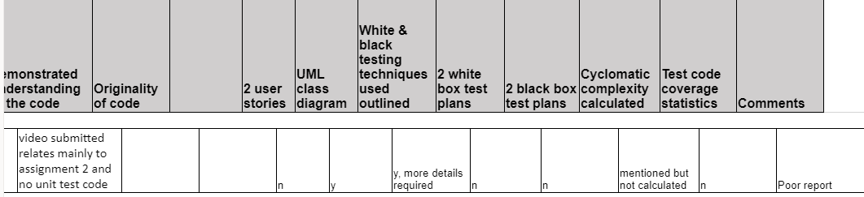
3
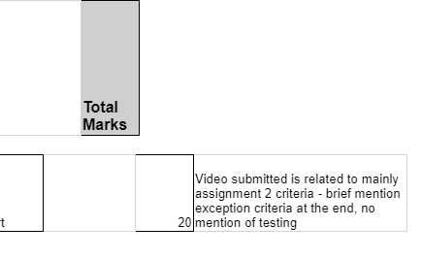
Student Name | Handling for built in exception types | Handling for user defined exception types | All exception handling clauses covered | Code for unit test cases | Code for unit test cases for exception handling | Additional functionality | Demonstrated understanding of the code | Originality of code |  | 2 user stories | UML class diagram | White & black testing techniques used outlined | 2 white box test plans | 2 black box test plans | Cyclomatic complexity calculated | Test code coverage statistics | Comments |  | Total Marks

Mustafa Tariq | code for this submitted but not addressed in video | code for this submitted but not addressed in video | code for try, except, else submitted but not addressed in video | n, no code for unit test cases | n | n | video submitted relates mainly to assignment 2 and no unit test code |  |  |  | n | y | y, more details required | n | n | mentioned but not calculated | n | Poor report |  | 20 | Video submitted is related to mainly assignment 2 criteria - brief mention exception criteria at the end, no mention of testing

