Question 6
Productivity is based on output, in this scenario there is a comparison on productivity between brooms and textbooks. There are two producers Harry, and Potter the two are productive in the two areas. Harry is productive in both production for brooms and textbooks, however the two should divide the task and one should specialize in one each. Harry should specialize in producing brooms while Potter should specialize in producing textbooks. Specialization is necessary to ensure there is maximum production for brooms and textbooks. There is higher production of brooms and textbooks produced through specialization. Number of brooms and textbooks are indicated below.
Comparative advantage is producing at low costs, under comparative advantage there is maximum production under low costs. Absolute advantage on the other hand refers to producing more goods and services under low costs (Brecher,et.al,2002). In a broom and textbook production, it would mean there are low costs in the production. 20 brooms in this case will be produced with 2 productive units. There are 30 textbooks that will be produced with 4 productive units.
Question 8
- Demand and supply curve with increased population
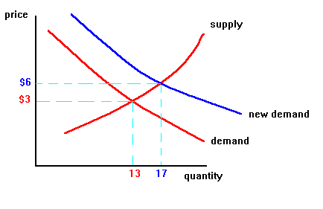

- Demand and supply with shifting income
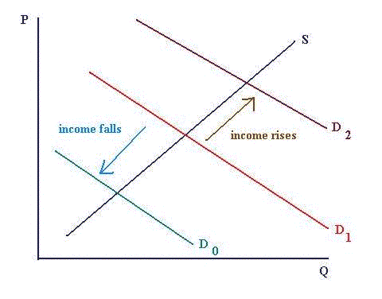
- The price of cotton under shifts a complement to sweaters goes down
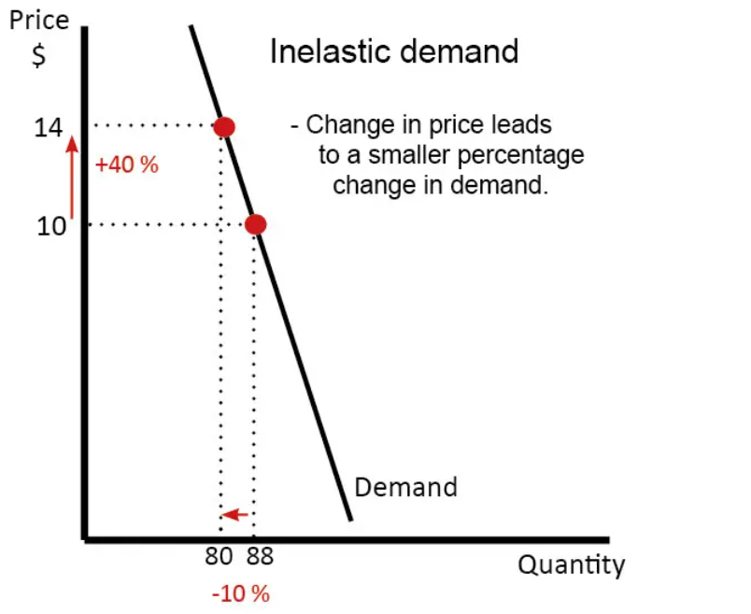

- A study shows wool sweaters causes eczema
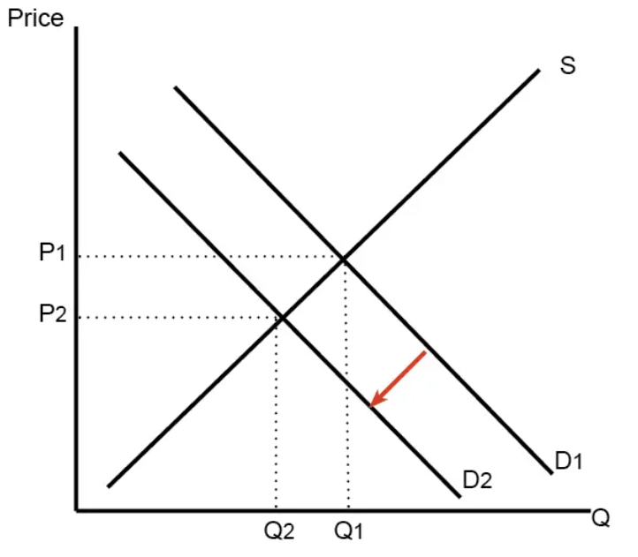
- The cost of yam has decreased significantly
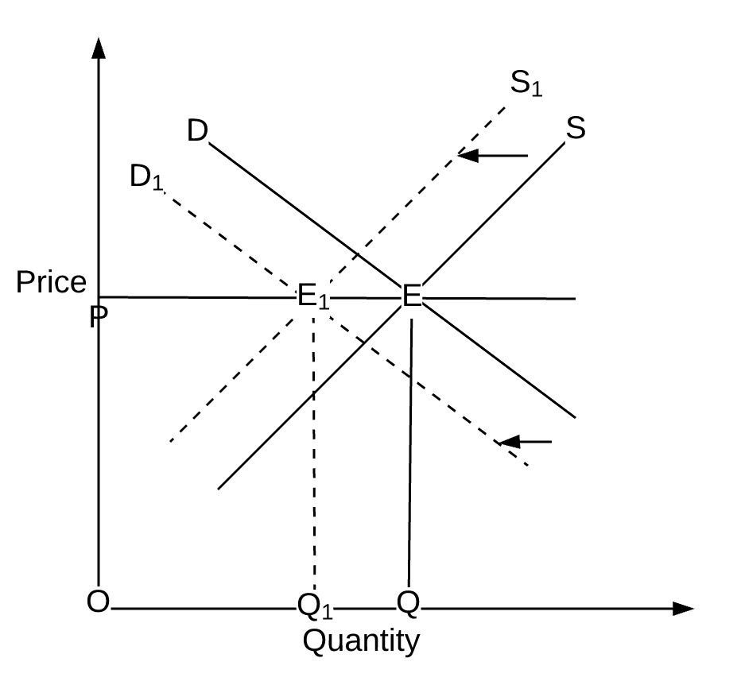

- Wool sweater retail stores mis read the market and raise price 20%
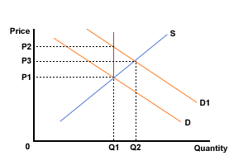
- Someone invented a new faster spinning wheel to make more sweaters per hour
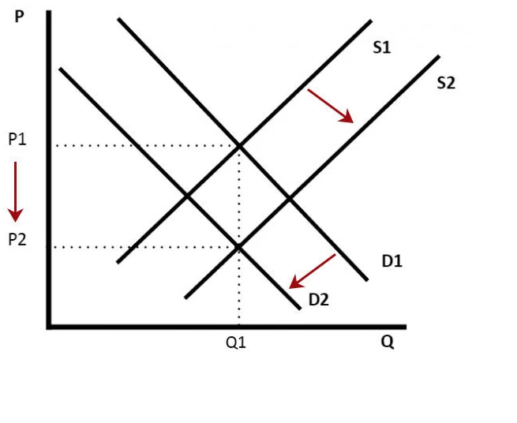

- The weather is warming and the need for sweater declines
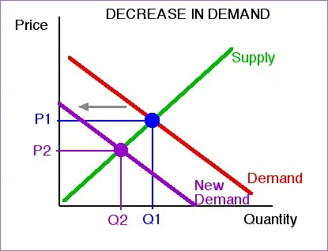

References
Brecher, R. A., Chen, Z., & Choudhri, E. U. (2002). Absolute and comparative advantage, reconsidered: the pattern of international trade with optimal saving. Review of International Economics, 10(4), 645-656.

