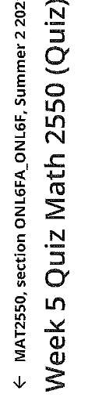
1.
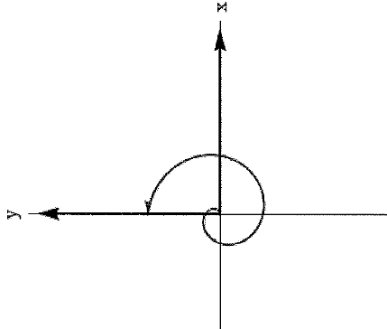
b)

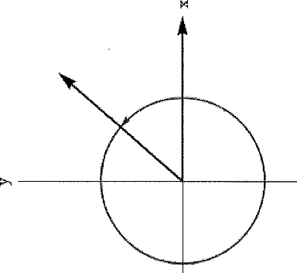
2.$sin{θ}=-\sqrt{\frac{6}{7}}$
cos$θ=-\frac{\sqrt{7}}{7}$
tan$θ=\sqrt{6}$
cosec$θ=-\sqrt{\frac{7}{6}}$
sec$θ=-\sqrt{7}$
cot$θ=\frac{\sqrt{6}}{6}$
b)$sin{θ}=\frac{2\sqrt{5}}{5}$
cos$θ=-\frac{\sqrt{5}}{5}$
tan$θ=-2$
cosec$θ=\frac{\sqrt{5}}{2}$
sec$θ=-\sqrt{5}$
cot$θ=-\frac{1}{2}$
3.
Sin t = $\frac{1}{2}$
cos t = $-\frac{\sqrt{3}}{2}$
tan t = - $\frac{1}{\sqrt{3}}$
4.a)
IV
b)III
5.
Sin $θ=\frac{12}{13}$
Cos $θ=\frac{5}{13}$
Cosec $θ=\frac{13}{12}$
Sec $θ=\frac{13}{5}$
Cot $θ=\frac{5}{12}$
6.
a) complement = 87 radians
supplement =177
b) complement = 89.5
supplement = 179.5
7.
cos$θ=\frac{4}{5}$
tan$θ=-\frac{1}{2}$
cosec$θ=-\sqrt{5}$
sec$θ=\frac{\sqrt{5}}{2}$
cot$θ=-2$
8.
Sin $θ=\frac{5}{13}$
cos$θ=\frac{12}{13}$
tan$θ=\frac{5}{12}$
cosec$θ=\frac{13}{5}$
sec$θ=\frac{13}{12}$
cot$θ=\frac{12}{5}$
9.
Sin 60⁰ , function value $\frac{\sqrt{3}}{2}$
10.
Sin t = $-\frac{21}{29}$
cos t = $-\frac{20}{29}$
tan t = $\frac{21}{20}$
cosec t = $-\frac{29}{21}$
sec t = $-\frac{29}{20}$
cot t = $\frac{20}{21}$

