Landing Vehicle
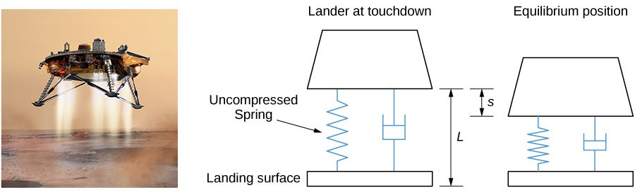
NASA is planning a mission to Mars. To save money, engineers have decided to adapt one of the moon landing vehicles for the new mission. However, they are concerned about how the different gravitational forces will affect the suspension system that cushions the craft when it touches down. The acceleration resulting from gravity on the moon is 1.6 m/sec², whereas on Mars it is 3.7 m/sec².
The suspension system on the craft can be modeled as a damped spring-mass system. In this case, the spring is below the moon lander, so the spring is slightly compressed at equilibrium, as shown in Figure 7.12.
Figure 7.12 The landing craft suspension can be represented as a damped spring-mass system. (credit “lander”:
NASA)
We retain the convention that down is positive. Despite the new orientation, an examination of the forces affecting the lander shows that the same differential equation can be used to model the position of the landing craft relative to equilibrium:
mx″ + bx′ + kx = 0,
where m is the mass of the lander, b is the damping coefficient, and k is the spring constant.
- The lander has a mass of 15,000 kg and the spring is 2 m long when uncompressed. The lander is designed to compress the spring 0.5 m to reach the equilibrium position under lunar gravity. The dashpot imparts a damping force equal to 48,000 times the instantaneous velocity of the lander. Set up the differential equation that models the motion of the lander when the craft lands on the moon.
- Let time t = 0 denote the instant the lander touches down. The rate of descent of the lander can be controlled by the crew, so that it is descending at a rate of 2 m/sec when it touches down. Find the equation of motion of the lander on the moon.
- If the lander is traveling too fast when it touches down, it could fully compress the spring and “bottom out.” Bottoming out could damage the landing craft and must be avoided at all costs. Graph the equation of motion found in part 2. If the spring is 0.5 m long when fully compressed, will the lander be in danger of bottoming out?
- Assuming NASA engineers make no adjustments to the spring or the damper, how far does the lander compress the spring to reach the equilibrium position under Martian gravity?
- If the lander crew uses the same procedures on Mars as on the moon, and keeps the rate of descent to 2 m/sec, will the lander bottom out when it lands on Mars?
- What adjustments, if any, should the NASA engineers make to use the lander safely on Mars

