1.

The matlab code below addresses the needs of question 1. Below it is the plot derived from running the code on matlab. As shown by the comments in the code, the first line declares the step size, the next line declares the variables for initial time t0 and initial value which is 0.5.
Next we calculate the number of times the code iterates which is the time space divided by the step size. Then we create a loop for the iterations. Next thing we do is declare true solution so that we can plot the two on a common grid. The final thing that we do is plot the approximations and the true solution on a common grid.

h = 0.0625; %declaring step size
% declare initial values
t0 = 0;
y0 = 0.5;
% declaring end-point
t_end = 20;

% fetching number of steps required
n = (t_end-t0)/h;

% storing Euler results
tt(1) = t0;
y(1) = y0;

for z=1:n
yres(z+1) = 4 - tt(z) +2*y(z);
tt(z+1) = tt(z) + h;
y(z+1) = y(z) + yres(z+1)*h;
end

% transpose values and storing
t_ans = tt';
y_ans = y';

% declare statement expression
equation = @(tt) 1+(y-1)*exp(cos(tt)-1);

%plot results
plot(tt,y);
hold on;
fplot(equation,[t0,t_end]);

% keep results in matrix
results = [t_ans y_ans equation(t_ans)]

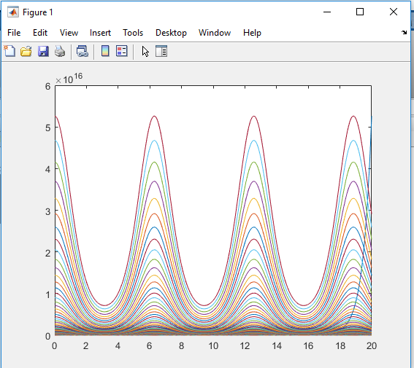

2.
The code below addresses the needs of question 2. We start by declaring the working differential that we have , followed by declaring the initial time. Next we make a vector h and store the step sizes and create a function of zeros . Next we create a for loop that iterates for all the step values and finally we plot that.
clear
clc

f=@(y,t)y-y^2+1.14*cos(exp(t/2));

t_1=0;

h=[1/8,1/16,1/32,1/64];

y=zeros (1,4);

for j=1:4
y_1=1;
for i=1:(20/h(j))

m_1=f(y_1,t_1);

y_1_1=y_1+h(j)*m_1;

t_1=t_1+h(j);

m_2=f(y_1_1,t_1);

y_2=y_1+h(j)*(m_1+m_2)/2;

y_1=y_2;

end
y(j)=y_1;
end

plot(h,y)
xlabel('Step Size'); ylabel('Approximate Value')

