Exercise 7.1
- Impulse response for IRR filter
function ran = random0(n, m)(1,3)

>> random0(4)
positive integer for seed: 1024

ans =

0.0598 1.0000 0.0905 0.2060
0.2620 0.6432 0.6325 0.8392
0.6278 0.5463 0.7551 0.4554
0.3177 0.9105 0.1289 0.6230

>> random0(4)
Enter a positive integer for seed: 32

ans =

0.1441 0.1992 0.8157 0.8275
0.6807 0.8620 0.3278 0.9322
0.8562 0.0354 0.5895 0.2502
0.7901 0.4512 0.3735 0.0233

>> random0(4)
Enter a positive integer for seed: 1024

ans =

0.0598 1.0000 0.0905 0.2060
0.2620 0.6432 0.6325 0.8392
0.6278 0.5463 0.7551 0.4554
0.3177 0.9105 0.1289 0.6230

>> random0(2, 3)
Enter a positive integer for seed: 32

ans =

0.1441 0.1992 0.8157
0.8275 0.6807 0.8620

- IRR filters
The given formula generates random numbers that are almost
% equally distributed between 0 and 1.
%
>> a1 = random0(1, 20000);
Enter a positive integer for seed: 1024
>> mean(a1)

ans =

0.5020

>>std(a1)

ans =

0.2881

>>hist(a1, 10);
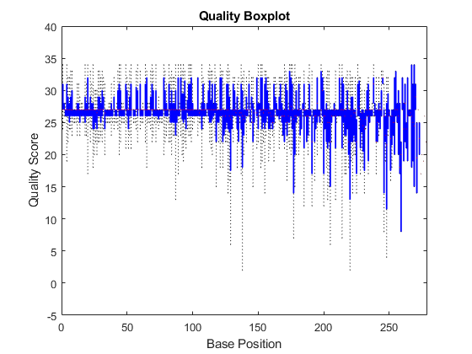
Exercise 7.2
- Nuling FIR
B. xm = 0:50:50*50; % 50 points from 0 to 2450, in steps of 50
[X,Y] = meshgrid(xm,xm);; % use xm twice for symmetric grid.
Z = zeros(50); % blank elevation data
for m = 1:numel(X); % for each index in X (this loops over the whole matrix)
xrng = XDATA < X(m)+25 & XDATA > X(m) - 25; % points where x data withing 25 meters
yrng = YDATA < Y(m)+25 & YDATA > Y(m) - 25; % y data withing 25 meters
- Normalized radian frequency
Z(m) = mean(ZDATA( xrng&yrng)); % take the mean of elevation points within grid range

2.a) x = randn(6,1);
y = randn(6,1);
A = [x y 2*y+3];
R = corrcoef(A)
R = 3×3

1.0000 -0.6237 -0.6237
-0.6237 1.0000 1.0000
-0.6237 1.0000 1.0000

A = randn(10,1);
B = randn(10,1);
R = corrcoef(A,B)
R = 2×2

1.0000 0.4518
0.4518 1.0000

A = randn(50,3);
A(:,4) = sum(A,2);
[R,P] = corrcoef(A)
R = 4×4

1.0000 0.1135 0.0879 0.7314
0.1135 1.0000 -0.1451 0.5082
0.0879 -0.1451 1.0000 0.5199
0.7314 0.5082 0.5199 1.0000

P = 4×4

1.0000 0.4325 0.5438 0.0000
0.4325 1.0000 0.3146 0.0002
0.5438 0.3146 1.0000 0.0001
0.0000 0.0002 0.0001 1.0000

A = randn(50,3);
A(:,4) = sum(A,2);
[R,P,RL,RU] = corrcoef(A)
R = 4×4

1.0000 0.1135 0.0879 0.7314
0.1135 1.0000 -0.1451 0.5082
0.0879 -0.1451 1.0000 0.5199
0.7314 0.5082 0.5199 1.0000

P = 4×4

1.0000 0.4325 0.5438 0.0000
0.4325 1.0000 0.3146 0.0002
0.5438 0.3146 1.0000 0.0001
0.0000 0.0002 0.0001 1.0000

RL = 4×4

1.0000 -0.1702 -0.1952 0.5688
-0.1702 1.0000 -0.4070 0.2677
-0.1952 -0.4070 1.0000 0.2825
0.5688 0.2677 0.2825 1.0000

RU = 4×4

1.0000 0.3799 0.3575 0.8389
0.3799 1.0000 0.1388 0.6890
0.3575 0.1388 1.0000 0.6974
0.8389 0.6890 0.6974 1.0000

The matrices RL and RU give lower and upper bounds, respectively, on each correlation coefficient according to a 95% confidence interval by default.
2b)[R,P,RL,RU] = corrcoef(A,'Alpha',0.01)
R = 4×4

1.0000 0.1135 0.0879 0.7314
0.1135 1.0000 -0.1451 0.5082
0.0879 -0.1451 1.0000 0.5199
0.7314 0.5082 0.5199 1.0000

P = 4×4

1.0000 0.4325 0.5438 0.0000
0.4325 1.0000 0.3146 0.0002
0.5438 0.3146 1.0000 0.0001
0.0000 0.0002 0.0001 1.0000

RL = 4×4

1.0000 -0.2559 -0.2799 0.5049
-0.2559 1.0000 -0.4792 0.1825
-0.2799 -0.4792 1.0000 0.1979
0.5049 0.1825 0.1979 1.0000

RU = 4×4

1.0000 0.4540 0.4332 0.8636
0.4540 1.0000 0.2256 0.7334
0.4332 0.2256 1.0000 0.7407
0.8636 0.7334 0.7407 1.0000

NaN.
A = randn(5,3);
A(1,3) = NaN;
A(3,2) = NaN;
A
A = 5×3

0.5377 -1.3077 NaN
1.8339 -0.4336 3.0349
-2.2588 NaN 0.7254
0.8622 3.5784 -0.0631
0.3188 2.7694 0.7147

R = corrcoef(A,'Rows','complete')
R = 3×3

1.0000 -0.8506 0.8222
-0.8506 1.0000 -0.9987
0.8222 -0.9987 1.0000

R = corrcoef(A,'Rows','all')
R = 3×3

R = corrcoef(A,'Rows','pairwise')
R = 3×3

1.0000 -0.3388 0.4649
-0.3388 1.0000 -0.9987
0.4649 -0.9987 1.0000
c) Analytics if IRR frequency in alpha
function u=seqtan(x0)
x=x0;
y=x-tan(x);
while delta >etol
y=x-tan(x);
x=y;
d)magnitude spectrum
x0=8;
etol=2e-10;
y=x-tan(x);
delta= abs(y-x)/abs(y)
x=y;
while delta >etol
y=x-tan(x);
delta= abs(y-x)/abs(y);
u=y;
end
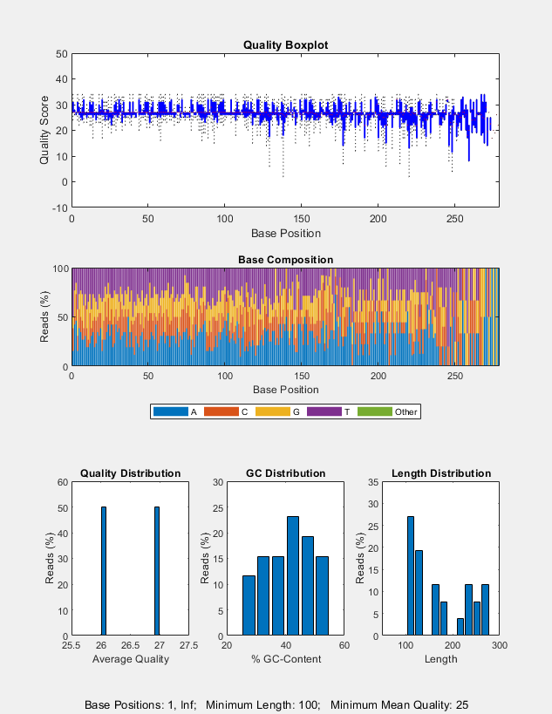
(b)
>> u=y;
>> u
end
u =

14.7997
B) function x= seqtan(x0,etol

x=1;

y=x-tan(x);

x=y;

while delta >etol

y=x-tan(x);
delta=abs(y-x)
x=y;
end

