CMSC 411 – Homework #3
Author:
Institution:

MULTIPLICATION OF MATRICES
Abstract
This paper explores the possibilities of multiplying two matrices. The multiplication of two matrices is possible only if the number of columns in the first matrix is equal to the number of rows in the second matrix. The resulting matrix (i.e. product) will have the number of rows equal to the number of rows in the first matrix and no of columns equal to the number of columns in the second matrix.
The multiplication of two matrices of order m*n and p*q is possible only if n=p and the order of resultant matrix will be m*q. The ij_{th} element of the product matrix is obtained by the summation of the product of the corresponding terms of the i_{th} row of the first matrix and j_{th} column of the second matrix

C++ PROGRAM TO FIND THE PRODUCT OF TWO MATRICES OF ORDER m*n AND p*q.
In the program, we input two matrices using nested for loop in the form of a two-dimensional array. We need to check the condition required for the multiplication of two matrices. We also need to confirm that the user has entered the rows and columns of matrix smaller than the size of the array. If both conditions satisfy then the multiplication is performed and we get the result.
Program
#include <iostream>
using namespace std;

int main()
{
int a[10][10], b[10][10], mult[10][10], r1, c1, r2, c2, i, j, k;

cout<< "Enter rows and columns for matrix A: ";
cin>> r1 >> c1;
cout<< "Enter rows and columns for matrix B: ";
cin>> r2 >> c2;

// If column of first matrix in not equal to row of second matrix,
// ask the user to enter the size of matrix again.
while (c1!=r2)
{
cout<< "Error! column of matrix A not equal to row of matrix B.";

cout<< "Enter rows and columns for A: ";
cin>> r1 >> c1;

cout<< "Enter rows and columns for B: ";
cin>> r2 >> c2;
}

// Storing elements of first matrix.
cout<<endl<< "Enter elements of matrix A:" <<endl;
for(i = 0; i< r1; ++i)
for(j = 0; j < c1; ++j)
{
cout<< "Enter element a" <<i + 1 << j + 1 <<" : ";
cin>> a[i][j];
}

// Storing elements of second matrix.
cout<<endl<< "Enter elements of matrix B:" <<endl;
for(i = 0; i< r2; ++i)
for(j = 0; j < c2; ++j)
{
cout<< "Enter element b" <<i + 1 << j + 1 <<" : ";
cin>> b[i][j];
}

// Initializing elements of matrix mult to 0.
for(i = 0; i< r1; ++i)
for(j = 0; j < c2; ++j)
{
mult[i][j]=0;
}

// Multiplying matrix a and b and storing in array mult.
for(i = 0; i< r1; ++i)
for(j = 0; j < c2; ++j)
for(k = 0; k < c1; ++k)
{
mult[i][j] += a[i][k] * b[k][j];
}

// Displaying the multiplication of two matrix.
cout<<endl<< "Output Matrix: " <<endl;
for(i = 0; i< r1; ++i){
for(j = 0; j < c2; ++j){
cout<< " " <<mult[i][j];
if(j == c2-1)
cout<<endl;
}
}

return 0;
}
In this program, user is asked to enter the size of two matrix at first.
The column of first matrix should be equal to row of second matrix for multiplication. If this condition is not satisfied then, the size of matrix is again asked using while loop.
Then, user is asked to enter two matrix and finally the output of two matrix is calculated and displayed.

Output
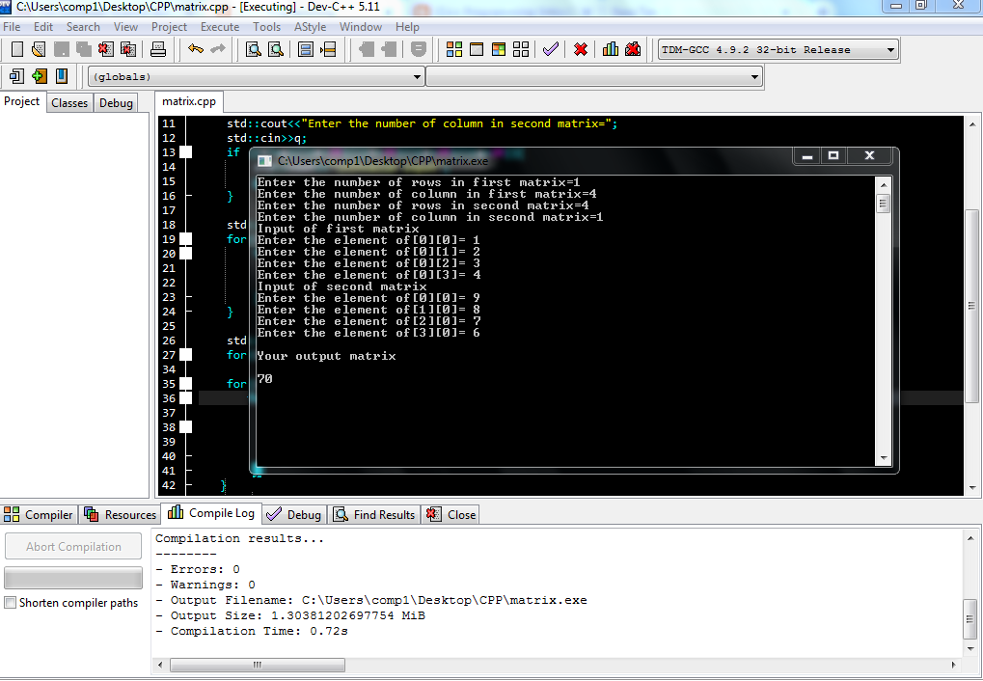
Figure 1: The Output for C = AB

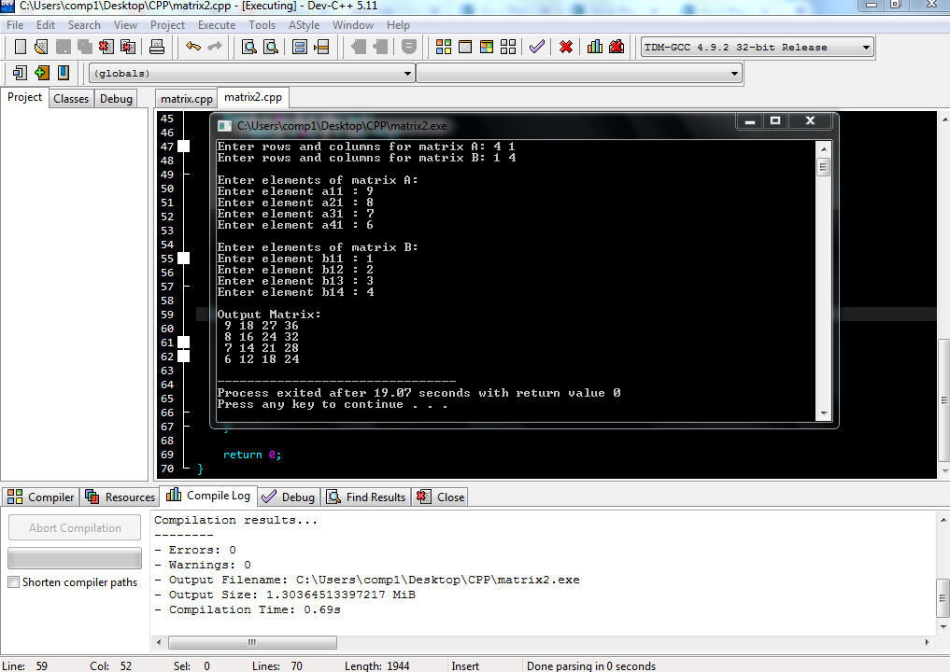
Figure 2: The Output for D = BA

