WHAT ROLE DOES MEMORY PLAY IN AFFECTING OUR PERCEPTION?
Student name
Institution
Course
Date
Abstract
The research analyses how memory affects our perception. The study aims to understand various ways that mind can affect how we perceive objects, events and the occasions that we may encounter within our environment. According to multiple studies, visual memory influences our perceptions so that our mental pictures in our eyes can change the way we see things. An individual need to understand the type of perceptual demands that can be applied to human senses without conceding security and stability. The world information that people have has an impact on how people perceive the world in general. The research will show how the effect is interceded by a declarative memory. For instance, the Dutch and the German grouped hues yellow to orange. The participants from German and Dutch were tested on the traffic lights which related to the orange label in Dutch and the yellow label in German. Though the unbiassed colour is the same for all the groups, the Dutch participants considered the traffic light as orange frequently than the German participants. This could indicate that the declarative information intercedes the impact of the world information about colour grouping. The data was obtained from various scholars.

Introduction
When it comes to memory and perception, the two are strictly interconnected, and the brain manages the process. Consciousness is defined as the system that processes data with clear and understood ways, and the processor is made up of short- and long-term memory. Perception, on the other hand, is the process by which the sensory organs in a body can be aware of the conditions, objects or occasions. Memory plays two roles in affecting our perception. One of the characters is the recognition of how events and purposes can be similar to the past and the present ones and thus making viable decisions on what to do in the current situation ("Cognitive Control, Visual Perception, Auditory Perception, Language and the Brain, Time Perception, Visual Processing, Taste Perception," 2009, p. 45) The second role is that memory keeps a record of the occasions and events which are happening in the present moment so that one can have a piece of extensive knowledge on how to deal with the times and memory that might occur in the future. Most people do take it for granted that the world is just a place they live in.
In most cases, perception occurs in five stages, that is stimulation, memory, recall, organization and evaluation. The reason why people choose to study perception so that they can be able to evaluate problems that they may encounter in their life. The knowledge that people have in the world is the brain because it can guess what is happening regarding the information that is received via the senses. Many factors influence human perceptions. The factors have been analyzed as follows.

Role of Memory in Affecting Our Perception
Memories of an individual change the perspective over time. According to the study that has been carried out about memory shows that memories are likely to be from a viewer’s perspective. Another research shows that this occurs mostly on people who have remembering anxiety infuriating social circumstances. Individuals can recognize pictures of past concerns that aggravate social situations (Hastie, 2014, p.55) Memories hence play an essential role in determining the perception of an individual. When a person recalls a specific event or object, various perspectives would be created in the mind of the individual, such as the type of game that happened or a future event to occur.
The perception of the events that are happening usually has a connected relationship to the mind. For instance, if a person says that he or she has a trip to go to the beach on Friday. When we analyze what the individual is saying, another person can start imagining on the visit; they went to Miami beach. After a while, another person realizes that what the second person told of visiting Miami beach does not even relate to what the first individual said (Canos, n.d, p.65). He or she did not mention the specific beach that he/she visited. This is a perfect example to conclude how often a person can recall the information that is closely related to the current perception and understanding despite the events that are mentioned never occurred.
Another instance that can be related to memory and perception is if a special mention about the death. If there were more than three people who were contributing to the conversation, before the narrator finishes his/her statements, the other two people make their conclusions or the way they perceive death. One person can reflect on memories of a dead relative, and the other one could understand it as the phrase that people cannot live forever. This is a clear explanation of the role that memory can affect our perceptions. The person who started the conversation could have had a different perspective, like asking the past tense of the word death.
Memory plays a role in affecting our visual perception. This is because our memory usually begins with perception (Wong and Peterson, 2016, p.33). Human beings often cannot recall what they don't perceive; therefore, the memory of people is mostly influenced by how individuals see them. Human beings mostly perceive a wide range of physical features due to good visual memory. Therefore, individuals have an added advantage because they process the environment quickly than other creatures in the universe.
An experiment was conducted to test the role of memory in our perception. The design, analysis and results have been discussed as follows.
Participants
The participants were chosen randomly, and the gender balance was considered. They were confirmed as having good vision.
Design and analysis
The procedure needed to have a motion repulsion. The participants were then shown on how to give the responses on what they observed. They were supposed to look at the two dots, one at a time. All participants were supposed to recall the direction of the dots and give their conclusion on whether the pattern of the dots was moving in a clockwise direction or anticlockwise direction with relation to the first dot.

Results and discussion
Different research that has been conducted and published explains that memory is responsible for perception in human beings (Stanley and Scott, n.d., p.44). The experiment was conducted using optical illusion in which the angle between any two objects seemed to be overstated. Then the participants were asked to recall in which the first dot moved. They were also asked to give judgment on the direction of the second dot that is clockwise or anticlockwise.
The reports from the participants indicated that the direction they perceived was clockwise. This can be explained by the fact that there was motion after effect. This technique usually happens when an individual has been staring at a moving object for some time and immediately shifting the gaze to a stationary object. The effect of this is that the second object moves the opposite direction to the first object. The time that the dot was showed was less than a second that is not enough to deliver motion after effect; thus, the result is likely to produce a perspective that the second dot is moving to the direction opposite the first dot. This is evidence of how memory can affect our outlook on various objectives and occasions.
Various researchers have done experiments to determine how memory can affect one's perception. The researchers concluded that our working memory could significantly affect our perception view. For example, research is done on five participants to show how the mind affects their perception (Adam, 2018, p.36). The results of the experiment showed that the participants were able to remember the pattern of the dots and maintained the mental picture of how the dot moved and how it looked. The mental image the participants created in the first sight changed the perception of the second pattern.
Visual working memory connects with perception closely. This is because the machine of the brain is designated to perform both of the processes. There is evidence that the features that are contained in the visual working memory, which is programmed in the visual cortex; thus, it can be reserved there for some seconds. The findings show significant impacts on our everyday life.

Influence of memory on perception
For one to distinguish between the perceptual training and perceptual decision, knowledge must be involved so that one of the accounts can be ruled out. For instance, in colour perception, the participants are requested to change the hue of the object through pressing any of the four buttons that were provided which led to the increase or decrease of the hue values which were in the colour space. The participants concluded that the colour was grey, and they ultimately said the opposite of what was expected. The participants were required to choose one colour that is yellow or orange. In the experiment, the objects that did not have a typical colour, they were able to say the correct colour. When it came to the objects which had a standard colour, the participants failed to predict the right colour. This instance clearly shows that the shows that there is a possibility that the knowledge which an individual has in declaring any other object also had an impact on the perceptual decision making.
In the figure below, the various forms of memory perception have been illustrated showing the top-down flow of information and the merging of the data. The diagram also shows the relationship between perceptual memory and declarative memory.
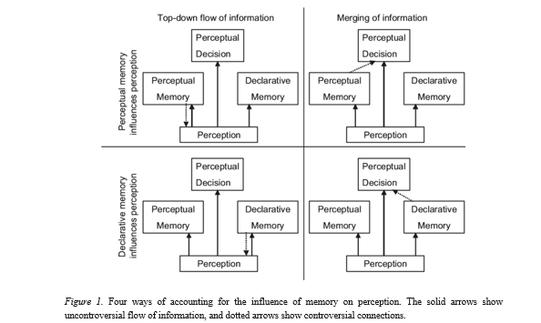

An experiment was conducted to determine how human beings perceived different colours. The stimuli that were used are; socks, carrot, banana and traffic light. The following diagram shows the objects that were used in the experiment. The design, analysis and results are discussed below.
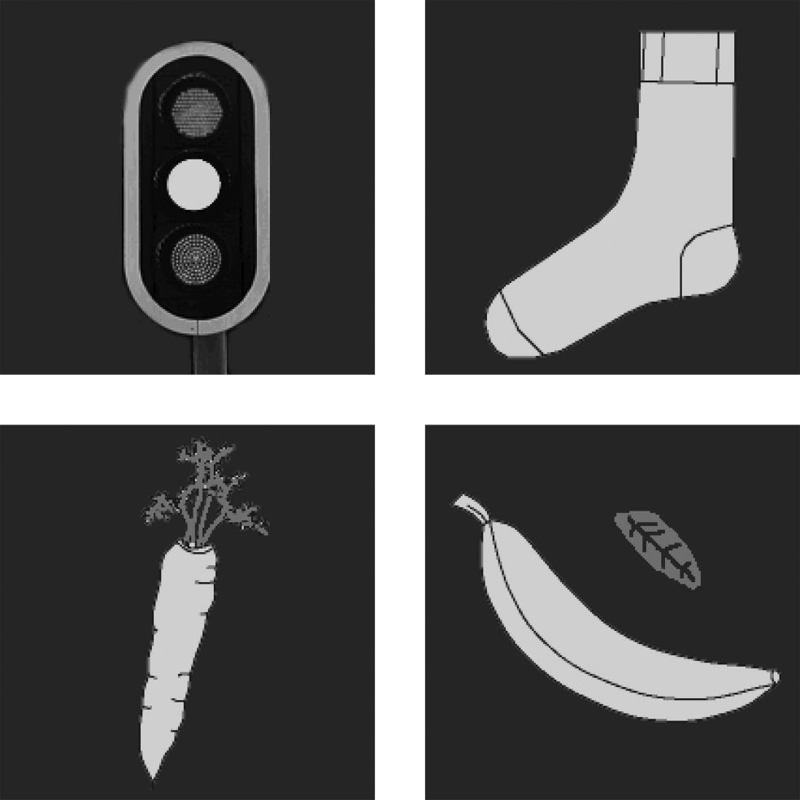

Participants
The number of people who were selected to participate in the study was 39. The chosen participants had normal vision, and no one was reported to be having any vision impairments. Among the chosen participants, 20 of them were from German, and the rest were Dutch speakers.
Materials and the procedure involved.

The study was conducted in a dark room which had LCD monitors that provided light. The participants were then tested, and each of them had to face the computer screen. They were then asked to identify the colours that were reflected in the object as yellow or orange. They were supposed to respond by pressing a button.

Design and analysis
In the experiment, responses that were given were determined by the object identifier that was shown light. The linear model that was applied in this experiment had the function that predicted the ratio of yellow responses along with the factors, hue, object and the language of the participant.
Results
In figure 3 below, the results were presented as a percentage of yellow responses. The Dutch participants gave their answers more on the yellow colour than the traffic lights. The data that was analyzed shows the statistical analysis. The analyses were conducted separately for each of the objects, and there was no impact of the native language for the purposes that is carrot, socks, and banana.

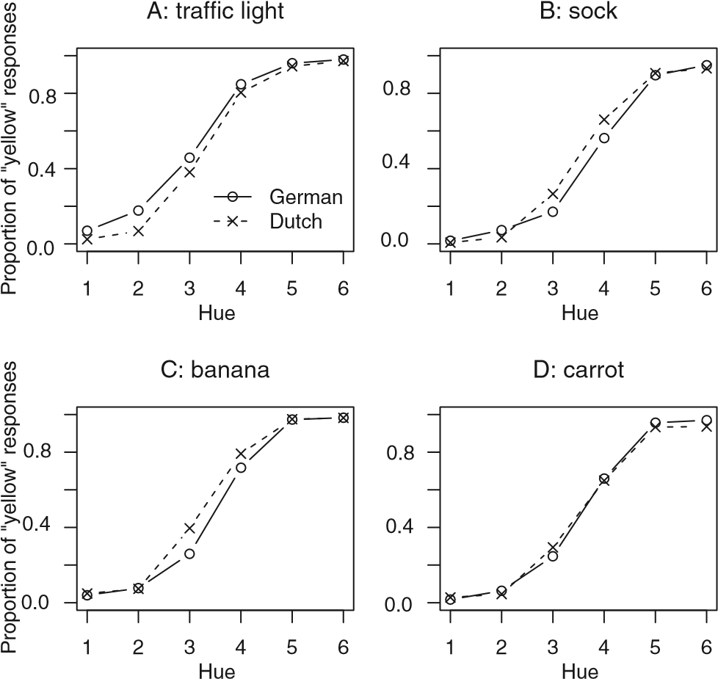figure 3
From the graphs, it can be concluded that a large number of degrees of freedom. Apart from the native language variable, it was found that the yellow responses across the hues were more compared to how the hues were on the banana and the carrot. The other conclusion that was drawn is that there were more orange responses if the hue was placed on the sock than it was on the carrot and banana.
Discussion
In the discussion, the test was to determine if an influence on the world information about the perception category, is caused by the perceptual memory. This was observed by the way the Dutch and the German had a difference in their declaration and did not include the memory of the traffic lights (Rogers, 2017, p.103). The traffic lights are mostly found in the European countries compared to the Dutch who are used to calling the middle light Oranje (0range) while the Germans call it Gelb (yellow). In the experiment, the German participants defined the hues that were put in the middle of the traffic lights as yellow often than the Dutch participants did. The result showed that the participants had a difference in declarative memory of the traffic lights.
There were also two other additional results that were obtained from the study. The results obtained were independent of the native language, and they were expected and unexpected. Both of the participants were able to give more yellow responses for the banana compared to the carrot with the general knowledge that a banana is yellow and the carrot has orange color (Overas, Kapstad, Brunorg, Landro And Lask, 2014,p.56)The unexpected part of the result was that the sock object obtained more orange responses than the carrot. The reason behind this result is the difference that was in the brightness contrast between the objects.
The capable effect of the simultaneous contrast is not the possible cause of the main result of the experiment. The difference that came out in the yellow responses between the German and the Dutch shows the traffic light stimulus. Both the participants developed the same picture in the memory. The other explanation of the observed difference can be in the possibility that existed in the colour boundaries between yellow and orange. This explanation was cancelled when the non-traffic light objects were included. The difference that could have lived in the colour limits could be determined by the responses on the purposes also, and it turned out that there were no differences found out in the two groups.
The results indicate that the declarative information excluding the perspective information is the one that is leading people in the world to perceive with our expectations. The participants made conclusions that the two colours that are from the different linguistic group were similar t each other compared to the stimuli that were obtained from the two linguistic categories. Usually, when the color borders differ across all the languages, the performance is determined by the language groups that are specific instead of the perspective distance that is associated. Sometimes these the effects can be facilitated by language association bur the most effective that they can be mediated by using colour labels. The active role of the colour label is to ensure that there is an excellent visual filed that will be anticipated to the left side.
We cannot cancel out the perceptual memory because it has a significant role to play also. The task sometimes is classified as a minor one. For instance, the data that was obtained shows that the perceptual memory has a small impact (Perceptual imagination and perpetual memory,2018, p.76). This is because the study shows that the effect of object identity that is banana and the carrot, have a similar size when the two are combined. The results in the description data are 5% which leads to 0.5 when it is changed into log data in the statistical model. This is the reason why the labelling bias is sufficient kin describing the difference in numerical values that give the yellow responses to the banana and the carrot.
From the results, we can argue that verbal labels have an influence in the world because they give knowledge about the perspective decisions that can be made. When that one is done, the idea comes in that language can enhance the memory of an individual and the perception. The results that were obtained from the experiments clearly show that when you call an object yellow, or orange, has an impact on how the hues on the objects are grouped. Sometimes, there are when the native language on perceptual training instead of the perceptual decisions that can be made (Levino and Morais, 2014, p.99). The results can be predicted that various responses are recommended by perspective evidence and the declarative information which support the different issue of the same colour.
Conclusion
To understand the mechanisms of the memory usually takes a lot of time. From the experiment that was conducted on the two native language speakers, we can support the idea that declarative language can impact perceptual decisions. The data that was obtained shows that there is a probability of more than 0.5 that it can influence perceptual choices. The information collected also indicates that the perceptual acquaintance cannot lead to the object created prejudices in perception.
Therefore, memory has a significant effect on our perspectives. Wrong memories can lead to making the wrong perspectives. Thus, memory and perception affect each other through human development. Memory defines how human beings identify and respond to various events and objects in our environment. Since every individual has different beliefs and experiences, the role of the mind in our perspective may lead us into making excellent views that are related to the subject matter or even make conclusions that are out of topic. Thus, we should stop the idea of reading other people's minds from the behaviour that they expose to us.

References
Camos, V. (n.d.). The role of working memory in development. Working Memory in Development, 1-62. doi:10.4324/9781315660851-10
Cognitive Control, Visual Perception, Auditory Perception, Language and the Brain, Time Perception, Visual Processing, Taste Perception. (2018). Attention, Perception & Psychophysics, 71(8), 1679-1681. doi:10.3758/app.71.8.1679
Hastie, R. (2014). Person Memory (PLE: Memory). doi:10.4324/9781315778037
Proverbio, A. M., Vanutelli, M. E., & Viganò, S. (2017). How emotional memory affects face remembering: an ERP investigation. doi:10.1101/208256
Stanley, J., & Scott, C. (n.d.). The effects of the underwater environment on perception, cognition and memory. 'Challenges of Our Changing Global Environment.' Conference Proceedings. OCEANS '95 MTS/IEEE. doi:10.1109/oceans.1995.528718
Wong, J. H., & Peterson, M. S. (2018). What we remember affects how we see: Spatial working memory steers saccade programming. Attention, Perception, & Psychophysics, 75(2), 308-321. doi:10.3758/s13414-012-0388-7
Ádám, G. (2016). Interoception —sensory function without perception. Perception, Consciousness, Memory, 104-113. doi:10.1007/978-1-4684-2073-9_6
Marsh, K. L. (2017). Coordinating Social Beings in Motion. People Watching, 234-255. doi:10.1093/acprof:oso/9780195393705.003.0014

Levino, N. D., & Morais, D. C. (2014). A decision model for dealing with participatory environmental problems. 2014 IEEE International Conference on Systems, Man, and Cybernetics (SMC).
Perceptual Imagination and Perceptual Memory. (2018). Oxford Scholarship Online.
Rogers, B. (2017). 5. Perception of a 3-D world. Perception: A Very Short Introduction, 59-83.
Øverås, M., Kapstad, H., Brunborg, C., Landrø, N. I., & Lask, B. (2014). Memory Versus Perception of Body Size in Patients with Anorexia Nervosa and Healthy Controls. European Eating Disorders Review, 22(2), 109-115.
https://www.theguardian.com/science/neurophilosophy/2011/aug/17/memory-contaminates-perception
https://pdfs.semanticscholar.org/f939/cfac4e43fe2c204495269ef7542e5c854333.pdf

