
Mathematics 30-2 -- Unit 2: Counting Methods Name:
Assignment
Total /31 marks

Multiple Choice: (11 marks)
- If all the letters in the word JOUSTING are used, then the number of different 8-letter arrangements that can be made beginning with the 3 vowels can be evaluated using the expression

A.
B.
C.
D.

Ans: b)

- Evaluate 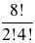

  - 1
  - 4
C. 840
D. 3360

Ans: c)

- Which expression represents the value of ?

A.
B.
C.

D.

Ans: b)
- How many different arrangements can be made using all the letters in ALBERTA?

A.
B.
C.
D.

Ans: b)
- Assume that in a given set of 3 digit area codes, the middle digit of each code is a 5. Which of the following conditions on digits would result in exactly 90 area codes?

  - All three digits cannot repeat.
  - The first and last digit cannot be a zero and repetition is allowed.
  - The first digit cannot be a zero and repetition is allowed.
  - There are no restrictions on the possible values.

Ans: b)
- A Phys. Ed. Teacher can remove 3 students at a time for testing. If there are 27 students in the class, the number of ways he can choose a group of three, is:

A.
B.
C. 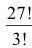
D.

Ans: A)

- Martha wants to use the digits 2, 3, 4 and 5 for her personal banking identification number. If repetitions are NOT allowed, how many different four-digit numbers can she create?

A. 256
B. 120
C. 24
D. 16

Ans: c)

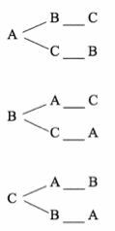
- A student models a problem with the following diagram.

The model allows the student to list all of the

  - A permutation of 3 items
  - A combination of 3 items
  - A permutation of 6 items
  - A combination of 6 items

Ans: A)

- Six distinct points are on the circumference of a circle as shown below. The number of quadrilaterals that can be formed using these 6 points is
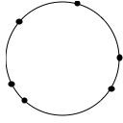
A. 360
- 30
- 24
- 15

Ans: d)
- A Bingo cage contains 4 different B balls and 15 different N balls. Suppose Veronica reaches in grabs 2 B balls and 3 N balls. Which expressions can be used to calculate how many different combinations of these balls there are?

A.
B.
C.
D.

Ans: d)

- A league consists of 12 teams. If each team plays each other once, how many games must be scheduled?

A.
B. C. 121
D. 144

Ans: a)

Numerical Response: (5 marks)

- The number of 3-digit numbers more than 800 that can be formed if the last digit is a 2 or a 3, and no digit can be repeated is .

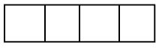
Record your answer in the numerical response box below.

0 0 3 2

- There are two values for r in the expression . What are the two values?

Record your answer in the numerical response box below.

0 and 3 4

- The number of five-card hands from a standard deck of 52 cards with exactly three jacks is .

Record your answer in the numerical response box below

4 5 1 2

- A hockey team has 3 right-wingers, 4 left-wingers and 2 centres. The number of different lines with 1 right-winger, 1 centre and 1 left-winger that the coach can form is .

Record your answer in the numerical response box below.

0 0 2 4

- Evaluate 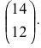

Record your answer in the numerical response box below

0 0 9 1

.

- How many different routes are there from A to B, if you only travel south or east?

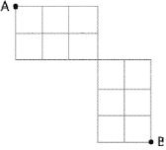

Record your answer in the numerical response box below.

0 1 0 0

Written Response: (14 marks)

  - A band sells shirts and CDs at their concerts. They have 3 CDs and there are 2 different styles of shirt available in small, medium, large, and extra large.

    - How many ways could you buy one CD and one shirt using the two methods below? (2 marks)

Solution :
Using Tree diagram :
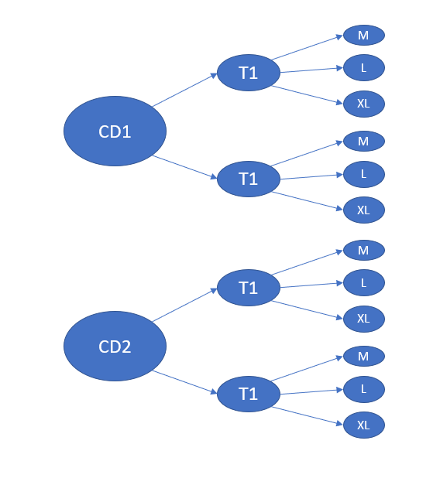

Total number of ways = 12

Using principle of multiplication for counting :

Since type of CD, type of Tshirt and size of T shirt are independent variables, total number of ways = number of CD x number of T-shirt x Size of Tshirt = 2 x 2 x 3 = 12
b. Which method did you like better? Explain your reasoning. (1 mark)

Answer : I liked the method using principle of multiplication for counting as it can be extended for many variables and large number of elements as well while drawing tree diagram is a tedious task when the number of elements increase.

  - A combination lock opens with the correct three-letter code. Each wheel rotates through the letters A to O.

- How many different three-letter codes are possible? (1 mark)

Answer : 3375
Explanation : Each position in code can be filled with any of the letter from A to O i.e. in 15 ways. Also since the code is having 3 letters, from the principle of counting of multiplication,
total number of ways = 15 x 15 x 15 = 3375.

- What assumptions did you make when answering the question? (1 mark)
Answer : The underlying assumptions were :
(i). The letter at any position in the code is unaffected by any other position’s letter.

  - Owners of vehicles in North America are required to purchase license plates in Alberta, a standard license plate consists of 3 letters followed by 3 digits.

- Determine the maximum number of different standard license plates available. State any assumption(s) that you make.

(2 marks)
Solution :
Assuming that the value at one position in the license plate is not influenced by value at any other value in the license plate, let’s solve this question.

Each digit can take values from 0 to 9 i.e. in 10 ways. Each letter can be filled with any letter from A to Z i.e. in 26 ways. Now we have 3 letters and 3 digits in the license plate so using principle of multiplication for counting,
Total number of ways = 10 x 10 x 10 x 26 x 26 x 26 = 17576000

- It has becomes necessary to increase the number of available license plates. New licence plates in Alberta now consist of 3 letters and 4 digits. How many more licence plates can be made? (2 marks)
Solution :
The number of plates possible with 3 letters and 4 digits = 10 x 10 x 10 x 10 x 26 x 26 x 26 = 175760000
Extra number of plates that can be made = 175760000 – 17576000 = 15,81,84,000

  - Euchre is played with a deck of 24 cards that is similar to a standard deck of 52 playing cards, but with only the ace, 9, 10, jack, queen, and king for all four suits.

- Count the number of possibilities of drawing a single card from a euchre deck and getting either a face card or a red card. (2 marks)
Solution :
Number of red cards = 1/2 x 24 = 12 (Half of the cards are red)
Number of face card = 2 x 4 = 8 (2 face card for each Heart, Spade, Club and Diamond)
Number of red face cards = 2 x 2 = 4 (2 cards each for heart and diamond which are red)

But we know that n(A U B) = n(A) + n(B) – n(A ∩ B) for any two sets hence :
Number of either red or face card = Number of red card + Number of face card – Number of face red card
- n(RED U FACE) = 12 + 8 – 4 = 16
Hence Answer = 16

- Does the Fundamental Counting Principle apply to this situation? Explain. (1 mark)
Answer :
Our problem can also be solved using the Fundamental counting principle. Let E be our event of getting a red or a face card. Let E₁ be an event of getting red card and E₂ be event of getting a face card which is not red. Event A can take place either with E₁ or E₂. So using fundamental counting principle, n(E) = n(E₁) + n(E₂). Hence we see the principle is applicable in this problem as well.

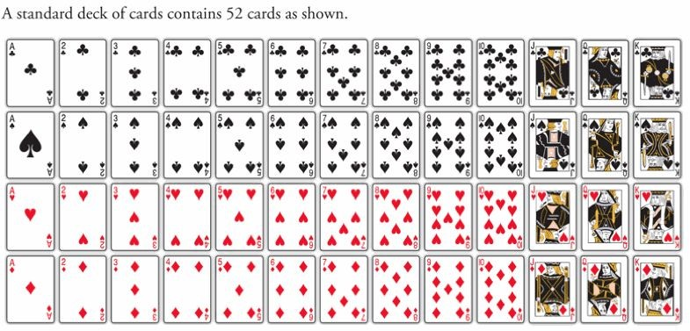
  - Use the diagram of a standard deck of cards to answer the question below.
From a standard deck of 52 cards, how many different three-card hands are there with at most one ace? (2 marks)

Solution :

The number of ace cards in the total deck is 4. Let’s consider two cases for our solution :
Case 1 : When number of ace cards is 0.
In this case, the 3 cards will be chosen only from the 48 cards which can be done in ⁴⁸C₃ ways i.e. 25944.
Case 2 : When number of ace card is 1 among the three cards.
In this case, two cards will be chosen from 48 cards and 1 ace card will be chosen from 4 ace cards. 2 cards can be chosen in ⁴⁸C₂ and 1 ace card can be chosen in ⁴C₁ ways so using principle of multiplication for counting, we can chose three cards containing exactly one ace in ⁴⁸C₂ x ⁴C₁ = 4512.

Hence answer = 4512 + 25944 = 30456.

