Animals Welfare
Name
Institutional Affiliation
Date

Preface
This is a multi-genre project that targets 15-year old children living in humble socio-economic areas. The project sensitizes the children on the importance of protecting and promoting animals’ welfare. The primary message in this project is love and respect for animals.
Dear Reader,
Animals are an essential part of the ecosystem and play an instrumental role in daily lives. They provide meat, milk, protection, economic values, and recreation among other services. We also keep them as pets at home making them our close friends. The history of our interactions with them traces back to pre-historic times when our ancestors were hunters and gatherers. As we advanced, the domestication became an essential aspect of our survival. Today, dogs and cats are some of our closest friends and provide us emotional satisfaction as well as protection.
However, animals are still getting ill-treatment and abuse from us. People make an assumption that they have no feelings thus deserve no love or respect. On the contrary, animals have feeling and develop strong relationships with their owners. Besides, it is our moral obligation to protect and respect all the creatures under our care.
I believe that this piece will inspire you positively and ignite your passion to advocate for animals welfare in your neighborhood. I hope this piece helps you see animals as living things with feelings that deserve respect and protection from you and your friends. Dogs, cats, birds, and all other animals are an important part of our eco-system and hopefully, you will see the urgency to protect them.
Sincerely yours
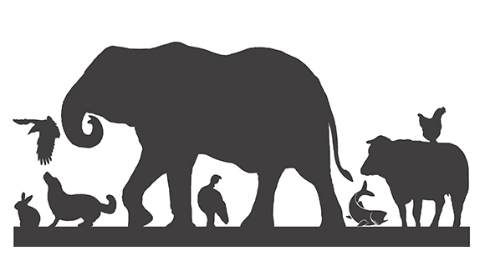
We are because you are. Respect us we are part of you.
Hear My Plea
I live with you every day
Guarding your home with zeal
And taking your orders without question
Because I’m your loyal friend
But you don’t respect
I provide your child with milk
At the expense of my own
Because I’m a loyal friend
But you don’t respect
You call me “beast of burden”
Because of the service I offer
I carry all your loads
And obey you as my lord
But you don’t respect me

I am an animal
A loyal friend, who protects, feeds, and help you
I too deserve respect, love, and protection.

Morning conversation between Cat and Dog
Cat: Good morning everyone! I hope you all had a lovely night.
Dog: Good morning to you! My night was everything but lovely. My kernel is dirty and no bothers to clean. Besides, no one appreciates the good work I do protecting this home.
Cat: At least you only complain of the dirty kernel. My eyes have been paining for the last two months but no one cares. They just look at me like everything is all right. Maybe we are lesser creatures in this home. Yesterday David complained of a headache and today he has been treated. But for us..!
Dog: You mean you haven’t discovered that some animals are more equal than others? My life here is miserable. No freedom to move and experience the world on my own. They pretend to protect while in real sense they abhor me. Living with our master is not for the faint-hearted. Maybe Fox- my cousin, is feeling better in the wild.
Cat: No one knows. Maybe one-day freedom will come. (Walks away leaving the dog gazing at the gate). Dog: I appreciate everyone fighting for my rights. You’re my heroes.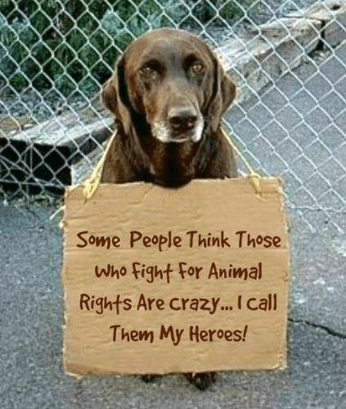

Animal Welfare
The human-animal interactions are as old as human's history. It also formed the foundation of various studies that seek to improve our understanding of their communication with each other. Scientists have discovered interesting facts about wild animals as well as domesticated ones. For instance, dogs have one strong sense of smell but poor sight. They thus use smell as a primary means of detecting their environments (Neocleous, 2016). The strong sense of smell has made dogs an essential component of security operations. Sniffer dogs help the police officers in detecting any suspicious objects (Lancaster, Hughes, & Ritter., 2017). Additionally, other animals like pigs, chicken, and cattle act as vital sources of proteins to human beings.

References
Lancaster, K., Hughes, C., & Ritter., A. (2017). Drug dogs unleashed’: An historical and political account of drug detection dogs for street-level policing of illicit drugs in New South Wales, Australia. Australian & New Zealand Journal of Criminology, 50(3), 360-378.
Neocleous, M. (2016). The smell of power: A contribution to the critique of the sniffer dog. In Body/state. London: Routledge.

